Supplementary file

Table S1. Genes that had the highest correlation (Pearson correlation coefficient >0.95) with 1q22 expression. Both positive and negative correlation are included. There is no overlap in these genes between the age groups.
Panel A: Nonagenarians Panel B: Young controls
 | Ensembl gene ID | Gene symbol | Correlation |  |  | Ensembl gene ID | Gene symbol | Correlation
1 | ENSG00000104447 | TRPS1 | 0.995 |  | 1 | ENSG00000137078 | SIT1 | 0.979
2 | ENSG00000198915 | RASGEF1A | -0.994 |  | 2 | ENSG00000180071 | ANKRD18A | 0.978
3 | ENSG00000113494 | PRLR | 0.984 |  | 3 | ENSG00000177570 | SAMD12 | 0.969
4 | ENSG00000132205 | EMILIN2 | 0.984 |  | 4 | ENSG00000148481 | MINDY3 | -0.968
5 | ENSG00000059377 | TBXAS1 | 0.982 |  | 5 | ENSG00000112996 | MRPS30 | 0.967
6 | ENSG00000140474 |  | -0.980 |  | 6 | ENSG00000172673 | THEMIS | -0.966
7 | ENSG00000144959 | NCEH1 | 0.979 |  | 7 | ENSG00000197162 | ZNF785 | 0.965
8 | ENSG00000134287 | ARF3 | 0.979 |  | 8 | ENSG00000110367 | DDX6 | -0.956
9 | ENSG00000126067 | PSMB2 | 0.970 |  | 9 | ENSG00000119185 | ITGB1BP1 | -0.951
10 | ENSG00000112531 | QKI | 0.968 |  | 10 | ENSG00000170734 | POLH | 0.951
11 | ENSG00000015676 | NUDCD3 | -0.967
12 | ENSG00000118564 | FBXL5 | 0.967
13 | ENSG00000125703 | ATG4C | 0.966
14 | ENSG00000108100 | CCNY | 0.965
15 | ENSG00000134755 | DSC2 | 0.965
16 | ENSG00000038427 | VCAN | 0.962
17 | ENSG00000140740 | UQCRC2 | 0.962
18 | ENSG00000108239 | TBC1D12 | 0.961
19 | ENSG00000196352 | CD55 | 0.960
20 | ENSG00000184441 |  | -0.959
21 | ENSG00000084234 | APLP2 | 0.959
22 | ENSG00000115762 | PLEKHB2 | 0.958
23 | ENSG00000109323 | MANBA | 0.957
24 | ENSG00000107185 | RGP1 | -0.957
25 | ENSG00000013523 | ANGEL1 | 0.957
26 | ENSG00000168615 | ADAM9 | 0.956
27 | ENSG00000188921 | HACD4 | 0.956
28 | ENSG00000108953 | YWHAE | 0.956
29 | ENSG00000005893 | LAMP2 | 0.956
30 | ENSG00000078369 | GNB1 | 0.955
31 | ENSG00000067208 | EVI5 | 0.955
32 | ENSG00000074935 | TUBE1 | -0.954
33 | ENSG00000132932 | ATP8A2 | -0.954
34 | ENSG00000068831 | RASGRP2 | -0.954
35 | ENSG00000121413 | ZSCAN18 | -0.952
36 | ENSG00000035681 | NSMAF | 0.952
37 | ENSG00000147168 | IL2RG | -0.952
38 | ENSG00000188171 | ZNF626 | -0.952
39 | ENSG00000115840 | SLC25A12 | -0.951
40 | ENSG00000109911 | ELP4 | 0.951
41 | ENSG00000162711 | NLRP3 | 0.951
42 | ENSG00000138829 | FBN2 | 0.951
43 | ENSG00000008083 | JARID2 | 0.951
44 | ENSG00000023318 | ERP44 | 0.950
45 | ENSG00000119900 | OGFRL1 | 0.950
46 | ENSG00000114450 | GNB4 | 0.950
47 | ENSG00000079277 | MKNK1 | 0.950

Figure S1. Q-Q plot of the HERV-K (HML-2) provirus at 1q22 expression across nonagenarian samples against normal distribution. The plot as well as a Shapiro-Wilk test (p-value = 0.58) support that the distribution of the expression of 1q22 in the studied samples approximates normal distribution.

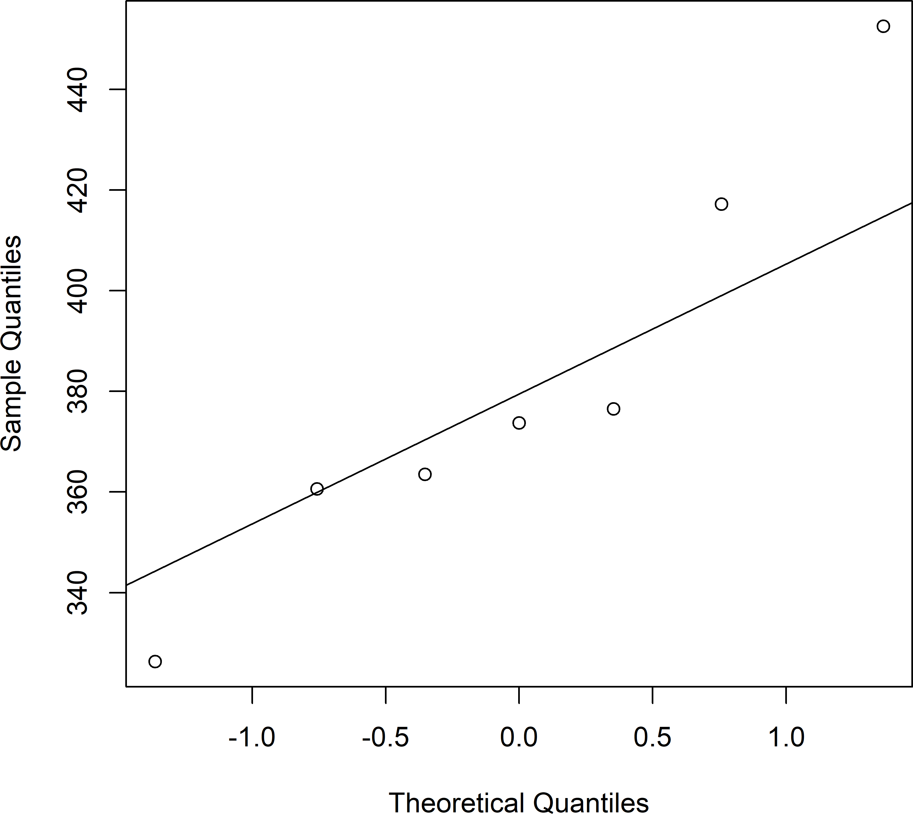

Figure S2. Q-Q plot of the HERV-K (HML-2) provirus at 1q22 expression across young samples against normal distribution. The plot as well as a Shapiro-Wilk test (p-value = 0.32) support that the distribution of the expression of 1q22 in the studied samples approximates normal distribution.
