Supplementary Material
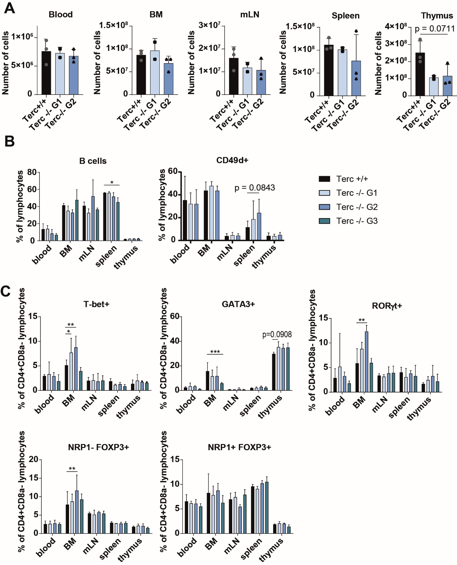
Supplementary Figure 1. Additional data on cell counts and composition of cell populations of mTerc-/- mice under steady-state conditions.
(A) Total cell counts from organs obtained by counting of single cell suspensions using a hemocytometer (n = 3 for Terc+/+ and Terc-/- G2, n = 2 for Terc-/- G1).
(B) Flow cytometric analysis of B cells (B220+, n = 3 from each generation) and NK cells (CD49d+, n = 3 for Terc+/+ and Terc-/- G2, n = 2 for Terc-/- G1) under steady-state conditions.
(C) Analysis of markers of T helper cell subsets among CD4+ T cells from mTerc-/- mice under steady-state conditions (n = 3 from each generation).
Graphs show the mean ± SD, * adjusted p ≤ 0.05, ** adjusted p ≤ 0.01, *** adjusted p ≤ 0.001.

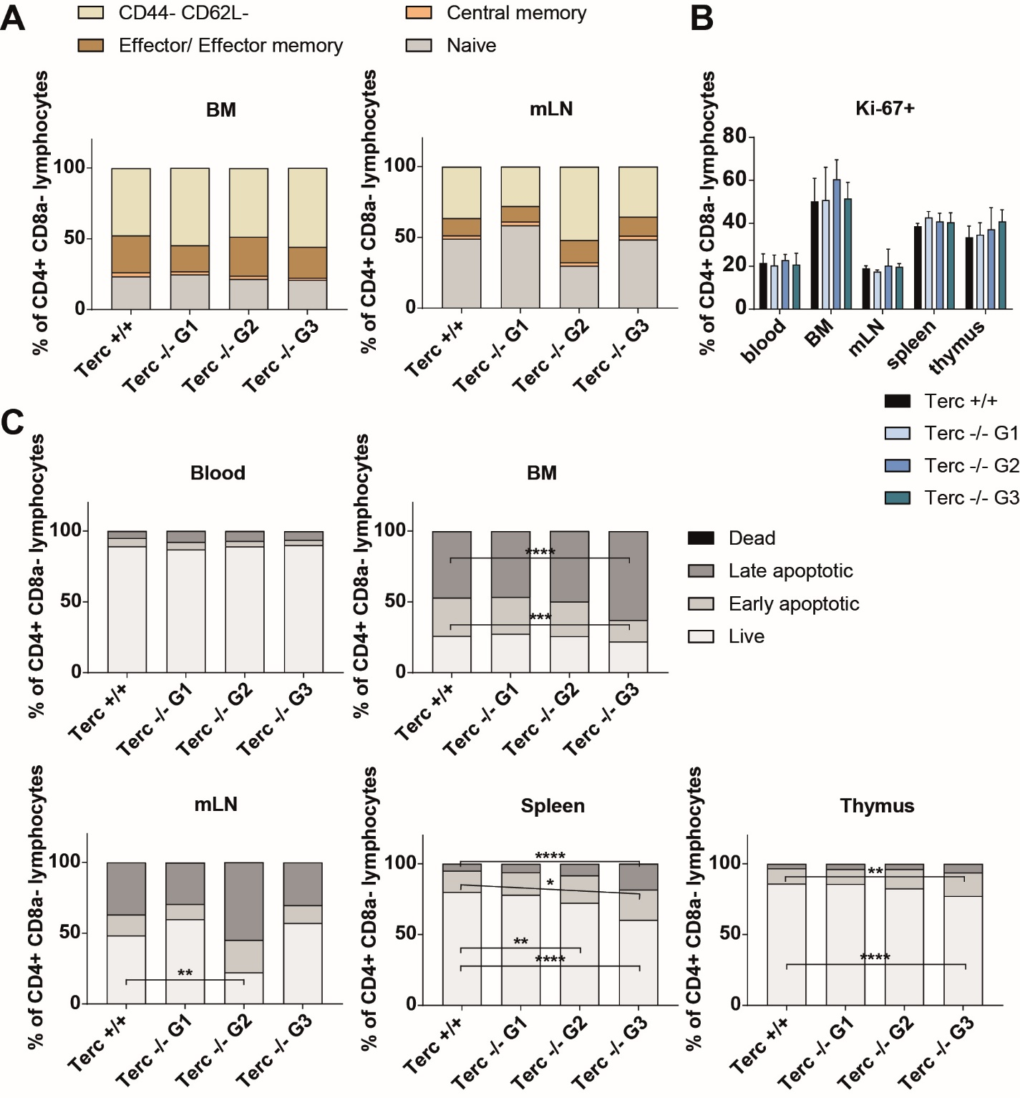
Supplementary Figure 2. Additional data on CD4+ T cells from mTerc-/- mice under steady-state conditions.
(A) Additional data on memory populations from lymphoid organs under steady-state conditions. Cells were defined as naïve (CD44- CD62L+), central memory (CD44+ CD62L+) and effector/effector memory (CD44+ CD62L-).
(B) Proliferation of CD4+ T cells under steady-state conditions determined by Ki-67 expression in flow cytometry.
(C) Cell death of CD4+ T cells under steady-state conditions as determined by flow cytometry. Cells were defined as live (Annexin V- PI-), early apoptotic (Annexin V+ PI-), late apoptotic (Annexin V+ PI+) and dead (Annexin V- PI+).
The experiment was performed one time with n = 3 mice from each generation. Graphs show the mean ± SD, * adjusted p ≤ 0.05, ** adjusted p ≤ 0.01, *** adjusted p ≤ 0.001.

Supplementary Figure 3. Further characterization of IFNγ secretion and proliferation of mTerc-/- CD4+ T cells during in vitro T cell polarization.
(A) Daily quantification of IFNγ in the supernatant of the in vitro culture by ELISA.
(B) and (C) Development of cell numbers during Th1 T cell polarization as determined by harvesting the cells and counting in a hemocytometer or quantification of total measured events in the lymphocyte gate in flow cytometry, respectively.
The graphs show pooled data from n = 2 experiments, with a total number of n ≥ 6 technical replicates. Graphs show the mean ± SD, * adjusted p ≤ 0.05, ** adjusted p ≤ 0.01.

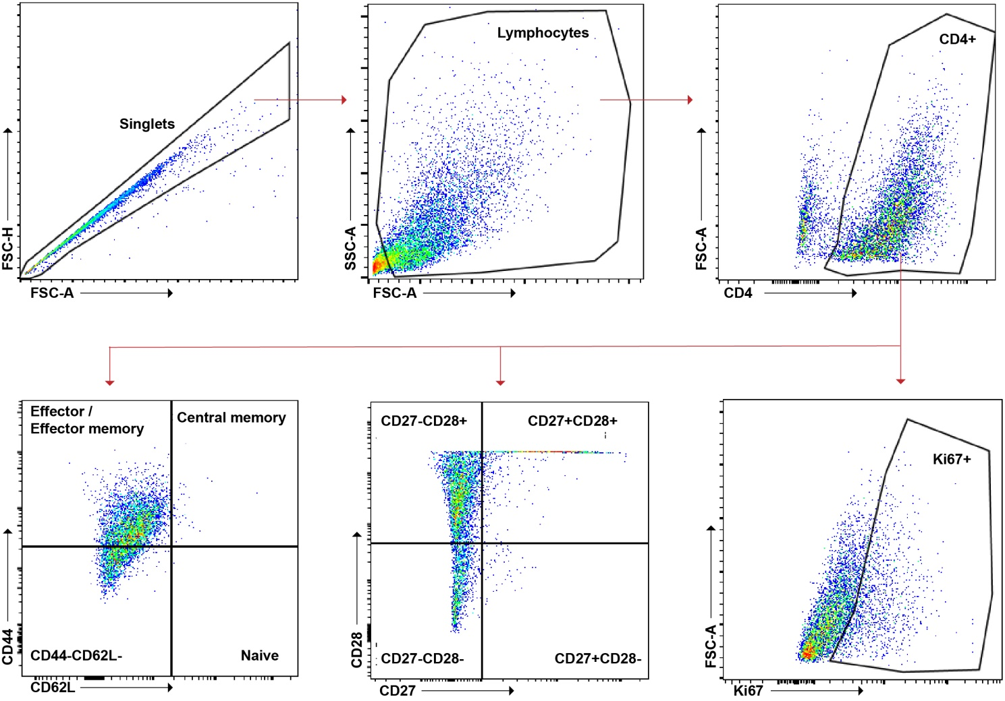
Supplementary Figure 4. Gating strategy for molecular markers assessed in flow cytometry.
Representative gating strategy for flow cytometric analysis of memory populations, costimulatory molecules, proliferation and apoptosis after in vitro polarization.

