Evaluation of T-cell aging-related immune phenotypes in the context of biological aging and multimorbidity in the Health and Retirement Study

Ramya Ramasubramanian¹, Helen C.S. Meier², Sithara Vivek³, Eric Klopack⁴, Eileen M. Crimmins⁴, Jessica Faul², Janko Nikolich-Žugich⁵, Bharat Thyagarajan³

¹Division of Epidemiology and Community Health, University of Minnesota School of Public Health, Minneapolis, MN, USA
²Institute for Social Research, Survey Research Center, University of Michigan, Ann Arbor, MI
³Department of Laboratory Medicine and Pathology, University of Minnesota, Minneapolis MN
⁴ Leonard Davis School of Gerontology, University of Southern California, Los Angeles, CA
⁵Department of Immunobiology and the University of Arizona Center on Aging, University of Arizona College of Medicine-Tucson, Tucson, AZ

Corresponding author
Dr. Bharat Thyagarajan
University of Minnesota
Department of Laboratory Medicine and Pathology
E-mail Address: thya0003@umn.edu

Supplementary Table 1: T cell subset definitions measured in the Health and Retirement Study
Cell type | Surface markers used | Parent Population
T cells | CD3+ CD19- | Single, Live lymphocytes
Cytotoxic T cells | CD3+ CD19- CD8+ CD4- | T cells
T_{N} (Naïve) cytotoxic T cells | CD3+ CD19- CD8+ CD4- CD45RA+ CCR7+ CD28+ | Cytotoxic T cells
T_{EM} (Effector Memory) cytotoxic T cells | CD3+ CD19- CD8+ CD4- CD45RA- CCR7- CD28- | Cytotoxic T cells
T_{EMRA} cytotoxic T cells | CD3+ CD19- CD8+ CD4- CD45RA+ CCR7- CD28- | Cytotoxic T cells
T_{CM} (Central Memory) cytotoxic T cells | CD3+ CD19- CD8+ CD4- CD45RA- CCR7+ CD28+ | Cytotoxic T cells
Helper T cells | CD3+ CD19- CD4+ CD8- | T cells
T_{N} (Naïve) helper T cells | CD3+ CD19- CD4+ CD8- CD45RA+ CCR7+ CD28+ | Helper T cells
T_{EM} (Effector Memory) helper T cells | CD3+ CD19- CD4+ CD8- CD45RA- CCR7- CD28- | Helper T cells
T_{EMRA} helper T cells | CD3+ CD19- CD4+ CD8- CD45RA+ CCR7- CD28- | Helper T cells
T_{CM} (Central Memory) helper T cells | CD3+ CD19- CD4+ CD8- CD45RA- CCR7+ CD28+ | Helper T cells

Supplementary figure 1: Pearson correlation heatmap between individual T-cell subsets measured in the Health and Retirement Study.
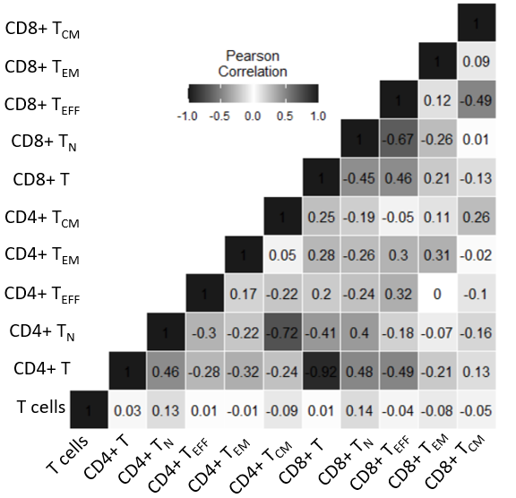

Supplementary figure 2: Association of individual T-cell subsets with chronological age. Age is used as the dependent variable in survey linear regression models. The beta estimates are estimated per one standard deviation unit of individual T-cell subsets. The models are adjusted for sex, race/ethnicity, and CMV status. The solid black line along 0 indicates no association.
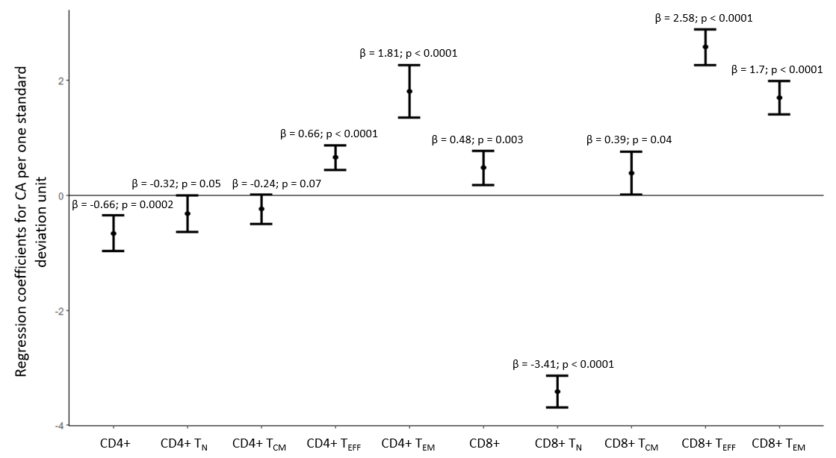

Supplementary Figure 3: Scatterplot of ARIP measures with chronological age with a LOWESS curve.

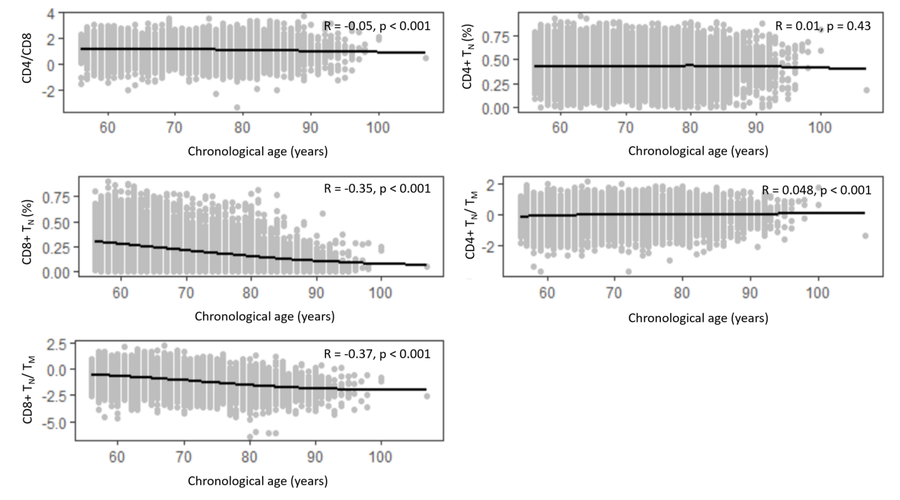

Supplementary figure 4: Association of individual T-cell subsets with biological age. Biological age is used as the dependent variable in survey linear regression models. The beta estimates are estimated per one standard deviation unit of individual T-cell subsets. The models are adjusted for chronological sex, race/ethnicity, and CMV status. The solid black line along 0 indicates no association.
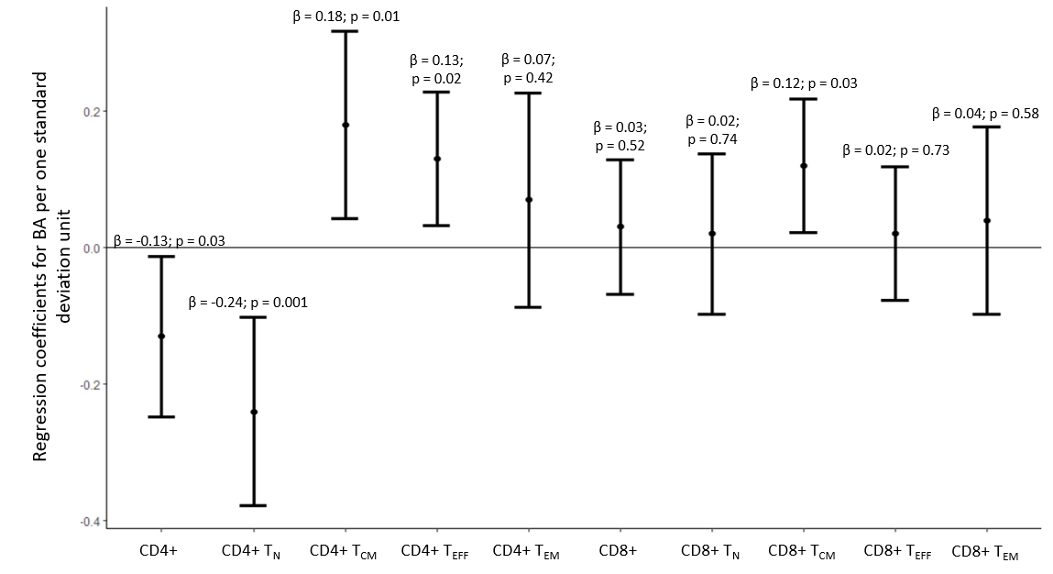
Supplementary Figure 5: Scatterplot of ARIP measures with biological age with a LOWESS curve.

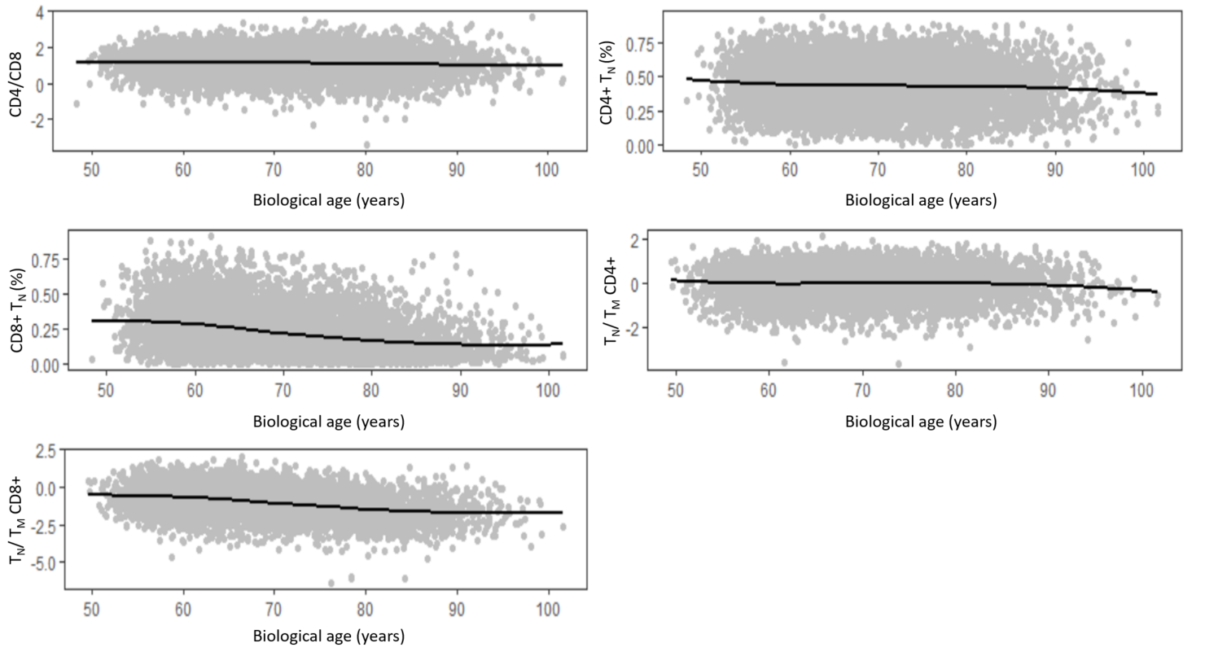

Supplementary table 2 – Beta estimates of the association between the additional ARIP measures with chronological age and biological age.
Measure | Chronological age (n= 9102) (68.54 ± 10.23) | Biological age (n= 7510)  (69.00 ± 12.35)
T_{N} CD4+/ T_{N} CD8+ | 2.86 ± 0.16 (<0.0001) | -0.20 ± 0.06 (0.001)
T_{N} + T_{CM} CD4+ | -2.31 ± 0.23 (<0.0001) | -0.09 ± 0.06 (0.13)
T_{N} + T_{CM} CD8+ | -3.71 ± 0.20 (<0.0001) | 0.11 ± 0.06 (0.06)

Supplementary Table 3: Beta estimates of the association between ARIP measures and biological age acceleration measure after adjustment for age, sex, race/ethnicity, and CMV status.
Measure | OR (95% CI) for the older (n=3189) vs younger age (n=4321) acceleration measure
CD4/CD8 | 0.97 (95% CI: 0.97 – 1.04; p=0.39)
CD4+ T_{N}/T_{M} | 0.92 (95% CI: 0.84-1.00; p=0.05)
CD8+ T_{N}/T_{M} | 1.04 (95% CI: 0.98-1.11; p=0.19)
CD8+ T_{N} | 0.99 (95% CI: 0.92 – 1.06; p=0.71)
CD4+ T_{N} | 0.89 (95% CI: 0.83 – 0.95; p=0.001)
CD4+ T_{CM} | 1.09 (95% CI: 1.02 – 1.17; p=0.01)

Supplementary figure 6: Odds ratios and 95% CI of association of multimorbidity levels with individual T-cell subsets per one SD unit increase in ARIP marker. Adjusted for age, sex, race/ethnicity, CMV status, smoking status, and BMI. The solid black line along OR of 1 indicates no association.
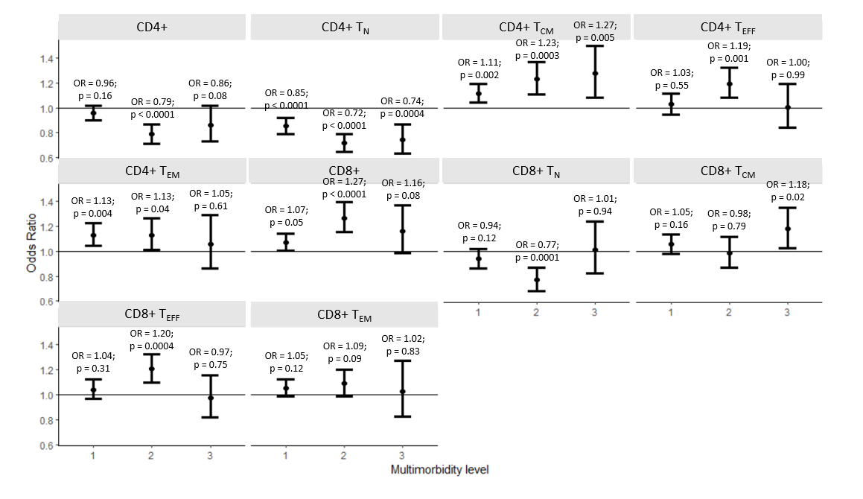
Supplementary table 4: Estimates of association of immunosenescence measures with age-related outcomes
ARIP measures
 | Multimorbidity – 2016
 | Model 1ª | Model 2^{b} | Model 3^{c}
 | OR (95% CI) | OR (95% CI) | OR (95% CI)
CD4/CD8 ratio | 0.80 (0.75 – 0.84) | 0.84 (0.79-0.90) | 0.83 (0.77 – 0.90)
CD4+ T_{N} / CD8+ T_{N} | 0.97 (0.91 – 1.03) | 0.87 (0.81-0.93) | 0.88 (0.81-0.96)
CD4+ T_{N} + T_{CM} | 0.80 (0.75 – 0.85) | 0.90 (0.85 – 0.96) | 0.85 (0.79-0.91)
CD8+ T_{N} + T_{CM} | 0.88 (0.82 – 0.95) | 1.04 (0.96 – 1.13) | 1.01 (0.91 – 1.12)
CD4+ T_{N}/T_{M} | 0.72 (0.64 – 0.80) | 0.71 (0.64 - 0.80) | 0.78 (0.68 – 0.89)
CD8+ T_{N}/T_{M} | 0.72 (0.67-0.79) | 0.82 (0.76-0.89) | 0.82 (0.75-0.89)
CD8+ T_{N} | 0.79 (0.75 – 0.83) | 0.93 (0.88 – 1.00) | 0.85 (0.77 – 0.93)
CD4+ T_{N} | 0.74 (0.68-0.79) | 0.75 (0.70 – 0.81) | 0.78 (0.71 – 0.85)
CD4+ T_{CM} | 1.22 (1.13 – 1.31) | 1.23 (1.14 – 1.34) | 1.18 (1.07 – 1.30)
Associations of immunosenescence measures with individual components of multimorbidity in 2016
 | Type II diabetes – 2016
 | Model 1ª | Model 2^{b} | Model 3^{c}
 | OR (95% CI) | OR (95% CI) | OR (95% CI)
CD4/CD8 ratio | 0.90 (0.85 – 0.96) | 0.97 (0.91 – 1.03) | 0.96 (0.88 – 1.05)
CD4+ T_{N} / CD8+ T_{N} | 0.92 (0.86 – 0.98) | 0.93 (0.86 – 1.00) | 0.92 (0.84 – 1.01)
CD4+ T_{N} + T_{CM} | 1.02 (0.96 – 1.08) | 1.10 (1.04 – 1.16) | 1.05 (0.98-1.12)
CD8+ T_{N} + T_{CM} | 1.03 (0.97 – 1.10) | 1.08 (1.00 - 1.16) | 1.09 (0.99 -1.20)
CD4+ T_{N}/T_{M} | 0.69 (0.64 – 0.74) | 0.73 (0.68 – 0.79) | 0.82 (0.75 – 0.90)
CD8+ T_{N}/T_{M} | 0.83 (0.78 – 0.89) | 0.87 (0.80 – 0.94) | 0.90 (0.82 – 0.99)
CD8+ T_{N} | 0.94 (0.88 – 1.00) | 0.99 (0.92 – 1.07) | 0.86 (0.79-0.93)
CD4+ T_{N} | 0.75 (0.69 – 0.81) | 0.80 (0.74 – 0.86) | 0.82 (0.76-0.90)
CD4+ T_{CM} | 1.33 (1.25 – 1.41) | 1.27 (1.20 – 1.35) | 1.20 (1.12 – 1.29)
 | Heart Disease - 2016
 | Model 1ª | Model 2^{b} | Model 3^{c}
 | OR (95% CI) | OR (95% CI) | OR (95% CI)
CD4/CD8 ratio | 0.92 (0.88 – 0.96) | 0.95 (0.90-1.00) | 0.93 (0.87 – 0.99)
CD4+ T_{N} / CD8+ T_{N} | 1.13 (1.07 – 1.20) | 0.98 (0.93 – 1.03) | 0.99 (0.93 – 1.05)
CD4+ T_{N} + T_{CM} | 0.83 (0.78 – 0.88) | 0.95 (0.90 1.00) | 0.92 (0.87-0.98)
CD8+ T_{N} + T_{CM} | 0.81 (0.76 – 0.87) | 0.99 (0.92-1.06) | 0.98 (0.90 – 1.06)
CD4+ T_{N}/T_{M} | 0.90 (0.83 – 0.98) | 0.89 (0.81 – 0.98) | 0.92 (0.84 – 1.02)
CD8+ T_{N}/T_{M} | 0.78 (0.73 – 0.83) | 0.90 (0.84 – 0.97) | 0.91 (0.83-0.98)
CD8+ T_{N} | 0.76 (0.72 – 0.81) | 0.94 (0.89 – 0.99) | 0.94 (0.86 – 1.03)
CD4+ T_{N} | 0.88 (0.83 – 0.93) | 0.90 (0.84 – 0.95) | 0.92 (0.86 – 0.97)
CD4+ T_{CM} | 1.08 (1.02 – 1.14) | 1.10 (1.04 – 1.16) | 1.06 (1.00 -1.12)
 | Lung Disease - 2016
 | Model 1ª | Model 2^{b} | Model 3^{c}
 | OR (95% CI) | OR (95% CI) | OR (95% CI)
CD4/CD8 ratio | 0.93 (0.85 – 1.01) | 0.97 (0.89 – 1.05) | 0.97 (0.88 – 1.07)
CD4+ T_{N} / CD8+ T_{N} | 0.94 (0.87 – 1.03) | 0.91 (0.83 – 0.99) | 0.94 (0.85 – 1.04)
CD4+ T_{N} + T_{CM} | 0.93 (0.86 – 1.01) | 0.95 (0.87 – 1.03) | 0.88 (0.80 – 0.97)
CD8+ T_{N} + T_{CM} | 1.01 (0.93 – 1.11) | 1.05 (0.94 – 1.16) | 0.92 (0.81 – 1.05)
CD4+ T_{N}/T_{M} | 0.83 (0.74 – 0.94) | 0.81 (0.71 – 0.92) | 0.88 (0.76-1.03)
CD8+ T_{N}/T_{M} | 0.92 (0.84 – 1.02) | 0.97 (0.88 – 1.07) | 0.95 (0.84 – 1.07)
CD8+ T_{N} | 0.94 (0.87 – 1.02) | 0.97 (0.88 – 1.06) | 0.94 (0.83 – 1.08)
CD4+ T_{N} | 0.84 (0.76 – 0.93) | 0.83 (0.75 – 0.93) | 0.90 (0.79 – 1.01)
CD4+ T_{CM} | 1.12 (0.99 – 1.26) | 1.16 (1.02 – 1.32) | 1.09 (0.94 – 1.28)
 | Stroke - 2016
 | Model 1ª | Model 2^{b} | Model 3^{c}
 | OR (95% CI) | OR (95% CI) | OR (95% CI)
CD4/CD8 ratio | 0.90 (0.81 – 1.00) | 1.00 (0.89 – 1.12) | 0.97 (0.85-1.10)
CD4+ T_{N} / CD8+ T_{N} | 1.03 (0.92 – 1.15) | 0.97 (0.86 – 1.10) | 0.98 (0.87 – 1.10)
CD4+ T_{N} + T_{CM} | 0.86 (0.79 – 0.93) | 0.98 (0.89 – 1.09) | 0.95 (0.86 – 1.06)
CD8+ T_{N} + T_{CM} | 0.86 (0.77 – 0.96) | 0.99 (0.86 – 1.12) | 0.99 (0.87 – 1.14)
CD4+ T_{N}/T_{M} | 0.83 (0.73 – 0.95) | 0.89 (0.77 – 1.02) | 0.92 (0.80 – 1.06)
CD8+ T_{N}/T_{M} | 0.87 (0.79 – 0.95) | 1.04 (0.91 – 1.18) | 1.04 (0.89 – 1.20)
CD8+ T_{N} | 0.83 (0.77 – 0.89) | 0.96 (0.86 – 1.06) | 1.03 (0.87 – 1.21)
CD4+ T_{N} | 0.83 (0.74 – 0.93) | 0.93 (0.82 – 1.05) | 0.96 (0.85 – 1.08)
CD4+ T_{CM} | 1.17 (1.03 – 1.32) | 1.12 (0.99 – 1.27) | 1.09 (0.96 – 1.24)
 | Cancer - 2016
 | Model 1ª | Model 2^{b} | Model 3^{c}
 | OR (95% CI) | OR (95% CI) | OR (95% CI)
CD4/CD8 ratio | 0.83 (0.77 – 0.90) | 0.81 (0.75 – 0.88) | 0.79 (0.72-0.86)
CD4+ T_{N} / CD8+ T_{N} | 0.94 (0.86 – 1.04) | 0.78 (0.71 – 0.86) | 0.79 (0.72 – 0.87)
CD4+ T_{N} + T_{CM} | 0.65 (0.60 – 0.71) | 0.69 (0.63 – 0.76) | 0.66 (0.61 – 0.72)
CD8+ T_{N} + T_{CM} | 0.79 (0.71 – 0.87) | 0.92 (0.83 – 1.02) | 0.89 (0.80 – 1.00)
CD4+ T_{N}/T_{M} | 0.87 (0.79 – 0.95) | 0.81 (0.74 – 0.89) | 0.81 (0.74 – 0.89)
CD8+ T_{N}/T_{M} | 0.82 (0.76 – 0.89) | 0.92 (0.86 – 1.00) | 0.89 (0.82 – 0.96)
CD8+ T_{N} | 0.75 (0.70 – 0.82) | 0.92 (0.84 – 1.00) | 0.92 (0.84 – 1.01)
CD4+ T_{N} | 0.80 (0.73 – 0.87) | 0.76 (0.70 – 0.83) | 0.75 (0.68 – 0.82)
CD4+ T_{CM} | 1.07 (0.98 – 1.17) | 1.12 (1.03 – 1.22) | 1.12 (1.03 – 1.23)
 | Incident multimorbidity – 2018 and 2020
 | Model 1ª | Model 2^{b} | Model 3^{c}
 | Hazard Ratio (95% CI) | Hazard Ratio (95% CI) | Hazard Ratio (95% CI)
CD4/CD8 ratio | 0.93 (0.85 – 1.02) | 0.95 (0.86 – 1.05) | 0.94 (0.85 – 1.04)
CD4+ T_{N} / CD8+ T_{N} | 0.98 (0.90 – 1.08) | 0.95 (0.87 – 1.05) | 0.96 (0.87 – 1.06)
CD4+ T_{N} + T_{CM} | 0.99 (0.92 – 1.06) | 1.07 (0.98 – 1.16) | 1.04 (0.95 – 1.13)
CD8+ T_{N} + T_{CM} | 0.99 (0.90 – 1.11) | 1.09 (0.98 – 1.22) | 1.07 (0.95 – 1.19)
CD4+ T_{N}/T_{M} | 0.82 (0.75 – 0.90) | 0.86 (0.77 – 0.95) | 0.91 (0.82 – 1.02)
CD8+ T_{N}/T_{M} | 0.87 (0.82 – 0.92) | 0.93 (0.87 – 1.00) | 0.94 (0.87 – 1.02)
CD8+ T_{N} | 0.92 (0.84 – 1.01) | 0.99 (0.89 – 1.09) | 0.99 (0.89 – 1.10)
CD4+ T_{N} | 0.87 (0.80 – 0.95) | 0.90 (0.82 – 0.99) | 0.91 (0.82 – 1.01)
CD4+ T_{CM} | 1.17 (1.09 – 1.26) | 1.14 (1.06 – 1.23) | 1.09 (1.01 – 1.18)
ªModel 1 assessed bivariate associations.
^{b}Model 2 adjusted for age, sex, race, and CMV status.
^{c}Model 3 additionally adjusted for smoking status, BMI.
Note: Effect estimates are per one SD unit increase in immunosenescence measures.

Supplementary Table 5: Associations between self-rated health and ARIP measures after adjustment for age, sex, race/ethnicity, CMV status, smoking status, and BMI.
Measure | Odds ratio (bad (n=2486) vs good self-rated health (6108))
CD4/CD8 | 0.89 (95% CI: 0.82 – 0.96); p=0.002
T_{N}/T_{M} CD4+ | 0.84 (95% CI: 0.78 – 0.91); p <0.0001
T_{N}/T_{M} CD8+ | 0.88 (95% CI: 0.80 – 0.96); p=0.01
T_{N} CD8+ | 0.91 (95% CI: 0.83 – 1.01); p=0.07
T_{N} CD4+ | 0.83 (95% CI: 0.77 – 0.89); p<0.0001
T_{CM} CD4+ | 1.12 (95% CI: 1.04 – 1.20); p =0.004

