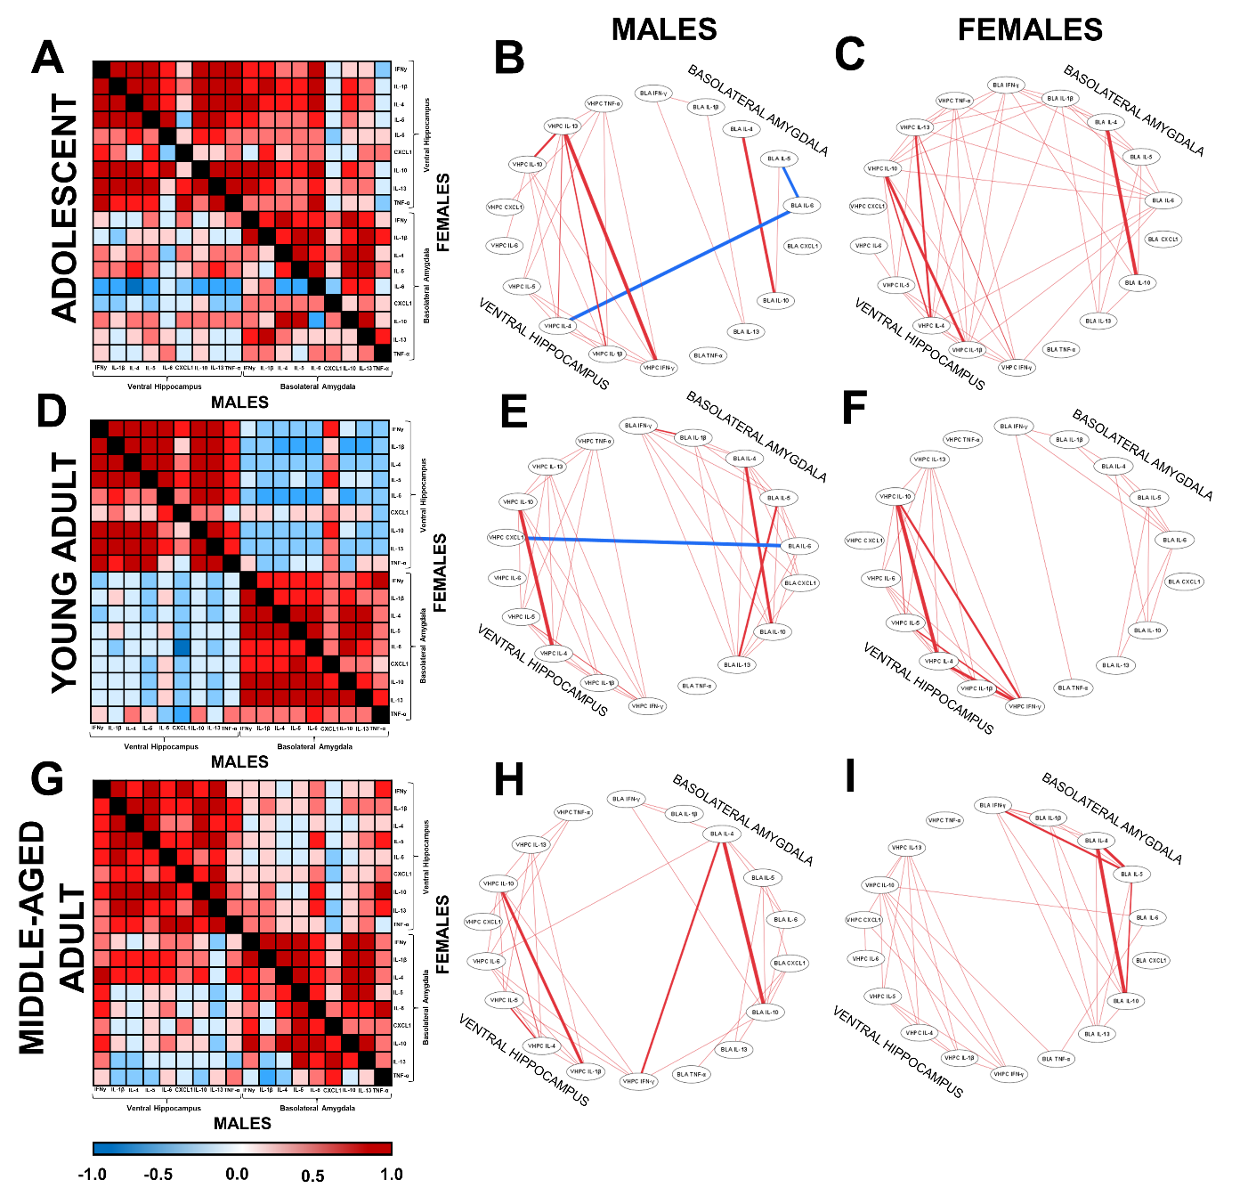
Fig. S1. Heatmaps showing all correlations and cytoscape graphs showing significant correlations ≥0.7 between inflammatory marker correlations between the ventral hippocampus and basolateral amygdala in male and female adolescent (A-C), young adult (D-F), and middle-aged (G-I) rats after cognitive bias testing. The thickness of the lines in B, C, E, F, H, and I are related to the strength of the correlation (stronger is thicker), whereas the color relates to the valence (positive (red) or negative (blue)) of the correlation. Correlations of inflammatory marker levels within the ventral hippocampus and basolateral amygdala were largely positive in all age groups, although correlations between regions were more negative in male and female young adults compared to the other age groups. In adolescence, there was a sex difference in the correlations between basolateral amygdala IL-6 and cytokines (IFN-γ, IL-1β, IL-4, IL-5, IL-10, IL-13, TNF-α) in the ventral hippocampus, with positive correlations in adolescent females compared to negative correlations in adolescent males. n=7-11 per group.

Table S1. Correlations between inflammation and freezing in the ambiguous context or cognitive bias score. Bold * indicates p<0.05. n=7-11 per group.
 |  | Adolescent male |  |  |  |  | Adolescent female |  |  |  |  | Young adult male |  |  |  |  | Young adult female |  |  |  |  | Middle-age male |  |  |  |  | Middle-age female
 |  | Freezing |  | Score |  | Freezing |  |  | Score |  | Freezing |  |  | Score |  | Freezing |  |  | Score |  | Freezing |  |  | Score |  | Freezing |  |  | Score
Ventral
hippocampus
IFN-γ | 0.174 |  | 0.317 |  | -0.237 |  |  | -0.034 |  | -0.389 |  |  | -0.018 |  | 0.137 |  |  | 0.099 |  | 0.211 |  |  | 0.254 |  | 0.003 |  |  | 0.193
IL-1β | 0.278 |  | 0.021 |  | 0.019 |  |  | 0.014 |  | -0.576 |  |  | -0.153 |  | 0.067 |  |  | 0.035 |  | 0.094 |  |  | 0.357 |  | -0.288 |  |  | 0.085
IL-4 | 0.145 |  | -0.164 |  | -0.006 |  |  | 0.077 |  | -0.266 |  |  | 0.094 |  | 0.134 |  |  | 0.105 |  | -0.101 |  |  | 0.103 |  | -0.133 |  |  | 0.005
IL-5 | 0.166 |  | 0.208 |  | -0.089 |  |  | 0.030 |  | -0.446 |  |  | -0.113 |  | 0.024 |  |  | -0.001 |  | 0.062 |  |  | 0.124 |  | -0.101 |  |  | 0.179
IL-6 | 0.008 |  | -0.639 |  | 0.207 |  |  | 0.334 |  | -0.625 |  |  | -0.625 |  | 0.143 |  |  | 0.092 |  | 0.049 |  |  | 0.427 |  | 0.095 |  |  | 0.376
CXCL1 | 0.542 |  | 0.636 |  | 0.138 |  |  | 0.201 |  | -0.259 |  |  | -0.201 |  | -0.388 |  |  | -0.425 |  | -0.302 |  |  | 0.106 |  | -0.222 |  |  | 0.012
IL-10 | 0.441 |  | -0.331 |  | 0.154 |  |  | 0.191 |  | -0.236 |  |  | 0.084 |  | 0.150 |  |  | 0.125 |  | 0.071 |  |  | 0.269 |  | 0.092 |  |  | 0.405
IL-13 | 0.373 |  | 0.341 |  | -0.237 |  |  | -0.166 |  | -0.576 |  |  | -0.297 |  | 0.037 |  |  | -0.014 |  | 0.545 |  |  | 0.277 |  | -0.032 |  |  | 0.273
TNF-α | 0.184 |  | 0.537 |  | -0.093 |  |  | 0.233 |  | -0.163 |  |  | 0.104 |  | 0.630 |  |  | 0.580 |  | -0.556 |  |  | -0.053 |  | -0.483 |  |  | -0.208
Basolateral
amygdala
IFN-γ | -0.017 |  | 0.424 |  | 0.087 |  |  | -0.103 |  | 0.251 |  |  | 0.339 |  | 0.193 |  |  | 0.260 |  | -0.433 |  |  | 0.154 |  | -0.363 |  |  | -0.130
IL-1β | -0.140 |  | -0.115 |  | -0.038 |  |  | -0.138 |  | 0.135 |  |  | 0.262 |  | -0.101 |  |  | 0.011 |  | -0.306 |  |  | 0.415 |  | -0.347 |  |  | -0.013
IL-4 | 0.340 |  | 0.851* |  | 0.456 |  |  | 0.250 |  | 0.422 |  |  | 0.399 |  | 0.184 |  |  | 0.237 |  | -0.440 |  |  | 0.000 |  | -0.366 |  |  | -0.121
IL-5 | 0.478 |  | 0.422 |  | 0.432 |  |  | 0.254 |  | 0.133 |  |  | 0.125 |  | 0.087 |  |  | 0.129 |  | -0.012 |  |  | 0.165 |  | -0.353 |  |  | -0.112
IL-6 | -0.394 |  | -0.307 |  | 0.281 |  |  | 0.220 |  | 0.352 |  |  | -0.002 |  | 0.131 |  |  | 0.176 |  | -0.070 |  |  | -0.070 |  | -0.052 |  |  | 0.424
CXCL1 | 0.453 |  | 0.199 |  | -0.382 |  |  | -0.197 |  | 0.144 |  |  | -0.053 |  | 0.084 |  |  | 0.145 |  | -0.361 |  |  | -0.321 |  | 0.429 |  |  | 0.474
IL-10 | 0.449 |  | 0.719* |  | 0.545 |  |  | 0.269 |  | 0.422 |  |  | 0.387 |  | 0.156 |  |  | 0.209 |  | -0.237 |  |  | 0.197 |  | -0.422 |  |  | -0.128
IL-13 | -0.542 |  | 0.057 |  | 0.352 |  |  | 0.039 |  | 0.280 |  |  | 0.233 |  | 0.352 |  |  | 0.402 |  | 0.416 |  |  | 0.296 |  | -0.367 |  |  | 0.073
TNF-α | -0.165 |  | 0.097 |  | 0.042 |  |  | -0.256 |  | 0.692 |  |  | 0.626 |  | 0.512 |  |  | 0.588 |  | 0.212 |  |  | -0.212 |  | 0.165 |  |  | 0.557

Table S2. Correlations between doublecortin (DCX) in the dorsal and ventral hippocampus and freezing in the ambiguous context or cognitive bias score. Bold * indicates p<0.05. n=7-11 per group.
 |  | Adolescent male |  |  |  |  | Adolescent female |  |  |  |  | Young adult male |  |  |  |  | Young adult female |  |  |  |  | Middle-age male |  |  |  |  | Middle-age female
 |  | Freezing |  | Score |  | Freezing |  |  | Score |  | Freezing |  |  | Score |  | Freezing |  |  | Score |  | Freezing |  |  | Score |  | Freezing |  |  | Score
Dorsal DCX | 0.0128 |  | -0.1326 |  | 0.1117 |  |  | -0.2349 |  | -0.7872* |  |  | -0.7643* |  | -0.3776 |  |  | -0.4355 |  | 0.2654 |  |  | -0.2744 |  | -0.2008 |  |  | 0.2077
Ventral DCX | 0.2519 |  | 0.2326 |  | 0.1908 |  |  | 0.2651 |  | -0.1128 |  |  | 0.0656 |  | 0.0162 |  |  | -0.0600 |  | 0.5771 |  |  | 0.1016 |  | -0.3227 |  |  | -0.2652

Table S3. Correlations between DCX in the dorsal and ventral hippocampus and inflammation in the ventral hippocampus and basolateral amygdala. Bold * indicates p<0.05. n=7-11 per group.
 |  | Adolescent male |  |  |  |  | Adolescent female |  |  |  |  | Young adult male |  |  |  |  | Young adult female |  |  |  |  | Middle-age male |  |  |  |  | Middle-age female
 |  | Dorsal DCX |  | Ventral DCX |  | Dorsal DCX |  |  | Ventral DCX |  | Dorsal DCX |  |  | Ventral DCX |  | Dorsal DCX |  |  | Ventral DCX |  | Dorsal DCX |  |  | Ventral DCX |  | Dorsal DCX |  |  | Ventral DCX
Ventral
hippocampus
IFN-γ | -0.4448 |  | -0.1277 |  | -0.0499 |  |  | -0.3264 |  | 0.0294 |  |  | 0.0854 |  | 0.728* |  |  | 0.311 |  | -0.211 |  |  | 0.280 |  | 0.087 |  |  | 0.095
IL-1β | -0.3168 |  | -0.1368 |  | -0.0206 |  |  | -0.2551 |  | 0.1196 |  |  | -0.0532 |  | 0.629 |  |  | 0.112 |  | -0.303 |  |  | 0.484 |  | 0.158 |  |  | 0.375
IL-4 | -0.5127 |  | 0.4639 |  | -0.1772 |  |  | -0.4759 |  | -0.1031 |  |  | 0.0302 |  | 0.628 |  |  | 0.253 |  | -0.231 |  |  | 0.520 |  | -0.270 |  |  | 0.384
IL-5 | -0.4635 |  | 0.1019 |  | 0.0416 |  |  | -0.2856 |  | 0.0922 |  |  | 0.071 |  | 0.722* |  |  | 0.175 |  | -0.197 |  |  | 0.501 |  | 0.181 |  |  | 0.240
IL-6 | -0.3374 |  | -0.1661 |  | -0.0075 |  |  | 0.1923 |  | 0.1991 |  |  | -0.4893 |  | 0.616 |  |  | 0.136 |  | -0.261 |  |  | 0.496 |  | 0.201 |  |  | -0.124
CXCL1 | 0.0053 |  | -0.1271 |  | -0.3196 |  |  | 0.4155 |  | -0.2028 |  |  | -0.6869 |  | 0.718* |  |  | 0.235 |  | -0.315 |  |  | 0.131 |  | 0.203 |  |  | 0.096
IL-10 | -0.5334 |  | 0.0636 |  | -0.158 |  |  | -0.2711 |  | -0.1199 |  |  | 0.0216 |  | 0.636 |  |  | 0.226 |  | -0.112 |  |  | 0.511 |  | 0.109 |  |  | 0.088
IL-13 | -0.3578 |  | -0.1004 |  | -0.1261 |  |  | -0.4287 |  | 0.1343 |  |  | -0.1272 |  | 0.774* |  |  | 0.277 |  | -0.017 |  |  | 0.861* |  | 0.360 |  |  | 0.141
TNF-α | -0.1964 |  | -0.1325 |  | -0.3429 |  |  | -0.2221 |  | 0.0649 |  |  | 0.4146 |  | 0.264 |  |  | -0.138 |  | -0.255 |  |  | 0.711* |  | -0.054 |  |  | 0.002
Basolateral
amygdala
IFN-γ | -0.5949 |  | 0.0161 |  | -0.117 |  |  | -0.5909 |  | -0.1108 |  |  | 0.188 |  | -0.072 |  |  | -0.136 |  | -0.409 |  |  | -0.517 |  | 0.523 |  |  | 0.215
IL-1β | -0.6474 |  | 0.0086 |  | -0.3808 |  |  | -0.0435 |  | -0.0931 |  |  | 0.0855 |  | -0.080 |  |  | 0.133 |  | -0.722* |  |  | -0.415 |  | 0.481 |  |  | 0.222
IL-4 | -0.4165 |  | 0.5422 |  | -0.472 |  |  | -0.4223 |  | -0.3332 |  |  | -0.0316 |  | -0.175 |  |  | 0.126 |  | -0.186 |  |  | -0.485 |  | 0.616* |  |  | 0.298
IL-5 | -0.5308 |  | 0.5824 |  | -0.5203 |  |  | -0.159 |  | -0.0268 |  |  | 0.0943 |  | -0.105 |  |  | -0.299 |  | -0.257 |  |  | -0.318 |  | 0.640* |  |  | 0.208
IL-6 | 0.1155 |  | -0.6178 |  | -0.1095 |  |  | -0.3704 |  | 0.0381 |  |  | 0.2966 |  | -0.011 |  |  | -0.016 |  | 0.212 |  |  | -0.236 |  | 0.571 |  |  | 0.096
CXCL1 | -0.4334 |  | 0.1844 |  | -0.6629 |  |  | -0.2495 |  | 0.1134 |  |  | 0.2037 |  | 0.438 |  |  | -0.009 |  | -0.132 |  |  | -0.061 |  | 0.234 |  |  | -0.025
IL-10 | -0.5335 |  | 0.5942 |  | -0.3371 |  |  | -0.4236 |  | -0.3611 |  |  | -0.0699 |  | -0.128 |  |  | 0.113 |  | -0.347 |  |  | -0.465 |  | 0.665* |  |  | 0.237
IL-13 | -0.6891 |  | 0.1474 |  | -0.4559 |  |  | -0.1606 |  | -0.1027 |  |  | 0.1337 |  | -0.356 |  |  | -0.552 |  | 0.053 |  |  | -0.021 |  | 0.690* |  |  | 0.367
TNF-α | -0.391 |  | -0.3833 |  | -0.3182 |  |  | 0.2018 |  | -0.5432 |  |  | 0.2759 |  | -0.530 |  |  | -0.241 |  | 0.246 |  |  | 0.581 |  | 0.380 |  |  | -0.071

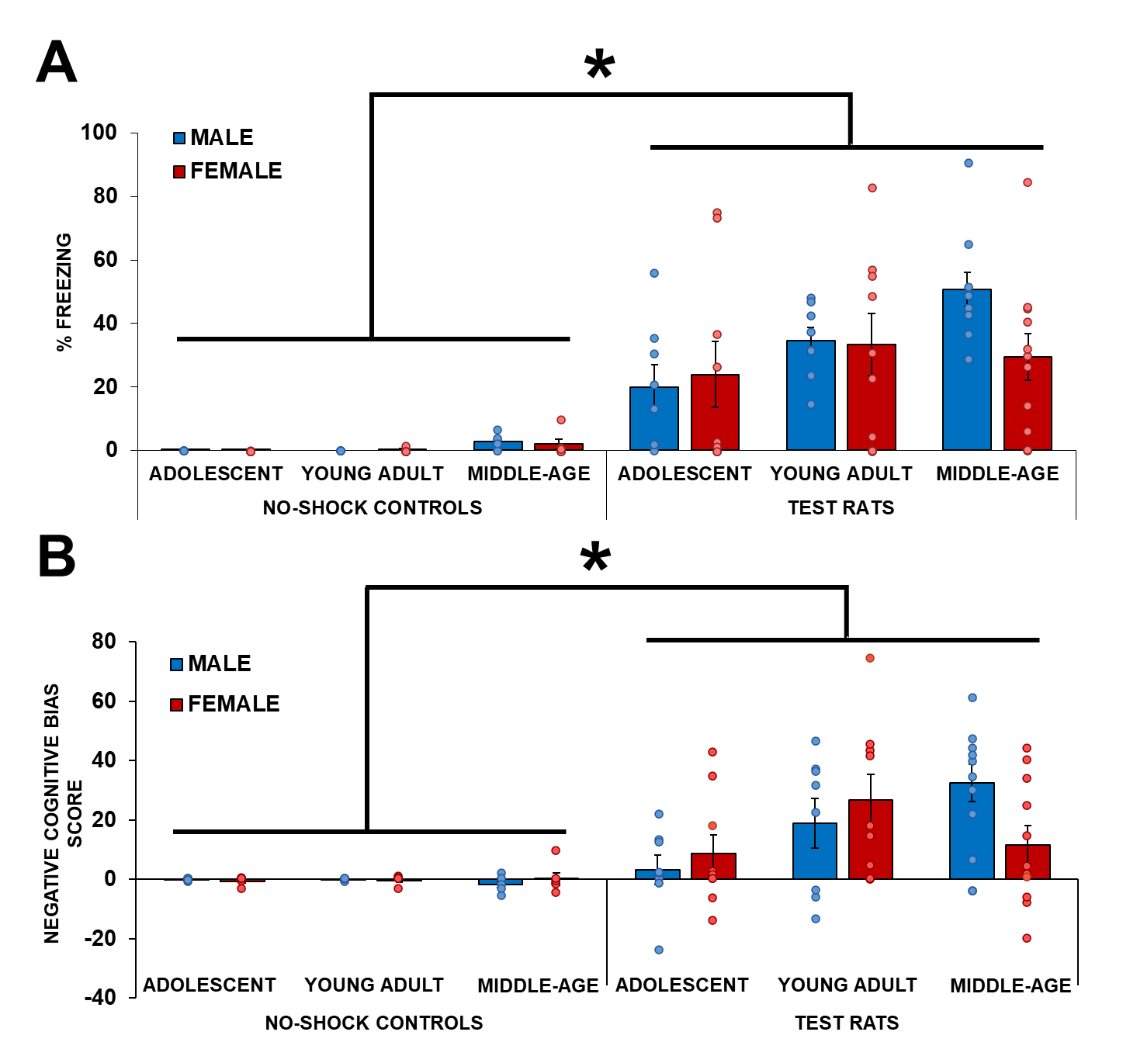
Fig. S2. Mean (±SEM) percentage of time spent freezing (A) and negative cognitive bias discrimination scores (B) of male and female adolescent, young adult, and middle-aged test rats and no-shock controls. Negative cognitive bias scores > 0 are rats with a negative cognitive bias and scores ≤ 0 are rats that had a neutral or positive cognitive bias. Test rats have a greater negative cognitive bias than no-shock controls. In test rats, young adults and middle-aged rats had greater negative cognitive bias scores than adolescents, and males had greater negative cognitive bias than females in middle-age. *indicates p’s<0.000005: main effect of condition. n=6 for no-shock controls, n=8-11 for test rats. Figures modified and reprinted with permission from Hodges et al. [52].

