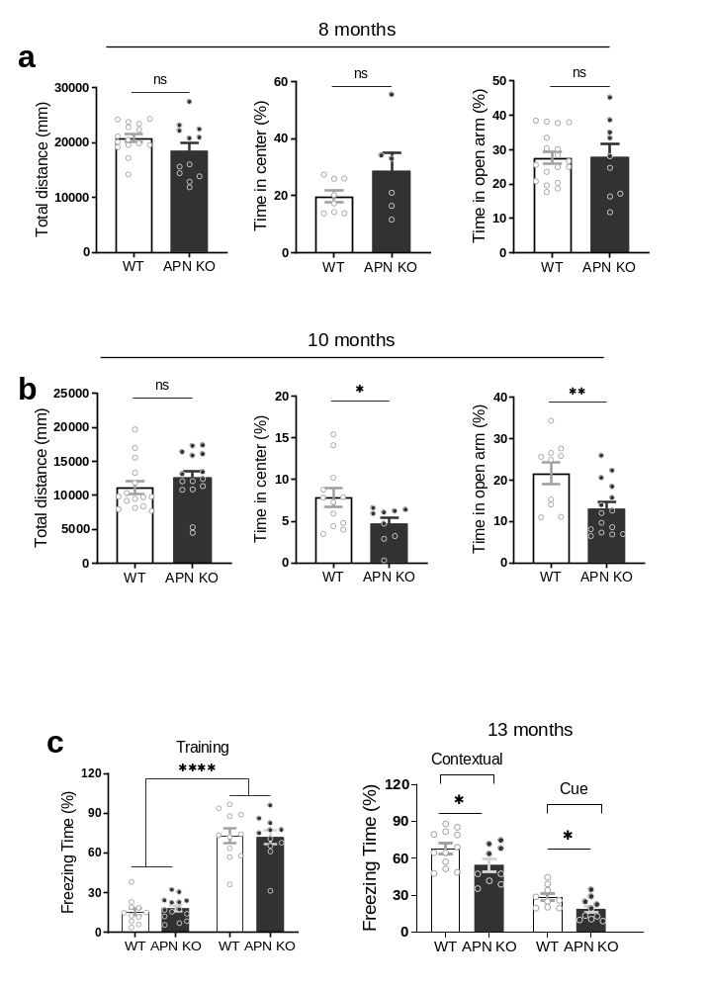
Figure S1: APN KO aged-mice displayed anxiety and cognitive impairment
a: Bar graphs show total distance and time in the center of open field test, time in the open arm of elevated plus-maze test in 8-month-old APN KO vs. WT mice. b: Total distance traveled and time in center of open field test, and time in open arm spent of elevated plus-maze test in 10-month-old APN KO vs. WT mice. c: Bar graphs showing freezing time during training and test of fear conditioning (at 13-months of age) of APN KO vs. WT mice. Data expressed as mean ± SEM, *p < 0.05, **p < 0.01, ****p < 0.0001.
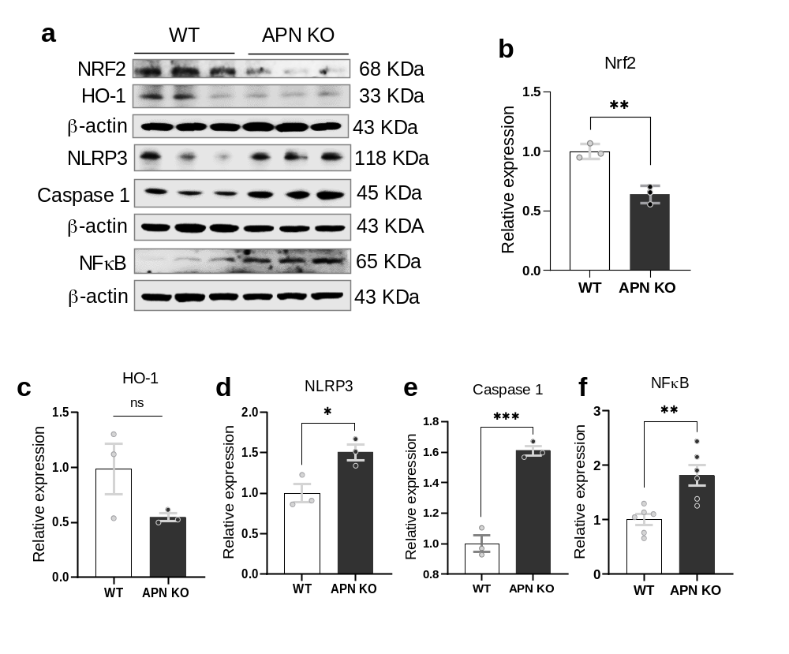
Figure S2: APN deficiency increases the expression of neuroinflammatory markers
a: Representative images of immunoblots showing NRF2, HO-1, NLRP3, Caspase 1, and NF-kB. b, c, d, e and f: Bar graphs showing relative expression of Nrf2, HO-1, NLRP3, Caspase 1 and NF-kB, respectively. Immunoblot densities were optimized by standard (GAPDH/β-actin). Data expressed as mean ± SEM, *p < 0.05, **p < 0.01, ***p < 0.001.

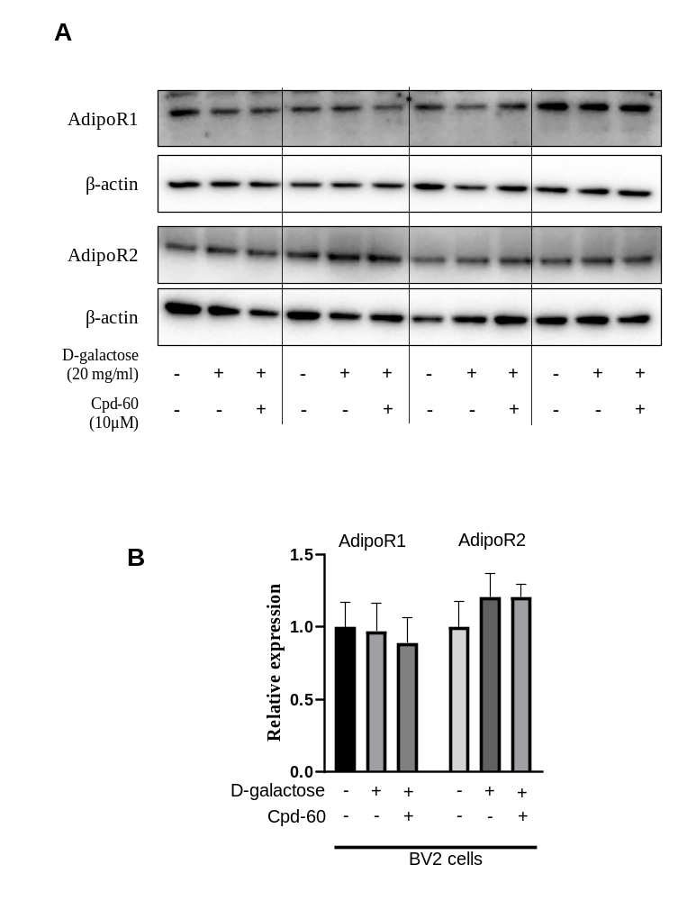

Figure S3: The effect of HDAC1 inhibitor (Cpd-60) treatment on the expression of Adiponectin receptors in D-galactose-induced aged BV2 cells.
a-b: Representative immunoblots and bar graphs showing expression of AdipoR1 and AdipoR2 in D-galactose-induced aged BV2 cells with or without Cpd-60 treatment. Data expressed as mean ± SEM.

