Supplementary material

Supplementary Table 1. Summary of thymic measurements (mm) based on thymic score.
Subjects with any detectable thymic tissue are included in the analysis; Score 1, predominantly fatty thymus, Score 2, approximately one-half fatty and one-half soft tissue attenuation thymus, and Score 3, predominantly soft tissue attenuation thymus.

 | Score 1 (n=259) | Score 2 (n=105) | Score 3 (n=69) | pª
AP diameter | 29 (23-36) | 25 (20-30) | 24 (16-30) | <0.001
Transverse diameter | 34 (28-41) | 30 (25-34) | 28 (24-34) | <0.001
R, length | 22 (19-30) | 20 (16-26) | 18 (12-24) | <0.001
R, thickness | 11 (8.2-13) | 9.1 (7.5-12) | 8.1 (6.2-10) | <0.001
L, length | 34 (27-41) | 28 (22-35) | 27 (20-35) | <0.001
L, thickness | 10 (8.1-13) | 9.3 (7.6-11) | 8.6 (7.0-10) | <0.001
AP, anteroposterior, R, right, L, left. Values are given as median (inter-quartile range).
ª The Kruskal-Wallis H test was used to compare characteristics between groups with different thymic scores.

Supplementary Table 2. Intra- and inter-reader agreement of thymic scores.
- Intra-observer agreement of thymic score.
 |  |  | Observer 1 (First)
 | Thymic score |  |  |  |  |  | Total
 |  |  | 0 | 1 | 2 | 3 | Total
Observer 1 (Second) |  | 0 | 70 | 4 | 1 | 0 | 75
 |  | 1 | 5 | 16 | 3 | 0 | 24
 |  | 2 | 0 | 1 | 6 | 2 | 9
 |  | 3 | 0 | 0 | 0 | 4 | 4
 | Total |  | 75 | 21 | 10 | 6 | 112
For intra-observer agreement between two sets of scores by one radiologist, the weighed Cohen kappa coefficient was 0.72 (95% CI: 0.59-0.84).

- Inter-observer agreement of thymic score.

 |  |  | Observer 2
 | Thymic score |  |  |  |  |  | Total
 |  |  | 0 | 1 | 2 | 3 | Total
Observer 1 |  | 0 | 66 | 8 | 1 | 0 | 75
 |  | 1 | 3 | 19 | 2 | 0 | 24
 |  | 2 | 0 | 2 | 7 | 0 | 9
 |  | 3 | 0 | 0 | 3 | 1 | 4
 | Total |  | 75 | 69 | 29 | 13 | 1
For inter-observer agreement between two radiologists, the weighed Cohen kappa coefficient was 0.68 (95% CI: 0.54-0.79).

Supplementary Table 3. Daily intake of micronutrients based on thymic scores.
Daily intake of micronutrients is based on the food frequency questionnaire MiniMeal-Q. Four groups of thymic scores are presented; Score 0, complete fatty replacement, no identifiable soft tissue in the thymic bed, Score 1, predominantly fatty thymus, Score 2, approximately one-half fatty and one-half soft tissue attenuation thymus, and Score 3, predominantly soft tissue attenuation thymus.

 | 0 (n=615) | 1 (n=258) | 2 (n=103) | 3 (n=67) | pª
Calculated nutrients
Vitamin A | 0.63 (0.43-0.86) | 0.67 (0.48-0.90) | 0.73 (0.49-0.87) | 0.68 (0.46-0.92) | 0.106
Retinol | 0.29 (0.21-0.41) | 0.28 (0.21-0.36) | 0.27 (0.22-0.40) | 0.27 (0.19-0.40) | 0.349
β-carotene (μg) | 2837 (1669-4829) | 3502 (1959-5505) | 3691 (2227-6260) | 3768 (1988-6625) | <0.001
Vitamin D | 5.6 (3.9-7.7) | 5.3 (3.7-7.7) | 5.7 (4.3-7.6) | 4.9 (4.0-6.5) | 0.356
Vitamin E (mg) | 8.2 (6.1-11) | 8.7 (6.6-12) | 9.4 (7.2-12) | 9.1 (6.1-11) | 0.006
Vitamin K (μg) | 24 (17-35) | 27 (20-38) | 28 (20-42) | 28 (19-39) | <0.001
Thiamine (mg) | 1.1 (0.8-1.4) | 1.2 (0.9-1.5) | 1.2 (0.9-1.6) | 1.2 (0.9-1.6) | 0.003
Riboflavin | 1.44 (1.05-1.89) | 1.53 (1.17-1.92) | 1.53 (1.09-1.95) | 1.50 (1.02-1.91) | 0.232
Vitamin C | 72 (47-101) | 80 (54-111) | 73 (49-110) | 88 (57-111) | 0.042
Niacin | 16 (13-20) | 16 (13-20) | 16 (13-19) | 16 (13-20) | 0.893
Vitamin B6 | 1.54 (1.20-1.92) | 1.62 (1.33-2.07) | 1.72 (1.36-2.06) | 1.53 (1.16-2.15) | 0.010
Vitamin B12 | 3.96 (2.87-5.19) | 3.88 (2.89-5.26) | 4.35 (2.99-5.30) | 3.76 (2.93-4.68) | 0.456
Phosphorus | 1228 (945-1563) | 1267 (998-1624) | 1349 (1100-1547) | 1172 (1025-1615) | 0.191
Folate (μg) | 276 (213-356) | 307 (241-382) | 319 (252-377) | 307 (234-379) | <0.001
Iron (mg) | 8.9 (6.7-12) | 10 (8.0-13) | 10 (7.4-14) | 9.7 (7.6-12) | 0.004
Calcium | 826 (595-1101) | 847 (636-1132) | 892 (652-1045) | 788 (636-1071) | 0.646
Potassium | 2812 (2287-3397) | 2915 (2469-3612) | 3072 (2426-3542) | 2744 (2175-7740) | 0.045
Magnesium mg) | 303 (245-384) | 332 (270-418) | 361 (273-420) | 329 (249-422) | <0.001
Sodium | 2078 (1641-2620) | 2095 (1652-2593) | 2133 (1731-2579) | 1975 (1624-2452) | 0.531
Selenium | 40 (29-54) | 41 (30-65) | 48 (30-69) | 41 (30-55) | 0.013
Zinc | 8.6 (6.9-11) | 8.8 (7.0-11) | 9.4 (7.4-11) | 8.3 (6.8-11) | 0.339

Supplementary Table 4. Correlations between fiber and micronutrients in all participants.
Daily intake of micronutrients is based on the food frequency questionnaire MiniMeal-Q. The micronutrients presented in Table 2 are included in the analysis.

 | Fiber | β-carotene | Vitamin E | Vitamin K | Thiamine | Folate | Iron | Magnesium
Fiber | - | - | - | - | - | - | - | -
β-carotene | 0.550∗∗ | - | - | - | - | - | - | -
Vitamin E | 0.746∗∗ | 0.528∗∗ | - | - | - | - | - | -
Vitamin K | 0.602∗∗ | 0.672∗∗ | 0.752∗∗ | - | - | - | - | -
Thiamine | 0.747∗∗ | 0.399∗∗ | 0.682∗∗ | 0.481∗∗ | - | - | - | -
Folate | 0.801∗∗ | 0.575∗∗ | 0.777∗∗ | 0.720∗∗ | 0.799∗∗ | - | - | -
Iron | 0.759∗∗ | 0.415∗∗ | 0.729∗∗ | 0.571∗∗ | 0.821∗∗ | 0.755∗∗ | - | -
Magnesium | 0.809∗∗ | 0.454∗∗ | 0.787∗∗ | 0.590∗∗ | 0.830∗∗ | 0.835∗∗ | 0.868∗∗ | -

∗∗ Spearman correlation coefficient, p< 0.001

Supplementary Table 5. Characteristics of male participants (n=530) based on thymic scores.

Four groups of thymic scores are presented; Score 0, complete fatty replacement, no identifiable soft tissue in the thymic bed, Score 1, predominantly fatty thymus, Score 2, approximately one-half fatty and one-half soft tissue attenuation thymus, and Score 3, predominantly soft tissue attenuation thymus.

Readers should be mindful of small sample sizes in groups with Score 2 and 3 affecting statistical interpretation.

 | Thymic scores
 | 0 (n=391) | 1 (n=103) | 2 (n=26) | 3 (n=10) | pª
Demographic and clinical characteristics
Age, years | 58 (55-62) | 55 (52-60) | 57 (53-59) | 56 (53-62) | <0.001
BMI | 27 (25-30) | 26 (24-28) | 25 (23-26) | 24 (23-26) | <0.001
Abdominal obesity | 350 (90) | 73 (71) | 15 (58) | 6 (60) | <0.001
Smoking, current  former | 32 (8.2) | 3 (2.9) | 2 (7.7) | 1 (10) | NS
Smoking, current  former | 120 (31) | 21 (20) | 4 (15) | 1 (10) | 0.045
Anti-hypertensive medication | 96 (25) | 15 (15) | 1 (3.8) | 1 (10) | NS
Hypertension, systolic^{b}  diastolic^{c} | 141 (36) | 29 (28) | 7 (27) | 3 (30) | NS
Hypertension, systolic^{b}  diastolic^{c} | 110 (28) | 18 (17) | 6 (23) | 1 (10) | NS
Anti-diabetic medication | 28 (7.2) | 1 (1.0) | 1 (3.8) | 1 (10) | NS
Diabetes^{d} | 23 (5.9) | 1 (1.0) | 1 (3.8) | 1 (10) | NS
Clinical chemistry
Total cholesterol, mmol/L | 5.3 (4.5-6.0) | 5.2 (4.6-5.8) | 5.2 (4.6-6.0) | 5.1 (4.3-5.6) | NS
LDL cholesterol, mmol/L | 3.2 (2.6-4.0) | 3.2 (2.8-3.8) | 3.3 (2.6-3.7) | 2.6 (2.2-3.3) | NS
HDL cholesterol, mmol/L | 1.4 (1.1-1.6) | 1.4 (1.2-1.7) | 1.5 (1.2-1.7) | 2.1 (1.6-2.3) | <0.001
Triglycerides, mmol/L | 1.2 (0.9-1.8) | 1.1 (0.8-1.5) | 1.1 (0.8-1.3) | 0.6 (0.4-1.1) | <0.001
CRP, mg/L | 1.0 (0.5-2.0) | 0.9 (0.4-1.6) | 0.6 (0.3-1.0) | 0.8 (0.4-1.7) | 0.013
IL-6, pg/mL | 1.13 (0.78-1.50) | 1.00 (0.67-1.36) | 0.89 (0.58-1.24) | 1.15 (1.00-1.77) | 0.043
IL-18, pg/mL | 390 (312-507) | 374 (299-469) | 423 (284-586) | 328 (249-377) | NS
White blood cell differential counts
Leukocytes, 10³/μL | 6.0 (5.1-7.1) | 5.6 (4.7-6.2) | 5.4 (4.7-6.3) | 5.2 (4.4-6.1) | 0.003
Granulocytes, 10³/μL | 3.5 (2.9-4.4) | 3.1 (2.7-3.6) | 3.1 (2.6-3.6) | 2.6 (2.1-3.7) | NS
Lymphocytes, 10³/μL | 1.8 (1.4-2.1) | 1.8 (1.4-2.1) | 1.8 (1.4-2.3) | 1.7 (1.4-2.0) | NS
Physical activity, % of daily wear time
Sedentary | 58 (51-64) | 57 (52-63) | 57 (51-60) | 51 (42-58) | NS
Low intensity | 36 (31-43) | 36 (31-43) | 36 (32-44) | 42 (35-53) | NS
Moderate-vigorous | 6.0 (4.0-7.0) | 6.0 (4.0-8.0) | 6.5 (4.5-8.3) | 7.0 (4.8-8.3) | NS
Calculated nutrients
Energy (kcal) | 1647 (1300-2087) | 1712 (1385-2135) | 1782 (1480-2022) | 1713 (1268-2912) | NS
Protein (g) | 68 (54-83) | 68 (55-88) | 71 (59-82) | 59 (47-101) | NS
Carbohydrates (g) | 172 (133-227) | 186 (145-239) | 177 (154-208) | 226 (140-321) | NS
Total fat (g) | 65 (48-83) | 64 (50-83) | 74 (54-84) | 59 (35-127) | NS
Fiber (g) | 16 (11-22) | 19 (13-25) | 20 (14-26) | 21 (12-30) | 0.006
β-carotene (μg) | 2534 (1591-4142) | 3072 (1840-4908) | 3510 (1700-6690) | 3117 (1002-5516) | NS
Vitamin E (mg) | 8.1 (6.1-11) | 8.7 (6.5-11) | 10 (7.8-13) | 8.7 (6.0-11) | NS
Vitamin K (μg) | 23 (16-32) | 24 (18-36) | 29 (18-46) | 27 (12-37) | NS
Thiamine (mg) | 1.1 (0.9-1.4) | 1.3 (1.0-1.6) | 1.3 (0.9-1.9) | 1.3 (0.9-1.8) | 0.046
Folate (μg) | 275 (209-357) | 290 (219-392) | 316 (267-381) | 314 (226-391) | NS
Iron (mg) | 9.2 (6.7-12) | 11 (8.2-13) | 12 (8.2-14) | 12 (8.1-14) | 0.007
Magnesium mg) | 307 (248-384) | 333 (271-426) | 378 (291-423) | 364 (232-4479) | 0.031
Flow cytometric data on CD3⁺ T cells and T cell subsets
CD3⁺ T cells/μL | 1291 (1059-1598) | 1286 (1043-1611) | 1350 (1198-1664) | 1270 (1122-1667) | NS
CD4⁺ T cells/μL | 834 (660-1015) | 770 (616-1019) | 781 (634-1164) | 776 (680-937) | NS
CD8⁺ T cells/μL | 417 (285-593) | 446 (304-559) | 467 (325-653) | 488 (254-726) | NS
CD4⁺ T cells, % of CD3⁺ | 48 (42-54) | 47 (41-53) | 48 (45-52) | 46 (36-54) | NS
CD8⁺ T cells, % of CD3⁺ | 24 (18-31) | 25 (19-31) | 28 (22-34) | 29 (20-40) | NS
T_{reg} cells, % of CD4⁺ cells | 3.8 (3.2-4.7) | 4.0 (3.3-4.9) | 4.1 (3.5-5.2) | 4.4 (3.2-5.2) | NS
Naive CD4⁺ T cells, % of CD4⁺ | 38 (26-49) | 44 (34-54) | 46 (35-54) | 46 (33-59) | <0.001
Naïve CD8⁺ T cells, % of CD8⁺ | 12 (6.9-20) | 18 (9.7-28) | 18 (12-34) | 16 (14-39) | <0.001
Naïve T_{reg} cells, % of CD4⁺ cells | 1.4 (1.0-1.8) | 1.8 (1.3-2.2) | 1.8 (1.4-2.2) | 2.0 (1.5-2.7) | <0.001
Continuous data are expressed as median (interquartile range) and dichotomous data as n (%). ªThe Kruskal-Wallis H test was used to compare characteristics between groups with different thymic scores. ^{b}Systolic hypertension, defined as > 140 mm Hg. ^{c}Diastolic hypertension, defined as > 90 mm Hg. ^{d}Diabetes, defined as HbA1c > 48 mmol/mol.
Supplementary Table 6. Characteristics of female (n=518) participants based on thymic scores.

Four groups of thymic scores are presented; Score 0, complete fatty replacement, no identifiable soft tissue in the thymic bed, Score 1, predominantly fatty thymus, Score 2, approximately one-half fatty and one-half soft tissue attenuation thymus, and Score 3, predominantly soft tissue attenuation thymus.

 | Thymic scores
 | 0 (n=224) | 1 (n=156) | 2 (n=79) | 3 (n=59) | pª
Demographic and clinical characteristics
Age, years | 59 (54-62) | 56 (53-60) | 54 (51-58) | 54 (52-58) | <0.001
BMI | 27 (24-31) | 25 (23-28) | 24 (22-27) | 24 (21-26) | <0.001
Abdominal obesity | 138 (62) | 71 (46) | 25 (32) | 10 (17) | <0.001
Smoking, current  former | 20 (8.9) | 9 (5.8) | 4 (5.1) | 3 (5.1) | NS
Smoking, current  former | 84 (38) | 50 (32) | 22 (28) | 10 (17) | 0.020
Anti-hypertensive medication | 40 (18) | 23 (15) | 2 (2.5) | 9 (15) | NS
Hypertension, systolic^{b}  diastolic^{c} | 71 (32) | 41 (26) | 13 (16) | 13 (22) | NS (0.051)
Hypertension, systolic^{b}  diastolic^{c} | 66 (29) | 37 (24) | 11 (14) | 12 (20) | 0.038
Anti-diabetic medication | 12 (5.4) | 3 (1.9) | 2 (2.5) | 1 (1.7) | NS
Diabetes^{d} | 11 (4.9) | 1 (0.6) | 2 (2.5) | 1 (1.7) | NS
Clinical chemistry
Total cholesterol, mmol/L | 5.7 (4.8-6.6) | 5.6 (5.0-6.2) | 5.6 (4.9-6.3) | 5.3 (4.9-5.9) | NS
LDL cholesterol, mmol/L | 3.3 (2.6-4.1) | 3.2 (2.7-3.8) | 3.2 (2.5-3.9) | 2.9 (2.3-3.3) | 0.011
HDL cholesterol, mmol/L | 1.7 (1.4-2.1) | 1.8 (1.6-2.2) | 1.9 (1.6-2.2) | 2.0 (1.8-2.4) | <0.001
Triglycerides, mmol/L | 1.1 (0.8-1.5) | 0.9 (0.7-1.2) | 0.9 (0.7-1.2) | 0.8 (0.6-1.0) | <0.001
CRP, mg/L | 1.3 (0.6-3.0) | 0.8 (0.4-1.8) | 0.7 (0.4-1.4) | 0.7 (0.3-1.4) | <0.001
IL-6, pg/mL | 1.24 (0.84-1.69) | 1.02 (0.68-1.47) | 1.00 (0.72-1.43) | 0.96 (0.76-1.30) | 0.014
IL-18, pg/mL | 319 (247-415) | 294 (237-365) | 299 (231-399) | 269 (222-363) | 0.034
White blood cell differential counts
Leukocytes, 10³/μL | 5.8 (5.0-6.8) | 5.5 (4.7-6.6) | 5.3 (4.3-6.5) | 5.5 (4.4-6.4) | 0.049
Granulocytes, 10³/μL | 3.3 (2.7-4.0) | 3.0 (2.4-3.9) | 2.9 (2.2-3.8) | 2.9 (2.3-3.8) | 0.001
Lymphocytes, 10³/μL | 1.8 (1.5-2.1) | 1.7 (1.5-2.2) | 1.9 (1.5-2.2) | 1.7 (1.5-2.1) | NS
Physical activity, % of daily wear time
Sedentary | 53 (46-60) | 53 (45-59) | 51 (44-58) | 52 (46-57) | NS
Low intensity | 41 (35-48) | 41 (36-47) | 42 (36-47) | 41 (36-46) | NS
Moderate-vigorous | 5.0 (4.0-7.0) | 6.0 (4.0-8.0) | 7.0 (5.0-8.0) | 7.0 (5.0-9.0) | < 0.001
Calculated nutrients
Energy (kcal) | 1416 (1428-1841) | 1505(1232-1871) | 1630 (1241-1843) | 1430 (1161-1895) | NS
Protein (g) | 58 (46-73) | 61 (49-76) | 65 (51-77) | 58 (50-75) | NS
Carbohydrates (g) | 147 (116-204) | 160 (128-199) | 166 (134-202) | 152 (120-213) | NS
Total fat (g) | 57 (45-77) | 62 (46-80) | 64 (51-79) | 54 (45-77) | NS
Fiber (g) | 17 (12-23) | 19 (14-25) | 19 (14-25) | 19 (13-25) | 0.022
β-carotene (μg) | 3727 (1889-6077) | 3915 (2192-6002) | 3719 (2289-6150) | 3840 (2246-6726) | NS
Vitamin E (mg) | 8.3 (6.1-11) | 8.8 (6.7-12) | 9.3 (7.0-12) | 9.1 (6.0-11) | NS
Vitamin K (μg) | 27 (18-41) | 30 (22-41) | 28 (20-41) | 28 (20-40) | NS
Thiamine (mg) | 1.1 (0.8-1.4) | 1.2 (0.9-1.5) | 1.2 (0.9-1.6) | 1.2 (0.9-1.6) | 0.003
Folate (μg) | 278 (220-356) | 315 (251-381) | 319 (250-374) | 303 (234-380) | 0.012
Iron (mg) | 8.7 (6.8-12) | 9.7 (7.6-12) | 9.8 (7.3-13) | 9.2 (7.4-12) | NS
Magnesium mg) | 296 (242-381) | 331 (269-417) | 352 (271-424) | 320 (250-429) | 0.013
Flow cytometric data on CD3⁺ T cells and T cell subsets
CD3⁺ T cells/μL | 1364 (1094-1631) | 1354 (1115-1688) | 1474 (1192-1715) | 1306 (1080-1666) | NS
CD4⁺ T cells/μL | 892 (736-1109) | 901 (731-1154) | 925 (769-1169) | 903 (669-1093) | NS
CD8⁺ T cells/μL | 391 (294-566) | 436 (322-583) | 436 (336-589) | 407 (342-524) | NS
CD4⁺ T cells, % of CD3⁺ | 51 (45-58) | 52 (45-57) | 53 (48-57) | 49 (44-56) | NS
CD8⁺ T cells, % of CD3⁺ | 23 (18-29) | 25 (20-30) | 24 (19-30) | 25 (19-33) | NS
T_{reg} cells, % of CD4⁺ cells | 3.8 (3.1-4.5) | 4.0 (3.3-4.6) | 4.2 (3.3-4.8) | 3.8 (3.3-4.6) | NS
Naive CD4⁺ T cells, % of CD4⁺ | 42 (31-52) | 46 (36-54) | 50 (40-60) | 46 (37-56) | <0.001
Naïve CD8⁺ T cells, % of CD8⁺ | 14 (7.4-23) | 20 (14-33) | 27 (16-38) | 34 (16-44) | <0.001
Naïve T_{reg} cells, % of CD4⁺ cells | 1.4 (1.0-1.8) | 1.5 (1.1-2.1 | 1.6 (1.3-2.2) | 1.8 (1.4-2.2) | <0.001
Continuous data are expressed as median (interquartile range) and dichotomous data as n (%). ªThe Kruskal-Wallis H test was used to compare characteristics between groups with different thymic scores. ^{b}Systolic hypertension, defined as > 140 mm Hg. ^{c}Diastolic hypertension, defined as > 90 mm Hg. ^{d}Diabetes, defined as HbA1c > 48 mmol/mol.

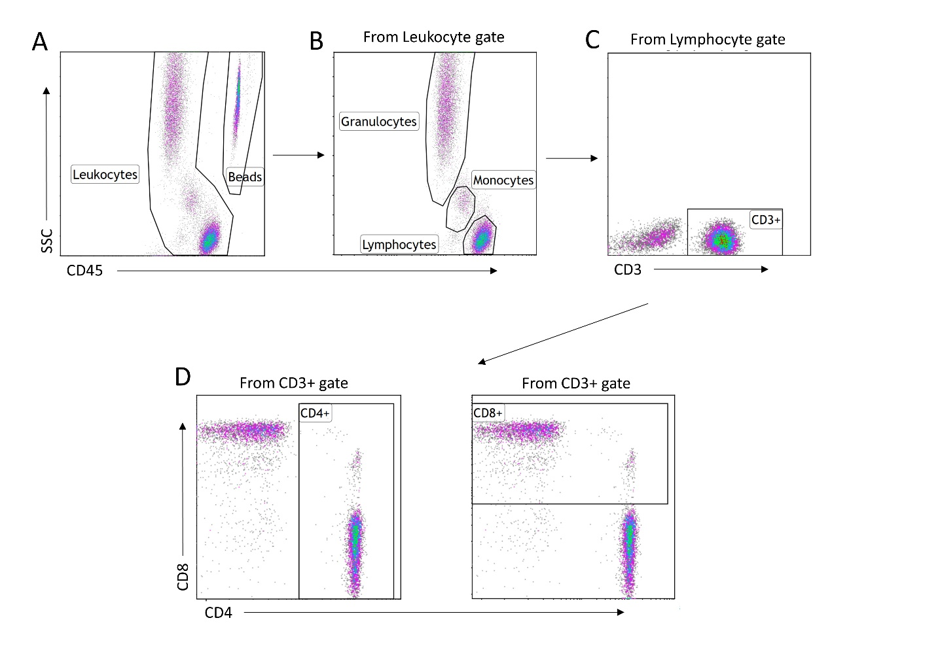

Supplementary Figure 1. Gating strategy for the absolute counts of CD3⁺, CD4⁺ and CD8⁺ T cells in whole blood. A) Viable leukocytes and Trucount beads were identified in separate gates based on their locations in the plot, according to the manufacturer’s instruction. B) From the “Leukocyte” gate, granulocytes, monocytes and lymphocytes were gated based on their granularity and expression of CD45. C) From the “Lymphocytes” gate, CD3⁺ T cells were gated based on CD3 expression. D) From the “CD3⁺“ gate, CD4⁺ and CD8⁺ T cells were identified based on CD4 and CD8 expression, respectively.

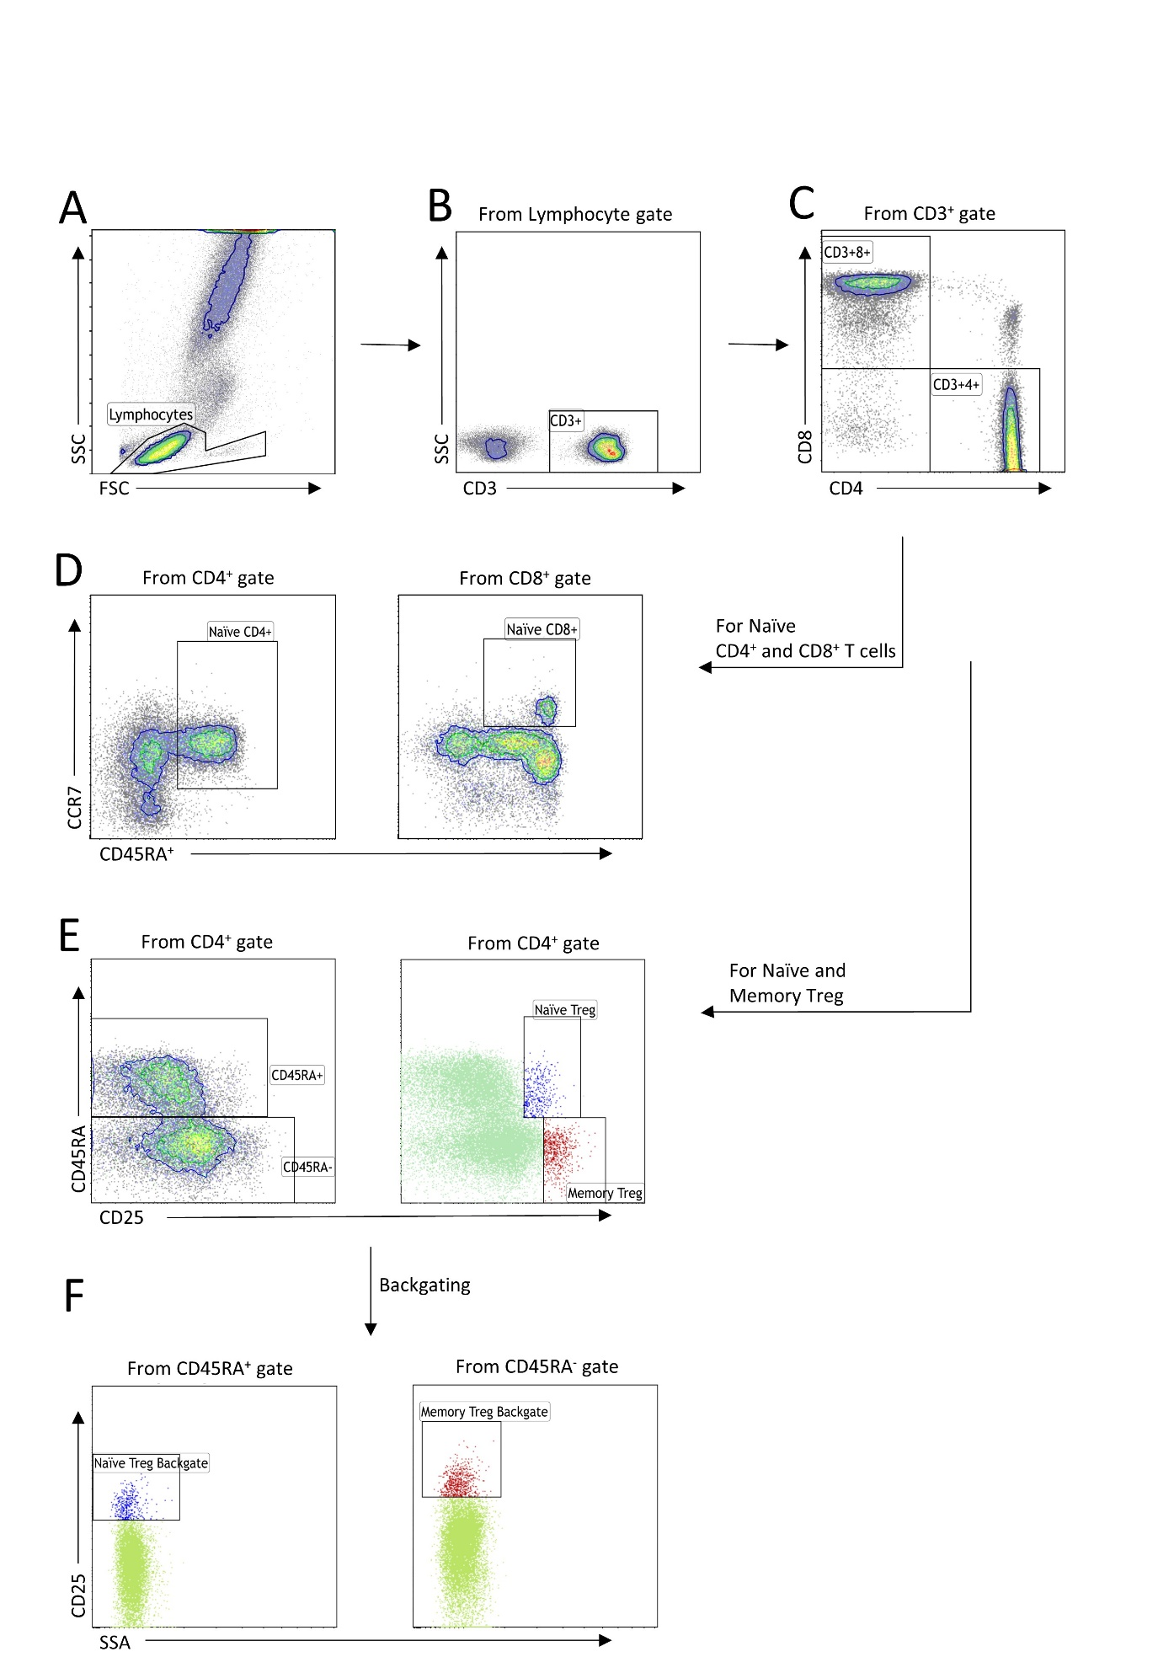
Supplementary Figure 2. Gating strategy for naïve CD4+ T cells, naive CD8+ T cells and naïve regulatory T cells (T_{reg} cells). A) Viable lymphocytes were gated based on size and granularity. B) From the “Lymphocyte” gate, CD3⁺ T cells were identified based on CD3 expression. C) From the “CD3⁺“gate, CD4⁺ and CD8⁺ T cells were gated based on CD4 and CD8 expression, respectively. D) From the “CD4⁺” and “CD8⁺” gates, naive T cell subsets were gated defined as CD45RA⁺ CCR7⁺. E) From the “CD4⁺“ gate, naïve and memory T_{reg} cells were identified as CD25⁺⁺CD45RA⁺ and CD25⁺⁺CD45RA⁻, respectively. F) The naïve and memory T_{reg} cells identified in E) were backgated by displaying gate specific coloring on the CD45RA⁺ and CD45RA⁻ populations in CD25 and side scatter (SSA) plots. T_{reg} cells were defined as CD25++ with relatively lower granularity compared to the rest of the T cells in the respective plots.

