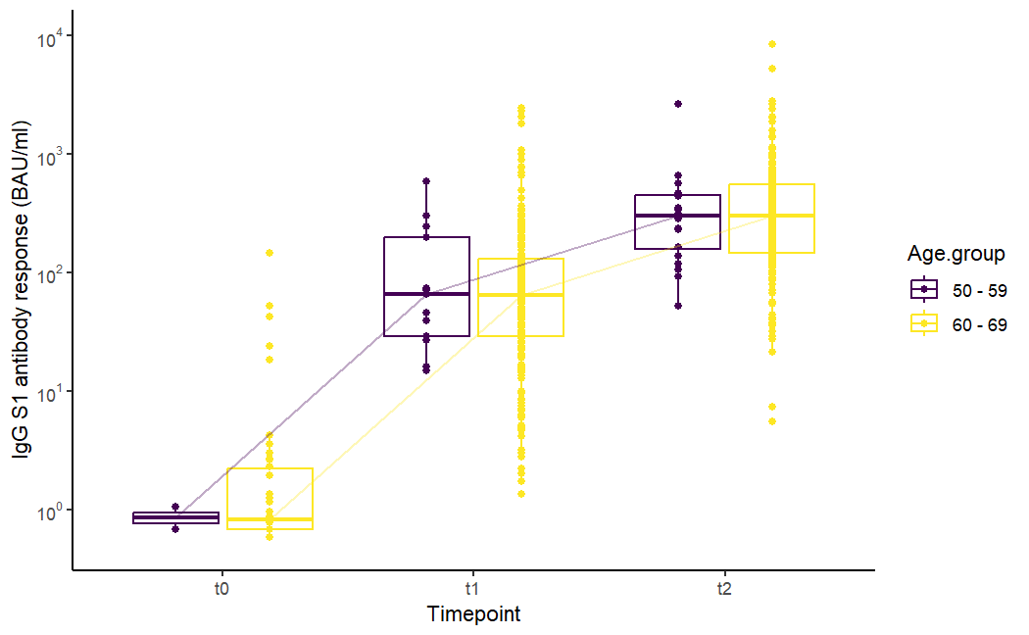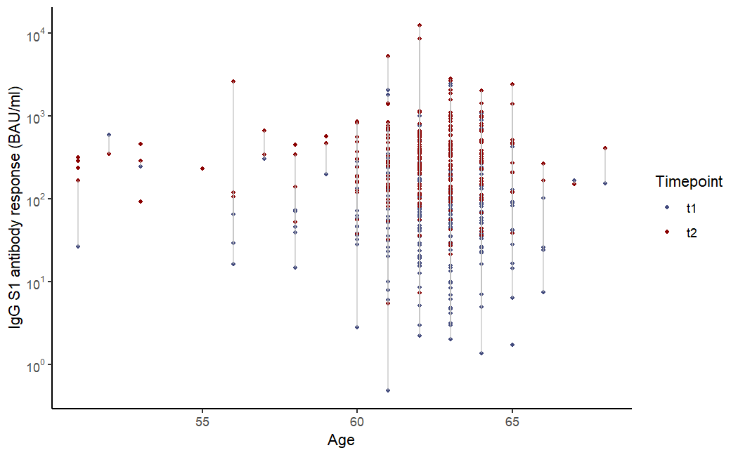
A
B
Figure S1: Distribution of the SARS-CoV-2 -S1 IgG antibody concentrations in binding antibody units per milliliter (BAU/ml) in persons aged 50-70 years of age vaccinated with AZD1222 at T0, T1, and T2 per ten year age group (A) and matched antibody concentrations per individual at T1 (blue) and T2 (red) across age in years (B).

