Supplementary material
Figure S1
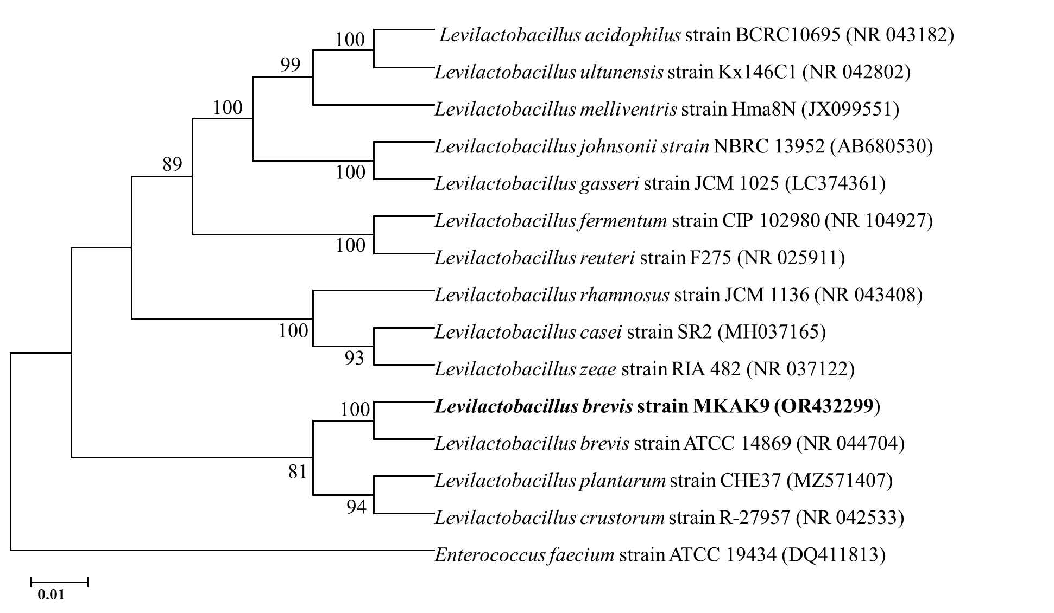
Figure S1. The evolutionary distance between Levilactobacillus brevis strain MKAK9 (Accession no.: OR432299), type strain Levilactobacillus brevis strain ATCC 14869 (Accesion no.: NR 044704), and related species of Lactobacillus was calculated based on 16S rRNA sequences and neighbour-joining tree was computed. The nodes consist bootstrap value (percentages of 1000 replications) greater than 60%. The parentheses of each strain are represented with the GenBank accession number. An outgroup, Enterococcus faecium ATCC 19434 (Accession no.: DQ411813.1) was used to show the evolutionary distances. Kimura 2-parameter method was selected to compute the evolutionary distance in MEGA 7 software, showing the nucleotide substitutions per base. There were a total of 1369 positions in the final dataset. The bar representing 0.01 substitutions per base site.

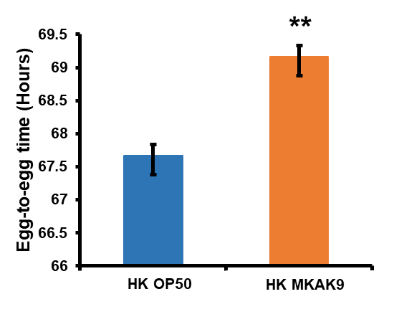
Figure S2. The developmental rate (egg-to-egg time) was measured after treatment with HK OP50 or HK MKAK9, as discussed by Soukas et al. [18]. Treatment effects were compared using Student’s t-test (**p > 0.01).

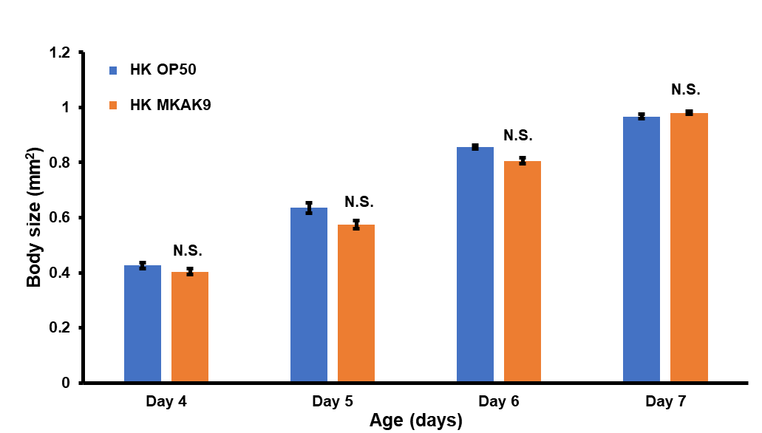
Figure S3. The body size was analyzed after feeding HK OP50 or HK MKAK9. Error bars represent mean ± SEM. Treatment effects were compared using Student’s t-test (N.S. P > 0.05).
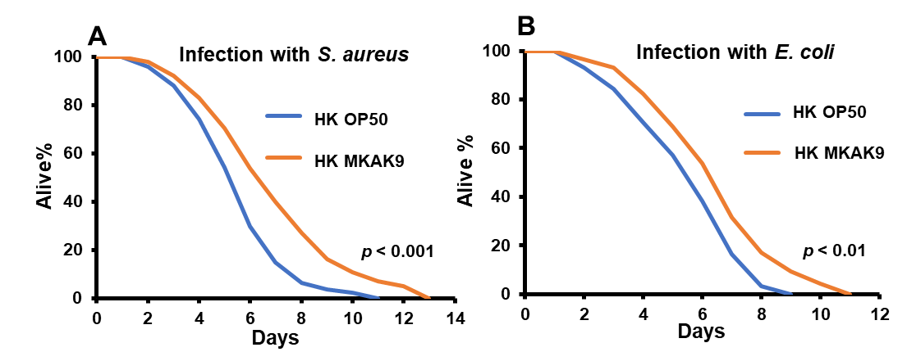
Figure S4. (A and B) Pre-treatment of worms on HK MKAK9 provided resistance against pathogens S. aureus MTCC3160 and E. coli MTCC 1687. The heat-killed bacterium-treated effects were statistically compared using Student’s t-test (**P < 0.01, and ***P < 0.001).

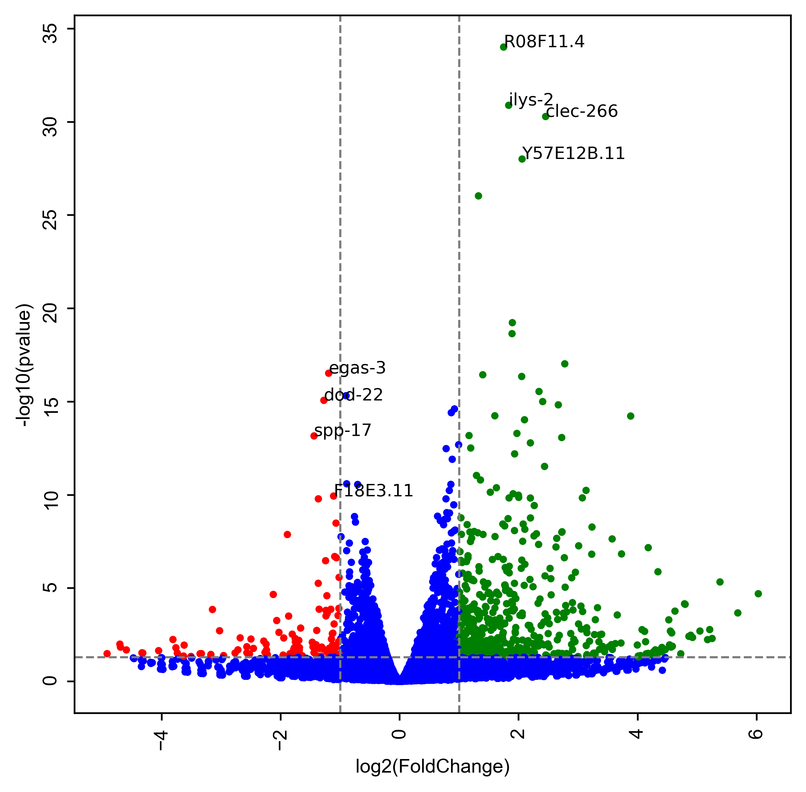
Figure S5. Gene transcription profile (volcano plot) of HK MKAK9-treated worms in comparison to HK OP50-treated worms. The red dots showed downregulated genes and green dots represented upregulated genes. The blue dots indicated genes with no significant change in the expression.

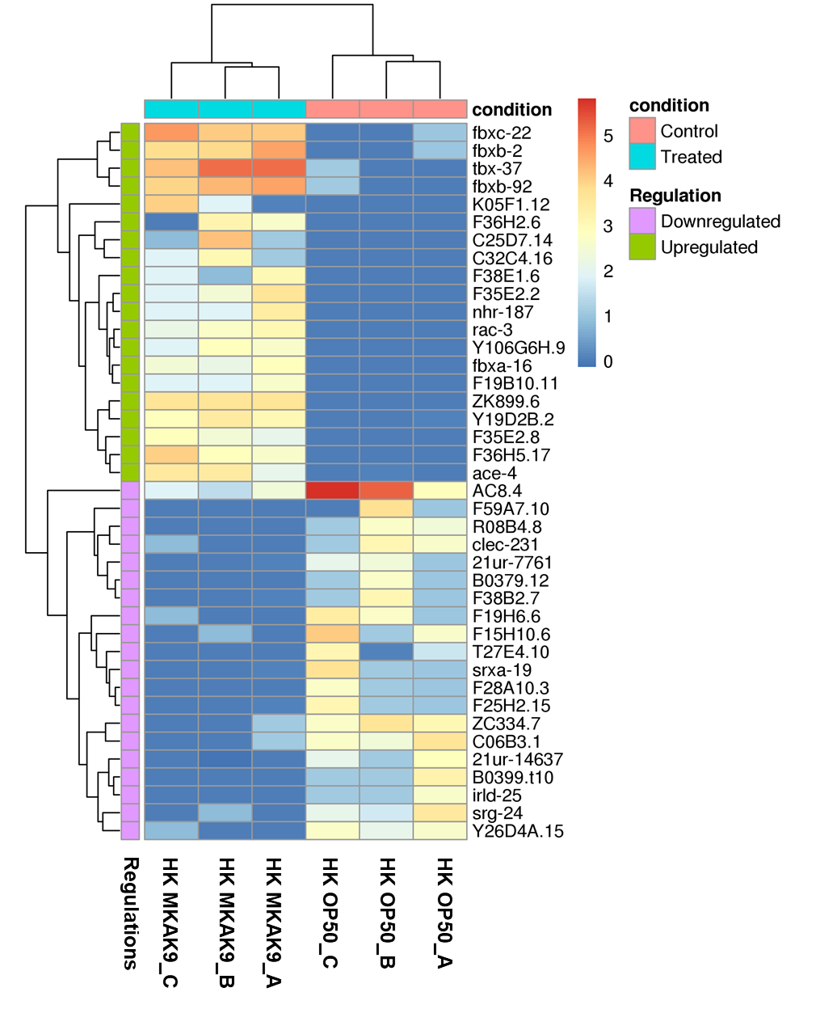
Figure S6. Heat map analysis of RNA sequencing data showing top 20 genes those were upregulated and downregulated in HK MKAK9-treated worms in comparison to HK OP50-treated worms. Each treatment group had three biological replicates. Each group has three single neurons tested. The red colors indicate high expression genes and blue colors denotes the low expression genes, respectively. The log2 value was calculated from mean signals.

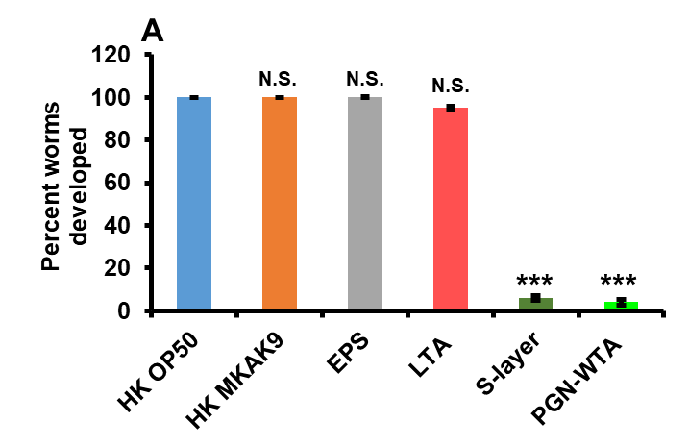
Figure S7. The effect of specific cellular components of HK MKAK9 on development of young adult (day 3) wild-type N2 worms. The graph was plotted as percent developed worms after 2 days (day 5) with different treatment groups by counting the number of developed worms.

Table S1 Closest relative of the strain Levilactobacillus brevis strain MKAK9 in the NCBI database.
Accession number of MKAK9 | Query length | Maximum score/ Total Score | Query coverage | E value | Pairwise sequence similarity | Closest homolog based on % identity)
OR432299 | 1495 bases | 2715/2715 | 99% | 0.0 | 99.46% | Levilactobacillus brevis strain ATCC 14869 (NR_044704.2)

Table S2 Primer sets designed for qRT-PCR analysis in this study
Gene Name  (Accession no.) | Primer | Sequence
nsy-1 | forward | 5'-AGTTGTAGACACGCCGGTTA-3'
(NM_001383826) | reverse | 5'-TGCACTGTTCAGGCTTTCAC-3'
sek-1 | forward | 5'-GCCGATGGAAAGTGGTTTTA-3'
(AB024087) | reverse | 5'-TAAACGGCATCGCCAATAAT-3'
skn-1 | forward | 5'-CTCTCTTCTGGCATCCTCTACCA-3'
(NM_171347) | reverse | 5'-TTCTTGGATTCTTCTTCTTGTTCGT-3'
pmk-1 | forward | 5'-CCGACTCCACGAGAAGGATA-3'
(NM_068964) | reverse | 5'-AGCGAGTACATTCAGCAGCA-3'
daf-16 | forward | 5'-TTCAATGCAAGGAGCATTTG-3'
(NM_001377628) | reverse | 5'-AGCTGGAGAAACACGAGACG-3'
daf-2 | forward | 5'-AAAAGATTTGGCTGGTCAGAGA-3'
(NM_001312989) | reverse | 5'-TTTCAGTACAAATGAGATTGTCAGC-3'
act-1 | forward | 5'-GCTGGACGTGATCTTACTGATTACC-3'
(NM_073418) | reverse | 5'-GTAGCAGAGCTTCTCCTTGATGTC-3'
thn-1 | forward | 5'-AGCCTACGGAACTCCAGACA-3'
(NM_069959) | reverse | 5'-AGTGTAGGAAGCACTTGGCT-3'
ilys-1 | forward | 5'- TGGAAAGCAACGTGGAGAGT-3'
(NM_067807) | reverse | 5'- TCCAAGGTTCCCGGATTACG-3'
cnc-2 | forward | 5'- ATGATGGGAGGTTATGGAGGA-3'
(NM_071017) | reverse | 5'- AAGCACTACCATCACGGCAA-3'
spp-9 | forward | 5'- CTGTCGACAACGAGCTCCATA-3'
(NM_077517) | reverse | 5'- CGAGCTCCTTGATGATCGGA-3'
spp-21 | forward | 5'- TCCCTTTGTGGACGAAGAGTTC-3'
(NM_001029756) | reverse | 5'- GATGATTGGACCGAACTCCGA-3'
clec-47 | forward | 5'- GAAATCCAAACGCCTGTGCT-3'
(NM_074343) | reverse | 5'- TTGCACGTAGCACTGAACCA-3'
clec-266 | forward | 5'- GCATTTGCCCTAATGCAGAAGT-3'
(NM_001392791) | reverse | 5'- TCCGTTTCTCTCGCAGATCG-3'
gst-44 | forward | 5'- ATCCCCCAACACTTTCCGCA-3'
(NM_075081) | reverse | 5'- TTCTTCCCCTCCGCATGCTC-3'
sod-3 | forward | 5'- CTCCAAGCACACTCTCCCAG-3'
(NM_078363) | reverse | 5'- TCCCTTTCGAAACAGCCTCG-3'
skr-7 | forward | 5'- AACGACGTGCTCTTCGACTT-3'
(AF440509) | reverse | 5'- AGAACGTGGGAGTTACTTGGA-3'
skr-8 | forward | 5'- ACCCAAACTTCTAAAAATGATTGCT-3'
(AF440510) | reverse | 5'- AGCAACATCCTCTGGAGCAC-3'
skr-9 | forward | 5'- AACGACGTGCTCTTCGACTT -3'
(NM_070642) | reverse | 5'- GTCCTTGTCGGTGATTGCCT -3'
skr-14 | forward | 5'- ACATACTCATCACCATGTCTGCT -3'
(AF440515) | reverse | 5'- TCTCACACCATTCAGCGACC -3'
skr-10 | forward | 5'- AAAACTACCAACAATGTCCGC -3'
(AF440512) | reverse | 5'- CAGCTCTCTCAGCAGCTTCA -3'
skr-12 | forward | 5'- GAAGCACAAAGCCGATGCAA -3'
(AF440513) | reverse | 5'- TGGTTCAAATTCGGCATGTGT -3'
skr-13 | forward | 5'- GAAGCACAAAGCCGATGCAA -3'
(AF440514) | reverse | 5'- TGTCAACAGCGGAATAACGA -3'
sqst-3 | forward | 5'- CGTGCCAGAAGCTTGTTTCC -3'
(NM_075337) | reverse | 5'- CGGGGATCTCGGTTCTCAAG -3'
sepa-1 | forward | 5'- GCCAGTTGCGGTGAAAACAT -3'
(NM_060938) | reverse | 5'- CTTCACAGGCTCTGGTTCGT -3'
vet-2 | forward | 5'- CAGTGGTTCCACCGGTATCC -3'
(NM_001264586) | reverse | 5'- CCGTACCGCTTTAGCTCCTT -3'
vet-6 | forward | 5'- TGGCTGCAAGAAACATGCAC -3'
(NM_060931) | reverse | 5'- TTCGGCATCCAGAACAGCTT -3'
Y48A6B.3 | forward | 5'- GGGAATCTGCGAGGAGAAGG -3'
(NM_067014) | reverse | 5'- GCTCCTTGAAGTCCCCACTC -3'
ddx-17 | forward | 5'- CGGTCGTACTGGTCGTAGTG -3'
(NM_001047669) | reverse | 5'- CCCTTGAGTTGCTACCTCCG -3'
nsun-1 | forward | 5'- TACCGGAGCAAAATCGGTGA -3'
(NM_061341) | reverse | 5'- CAGGCGAATTTGGATATTTTTCGT -3'
pas-3 | forward | 5'- GGCTGCCAGCTATCGTAACA -3'
(NM_001392262) | reverse | 5'- CCGAACGGTCTCTTTCCTCC -3'
lmp-1 | forward | 5'- TTGTCAGAGACGCCAATGCT -3'
(NM_076671) | reverse | 5'- AGATCCTCCGACGAGTCCAA -3'

Table S3 Survival and adhesion of MKAK9 under in vitro simulated gastro-intestinal conditions.
Gastrointestinal juice tolerance
Treatment | pH 1.0 |  | pH 3.0 |  | pH 7.0 |  | Pepsin (pH 2.0) |  |  | Pancreatin (pH 8.0)
Time | 0 h | 1 h | 0 h | 1 h | 0 h | 1 h | 0 h | 1 h | 3 h | 0 h | 4 h
Mean* ± SEM | 9.11 ± 0.10 | 7.28 ± 0.07 | 9.23 ± 0.018 | 7.70 ± 0.19 | 9.14 ± 0.16 | 8.98 ± 0.08 | 9.32 ± 0.09 | 7.74 ± 0.11 | 7.37 ± 0.15 | 9.26 ± 0.11 | 7.58 ± 0.08
#Survival % | 79.92% |  | 83.24% |  | 98.25% |  | 83.05% and 79.08% |  |  | 81.86%
P value | P < 0.05 |  | P > 0.05 |  | P > 0.05 |  | P < 0.05 for 1 h and 3 h |  |  | P < 0.05

 | Bile salt tolerance |  |  |  | Adhesion in HT-29 cell line
Treatment | 0.3% |  | 1%
Time | 0 h | 4 h | 0 h | 4 h | 0 h | 4 h
Mean* ± SEM | 9.18 ± 0.13 | 7.82 ± 0.10 | 9.05 ± 0.05 | 7.23 ± 0.19 | 9.09 ± 0.13 | 7.56 ± 0.18
#Survival % | 85.19% |  | 79.89% |  | 72.17%
P value | P > 0.05 |  | P > 0.05 |  | P < 0.05
* The values represent mean log (CFU/ml) ± standard error mean (SEM).
# Survival percentage (%) is expressed as the percentage of 1– [(log CFU per ml at T= initial) – (log CFU per ml at T = incubation hour) / (log CFU per ml at T = initial)].
Table S4 Antibiotic sensitivity of the strain MKAK9
Antibiotic | Sensitivity
Ampicillin (10 μg) | S
Chloramphenicol (25 μg) | R
Streptomycin (10 μg) | MS
Penicillin-G (10 μg) | R
Sulphatriad (300 μg) | MS
Tetracycline (25 μg) | S
S = Sensitive; MS = moderately sensitive; R = resistant

Table S5. The mean lifespan of C. elegans strains treated with HK MKAK9 or HK OP50 (N.S. for P > 0.05 and ***P < 0.0001, log-rank test).
C. elegans strain | Treatment | Mean life span in days ± SEM | Total Worms (150) = Dead/Censored | Max survival data (Days) | p-value (HK MKAK9  versus HK OP50)
N2 (Wild-type) | HK OP50 | 14.46 ± 0.38 | 141/9 | 23 | P < 0.0001 (***)
N2 (Wild-type) | HK MKAK9 | 17.99 ± 0.44 | 144/6 | 27 | P < 0.0001 (***)
daf-2 (e1368) | HK OP50 | 19.95 ± 0.42 | 138/12 | 29 | P > 0.05 (N.S.)
daf-2 (e1368) | HK MKAK9 | 21.13 ± 0.41 | 136/14 | 30 | P > 0.05 (N.S.)
daf-16 (mgDf50) | HK OP50 | 10.26 ± 0.17 | 142/8 | 13 | P > 0.05 (N.S.)
daf-16 (mgDf50) | HK MKAK9 | 10.73 ± 0.21 | 144/6 | 14 | P > 0.05 (N.S.)
nsy-1 (ag3) | HK OP50 | 10.99 ± 0.22 | 140/10 | 16 | P > 0.05 (N.S.)
nsy-1 (ag3) | HK MKAK9 | 11.62 ± 0.21 | 141/9 | 17 | P > 0.05 (N.S.)
sek-1 (ag1) | HK OP50 | 10.76 ± 0.22 | 137/13 | 15 | P > 0.05 (N.S.)
sek-1 (ag1) | HK MKAK9 | 11.49 ± 0.23 | 140/10 | 17 | P > 0.05 (N.S.)
pmk-1 (km25) | HK OP50 | 11.30 ± 0.18 | 139/11 | 15 | P > 0.05 (N.S.)
pmk-1 (km25) | HK MKAK9 | 11.91 ± 0.20 | 142/8 | 16 | P > 0.05 (N.S.)
skn-1 (zu67) | HK OP50 | 11.24 ± 0.16 | 144/6 | 15 | P > 0.05 (N.S.)
skn-1 (zu67) | HK MKAK9 | 11.58 ± 0.19 | 146/4 | 17 | P > 0.05 (N.S.)
dbl-1 (nk3) V | HK OP50 | 12.77 ± 0.21 | 145/5 | 19 | P < 0.0001 (***)
dbl-1 (nk3) V | HK MKAK9 | 15.47 ± 0.28 | 144/6 | 22 | P < 0.0001 (***)
lmp-1 (ok3228) X | HK OP50 | 12.20 ± 0.23 | 143/7 | 17 | P > 0.05 (N.S.)
lmp-1 (ok3228) X | HK MKAK9 | 11.94 ± 0.24 | 144/6 | 18 | P > 0.05 (N.S.)
mir-243(n4759) IV | HK OP50 | 9.78 ± 0.17 | 147/3 | 14 | P < 0.001 (**)
mir-243(n4759) IV | HK MKAK9 | 10.97 ± 0.18 | 144/6 | 15 | P < 0.001 (**)
mir-78(n4637) IV | HK OP50 | 8.97 ± 0.19 | 146/4 | 13 | P < 0.0001 (***)
mir-78(n4637) IV | HK MKAK9 | 11.08 ± 0.23 | 145/5 | 16 | P < 0.0001 (***)
mir-1818 | HK OP50 | 6.17 ± 0.14 | 143/7 | 9 | P < 0.0001 (***)
mir-1818 | HK MKAK9 | 8.06 ± 0.20 | 141/9 | 12 | P < 0.0001 (***)
mir-253 | HK OP50 | 8.90 ± 0.17 | 145/5 | 13 | P < 0.0001 (***)
mir-253 | HK MKAK9 | 11.17 ± 0.22 | 143/7 | 16 | P < 0.0001 (***)
N2 (wild-type) | HK OP50 | 14.27 ± 0.27 | 140/10 | 21
N2 (wild-type) | HK MKAK9 | 17.79 ± 0.44 | 138/12 | 25 | P < 0.0001 (***)
N2 (wild-type) | EPS | 18.27 ± 0.47 | 143/7 | 27 | P < 0.0001 (***)
N2 (wild-type) | LTA | 15.12 ± 0.30 | 146/4 | 22 | P > 0.05 (N.S.)
N2 (wild-type) | Cell wall | 17.26 ± 0.42 | 143/7 | 26 | P < 0.0001 (***)
mir-243(n4759) IV | HK OP50 | 8.93 ± 0.17 | 145/5 | 14
mir-243(n4759) IV | HK MRKAK9 | 10.17 ± 0.19 | 143/7 | 15 | P < 0.001 (**)
mir-243(n4759) IV | EPS | 10.37 ± 0.21 | 145/5 | 16 | P < 0.001 (**)

