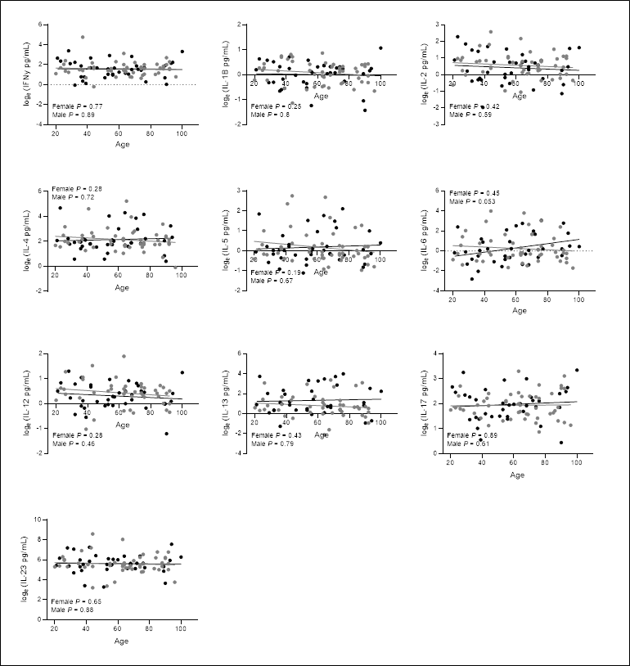
Additional File S3. Peripheral blood cytokines across the life-course in healthy agers.

