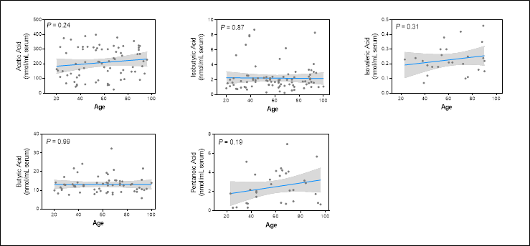
Additional File S4. Short-chain fatty acids in the peripheral blood of healthy agers.

