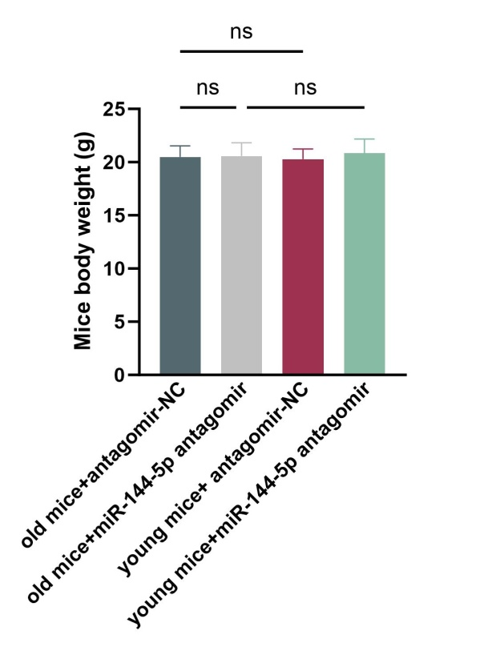
Fig S1: Measurement of body weight of mice in each group

