Supplementary Figure 1. Flow chart of analytical sample

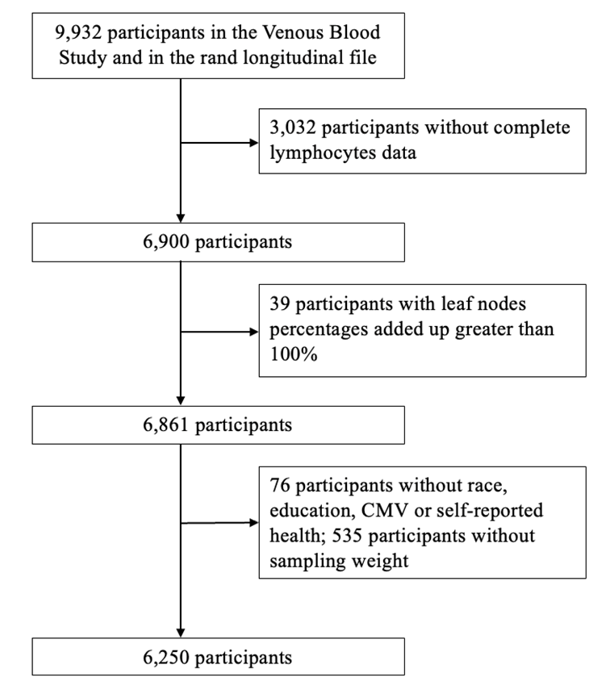

Supplementary Figure 2. Correlation heatmap of 16 subset cells of lymphocytes at the most granular level

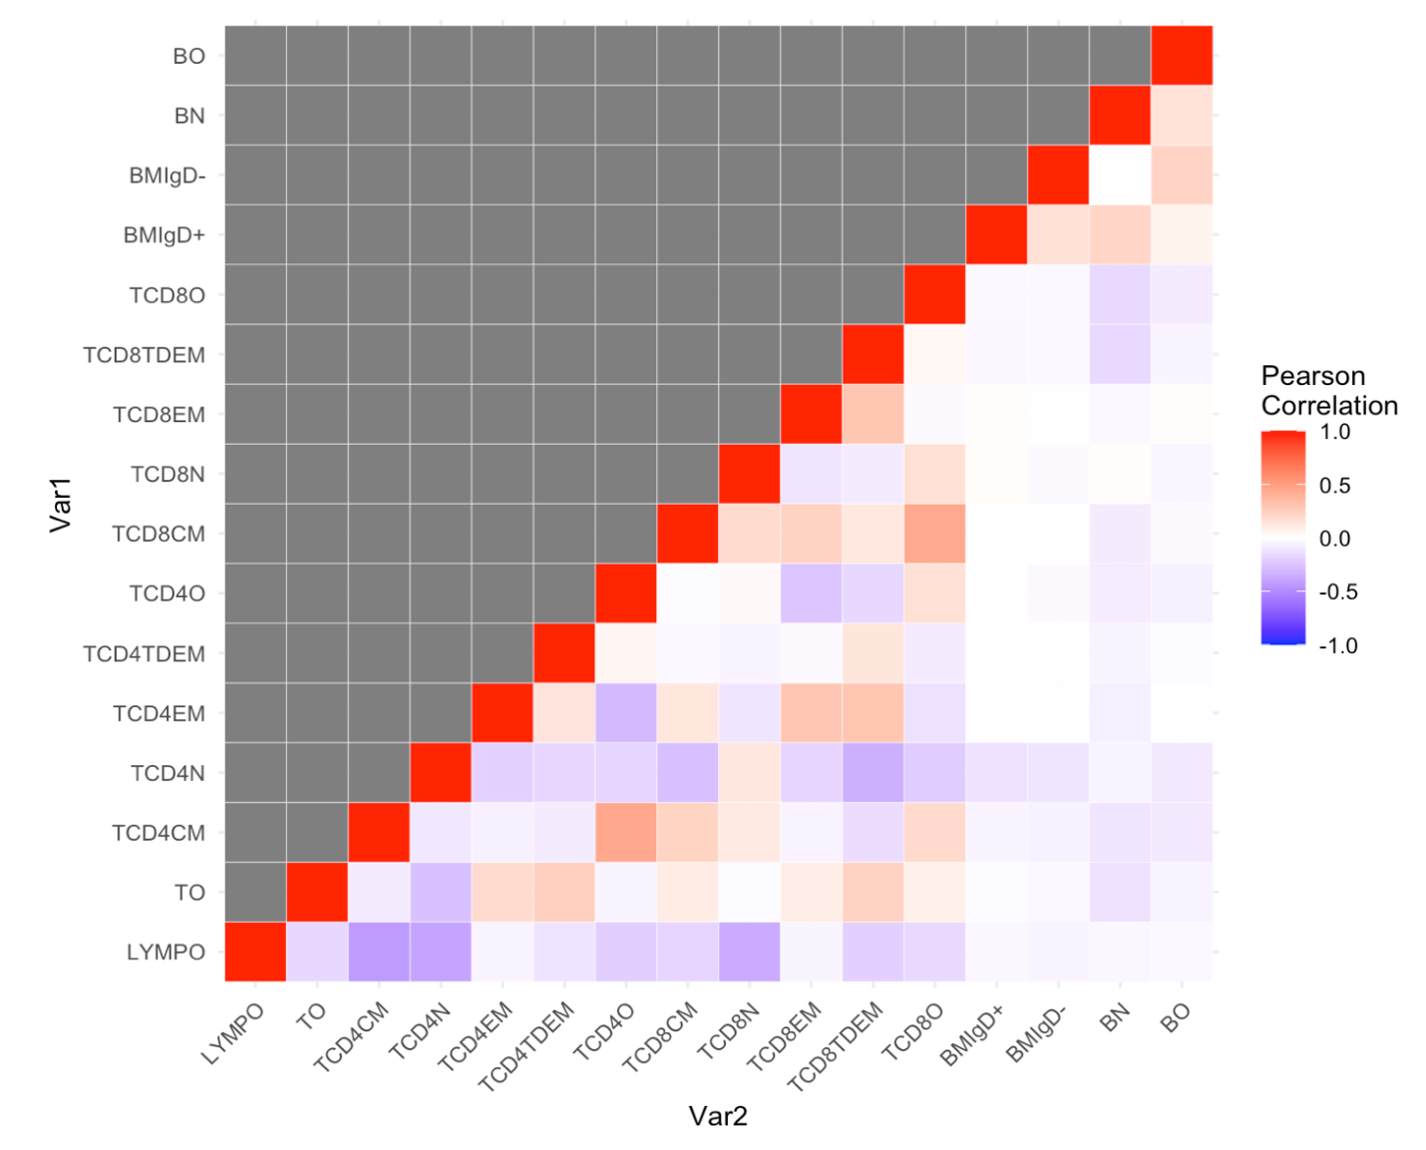

Supplementary Figure 3. Solution path for the linear penalized log-contrast model with self-reported health, adjusted for age, gender, race, education attainment, and CMV

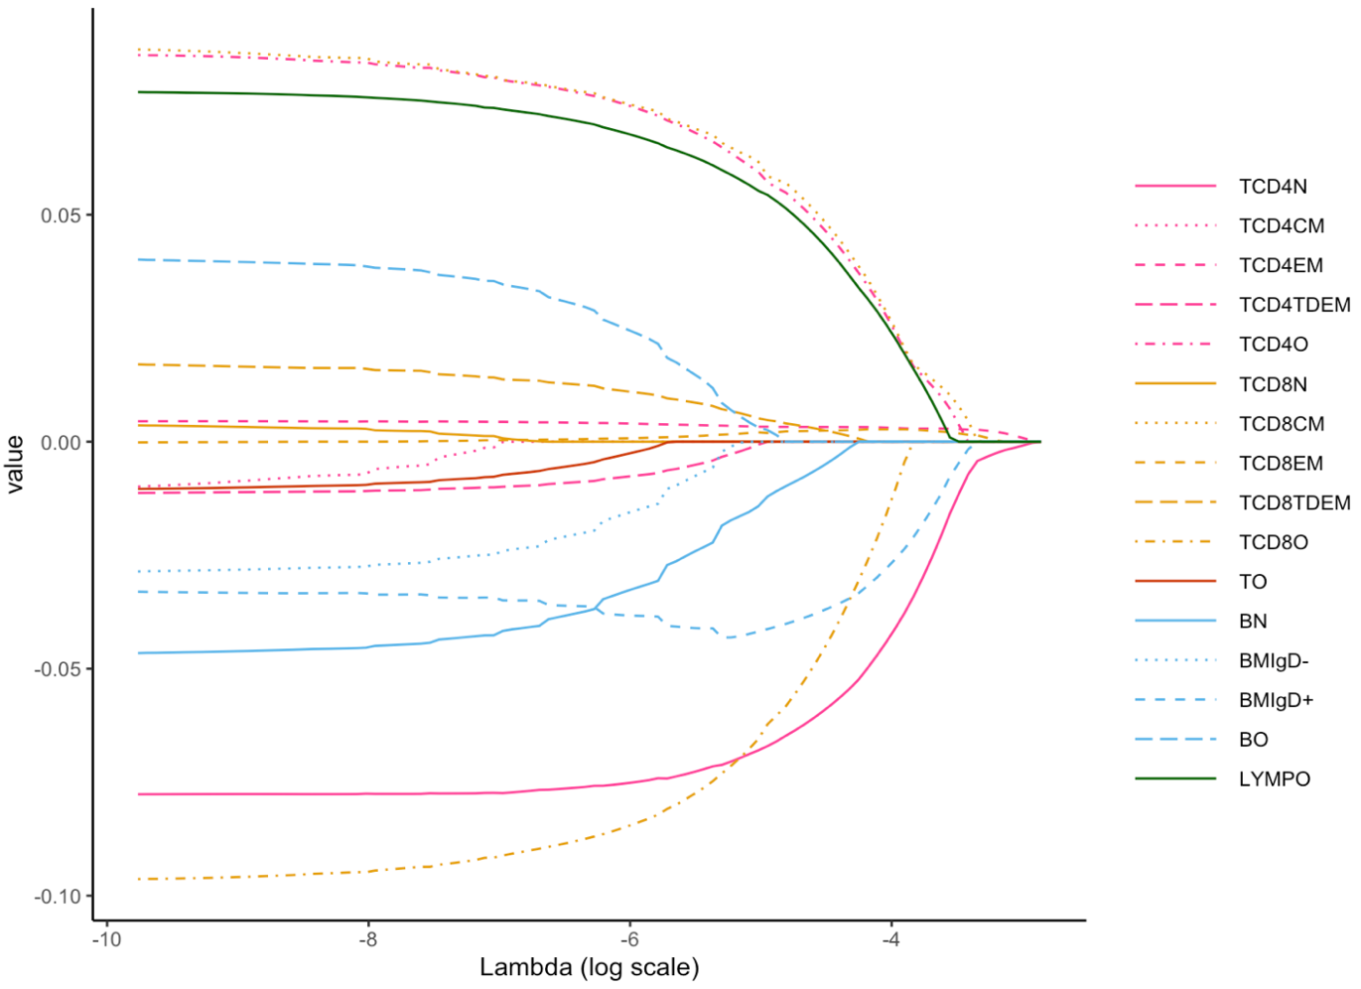
Footnote: The x-axis represents the log-transformed lambda values, and the y-axis indicates the estimated coefficient values. The plot illustrates how the coefficient for each cell type changes with the tuning parameter lambda. Larger lambdas impose greater penalization on non-zero coefficients, resulting in coefficients shrinking to zero as lambda increases.

Supplementary Table 1. Demographic characteristics of individuals with and without missing data on T and B cells and their subsets

 | With Missing Data |  |  | Without Missing Data
 | Median/Count | IQR/Percentage |  | Median/Count | IQR/Percentage
Age (years) | 68 | (61.0, 78.0) |  | 67 |  | (60.0, 76.0)
Gender
Men | 1225 | 40.4% |  | 2841 |  | 41.2%
Women | 1807 | 59.6% |  | 4059 |  | 58.8%
Race
Non-Hispanic White | 1993 |  | 65.7% | 4386 |  | 63.6%
Non-Hispanic Black | 551 |  | 18.2% | 1196 |  | 17.3%
Hispanic | 402 |  | 13.3% | 1074 |  | 15.6%
Other | 82 |  | 2.7% | 231 |  | 3.3%
Missing | 4 |  | 0.1% | 13 |  | 0.2%
Education
Below secondary | 253 |  | 8.3% | 606 |  | 8.8%
Lower secondary | 331 |  | 10.9% | 746 |  | 10.8%
Upper secondary | 928 |  | 30.6% | 2056 |  | 29.8%
Above upper secondary | 1508 |  | 49.7% | 3456 |  | 50.1%
Missing | 12 |  | 0.4% | 36 |  | 0.5%
CMV
Non-reactive | 838 |  | 27.6% | 1949 |  | 28.2%
Reactive or Borderline | 2140 |  | 70.6% | 4920 |  | 71.3%
Missing | 54 |  | 1.8% | 31 |  | 0.4%

Supplementary Table 2. Correlations among chronic disease index, self-reported health, and frailty level
 | Chronic disease index | Self-reported health | Frailty level
Chronic disease index |  | p<0.05 | p<0.05
Self-reported health | 0.37 |  | p<0.05
Frailty level | 0.60 | 0.54
Footnote: Kendall tau correlation coefficient was calculated for the ordinal categorical variables.

Supplementary Table 3. Cumulative and additional variances of by each logratio among the 15 linearly independent logratios based on SRDA

Logratios | Cumulative | Additional
TCD4N/TCD8TDEM | 0.265 | 0.265
LYMPO/TCD4N | 0.442 | 0.177
TCD4EM/TCD4O | 0.574 | 0.132
LYMPO/TCD4CM | 0.659 | 0.085
TCD4N/TCD4O | 0.727 | 0.068
LYMPO/BN | 0.790 | 0.062
TCD4TDEM/TCD8O | 0.834 | 0.044
TCD4N/TCD8N | 0.873 | 0.039
LYMPO/TCD8EM | 0.906 | 0.033
TO/TCD4CM | 0.938 | 0.032
LYMPO/TCD4TDEM | 0.962 | 0.023
LYMPO/BMIgD- | 0.980 | 0.018
BMIgD+/BO | 0.989 | 0.010
TCD4N/TCD8CM | 0.997 | 0.007
TCD4CM/BMIgD+ | 1.000 | 0.003

