Supplemental figures
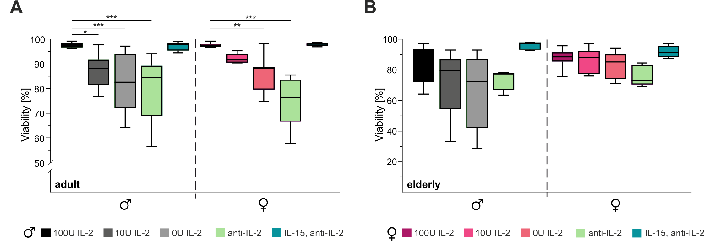
Figure S1: Viability of CTLs under IL-2 influence. Viability of CTLs from (A) adult and (B) elderly mice was assessed under varying IL-2 conditions (100U, 10U, 0U) and after treatment with anti-IL-2 antibodies, with or without IL-15 supplementation. Data are presented as median percentage. Significance levels are indicated as * p < 0.05, ** p < 0.01, *** p < 0.001 and **** p < 0.0001. Sample sizes were n = 4-6 per group.

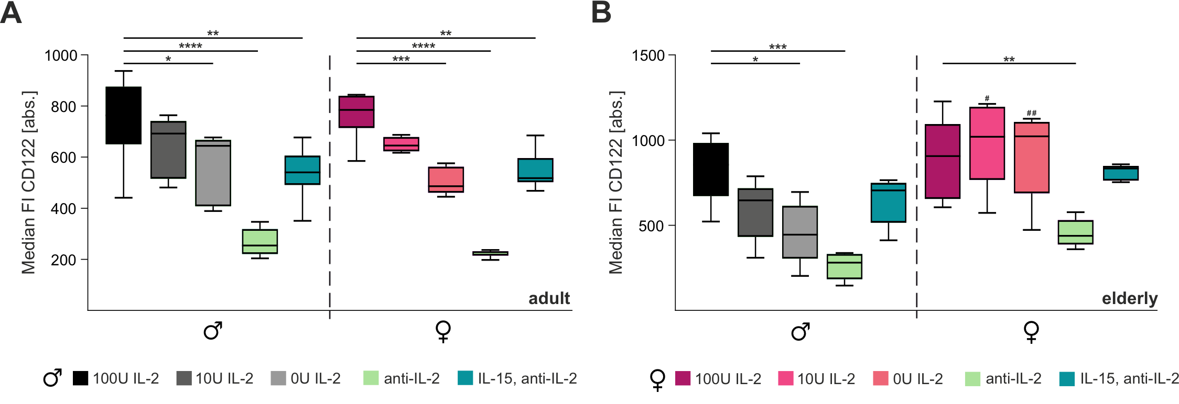
Figure S2: CD122 expression on CTLs under IL-2 influence. The figure depicts median fluorescence intensities (MFI) of CD122 expression on CTLs from (A) adult and (B) elderly male and female mice, assessed by flow cytometry following stimulation with varying IL-2 concentrations (100U IL-2, 10U IL-2, 0U IL-2) or treatments such as anti-IL-2 and IL-15/anti-IL-2. Data are presented as median fluorescence intensity (MFI). Significance levels are indicated as *,# p < 0.05; **,## p < 0.01; ***,### p < 0.001 and ****,#### p < 0.0001. Asterisks (*) denote differences between conditions, and hash marks (#) between sexes. Sample sizes were n = 4-6 per group.

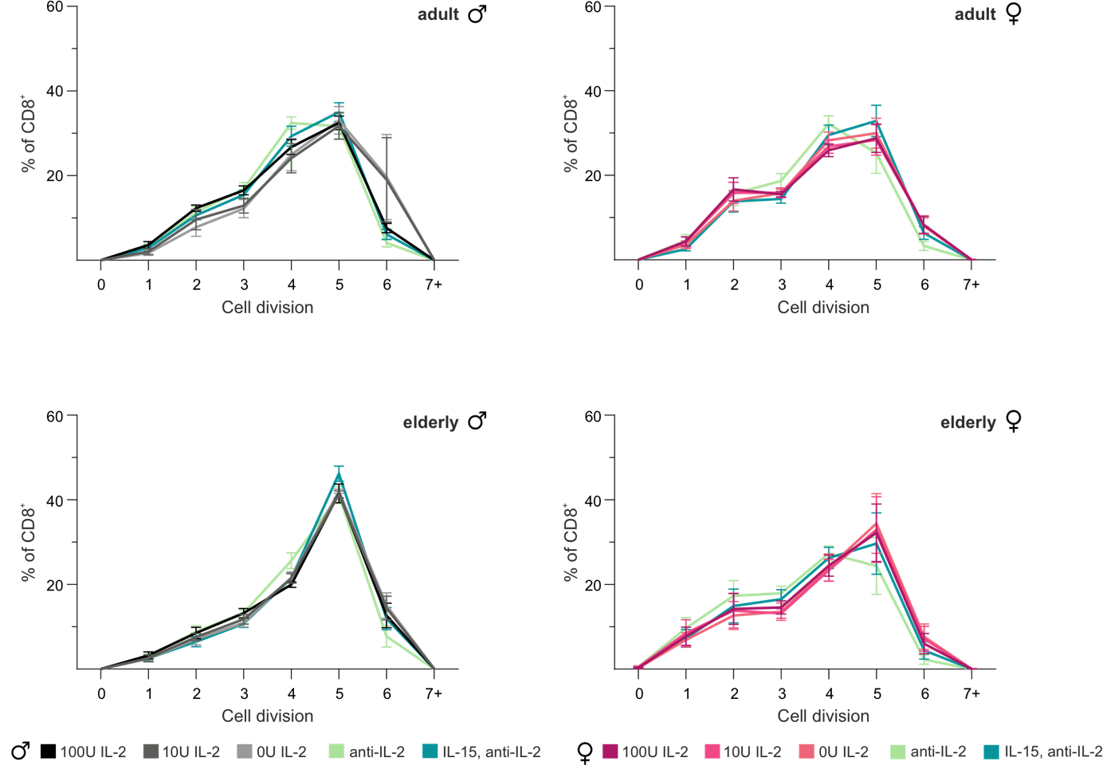
Figure S3: Proliferation of CTLs under IL-2 influence. The figure shows the proliferation of CTLs across various IL-2 stimulation conditions. Proliferation was assessed using flow cytometry-based analysis of CFSE dilution, which quantifies the quantity of cell division. Panels represent data from adult and elderly mice, respectively. Proliferation rates are depicted for different IL-2 concentrations (e.g., 100U IL-2, 10U IL-2, 0U IL-2) and following stimulation with IL-15/anti-IL-2 or anti-IL-2. Data are presented as mean percentage ± SEM. Significance levels are indicated as * p < 0.05, ** p < 0.01, *** p < 0.001 and **** p < 0.0001. Sample sizes were n = 4-6 per group.
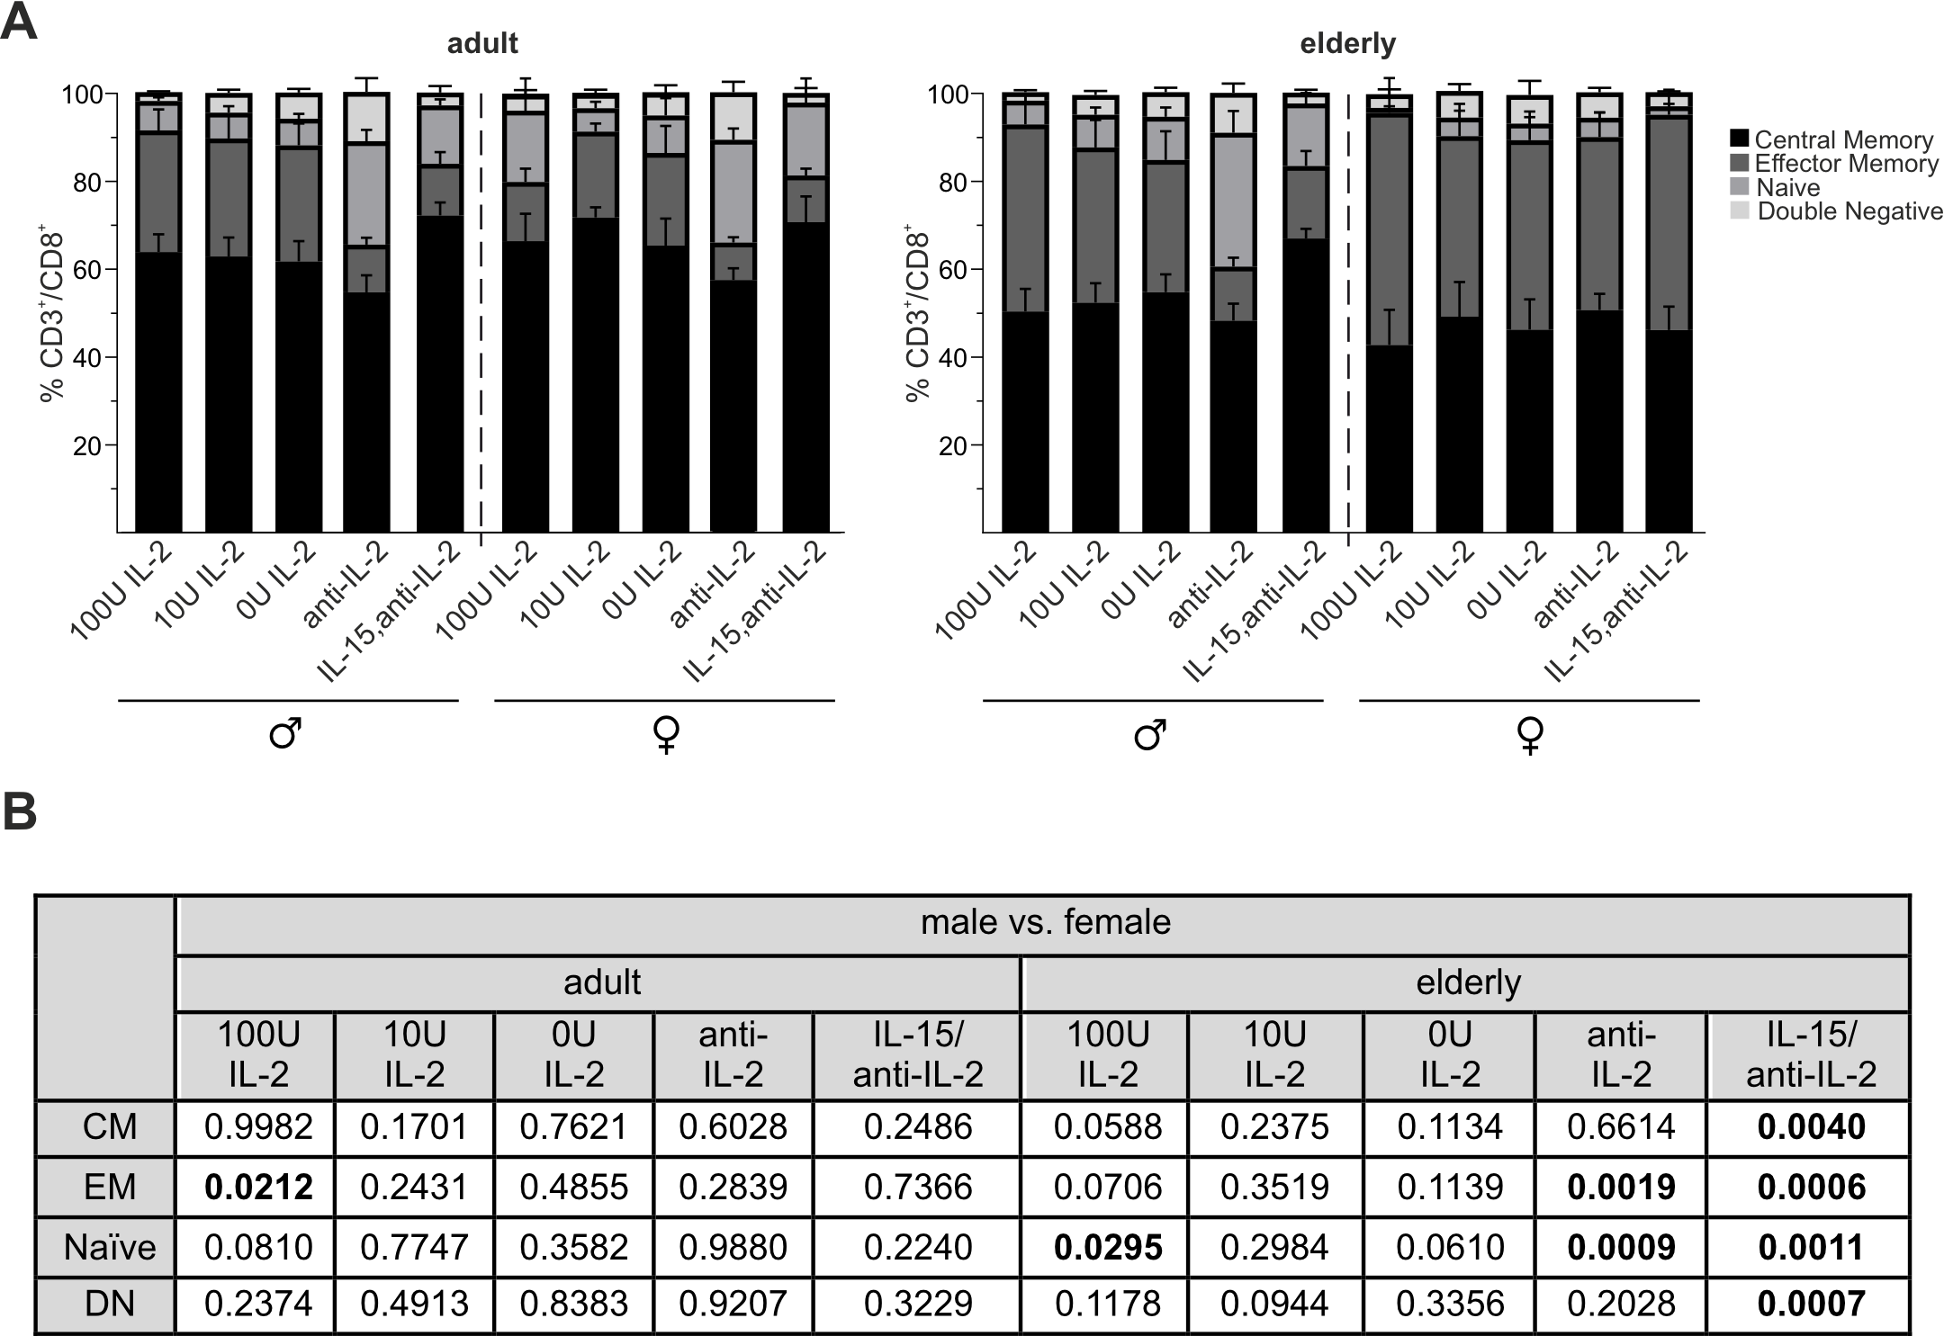
Figure S4: Subtypes distribution of CTLs under IL-2 influence. The figure depicts the distribution of CTL subpopulations across different IL-2 stimulation conditions. (A) Subpopulations are represented by columns, categorized based on CD44 and CD62L expression levels, identifying distinct subsets such as naïve (CD44⁻CD62L⁺), central memory (CD44⁺CD62L⁺), effector memory (CD44⁺CD62L⁻), effector (CD44⁺CD62L⁻), and double negative (CD44⁻CD62L⁻) T cells. Data are presented as mean percentage ± SEM. (B) Significance (p-values) between central memory (CM), effector memory (EM), naïve, and double negative (DN) was tested in male against female mice. Significant values (p<0.05) are highlighted. No significant differences were found compared to 100U IL-2. Sample sizes were n = 4-6 per group.

