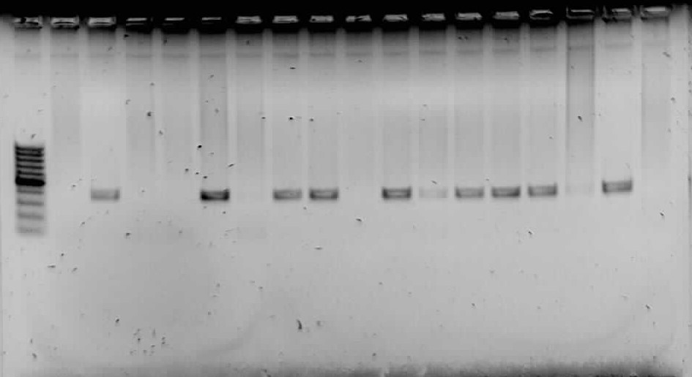
L 1 2 3 4 5 6 7 8 9 10 11 12 13 14 15 P N
Figure S1: A representation gel showing amplified HBV DNA from HBsAg negative plasma. Lane L is a 100 bp molecular weight marker. Expected DNA band sizes of 366bp were readily detected for samples on lanes 2, 5, 7, 8, 10-14. Lane P is a positive control obtained from the PCR optimization process and confirmed by sequencing. Lane N is a negative control (sterilized distilled water used as template).

