Additional file
Figure S1. Participants were asked a series of questions regarding their satisfaction with services received at the ART clinic.
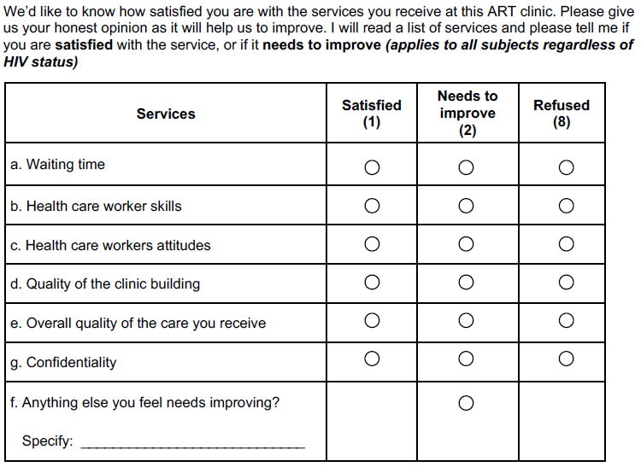

Table S1. Characteristics of PLWH by dissatisfaction with individual components of care at first annual visit after enrollment
 | Dissatisfied with waiting time  (n=177) | Dissatisfied with building quality  (n=59) | Dissatisfied with overall quality of care  (n=18) | Dissatisfied with healthcare workers attitudes  (n=16) | Dissatisfied with  healthcare worker  skills  (n=15)
Study site
Kayunga, Uganda | 36 (20.3%) | 24 (40.7%) | 7 (38.9%) | 5 (31.3%) | 0 (0.0%)
South Rift Valley, Kenya | 29 (16.4%) | 8 (13.6%) | 5 (27.8%) | 1 (6.3%) | 3 (20.0%)
Kisumu West, Kenya | 27 (15.3%) | 1 (1.7%) | 0 (0.0%) | 0 (0.0%) | 0 (0.0%)
Mbeya, Tanzania | 57 (32.2%) | 2 (3.4%) | 4 (22.2%) | 5 (31.3%) | 10 (66.7%)
Abuja & Lagos Nigeria | 28 (15.8%) | 24 (40.7%) | 2 (11.1%) | 5 (31.3%) | 2 (13.3%)
Age (years)
18-29 | 28 (15.8%) | 9 (15.3%) | 5 (27.8%) | 2 (12.5%) | 2 (13.3%)
30-39 | 62 (35.0%) | 17 (28.8%) | 2 (11.1%) | 8 (50.0%) | 3 (20.0%)
40-49 | 51 (28.8%) | 20 (33.9%) | 9 (50.0%) | 2 (12.5%) | 7 (46.7%)
50+ | 36 (20.3%) | 13 (22.0%) | 2 (11.1%) | 4 (25.0%) | 3 (20.0%)
Sex
Male | 80 (45.2%) | 24 (40.7%) | 7 (38.9%) | 7 (43.8%) | 7 (46.7%)
Female | 97 (54.8%) | 35 (59.3%) | 11 (61.1%) | 9 (56.3%) | 8 (53.3%)
Currently employed
No | 93 (52.5%) | 10 (16.9%) | 7 (38.9%) | 5 (31.3%) | 9 (60.0%)
Yes | 84 (47.5%) | 49 (83.1%) | 11 (61.1%) | 11 (68.8%) | 6 (40.0%)
Education
Primary or less | 92 (52.0%) | 25 (42.4%) | 8 (44.4%) | 9 (56.3%) | 7 (46.7%)
Secondary or above | 85 (48.0%) | 34 (57.6%) | 10 (55.6%) | 7 (43.8%) | 8 (53.3%)
Enough food to eat in past 12 months
No | 46 (26.0%) | 16 (27.1%) | 6 (33.3%) | 4 (25.0%) | 2 (13.3%)
Yes | 130 (73.4%) | 43 (72.9%) | 11 (61.1%) | 11 (68.8%) | 13 (86.7%)
Missing | 1 (0.6%) | 0 (0.0%) | 1 (5.6%) | 1 (6.3%) | 0 (0.0%)
Distance from facility (km), median (IQR) | 8 (5-18.5) | 10 (5-20) | 5.5 (2-20) | 7.5 (3-15) | 8 (6.6-12)
Time since HIV diagnosis
<1 year | 0 (0.0%) | 2 (3.4%) | 0 (0.0%) | 1 (6.3%) | 1 (6.7%)
1 to 4 years | 98 (55.4%) | 37 (62.7%) | 9 (50.0%) | 8 (50.0%) | 6 (40.0%)
5 to 9 years | 52 (29.4%) | 14 (23.7%) | 3 (16.7%) | 2 (12.5%) | 7 (46.7%)
10+ | 27 (15.3%) | 6 (10.2%) | 6 (33.3%) | 5 (31.3%) | 0 (0.0%)
Missing | 0 (0.0%) | 0 (0.0%) | 0 (0.0%) | 0 (0.0%) | 1 (6.7%)
Duration on ART
ART naïve | 9 (5.1%) | 6 (10.2%) | 4 (22.2%) | 2 (12.5%) | 3 (20.0%)
<6 months | 13 (7.3%) | 5 (8.5%) | 1 (5.6%) | 0 (0.0%) | 0 (0.0%)
6 months to <2 years | 52 (29.4%) | 28 (47.5%) | 3 (16.7%) | 4 (25.0%) | 3 (20.0%)
2 years to <4 years | 28 (15.8%) | 3 (5.1%) | 3 (16.7%) | 5 (31.3%) | 1 (6.7%)
>4 years | 74 (41.8%) | 17 (28.8%) | 7 (38.9%) | 5 (31.3%) | 7 (46.7%)
Missing | 1 (0.6%) | 0 (0.0%) | 0 (0.0%) | 0 (0.0%)

All data are presented as n (column percentage). P-values were calculated using Pearson’s chi-squared tests or Wilcoxon rank sum tests for continuous variables. Bold indicates significance at p<0.05.

