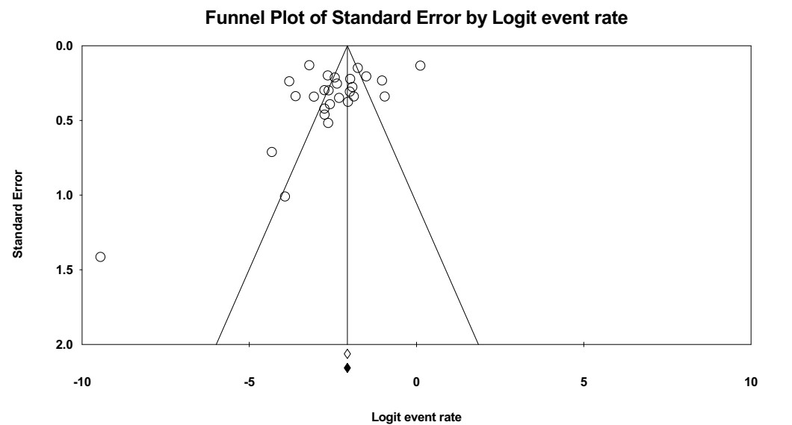
Figure 1. Funnel plots for detection of publication bias among studies in the meta-analysis of prevalence of subclinical hypothyroidism in patients with HIV.

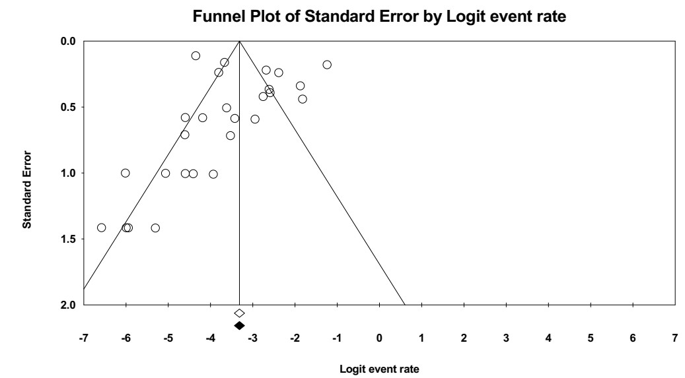

Figure 2. Funnel plots for detection of publication bias among studies in the meta-analysis of prevalence of hypothyroidism in patients with HIV

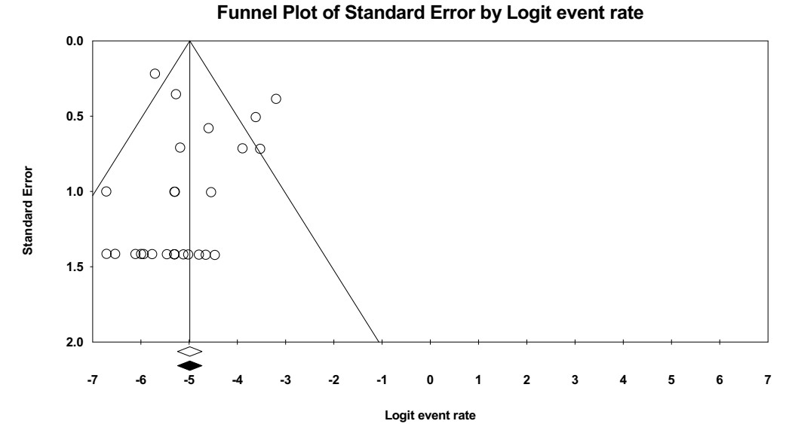

Figure 3. Funnel plots for detection of publication bias among studies in the meta-analysis of prevalence of hyperthyroidism in patients with HIV

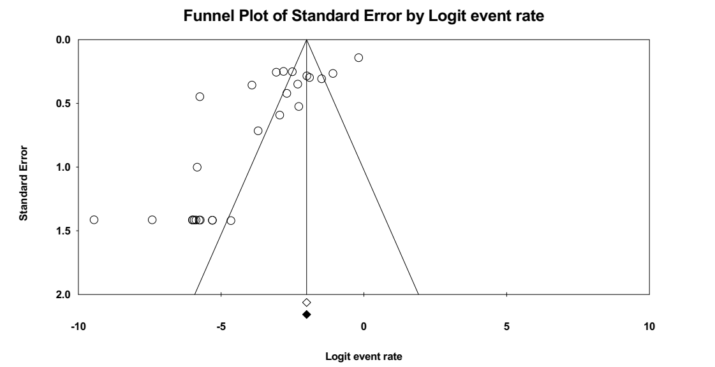

Figure 4. Funnel plots for detection of publication bias among studies in the meta-analysis of prevalence of sick euthyroid syndrome in patients with HIV

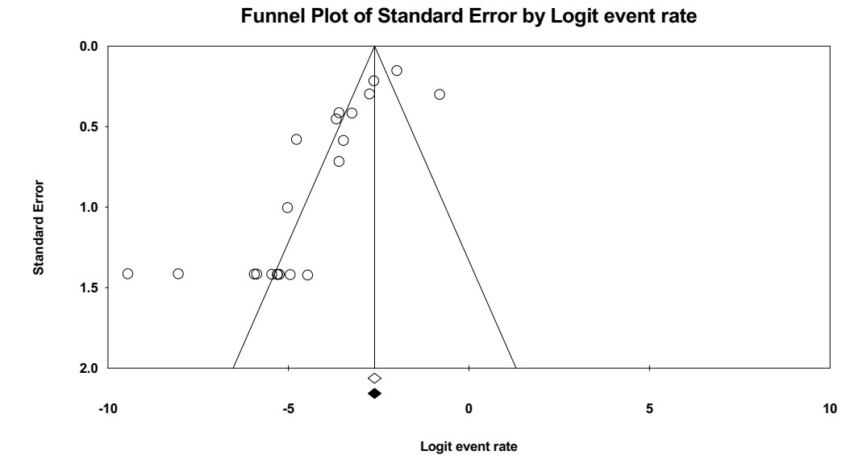

Figure 5. Funnel plots for detection of publication bias among studies in the meta-analysis of prevalence of isolated high FT4 in patients with HIV

