Supplement

Table S1. Site-specific enrolment dates.
Site number | Region | Activation date | End of enrolment date
380-4458-5220 | China | 17-Sep-2020 | 30-Mar-2021
380-4458-15762 | China | 19-Jul-2020 | 30-Mar-2021
380-4458-23024 | China | 12-Jul-2022 | 30-Mar-2021
380-4458-15763 | China | 13-Apr-2020 | 30-Mar-2021
380-4458-15764 | China | 6-Sep-2020 | 30-Mar-2021
380-4458-15765 | China | 13-Apr-2020 | 30-Mar-2021
380-4458-15766 | China | 27-Nov-2020 | 30-Mar-2021
380-4458-15767 | China | 24-Aug-2020 | 30-Mar-2021
380-4458-15768 | China | 24-Jun-2020 | 30-Mar-2021
380-4458-10742 | China | 30-Dec-2020 | 30-Mar-2021
380-4458-11551 | China | 23-Nov-2020 | 30-Mar-2021
380-4458-28729 | Dominican Republic | 29-Sep-2023 | 30-Mar-2021
380-4458-2447 | France | 15-Nov-2018 | 9-Jul-2020
380-4458-2866 | France | 4-Oct-2018 | 30-Mar-2021
380-4458-15266 | Greece | 12-Jun-2019 | 30-Mar-2021
380-4458-15269 | Greece | 21-Mar-2019 | 30-Mar-2021
380-4458-15272 | Greece | 31-Jan-2019 | 11-Feb-2021
380-4458-6171 | Greece | 18-Feb-2019 | 30-Mar-2021
380-4458-5606 | Hong Kong | 25-Jan-2019 | 30-Mar-2021
380-4458-15234 | Hong Kong | 4-Aug-2019 | 30-Mar-2021
380-4458-15235 | Hong Kong | 31-Oct-2018 | 23-Dec-2020
380-4458-27292 | Japan | 13-Mar-2023 | 30-Mar-2021
380-4458-16753 | Japan | 21-Oct-2020 | 30-Mar-2021
380-4458-27695 | Japan | 18-Feb-2020 | 30-Mar-2021
380-4458-16964 | Japan | 16-Feb-2020 | 30-Mar-2021
380-4458-16967 | Japan | 25-Dec-2019 | 30-Mar-2021
380-4458-16965 | Japan | 14-Jan-2020 | 30-Mar-2021
380-4458-16966 | Japan | 14-May-2020 | 30-Mar-2021
380-4458-16755 | Japan | 14-Dec-2019 | 30-Mar-2021
380-4458-15236 | Malaysia | 1-Mar-2019 | 30-Mar-2021
380-4458-15237 | Malaysia | 1-Mar-2019 | 30-Mar-2021
380-4458-15238 | Malaysia | 1-Apr-2019 | 30-Mar-2021
380-4458-15239 | Malaysia | 1-Mar-2019 | 30-Mar-2021
380-4458-15240 | Malaysia | 18-Dec-2018 | 30-Mar-2021
380-4458-15241 | Malaysia | 24-Jan-2019 | 30-Mar-2021
380-4458-15242 | Malaysia | 26-Dec-2018 | 30-Mar-2021
380-4458-15244 | Malaysia | 1-Sep-2019 | 30-Mar-2021
380-4458-15295 | Malaysia | 3-May-2019 | 30-Mar-2021
380-4458-1549 | Puerto Rico | 10-Sep-2019 | 30-Mar-2021
380-4458-15385 | Singapore | 1-Mar-2019 | 22-Dec-2020
380-4458-14272 | South Korea | 3-Jul-2019 | 20-Oct-2020
380-4458-14285 | South Korea | 3-Dec-2019 | 6-Aug-2020
380-4458-14270 | South Korea | 13-Dec-2018 | 25-May-2020
380-4458-15252 | South Korea | 19-Apr-2019 | 30-Mar-2021
380-4458-15388 | South Korea | 28-May-2019 | 5-Mar-2021
380-4458-14276 | South Korea | 4-Dec-2019 | 1-Jun-2020
380-4458-15748 | Spain | 26-Dec-2019 | 30-Mar-2021
380-4458-2795 | Spain | 29-Oct-2018 | 28-Oct-2019
380-4458-15265 | Spain | 31-Oct-2018 | 30-Mar-2021
380-4458-15267 | Spain | 8-Mar-2019 | 30-Mar-2021
380-4458-14601 | Spain | 4-Oct-2018 | 30-Mar-2021
380-4458-15270 | Spain | 23-Jan-2019 | 28-Sep-2020
380-4458-14898 | Spain | 13-Feb-2019 | 30-Mar-2021
380-4458-2794 | Spain | 30-Oct-2018 | 30-Mar-2021
380-4458-1029 | Spain | 28-Sep-2018 | 2-Feb-2021
380-4458-2768 | Spain | 13-Feb-2019 | 30-Mar-2021
380-4458-15245 | Taiwan | 28-May-2020 | 30-Mar-2021
380-4458-15248 | Taiwan | 16-Oct-2019 | 30-Mar-2021
380-4458-14903 | Taiwan | 12-Apr-2018 | 30-Mar-2021
380-4458-15249 | Taiwan | 2-Dec-2019 | 30-Mar-2021
380-4458-15250 | Taiwan | 1-Sep-2019 | 30-Mar-2021
380-4458-15251 | Taiwan | 13-Mar-2019 | 30-Mar-2021
380-4458-15247 | Taiwan | 14-Dec-2018 | 30-Mar-2021
380-4458-15376 | Taiwan | 4-Oct-2020 | 30-Mar-2021
380-4458-15381 | Taiwan | 23-Aug-2019 | 19-Mar-2021
380-4458-6918 | Thailand | 13-Nov-2018 | 30-Mar-2021
380-4458-8033 | Thailand | 1-Apr-2019 | 30-Mar-2021
380-4458-8217 | Thailand | 1-Feb-2019 | 30-Mar-2021
380-4458-4127 | Thailand | 1-Mar-2019 | 30-Mar-2021
380-4458-4169 | Thailand | 22-Jan-2019 | 30-Mar-2021
380-4458-1936 | Thailand | 14-Nov-2018 | 30-Mar-2021
380-4458-15735 | Thailand | 8-Dec-2020 | 30-Mar-2021
380-4458-5605 | Turkey | 22-Aug-2019 | 30-Mar-2021
380-4458-3541 | Turkey | 4-Jul-2019 | 30-Mar-2021
380-4458-15080 | United States | 8-Jun-2018 | 3-Jul-2019
380-4458-15083 | United States | 15-Oct-2018 | 1-Aug-2019
380-4458-1236 | United States | 8-Jun-2018 | 30-Mar-2021
380-4458-11678 | United States | 6-Jun-2018 | 28-Aug-2019
380-4458-1534 | United States | 25-Sep-2018 | 24-Jun-2019
380-4458-1624 | United States | 6-Jun-2018 | 25-Jul-2019
380-4458-2000 | United States | 3-Dec-2018 | 29-Jul-2020
380-4458-1198 | United States | 18-Jul-2018 | 23-Aug-2019
380-4458-2843 | United States | 21-Jun-2018 | 21-Aug-2020
380-4458-2106 | United States | 12-Jun-2018 | 30-Mar-2021
380-4458-109 | United States | 6-Dec-2018 | 10-Jul-2019
380-4458-754 | United States | 7-Jun-2018 | 3-Jul-2019
380-4458-2480 | United States | 3-Jul-2018 | 31-Jul-2019
380-4458-589 | United States | 6-Jul-2018 | 3-Jul-2019
380-4458-1645 | United States | 6-Jul-2018 | 19-Aug-2019
380-4458-2475 | United States | 1-Jun-2018 | 30-Mar-2021
380-4458-2825 | United States | 6-Jun-2018 | 12-Jul-2019
380-4458-2675 | United States | 21-Jun-2018 | 31-Jul-2019
380-4458-991 | United States | 6-Aug-2018 | 4-Nov-2019
380-4458-255 | United States | 27-Jun-2018 | 15-Jun-2019
380-4458-1966 | United States | 25-May-2018 | 12-Jul-2019
380-4458-1950 | United States | 21-Aug-2019 | 30-Mar-2021
380-4458-13183 | United States | 11-Mar-2019 | 29-Sep-2020

Table S2. Institutional review boards.
Geographic Region/Country or Region  Principal Investigator (Site Number) | Geographic Region/Country or Region
Asia Pacific/China
Chen, Jun, MD (23024) | Ethics Committee of Shanghai Public Health Clinical Centre, Shanghai, China
Dai, Lili, PhD (15762) | The Ethics Committee of Beijing YouAn Hospital, Capital Medical University, Beijing, China
Geng, Wenqing, MD (15761) | Medical Ethics Committee of The First Hospital of China Medical University, Shenyang, China
He, Shenghua, MB (15765) | Ethics Committee of Chengdu Public Health Clinical Centre, Sichuan, China
Li, Linghua, MD (15763) | Medical Ethics Committee of Guangzhou Eighth, People's Hospital, Guangzhou, China
Li, Taisheng, PhD (10742) | Drug Clinical Trial Ethics Committee of Peking, Union Medical College Hospital, Chinese Academy, of Medical Sciences, Beijing, China
Su, Minghua, MM (10899) | Medical Ethics Committee of The First Affiliated Hospital of Guangxi Medical University, Guangxi, China
Wang, Hui, MM (15764) | The Third People's Hospital of Shenzhen, Guangdong, China
Wang, Min, MD (15767) | Ethics Committee of The First Hospital of Changsha, Hunan, China
Wang, Fusheng, MD (11551) | Medical Ethics Committee of The Fifth Medical Centre of PLA General Hospital, Beijing, China
Wei, Hongxia, MM (15768) | Medical Ethics Committee of The Second Hospital of Nanjing, Jiangsu, China
Zhu, Biao, MD (15766) | Medical Ethics Committee of The First Affiliated Hospital of Zhejiang University, Zhejiang, China
Zhang, Fujie, PhD (05220) | The Ethics Committee of Beijing Ditan Hospital Capital Medical University, Chaoyang District, Beijing, China
Asia Pacific/ Hong Kong
Lee, Man-Po, MD (15234) | Research Ethics Committee (Kowloon  Central/Kowloon East), Kowloon, Hong Kong
Lui, Chung Yan Grace, Professor (15235) | The Joint Chinese University of Hong Kong - New Territories East Cluster Clinical Research Ethics  Committee, Shatin, Hong Kong
Tsang, Tak Yin Owen, Doctor (05606) | Kowloon West Cluster Research Ethics Committee, Princess Margaret Hospital, Kowloon, Hong Kong
Asia Pacific/ Japan
Naito, Toshio, MD (16964) | Juntendo University Hospital Institutional Review Board, Tokyo, Japan
Nakajima, Hideaki, MD (16966) | Yokohama City University Hospital Institutional Review Board, Yokohama, Japan
Oka, Shinichi, MD (07973) | Centre Hospital of the National Centre for Global Health and Medicine Institutional Review Board, Tokyo, Japan
Shirano, Michinori, MD (16967) | Osaka City General Hospital Institutional Review Board, Osaka, Japan
Shirasaka, Takuma, MD (11589) | National Hospital Organisation Osaka National Hospital Institutional Review Board, Osaka, Japan
Tateyama, Masao, MD (16965) | University of the Ryukyus Hospital Institutional Review Board, Okinawa, Japan
Yokomaku, Yoshiyuki, MD (16753) | National Hospital Organisation Nagoya Medical Centre Institutional Review Board, Nagoya, Japan
Yoshida, Masaki, MD (16755) | The Jikei University Hospital Institutional Review Board for Drugs, Tokyo, Japan
Asia Pacific/ South Korea
Choi, Jae-phil, PhD (14276) | Seoul Medical Centre, Institutional Review Board, Seoul, South Korea
Choi, Jun Yong, PhD (14285) | Severance Hospital, Yonsei University Health System, Institutional Review Board, Seoul, South Korea
Kim, Sang-II, PhD (15252) | The Catholic University of Korea, Seoul St. Mary's Hospital Institutional Review Board, Seoul, South Korea
Kim, Shin-Woo, PhD (14272) | Kyungpook National University Hospital  Institutional Review Board, Daegu, South Korea
Kim, Yeon Sook, PhD (14270) | Chungnam National University Hospital Institutional Review Board, Daejeon, South Korea
Lee, Sunhee, PhD (15388) | Pusan National University Hospital Institutional Review Board, Busan, South Korea
Asia Pacific/ Malaysia
Ab Rahman, Ahmad Kashfi Bin Hj, MD (15237)  Chidambaram, Suresh Kumar, MD (15242)  Chow, Ting Soo, MD (15240)  Chua, Hock Hin, MD (15239)  Ker, Hong Bee, MD (15241)  Lee, Heng Gee, MD (15236)  Leong, Chee Loon, MD (15244)  Mat Jelani, Anilawati, MD (15238) | Medical Research and Ethics Committee (MREC), National Institutes of Health, Ministry of Health  Malaysia, Shah Alam, Malaysia
Syed Omar, Sharifah Faridah, MD (15295) | UMMC Medical Research Ethics Committee, University Malays Medical Centre, Kuala Lumpur, Malaysia
Asia Pacific/ Singapore
Olszyna, Dariusz, MD (15385) | Domain Specific Review Board, Singapore
Asia Pacific/ Taiwan
Chen, Su-Jung, PhD (15381) | Institutional Review Board, Taipei Veterans General Hospital, Taipei, Taiwan
Cheng, Shu-Hsing, PhD (15250) | Medical Ethics and Institutional Review Board of Taoyuan General Hospital, Taoyuan, Taiwan
Hung, Chien-Ching, PhD (14903) | Research Ethics Committee, National Taiwan University Hospital, Taipei, Taiwan
Ko, Wen-Chien, MD (15248) | Institutional Review Board National Cheng Kung University Hospital, Tainan, Taiwan
Lin, Yu-Hui, MD (15376) | The Institutional Review Board of Taichung Veterans General Hospital, Taichung, Taiwan
Lu, Po-Liang, PhD (15247) | Institution Review Board, Kaohsiung Medical University Chung-Ho Memorial Hospital No. 100, Kaohsiung, Taiwan
Tsai, Hung-Chin, PhD (15251) | Kaohsiung Veterans General Hospital Institution Review Board, Kaohsiung, Taiwan
Wang, Chien-Chun, MD (15245) | Taipei City Hospital Research Ethics Committee No.10, Taipei, Taiwan
Yang, Chia-Jui, MD (15249) | Research Ethics Review Committee Far Eastern Memorial Hospital, New Taipei, Taiwan
Asia Pacific/ Thailand
Avihingsanon, Anchalee, PhD (01936) | Institutional Review Board, Faculty of Medicine, Chulalongkorn University, Bangkok, Thailand
Chetchotisakd, Ploenchan, MD (04127) | Centre for Ethics in Human Research, Khon Kaen University, Khon Kaen, Thailand
Khusuwan, Suwimon, MD (15735) | Central Research Ethics Committee (CREC), Bangkok, Thailand; Ethics Committee in Human Research, Chiangrai Prachanukroh Hospital, Chiang Rai, Thailand
Kiertiburanakul, Sasisopin, MD (08033) | The Committee on Human Rights Related to Researchers Involving Human Subjects, Ramathibodi Hospital, Bangkok, Thailand
Ratanasuwan, Winai, MD (06918) | Siriraj Institutional Review Board, Bangkok, Thailand
Siripassom, Krittaecho, MD (08217) | The Institutional Review Board of Bamrasnaradura Infectious Diseases Institute, Nonthaburi, Thailand
Supparatpinyo, Khuanchai, MD (04169) | Research Ethics Committee, Chiang Mai University, Chiang Mai, Thailand
EMEA/ France
Aumaitre, Hugues, MD (02447)  Miailhes, Patrick, MD (02866) | CHRU Tours - Hopsital Bretonneau - CPP Ouest I, Tours, France
EMEA/ Greece
Chini, Maria, MD (15266)  Metallidis, Symeon, MD (15269)  Papastamopoulos, Vasileios, MD (15272)  Psichogiou, Mina, MD (06171) | National Ethics Committee, Cholargos, Greece
EMEA/ Spain
Aleman, Maria Remedios, MD, PhD (15748)  Estrada Perez, Vicente, MD, PhD (02795)  Garcia Deltoro, Miguel, MD (15265)  Garcia Garcia, Josefina, MD, PhD (15267)  Gorgolas Hernandez-Mora, Miguel, MD, PhD  (02768)  Laguno Centeno, Montserrat, MD (14898)  Martin Carbonero, Luz, MD, PhD (14601)  Miralles Álvarez, Celia, MD (02794)  Pulido Ortega, Federico, MD (01029)  Ryan Murua, Pablo, MD (15270) | CEIC Hospital Clinico San Carlos, Madrid, Spain
Europe/ Turkey
Korten, Volkan, MD (03541)  Tabak, Omer Fehmi, MD (05605) | Istanbul University Cerrahpasa Medical Faculty Clinical Research Ethics Committee, Istanbul, Turkey
Latin America/Dominican Republic
Koenig, Ellen Levy, MD (00986) | Asociación de Bioética, Estudios Protocolares y Seguimientos (ABIEPROSE),Santo Domingo,  Dominican Republic
North America/ United States
Benson, Paul, DO (01236)  Berhe, Mezgebe, MD, MPH (11678)  Brinson, Cynthia C., MD (01624)  Goldstein, Deborah, MD (01198)  Creticos, Catherine, MD (01645)  Crofoot Jr., Gordon E., MD (02475)  Cruickshank, Frederick A., MD (02825)  Kinder, Clifford A., MD (02675)  Mayer, Cynthia A., DO (02843)  Osiyemi, Olayemi, MD (02106)  Prelutsky, David J., MD, FACP, AAHIVS (01966)  Ramgopal, Moti, MD (01950)  Rolle, Charlotte-Paige, MD, MPH (15080)  Santiago Colon, Lizette, MD (01549)  Vanig, Thanes, MD (00754)  Wohlfeiler, Michael B., MD (02480) | Advarra Institutional Review Board, Columbia, Maryland, USA
Brar, Indira, MD (01534) | Henry Ford Health System Institutional Review Board, Detroit, Michigan, USA
Fichtenbaum, Carl, MD (02000) | University of Cincinnati Institutional Review Board, Cincinnati, Ohio, USA
Morano, Jamie, MD, MPH (15083) | University of South Florida Institutional Review Board, Tampa, Florida, USA
Ogbuagu, Onyema, MD (13183) | Yale University Human Research Protection Program Human Investigation Committee, New Haven, Connecticut, USA
Pollard, Richard B., MD (00109) | UC Davis Institutional Review Board  Administration, Sacramento, California, USA
Roberts, Afsoon, MD (00589) | Western Institutional Review Board, Puyallup, Washington, USA
Stephens, Jeffrey, MD (00991) | Mercer University Institutional Review Board, Macon, Georgia, USA
Thompson, Melanie A., MD (00255) | AIDS Research Consortium of Atlanta Institutional Review Board, Atlanta, Georgia, USA

Fig S1. Study design.
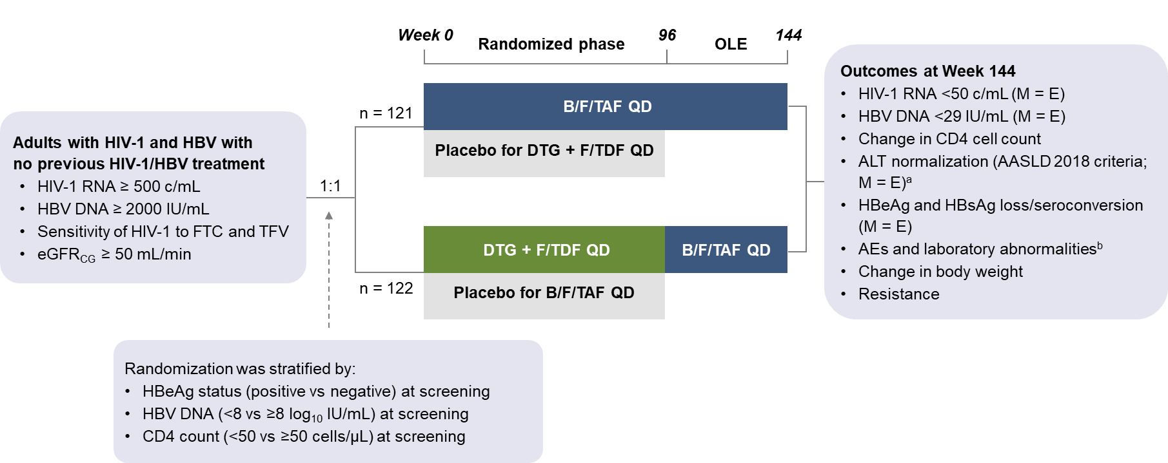
ªChange in ALT concentration from >ULN (female participants: 25 U/mL; male participants: 35 U/mL) at baseline to ≤ULN at Week 144.
^{b}Safety was assessed through the end of study.
AASLD 2018, American Association for the Study of Liver Diseases 2018 criteria; AE, adverse event; ALT, alanine aminotransferase;
B/F/TAF, bictegravir/emtricitabine/tenofovir alafenamide; c, copies; CD4, cluster of differentiation 4; DTG, dolutegravir; eGFR_{CG}, estimated glomerular filtration rate by Cockcroft-Gault equation; F/TDF, emtricitabine/tenofovir disoproxil fumarate; FTC, emtricitabine; HBeAg, HBV envelope antigen; HBsAg, HBV surface antigen; HBV, hepatitis B virus; M = E, missing = excluded; OLE, open-label extension; QD, once daily; TEAE, treatment-emergent adverse event;
TFV, tenofovir; ULN, upper limit of normal.

Fig S2. Participant disposition.
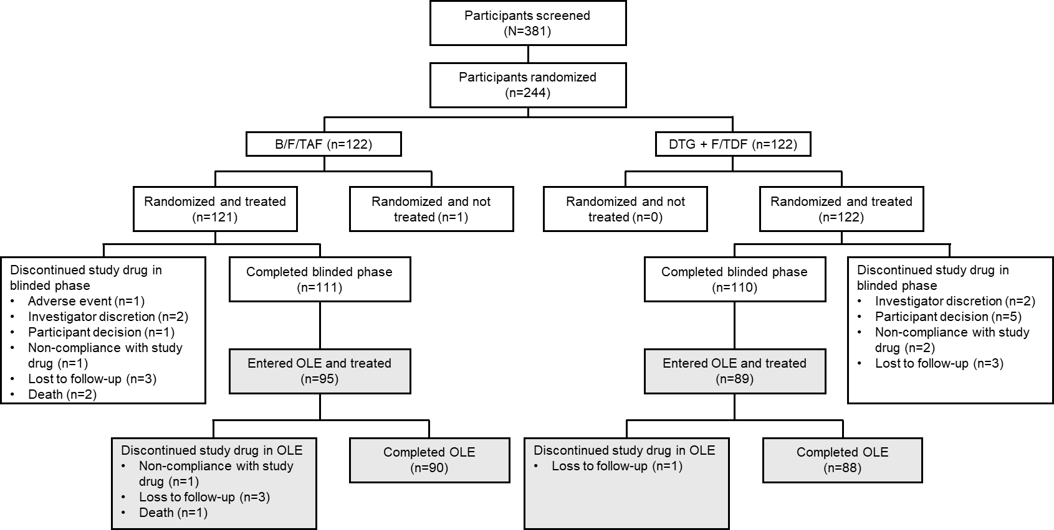
B/F/TAF, bictegravir, emtricitabine, and tenofovir alafenamide; DTG, dolutegravir; F/TDF, emtricitabine and tenofovir disoproxil fumarate.

Fig S3. Median change in CD4 cell count from study baseline at OLE Week 48.
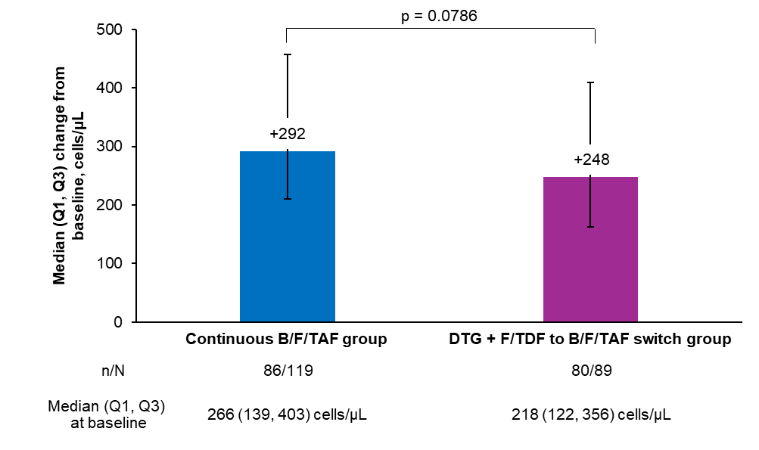
ªParticipants with CD4 count at baseline and 48 Weeks
B/F/TAF, bictegravir, emtricitabine, and tenofovir alafenamide; CD, cluster of differentiation; DTG, dolutegravir, F/TDF, emtricitabine and tenofovir disoproxil fumarate; Q, quartile.

Fig S4. Participants with normal ALT from B/F/TAF initiation (2018 AASLD criteria).
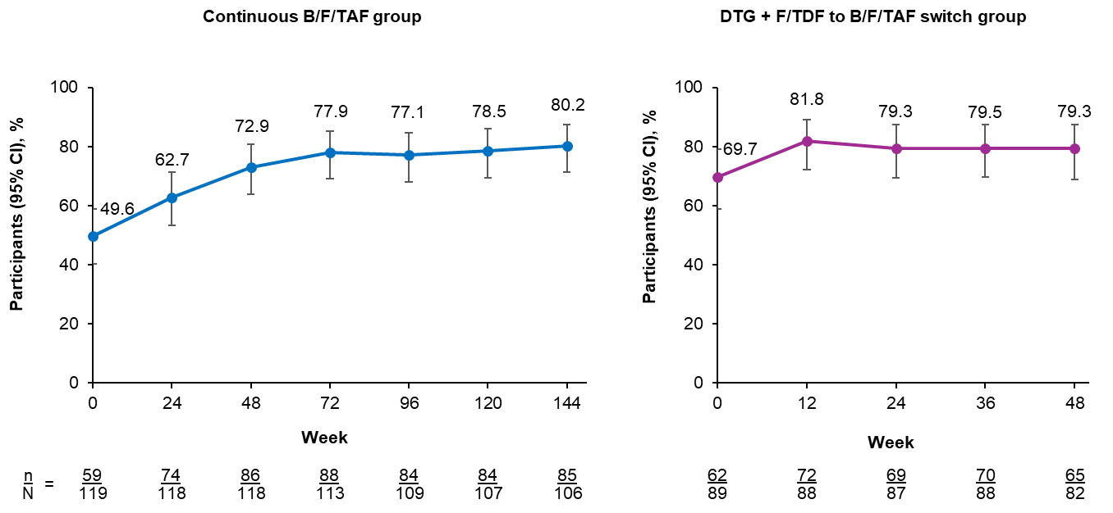
M=E analysis in the all B/F/TAF full analysis set. Based on the 2018 AASLD criteria; ULN is 25 U/L for females and 35 U/L for males. The continuous B/F/TAF and switch groups are not directly comparable due to differences in participant populations and duration of treatment.
AASLD, American Association for the Study of Liver Diseases; ALT, alanine aminotransferase; B/F/TAF, bictegravir, emtricitabine, and tenofovir alafenamide; DTG, dolutegravir; F/TDF, emtricitabine and tenofovir disoproxil fumarate; M=E, missing = excluded; ULN, upper limit of normal.

Fig S5. Fasting lipids and glucose, and weight from B/F/TAF initiation.
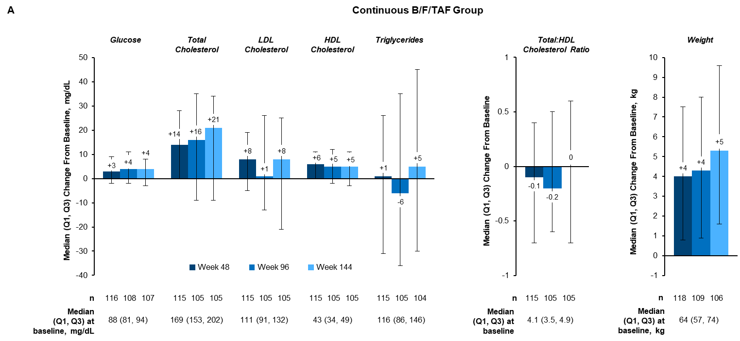
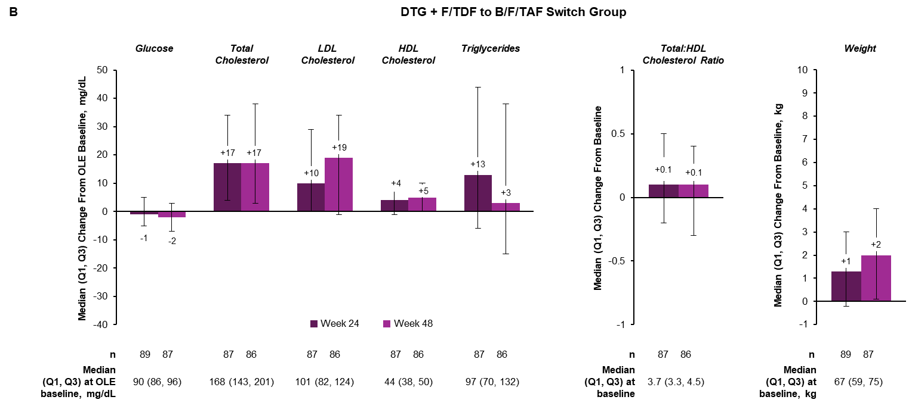
The continuous B/F/TAF and switch groups are not directly comparable due to differences in participant populations and duration of treatment.
B/F/TAF, bictegravir, emtricitabine, and tenofovir alafenamide; DTG, dolutegravir; F/TDF, emtricitabine and tenofovir disoproxil fumarate;
HDL, high-density lipoprotein; LDL, low-density lipoprotein; OLE, open-label extension.

Fig S6. eGFR_{CG} over time from B/F/TAF initiation.

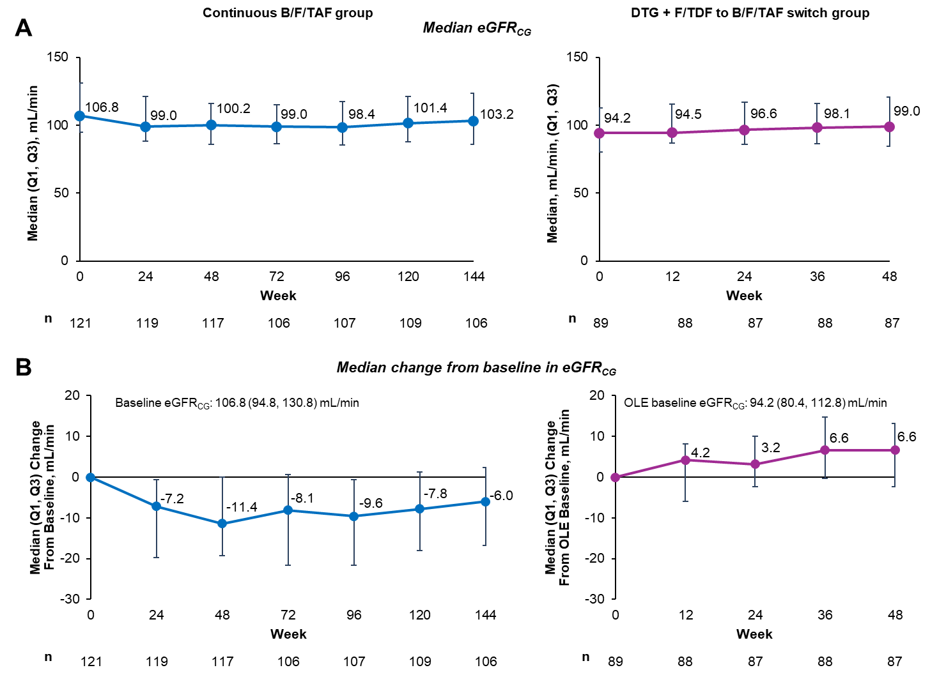
The continuous B/F/TAF and switch groups are not directly comparable due to differences in participant populations and duration of treatment.
B/F/TAF, bictegravir, emtricitabine, and tenofovir alafenamide; eGFR_{CG}, estimated glomerular
filtration rate by Cockcroft-Gault equation; DTG, dolutegravir, F/TDF, emtricitabine and tenofovir disoproxil fumarate.

