Supplementary content

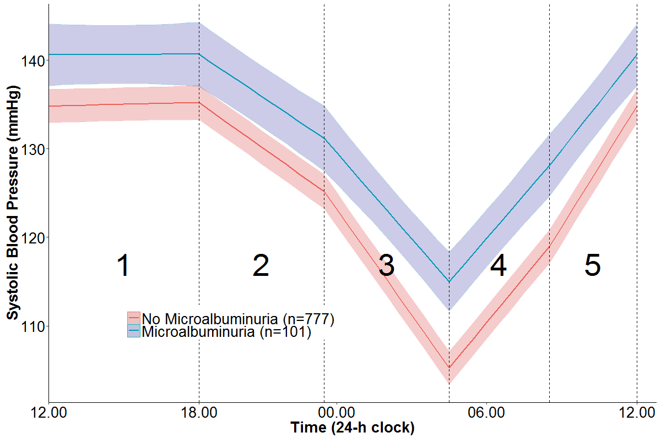
Predicted average (95% CI) piecewise linear trajectory of those with/without presence of microalbuminuria adjusted for age, sex, BMI and including an interaction of the spline terms with microalbuminuria using a linear mixed-effects model (Model 3). Each linear spline represents the rate of BP increase or decrease (slope) for that segment and has been given a corresponding number which is referred to in Table 2.
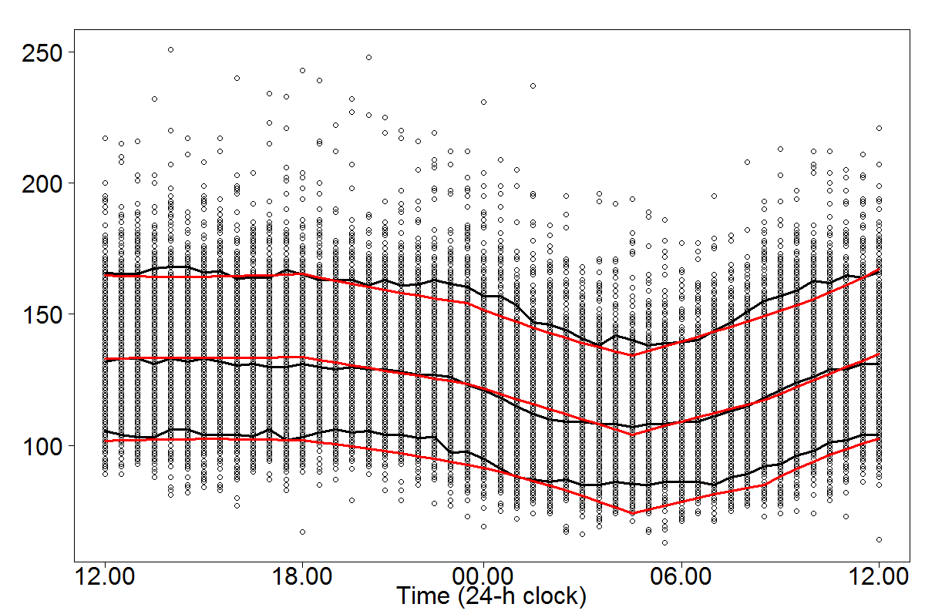
VPC (visual predictive check)plot. Black lines represent median of observed data with 90% interquantile range of observations. Red line is predicted mean along with 90% prediction interval.

