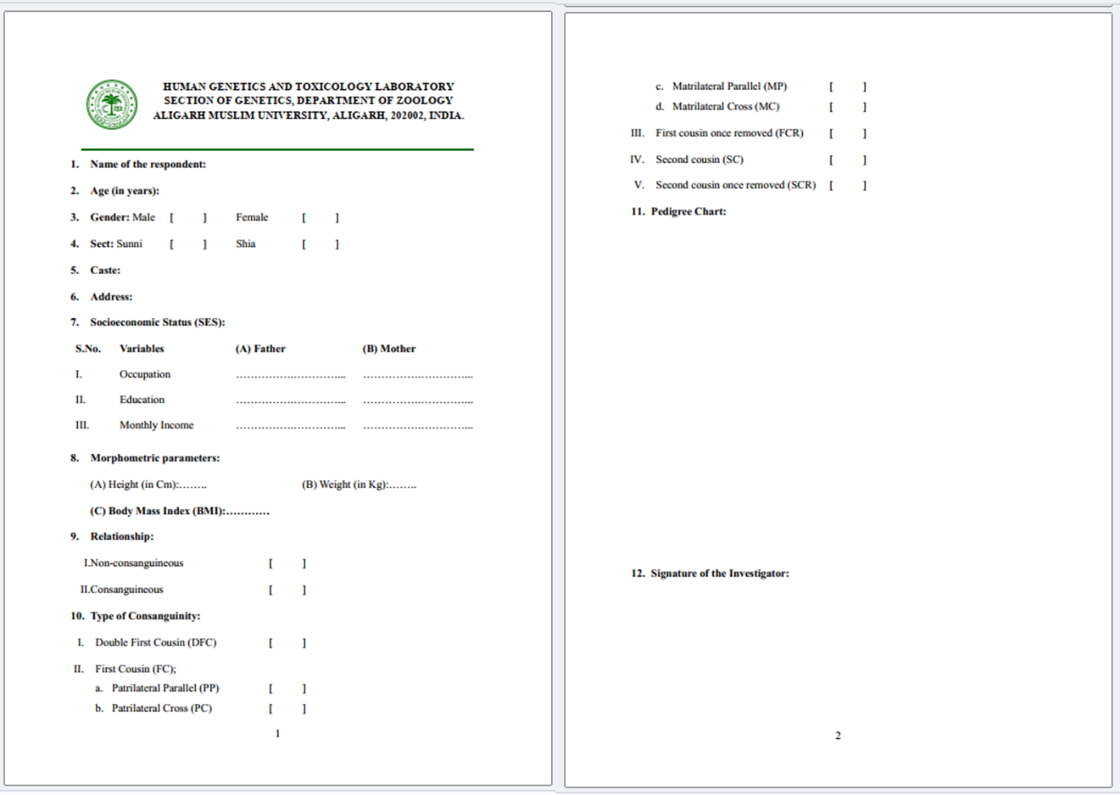
Supplementary Figure 1: General information questionnaire used for the survey of ‘Morphometric Parameters and Inbreeding” among North Indian Population.

