Supplementary Table 3: Pedigrees of different sub-types of first-cousin unions recorded during survey, along with their respective autosomal and sex-linked inbreeding coefficients (Fa and Fs). The percentage of homozygosity or autozygosity among the genomes of their progeny has also mentioned. The squares, circles and rhombus represent the male, female and the unspecified sex of the progeny, respectively.
Pedigree diagram | Description
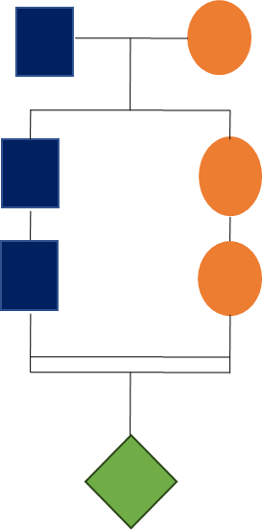 | Type: Patrilateral cross cousins (PC)  Fa = 1/16 (0.0625)  Autozygosity among autosomes = 6.25%  Fs = 0 (0)  Autozygosity among sex-chromosomes = 0
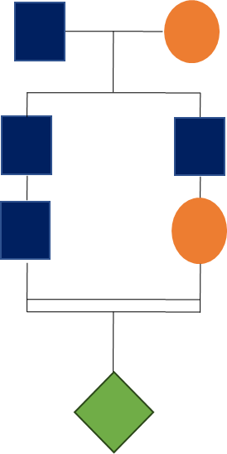 | Type: Patrilateral parallel cousins or patrilateral ortho-cousins (PP or PO)  Fa = 1/16 (0.0625)  Autozygosity among autosomes = 6.25%  Fs = 0 (0)  Autozygosity among sex-chromosomes = 0
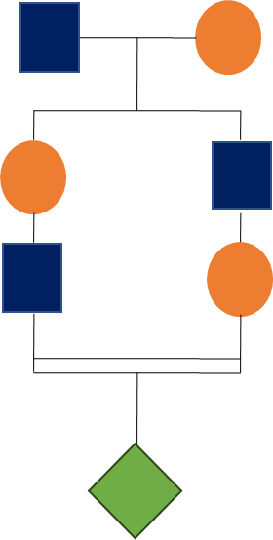 | Type: Matrilateral cross cousins (MC)  Fa = 1/16 (0.0625)  Autozygosity among autosomes = 6.25%  Fs = 1/8 (0.125)  Autozygosity among sex-chromosomes = 12.5%
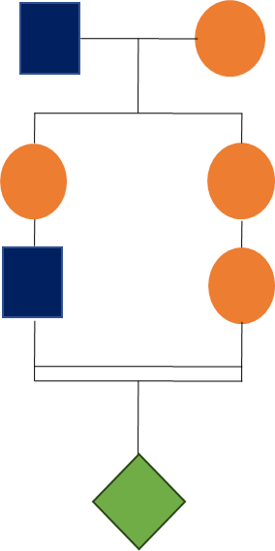 | Type: Matrilateral parallel cousins or matrilateral ortho-cousin (MP or MO)  Fa = 1/16 (0.0625)  Autozygosity among autosomes = 6.25%  Fs = 3/16 (0.1875)  Autozygosity among sex-chromosomes = 18.75%

