Supplementary Figure S1 – Number of heat wave days during summer 2023 for each department
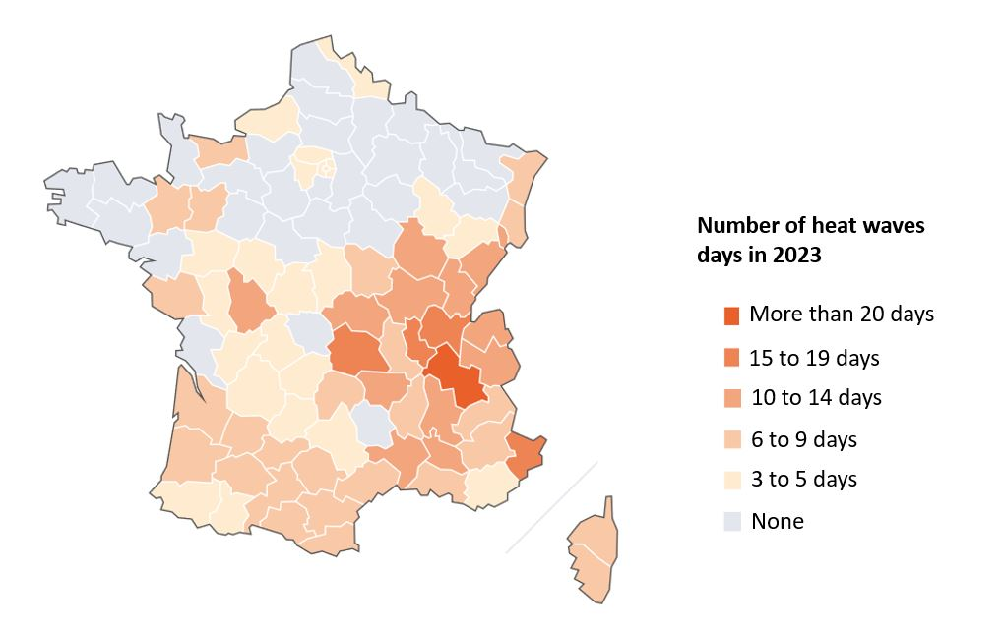

Supplementary Table S1 – AIC for the different models
 | 2014-2022 |  | 2020-2022
Covid-19 indicators | all ages | over 75 years old | all ages | over 75 years old
without | 519 705 | 482 070 | 172 187 | 160 259
binary pandemic indicator | 519 788 | 482 166 | n.c | n.c
daily number of hospital deaths | 519 785 | 482 155 | 172 269 | 160 348
daily number of hospitalizations | 519 790 | 482 169 | 172 268 | 160 364
daily number of hospitalizations with 0-7 days of lag | 519 788 | 482 151 | 172 276 | 160 347
daily number of hospitalizations with 0-14 days of lag | 519 784 | 482 148 | 172 277 | 160 348
daily incidence rate | 519 771 | 482 126 | 172 274 | 160 336
daily incidence rate with 0-7 days of lag | 519 758 | 482 122 | 172 270 | 160 335
daily incidence rate with 0-14 days of lag | 519 739 | 482 107 | 172 250 | 160 315

