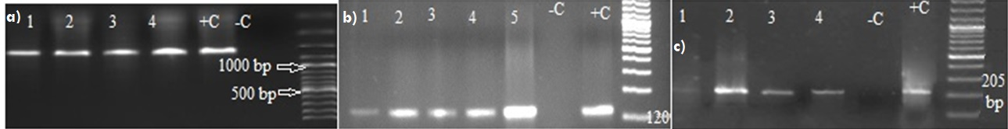
Supplementary Figure 1. Nested PCR results, a) indicating the 1100 bp product size of the 18sRNA gene of genus Plasmodium, b) revealing the 120 bp product size of the 18sRNA gene of genus P. vivax, c) showing the 205 bp product size of 18sRNA gene of genus P. falciparum; Lane 1-5 indicating sample amplification while +C = positive control; -C = negative control

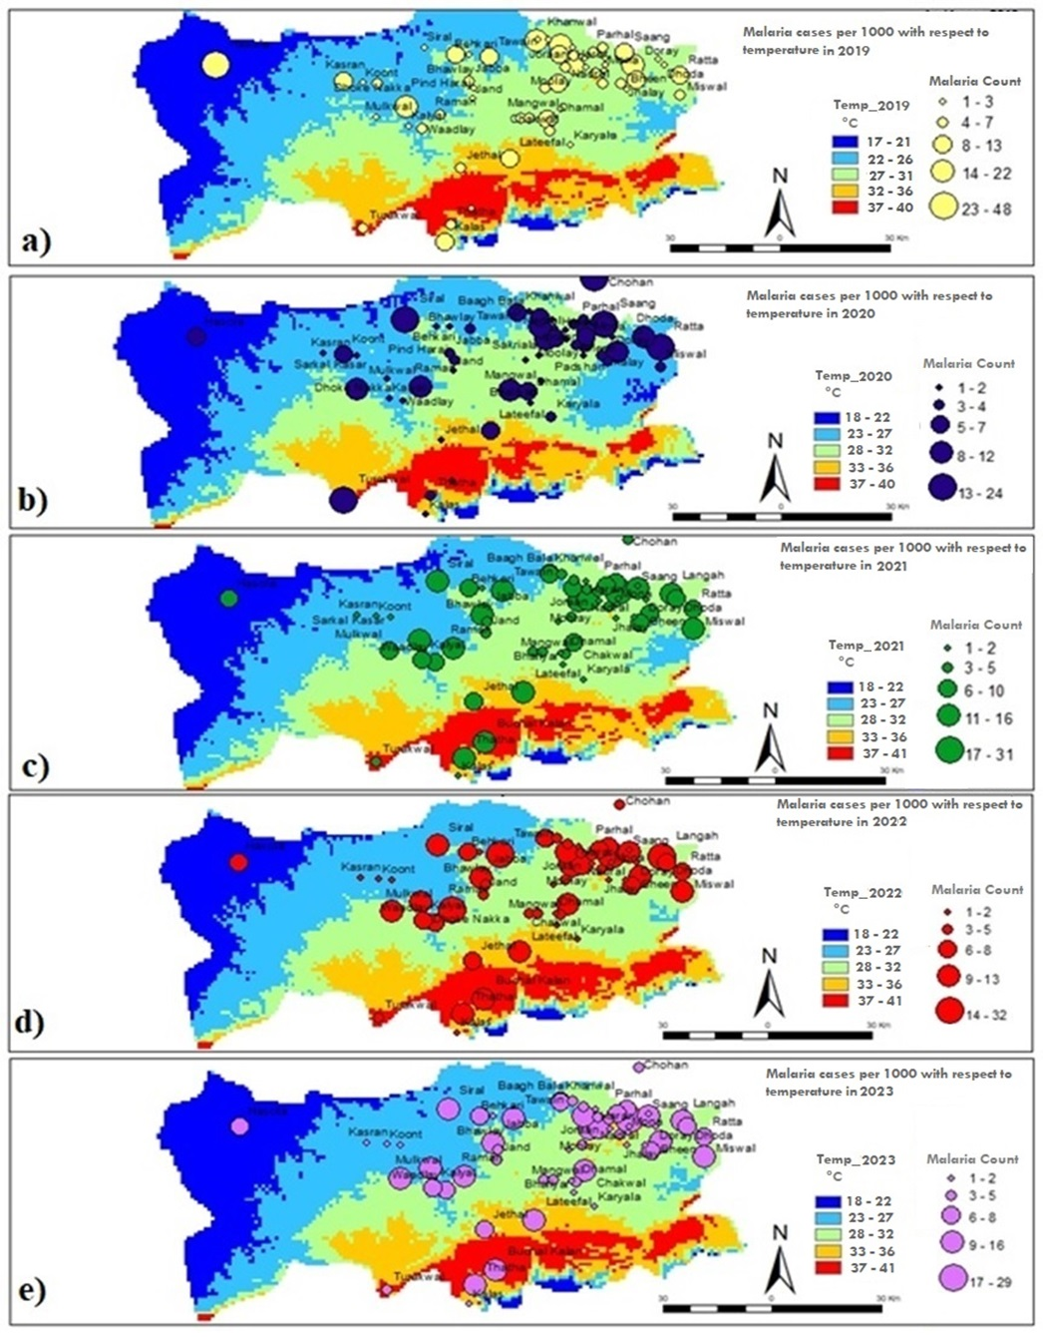
Supplementary Figure 2. The malaria distribution across Chakwal to temperature for five years; a) 2019, b) 2020, c) 2021, d) 2022 and e) 2023.
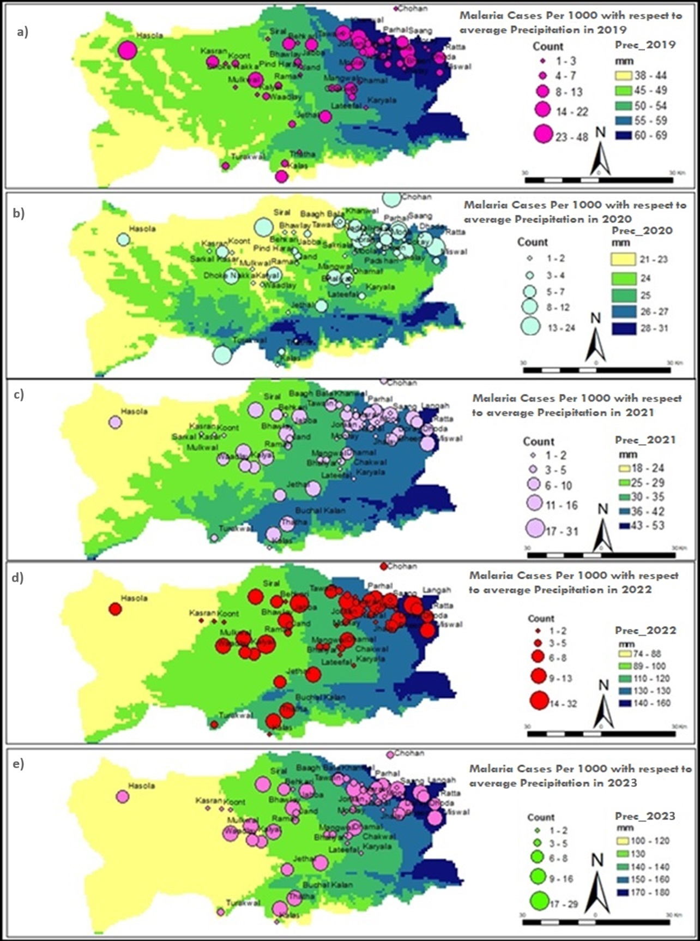
Supplementary Figure 3. The malaria distribution across Chakwal to precipitation for five years; a) 2019, b) 2020, c) 2021, d) 2022 and e) 2023.

