Appendices

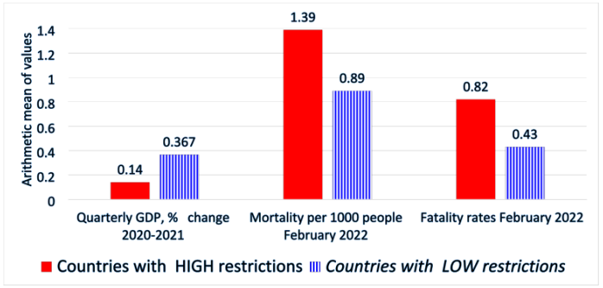
Figure 1. Comparison of health and economic metrics between nations with and without significant COVID-10 limitations

Appendix B. Stringency Index
A composite measure of nine response measures, known as the Stringency Index, is computed by the Oxford Coronavirus Government Response Tracker (OxCGRT) project. OxCGRT gathers data on government response indicators that is accessible to the public. These indicators use an ordinal scale to capture restrictions like travel bans and school closures. Financial indicators, such as monetary or fiscal policies, make up the remaining portion. Using its COVID-19 Government Response Stringency Index, OxCGRT quantifies the variation in governments' replies. Rescaled to range from 0 to 100, this composite measure is a simple additive score of nine indications measured on an ordinal scale. Please be aware that this score should not be construed as a judgment of the suitability or efficacy of a nation's response, but rather as a tool for comparison. 'COVID-19 Containment and Health Response' index (Hale et al., 2021; Stringency Index 2022). It is based on the same criteria as the 'Stringency Index' and incorporates testing policy, contact tracing, face coverings, and vaccine policy.

The specific policy and response categories are coded as follows:

School closures:
0 - No measures
1 - recommend closing
2 - Require closing (only some levels or categories,
e.g., just high school, or just public schools)
3 - Require closing all levels
No data - blank

Workplace closures:
0 - No measures
1 - recommend closing (or work from home)
2 - require closing (or work from home) for some
sectors or categories of workers
3 - require closing (or work from home) all but essential workplaces (e.g., grocery stores, doctors)
No data - blank

Cancel public events:
0- No measures
1 - Recommend cancelling
2 - Require cancelling
No data - blank

Restrictions on gatherings:
0 - No restrictions
1 - Restrictions on very large gatherings (the limit is above 1,000 people)
2 - Restrictions on gatherings between 100-1,000 people
3 - Restrictions on gatherings between 10-100 people
4 - Restrictions on gatherings of less than 10 people
No data - blank

Close public transport:
0 - No measures
1 - Recommend closing (or significantly reduce volume/route/means of transport available)
2 - Require closing (or prohibit most citizens from using it)

Public information campaigns:
0 -No COVID-19 public information campaign
1 - public officials urging caution about COVID-19
2 - coordinated public information campaign (e.g., across traditional and social media)
No data - blank

Stay at home:
0 - No measures
1 - recommend not leaving house
2 - require not leaving house with exceptions for daily exercise, grocery shopping, and ‘essential’ trips
3 - Require not leaving house with minimal exceptions (e.g., allowed to leave only once every few days, or only one person can leave at a time, etc.)
No data - blank

Restrictions on internal movement:
0 - No measures
1 - Recommend movement restriction
2 - Restrict movement

International travel controls:
0 - No measures
1 - Screening
2 - Quarantine arrivals from high-risk regions
3 - Ban on high-risk regions
4 - Total border closure
No data - blank

Testing policy
0 – No testing policy
1 – Only those who both (a) have symptoms AND (b) meet specific criteria (e.g., key workers, admitted to hospital, came into contact with a known case, returned from overseas)
2 – testing of anyone showing COVID-19 symptoms
3 – open public testing (e.g., “drive through” testing available to asymptomatic people)
No data

Contract tracing
0 - No contact tracing
1 - Limited contact tracing - not done for all cases
2 - Comprehensive contact tracing - done for all cases
No data

Face coverings
0- No policy
1- Recommended
2- Required in some specified shared/public spaces outside the home with other people present, or some situations when social distancing not possible
3- Required in all shared/public spaces outside the home with other people present or all situations when social distancing not possible
4- Required outside the home at all times, regardless of location or presence of other people

Vaccination policy
0 - No availability
1 - Availability for ONE of the following: key workers/ clinically vulnerable groups / elderly groups
2 - Availability for TWO of the following: key workers/ clinically vulnerable groups / elderly groups
3 - Availability for ALL the following: key workers/ clinically vulnerable groups / elderly groups
4 - Availability for all three, plus partial additional availability (select broad groups/ages)
5 - Universal availability

