Supplementary materials - Citizens’ initiative for connected healthcare

S1

Table 1. Topics as were used to guide the interviews with stakeholders

Topics
Preparation: discover in which way the orientation on the model had taken place, who were involved in the preparation, and why/what did the participant find interesting and what not.
Motivation: how and why was the participant was involved with Make the Citizen a Master.
Underlying principles: discover what, according to the participant, were the principles and unicity of the Esbjerg model / Make the Citizen a Master
Background of the implementation of Make the Village a Master: discover what is, according to the participant, the cause/reasons to start the pilot. And why it is situated in that village.
Goals: discover what, according to the participants, were the goals, the outcomes, and the desired results. When could the pilot be considered a success?
Decision making process: explore how the participants viewed the decision making process leading up to the pilot. What happened and why? What went well and what should have been done differently?
Decision: how was the model presented to the parties involved, what decision was made, what did they think of that, and which advice was given by the participants.
Execution: which steps and choices were essential during the design and execution of the pilot; who were involved in its execution?
Key figures/parties: who were essential to establishing or executing the pilot? Who are, generally speaking, viewed as important in these processes? What is the role of the general practitioner?
Involving other people: the degree in which other stakeholders besides politicians and initiators were informed about the model, and their level of involvement in the decision or execution processes; what were the results of this.
Collaboration: how did the collaboration between key participants proceed and why?
Benefits/drawbacks of the model: what are the potential benefits and drawbacks of this pilot?
Pitfalls: what could be the pitfalls or weak spots of this model?

S2

Table 1. Themes, categories and codes as established during open and thematic coding of verbatim transcripts of interviews with stakeholders of the CI-municipal cocreation process.

Theme | Category | Codes
Reason for CI | Need for change | Need for change due to leaving services;  Need for change due to individualization of society;  Need for change due to aging population;  Current system compensates loss of function but hampers function recovery;  Ideas about recovery are seen as austerity measures.
Reason for CI | Desired by the citizens | Goal is well-being and happiness in life for the citizens  Citizens want a location close by where healthcare and welfare work together  Goal is fighting loneliness  Being active recovers and maintains vitality and independence  Connecting formal care with caring for each other  Making contact discover the real question for help;  Goal is insight in and connecting with living world of citizens;  Reason for getting up in the morning  Goal is living independently at home longer  Need for the right people at the right place;  Citizens and municipality collaborating as equals feels good
Reason for CI | Collaboration civil servants and citizens | Municipality wants capabilities to offer recovery of function  Collaboration between municipality and citizens can take many forms  Collaboration policy making civil servants and citizens aids design  Municipality wants citizens to design the initiative themselves  Resistance of policy making civil servants towards change  Policy making civil servants do not consult citizens  Knowing what the citizens want is necessary  Municipality workers and professionals need to go to the citizens
Reason for CI | Importance of the collaboration of professionals and citizens | Professionals work past each other which limits organization and clarity  Connecting professionals to collaborate with each other  Collaborating for a fitting, all-encompassing approach  Connected care provides better care  Being open to new ideas from other people is necessary  Necessary in a collaboration to know each other’s capabilities  Collaboration needs to be achievable and should provide added value  Municipality wants capabilities to offer recovery of function  Satisfaction citizens and professionals are essential for success  Key figures are active networkers  Current (financial) system hampers collaboration between healthcare and welfare  Desire to collaborate with primary care  Asking professionals to join is also possible at a later timepoint  Initial choice in collaboration encompasses social neighbourhood team/welfare workers/volunteers
Ability to change | Willingness to change | Key figures are active networkers  Working differently to save on money and support  Shared interest is needed  Collaboration according to jointly presented vision and method  Change needs to be thought of as necessary  Financing guides possibilities for change in care  Welfare organization competes with initiative  Resistance of professionals towards change  Change in the Netherlands is possible if you know who to go to  Working differently also asks for releasing control  Fear to be the cause that the pilot fails  If you do not try out new initiatives you will not learn anything
Ability to change | Internal working process of municipal office | Policy making civil servant reviews achievability of plans  Municipality has a duty of care towards its citizens  Municipality wants ownership and control  Ideas about recovery in the model corresponds to the guiding principles of the WMO  Municipality needs to support and steer  Municipality can co-create  Resistance of policy making civil servants towards change  Policy making civil servants are standing between politicians and citizens  Policy making civil servants can hinder politicians  Citizens are confronted by an opaque way of working and decision making of the municipality  Municipality did not adequately define the tasks of social neighbourhood teams  Consulting everyone hinders decision making  Ideas about recovery are seen as austerity measures  Pitfall is looking too much for financial results
Decision making | Decision making | Key figures are active networkers  Initiators of CI’s need political support  Politicians establish frameworks  Decision-making in the municipality is top-down  Municipality workers want a clear assignment for politicians  Political pressure and motions influence the ultimate decision  Political processes require time and enthusiasm and influence the content  Selecting fitting parts of the model  Collaboration according to jointly presented vision and method
Implementing the CI | Commitment | Getting inspired together gives energy  Expert enthuses and trains in philosophy  Trust in each other’s capabilities is needed  Required for success are involved citizens  Leading characters to persevere  Time investment could deter volunteers and initiators  Flexibility of the pilot is needed
Implementing the CI | Work process | Policy making civil servants organize execution of policy  Way of working aligns with positive health philosophy  Embedding philosophy is essential  Philosophy fades during process  Commitment to way of working asks persuasion of all those involved  Tuning way of working with all those involved  New way of working demands learning to think and work differently  All participants jointly learn a new language and way of working  Time, money and space needed for the change process and alignment  Collaboration according to jointly presented vision and method  Collaborating for a fitting, all-encompassing approach  Way of working needs to be known and used
Implementing the CI | Risk | Citizens do not think in domains  With informal care privacy is under pressure  Vulnerability relying on volunteers  Execution needs to be independent of individual persons  Wanting to be independent of volunteers  Vulnerable citizens also should be able to keep up  Living at home longer also has disadvantages
Overarching factors of importance | Social capital | Citizens want ownership of healthcare and welfare  Citizens want to contribute to their living environment with each other  Connecting citizens that solve health questions with each other  Digital citizen platform facilitates social capital  Seeking connection with existing initiatives and networks  Social capital is not essential at the start  Social capital contributes to vitality, well-being and activity  Care for each other has a low threshold and is effective  Citizens have other capabilities that the municipality or professionals  Consulting everyone hinders decision making
Overarching factors of importance | Implementation of the role of the citizens | Vision that citizens get and remain in control  Citizens stand for their initiative  Initiators willing to find a different partner  Citizens need to be able to present plans to the municipality  CI may fail  Sharing control between citizens and professionals  Citizens are confronted by an opaque way of working and decision making of the municipality  Capable and decisive core teams needs to represent citizens  Involvement in CI gives status  Tempting and supporting citizens to help themselves and other
Overarching factors of importance | Communication | Citizens and municipality speak a different language  Initiators need to speak the municipalities language  Contrasts in perspectives within municipality office  Communication from the municipality should be in understandable language  All participants jointly learn a new language and way of working  Coordinating facilitator could help
Overarching factors of importance | Scale | Citizens want a location close by where healthcare and welfare work together  Pilot in a socially active village  Pilot on a small scale is helpful  Picking the right scale  The right care at the right place
Overarching factors of importance | To measure is to know | Scientific underpinning is needed  Goals of the pilot need to be testable  How to evaluate a transition pilot

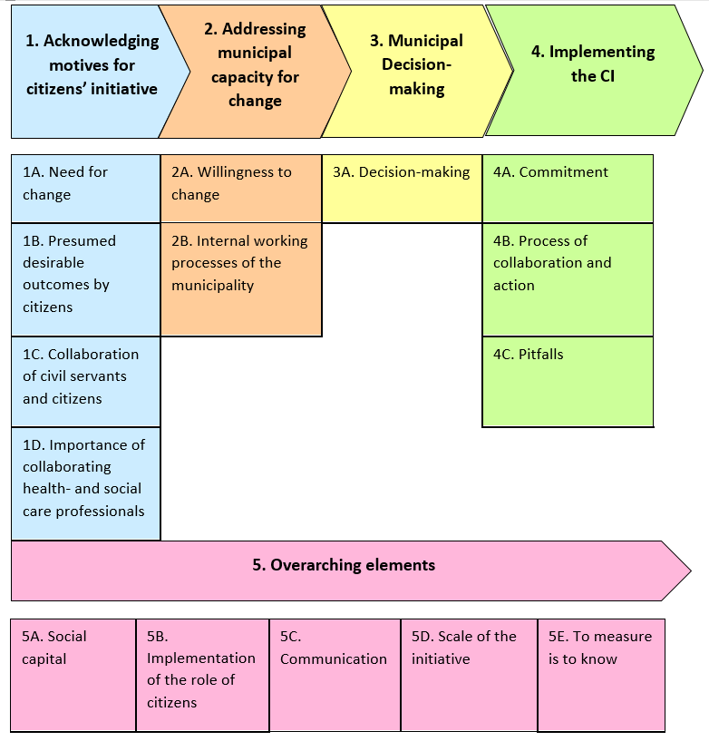
Figure S1: Phases and corresponding categories of elements deemed important when establishing a cocreation initiative between a CI and municipality; as arranged by the peer group during the analysis process.

