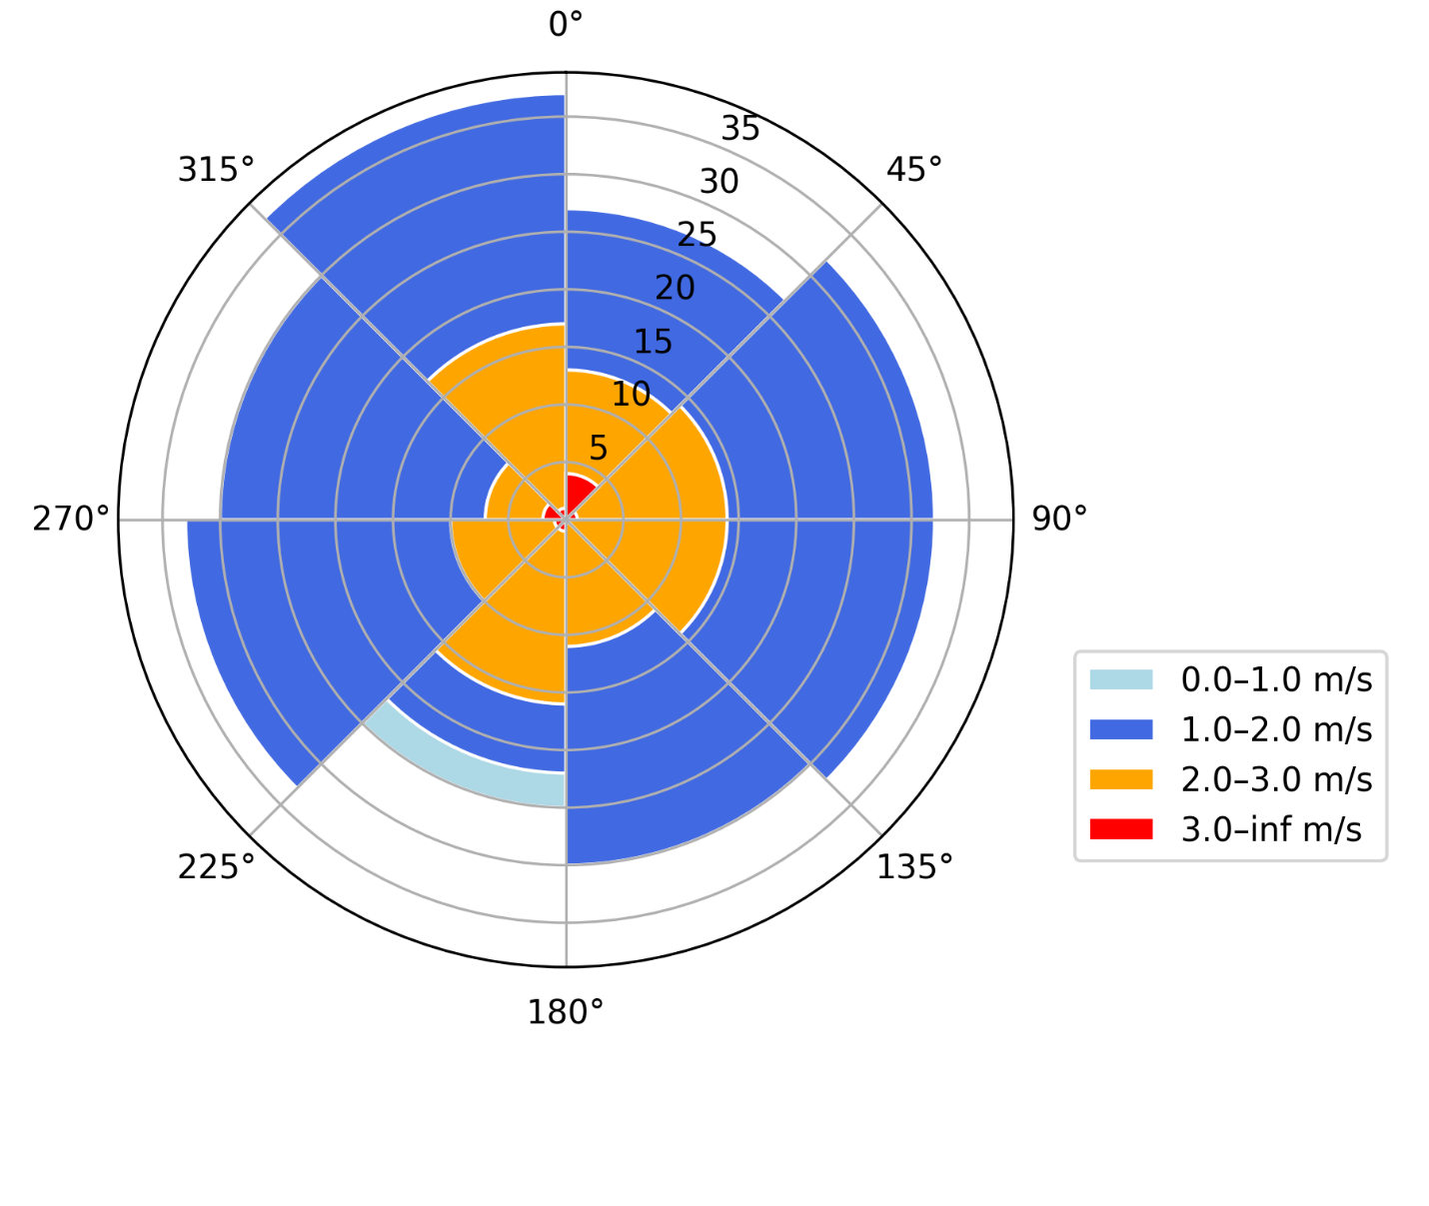

Figure S2 – Site-specific wind-rose diagrams showing wind speed and direction.

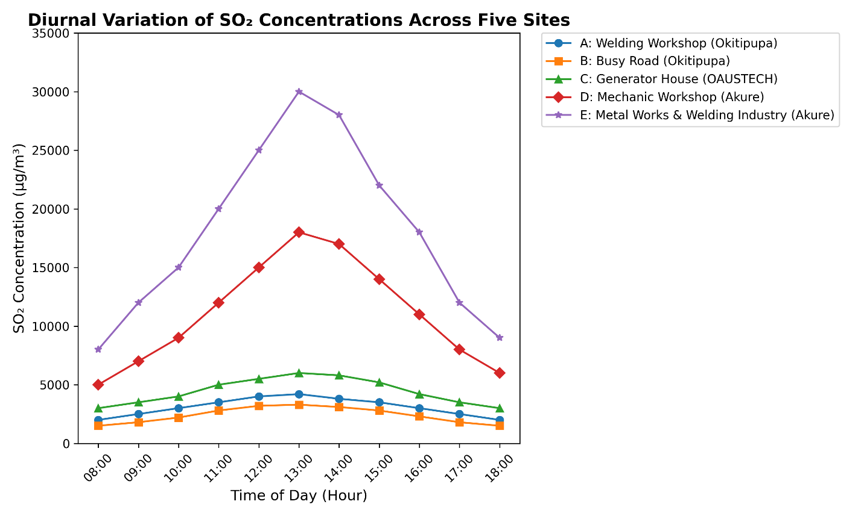
Figure S1 – Diurnal variation plots of hourly SO₂ averages (08:00–18:00) for all sites, highlighting midday peaks linked to industrial activity.

Table S1. Geographic coordinates of five atmospheric SO₂ sampling locations in Akure and Okitipupa, Ondo State, Nigeria
LOCATION | Welding Workshop (Okitipupa) | Busy Road (Okitipupa) | Generator House  (OAUSTECH, Okitipupa) | Mechanic workshop (Akure, Ondo state) | Metal works and Welding Industry (Akure, Ondo State)
ONDO | 6.4837651°N  4.7854981°E | 6.45206°N  4.76821°E | 6.4593024°N  4.7648048°E | 7.2492631°N  5.2019241°E | 7.2734944°N  5.1606419°E

Table S2: Spatial comparison of SO₂ and meteorological parameters
 | A | B | C | D | E | p
SO₂ (µg/m³) | 6,708 ± 1,274a | 4,940 ± 546b | 3,640 ± 676c | 5,902 ± 468ab | 30,368 ± 6,500d | 0.000
Temperature (K) | 33.17 ± 0.75a | 29.00 ± 0.89c | 34.17 ± 0.75a | 30.50 ± 1.64b | 33.50 ± 2.43ab | 0.000
Wind Speed (m/s) | 1.65 ± 0.10ab | 1.62 ± 0.15ab | 1.67 ± 0.20ab | 2.18 ± 0.44b | 1.85 ± 0.44ab | 0.019
Humidity (%) | 65.33 ± 1.21ab | 75.67 ± 1.21b | 78.67 ± 1.75b | 76.33 ± 1.97b | 85.67 ± 2.58c | 0.000
A - Welding Workshop (Okitipupa), B - Busy Road (Okitipupa), C - Generator House (OAUSTECH, Okitipupa), D - Mechanic workshop (Akure, Ondo state), E - Metal works and Welding Industry (Akure, Ondo State)

Table S3: Seasonal variation of SO₂ and meteorological parameters
 | Wet | Dry | T | p
SO₂ | 3.77±3.96 | 4.17±4.34 | -0.264 | 0.794
Temperature | 31.20±2.27 | 32.93±2.31 | -2.069 | 0.048
Windspeed | 1.88±0.36 | 1.71±0.34 | 1.356 | 0.186
Humidity | 75.00±6.55 | 77.67±7.14 | -1.066 | 0.295
Table S4: Regression analysis predicting SO₂ concentration
 | B | SE | β | t | P
(Constant) | -35.443 | 11.446 | 1.521 | -3.096 | 0.005
Temperature | 0.325 | 0.291 | 0.193 | 1.119 | 0.273
Wind speed | 2.378 | 1.941 | 0.207 | 1.225 | 0.232
Humidity | 0.324 | 0.094 | 0.544 | 3.446 | 0.002

Table S5: Correlation between SO₂ and meteorological parameters
 | SO₂ | Temperature | Windspeed | Humidity
SO₂ | 1 | 0.228 | 0.179 | 0.606
Temperature | 0.228 | 1 | -0.409* | 0.221
Windspeed | 0.179 | -0.409* | 1 | 0.094
Humidity | 0.606 | 0.221 | 0.094 | 1

Table S6. Sampling schedule and duration for SO₂ monitoring at five locations in Akure and Okitipupa, Nigeria
Location | Sampling Dates | Daily Time Window | Duration (hours/day) | Total Days | Instrument Used
A | Dec 10–20, 2024 | 8:00 AM – 6:00 PM | 10 | 11 | NORM Gas Detector
B | Dec 11–21, 2024 | 8:00 AM – 6:00 PM | 10 | 11 | NORM Gas Detector
C | Dec 12–22, 2024 | 8:00 AM – 6:00 PM | 10 | 11 | NORM Gas Detector
D | Jan 5–15, 2025 | 8:00 AM – 6:00 PM | 10 | 11 | NORM Gas Detector
E | Jan 6–16, 2025 | 8:00 AM – 6:00 PM | 10 | 11 | NORM Gas Detector

Table S7: Exposure Parameters Used in Health Risk Assessment

Parameter | Symbol | Children Value | Adult Value | Unit | Source
Exposure Frequency | EF | 350 | 350 | days/year | US EPA, 2011
Exposure Duration | ED | 6 | 24 | years | Assumed
Body Weight | BW | 15 | 70 | kg | US EPA, 2011
Inhalation Rate | IR | 9.9 | 16.8 | m³/day | US EPA, 2011
Skin Surface Area | SA | 2,390 | 18,150 | cm² | US EPA, 2011
Adherence Factor | AF | 0.2 | 0.2 | mg/cm²/day | US EPA, 2011
Absorption Factor (dermal) | ABS | 0.03 | 0.03 | unitless | US EPA, 2004
Particle Emission Factor | PEF | 1.36×10⁹ | 1.36×10⁹ | m³/kg | US EPA, 2011
Average Time (non-cancer) | AT | 2,190 | 8,760 | days | ED × 365
Slope Factor (SFO) | SFO | Not applied | Not applied | mg/kg/day | Removed (SO₂ not carcinogen)

