Supplementary Table 1: State-wise Distribution of Participants
State | Recovered Individuals (n) | Community Members (n) | Total (N)
Assam | 12 | 21 | 33
Delhi | 10 | 19 | 29
Madhya Pradesh | 14 | 20 | 34
Maharashtra | 9 | 19 | 28
Odisha | 11 | 17 | 28
Tamil Nadu | 16 | 21 | 37
Uttar Pradesh | 15 | 19 | 34
Total | 87 | 136 | 223

Supplementary Figure 1: Coding tree for thematic analysis of the Community Respondents

Major Themes

Sub Themes
Codes

Supplementary Figure 2: Coding tree for thematic analysis of the Recovered respondents.
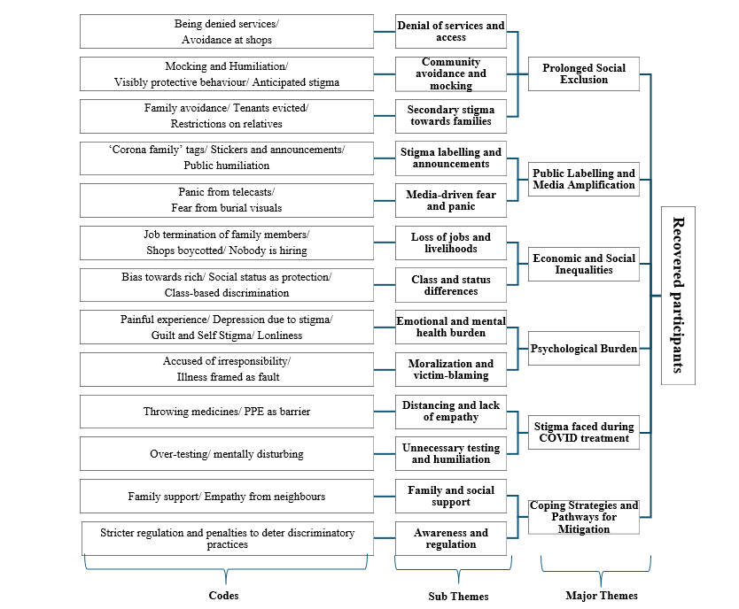

Supplementary Table 2. Codes, themes, and illustrative narratives from semi-structured interviews with community members (n=136) and recovered COVID-19 participants (n=87) in India
Domain (Theme) | Codes | Sub-themes | Qualitative narratives | Cohort / Participants
Fear → Moralisation | Avoidance; suspicion; blame; anticipated stigma | From fear of contagion to moral judgement and blame | Community: “Even if you’ve recovered, people avoid you… who knows whether you are fully recovered?” (Male, 35, Maharashtra).  “Our colony association head has stopped allowing vegetable vendors and maids.” (Female, 59, Tamil Nadu).  Recovered: “There were marriage invitations… but we refused them, thinking people would judge us.” (Female, 52, Delhi). | Community N=29  Recovered N=44
Institutional Labelling & Surveillance | Stigma labelling; surveillance; public marking | Official measures amplify stigma | Community: “Stickers and barricades made people talk about us.” (Male, 28, Tamil Nadu).  “They put up stickers at home… people started panicking.” (Male, 28, Tamil Nadu).  Recovered: “Officials came; people started calling us ‘corona family’.” (Male, 42, Tamil Nadu). | Community N=17  Recovered N=15
Structural Inequalities | Class bias; occupation; religion; poverty | Unequal burden of stigma | Community: “Vendors and maids were not allowed back…” (Female, 59, Tamil Nadu).  Recovered: “No one took vegetables from their shop.” (Odisha respondent).  “I was terminated from my job after my father’s positive status.” (Male, 54, MP).  “Muslim ladies… stopped from domestic work.” (Female, 32, MP). | Community N=9  Recovered N=22
Economic & Psychological Harms | Job loss; depression; anxiety; guilt; non-disclosure | Long-term consequences beyond infection | Community: “People get depressed… society may not accept them.” (Male, 52, Delhi).  Recovered: “I felt guilty my son got COVID because of me.” (Female, Tamil Nadu).  “Even after recovery, people were afraid to drink tea at my stall.” (Male, 48, MP).  “Those times were very painful… I was depressed and upset.” (Female, 25, Odisha). | Community N=16  Recovered N=37
Healthcare Stigma | Cold treatment; exaggerated distancing; unnecessary tests | Negative interactions in health-care settings | Community: “Notices with photos of positive cases were displayed, creating a marker of danger.” (Male, 35, Maharashtra).  Recovered: “They threw medicines from a distance.” (Female, 25, Assam).  “They did unnecessary tests; I wanted to leave.” (Male, 38, Delhi). | Community N=18  Recovered N=9
Coping & Mitigation Pathways | Family support; informal solidarity; ASHA/Anganwadi mediation; positive messaging | Coping mechanisms & stigma reduction strategies | Recovered: “My parents were very supportive… they asked me not to worry about community behaviour.” (Male, 30, Assam).  “Family support helped me ignore gossip.” (Tamil Nadu respondent).  Community: “ASHA didis and Anganwadi workers should create awareness, so people don’t discriminate.” (Male, 28, Odisha).  “Media should spread positive stories, not fear.” (Female, 32, Odisha). | Community N=27  Recovered N=22

