Supplementary Materials
Supplementary material A: Detailed Search Strings
The following search strings were used for each database:
PubMed: (“malaria” [MeSH Terms] AND “vector control” [MeSH Terms] AND (“multi-active” OR “dual-active” OR “combination”) AND (“long-lasting insecticidal nets” OR “insecticide-treated nets”) AND (“Africa” OR “sub-Saharan Africa”))
Web of Science: TS= (malaria AND vector control AND (“multi-active” OR “dual-active” OR combination) AND (“insecticide-treated nets” OR “long-lasting insecticidal nets”) AND (Africa OR “sub-Saharan Africa”))
Cochrane Library: (malaria AND “vector control” AND (“dual-active” OR “multi-active” OR combination) AND Africa)
Google Scholar: “malaria” AND “vector control” AND (“dual-active” OR “multi-active” OR “combination”) AND “Africa”
Supplementary Table 1. Summary of included studies assessing the impact of multi-active ingredient (MAI) long-lasting insecticidal nets (LLINs) on malaria vector density, sporozoite rate, and entomological inoculation rate (EIR) in sub-Saharan Africa
Author (Year) | Country / Study Area | Study Design | Intervention Groups | Sample Size / Households | Mean Indoor Vector Density (per household per night) | Sporozoite Rate (% positive mosquitoes) | Mean EIR (per household per night) | Main Observations
Mosha et al. (2021) | Tanzania (61,183 households) | Cluster-randomised trial | Pyrethroid-only; Pyriproxyfen–Pyrethroid; Chlorfenapyr–Pyrethroid; Piperonyl butoxide–Pyrethroid | 331 households analysed | Pyrethroid-only: 5.9 (0.7–11.1); Pyriproxyfen: 4.2 (0.8–7.0); Chlorfenapyr: 2.8 (0.0–6.0); PBO: 1.9 (0.4–3.4) | Pyrethroid-only: 4.4%; Pyriproxyfen: 3.3%; Chlorfenapyr: 2.2%; PBO: 3.0% | Pyrethroid-only: 0.35; Pyriproxyfen: 0.11; Chlorfenapyr: 0.04; PBO: 0.07 | Dual-active LLINs reduced vector density and EIR compared with pyrethroid-only nets, with chlorfenapyr and PBO showing the greatest reductions.
Mosha et al. (2024) | Tanzania (same sites, longitudinal follow-up) | Cluster-randomised trial | Same intervention groups as above | Same study population | Similar values observed across all intervention arms in the 2021 study | Similar to the previous year | Similar to the previous year | Results consistent with 2021; dual-active LLINs maintained lower vector density and EIR across years.
Accrombessi et al. (2023) | Benin (multi-district community trial) | Cluster-randomised controlled trial | Pyrethroid-only; Pyriproxyfen–Pyrethroid; Chlorfenapyr–Pyrethroid | Not reported (large-scale clusters) | Pyrethroid-only: 22.5 (9.5–40.5); Pyriproxyfen: 25.5 (13.5–43.5); Chlorfenapyr: 14.0 (7.0–29.5) | Not reported | Pyrethroid-only: 0.96 (0.43–1.49); Pyriproxyfen: 0.62 (0.20–1.04); Chlorfenapyr: 0.48 (0.19–0.77) | Chlorfenapyr–pyrethroid LLINs showed lower vector density and EIR compared with pyrethroid-only and pyriproxyfen nets.
Matowo et al. (2023) | Tanzania (670 households) | Cluster trial | Pyrethroid-only; Pyriproxyfen–Pyrethroid; Chlorfenapyr–Pyrethroid; PBO–Pyrethroid | 670 households | Pyrethroid-only: 2.0; Pyriproxyfen: 0.8; Chlorfenapyr: 0.2; PBO: 0.5 | Pyrethroid-only: 2.4%; Pyriproxyfen: 1.8%; Chlorfenapyr: 1.6%; PBO: 2.6% | Pyrethroid-only: 0.5; Pyriproxyfen: 0.4; Chlorfenapyr: 0.5; PBO: 0.3 | Dual-active nets showed reduced vector density and sporozoite rates compared with pyrethroid-only nets; PBO nets achieved the lowest EIR.
Supplementary Table 2: Malaria Prevalence showing Intention-to-treat analysis of Selected Studies
Intervention Group |  | Intention-To-Treat Analysis | aOR (95% CI) | P-value | Author, Year
Pyrethroid Group |  | 43.1% | 1 (ref*) | N/D | (25)
 |  | 45.2% | 1 (ref) | N/D | (26)
 |  | 26.2% | 1 (ref) | N/D | (27)
 |  | N/D | 1 (ref) | N/D | (28)
Pyriproxyfen group |  | 36.6% | 0.82 (0.54-1.17) | 0.4097 | (25)
 |  | 35.6% | 0.78 (0.55-1.23) | 0.23 | (26)
 |  | 28.4% | 1.12 (0.78-1.61) | 0.55 | (27)
 |  | N/D | 0.71 (0.47-1.12) | 0.28 | (28)
Chlorfenapyr group |  | 27.3% | 0.53 (0.30-0.67) | 0.0123 | (25)
 |  | 32.3% | 0.63 (0.38-0.86) | 0.038 | (26)
 |  | 22.5% | 0.82 (0.57-1.19) | 0.33 | (27)
 |  | N/D | 0.23 (0.17-0.41) | <0·0001 | (28)
Piperonylbutoxide  group |  | 34.4% | 0.80 (0.67-1.45) | 0.3909 | (25)
 |  | 40.7% | 0.97 (0.64-1.42) | 0.89 | (26)
 |  | N/D | 0.48 (0.32-0.76) | 0.043 | (28)
N/D=Not Determined, aOR (Adjusted Odds Ratio), Cl=Confidence Interval
Supplementary Table 3: Malaria Prevalence showing Per-protocol analysis of Selected Studies
Intervention Group | Per-Protocol analysis | aOR (95% CI) | P-value | Author, Year
Pyrethroid Group | 41.5% | 1 (ref) | N/D | (25)
 | 41.6% | 1 (ref) | N/D | (26)
 | N/D | 1 (ref) | N/D | (28)
Pyriproxyfen group | 32.9% | 0.70 (0.45-1.13) | 0.1808 | (25)
 | 31.8% | 0.66 (0.45-1.32) | 0.18 | (26)
 | N/D | 0.89 (0.60-1.34) | 0.52 | (28)
Chlorfenapyr group | 25.2% | 0.49 (0.25-0.67) | 0.1277 | (25)
 | 26.6% | 0.51 (0.30-0.83) | 0.006 | (26)
 | N/D | 0.83 (0.55-1.25) | 0.54 | (28)
Piperonylbutoxide  Group | 33.4% | 0.82 (0.60-1.55) | 0.4307 | (25)
 | 37.1% | 0.88 (0.40-1.25) | 0.55 | (26)
 | N/D | 0.76 (0.50-1.12) | 0.26 | (28)

a.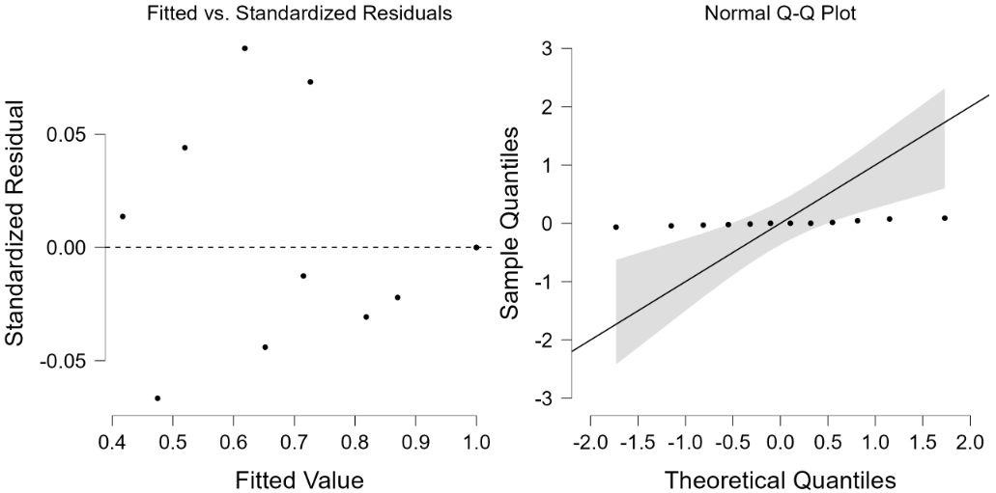
Supplementary Figure 1 (a) Diagnostic plot showing both the fitted vs. standardised residuals and normal Q-Q plot of MAI vs. SAI.
a.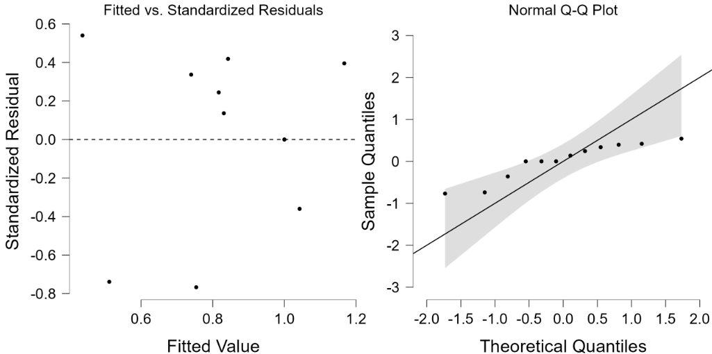
Supplementary Figure 2 (a) Diagnostic plot showing both the fitted vs standardised residuals and standard Q-Q plot of MAI vs. SAI

a.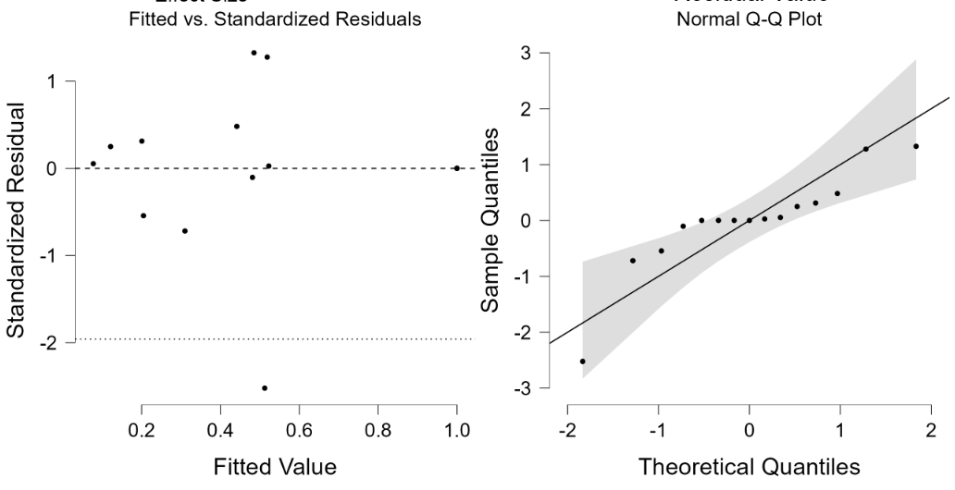
Supplementary Figure 3 (a) Diagnostic plot showing both the fitted vs. standardised residuals and normal Q-Q plot of MAI vs. SAI
- 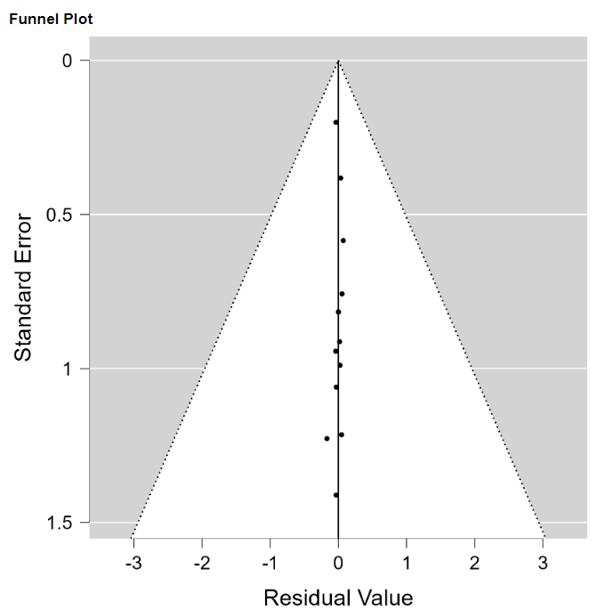
c.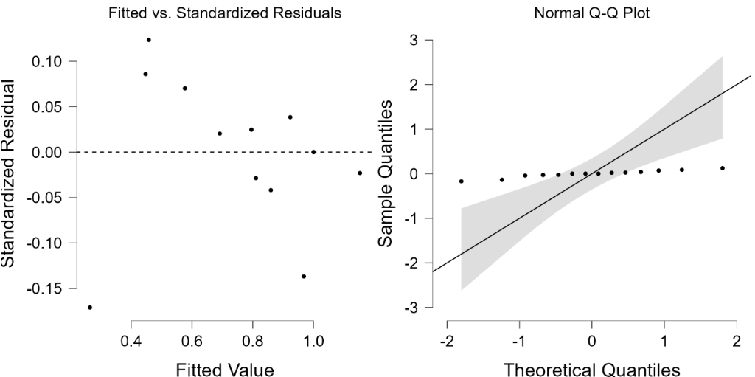
Supplementary Figure 4 (a) and (b) Forest and funnel plots showing MAI vs SAI contrast in Intention-to-treat analysis, (c) Diagnostic plot showing both the fitted vs standardized residuals and normal Q-Q plot of MAI vs SAI.
a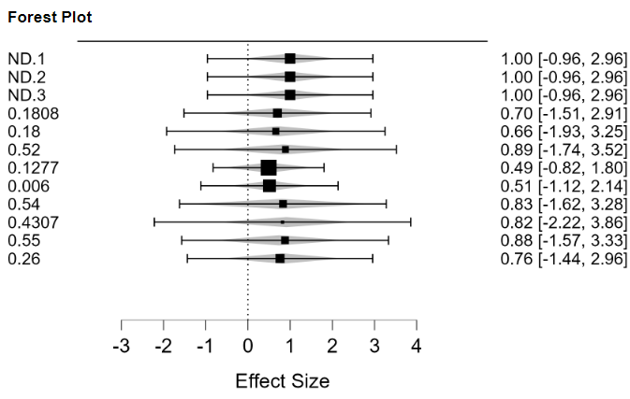.b.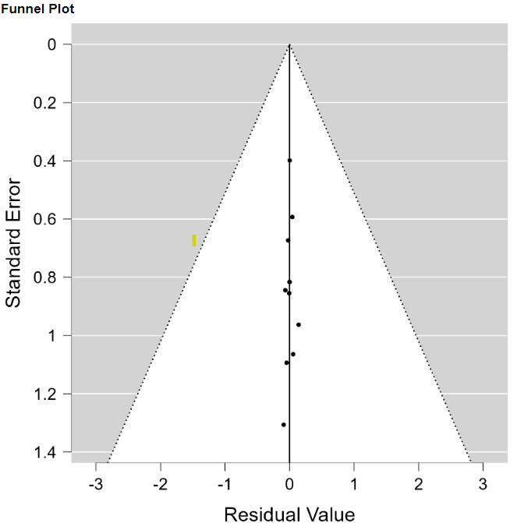
c.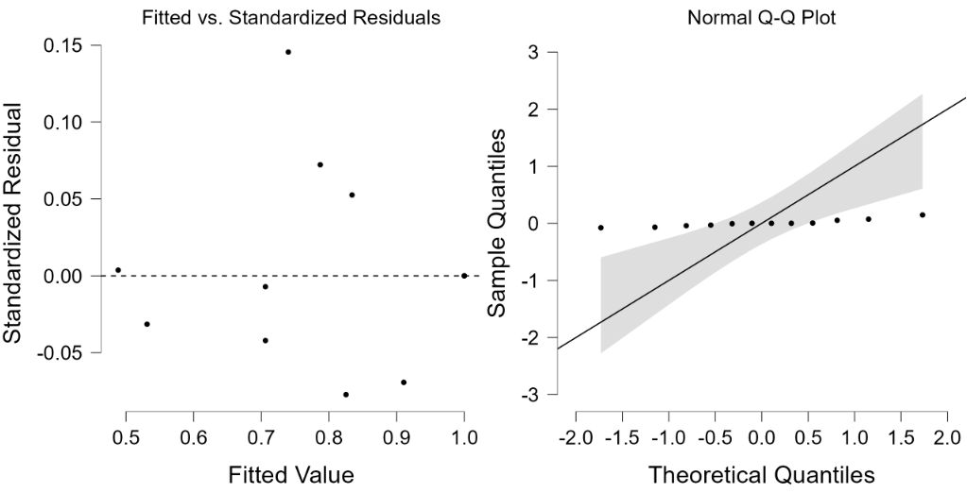
Supplementary Figure 5 (a) and (b) Forest and funnel plots showing MAI vs SAI contrast in Per-protocol analysis (malaria prevalence), (c) Diagnostic plot showing both the fitted vs standardised residuals and normal Q-Q plot of MAI vs SAI.

