Supplementary Material

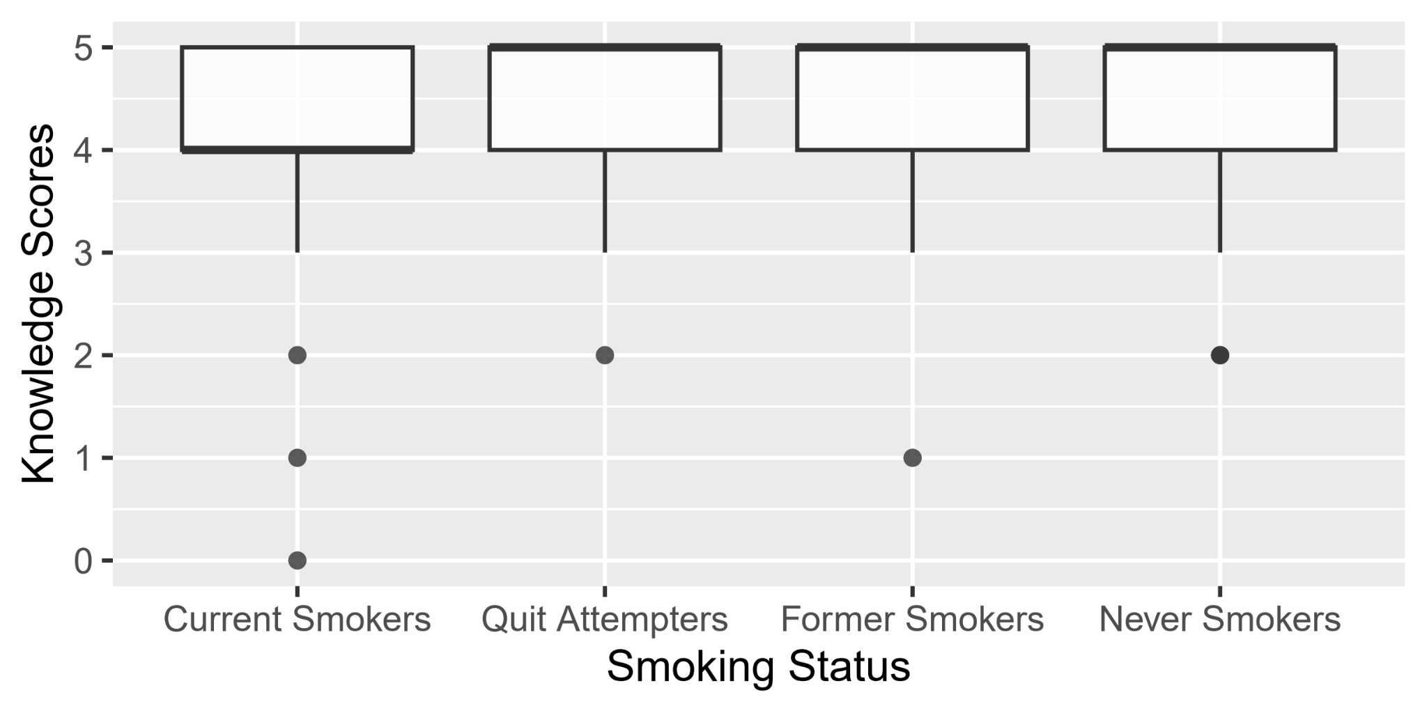
Figure S1. Boxplot of knowledge scores across different smoking behavior groups

Post-hoc analysis on knowledge

For the knowledge portion of the questionnaire, the total knowledge score was obtained by getting the total number of correct answers (highest = 5 points, lowest = 0 points). Kruskal-Wallis test was done to determine whether there were significant differences across strata. While visually, current smokers tend to have lower scores and more “No” or “I don’t know” answers (Figure 2), Kruskal-Wallis test indicates that this is not statistically (although borderline) significant (p = 0.09). However, Chi-square test and z-test of proportions showed that these findings are highly significant (p < 0.01):

Pearson's Chi-squared test

data: table(prop_data$Response, prop_data$p1)
X-squared = 21.605, df = 6, p-value = 0.001427

2-sample test for equality of proportions with continuity correction

data: c(24, 119) out of c(125, 1245)
X-squared = 10.288, df = 1, p-value = 0.001339
alternative hypothesis: two.sided
95 percent confidence interval:
0.02106313 0.17177222
sample estimates:
prop 1 prop 2
0.19200000 0.09558233

Post-hoc analysis on attitudes

Current smokers tend to agree more with the statement "People will find ways to buy cigarettes no matter how expensive a cigarette is" (p < 0.05).

R console outputs

chisq.test(table(dataset$a6, dataset$p1))

Pearson's Chi-squared test

data: table(dataset$a6, dataset$p1)
X-squared = 25.455, df = 12, p-value = 0.01281

chisq.test(table(dataset$a5, dataset$p1))

Pearson's Chi-squared test

data: table(dataset$a5, dataset$p1)
X-squared = 16.87, df = 12, p-value = 0.1545

chisq.test(table(dataset$a2, dataset$p1))

Pearson's Chi-squared test

data: table(dataset$a2, dataset$p1)
X-squared = 15.83, df = 12, p-value = 0.1991

chisq.test(table(dataset$a1, dataset$p1))

Pearson's Chi-squared test

data: table(dataset$a1, dataset$p1)
X-squared = 14.178, df = 12, p-value = 0.2895

