Monthly dengue incidence rate, ACF and PACF of log (incidence rate), parameter estimation, and forecasted incidence rate in the northern region of Thailand and by province
- Northern region of Thailand
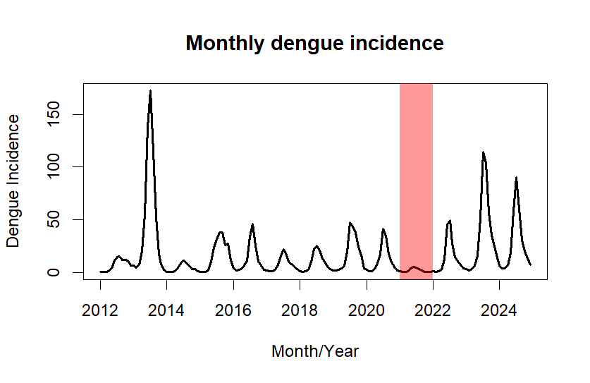 | 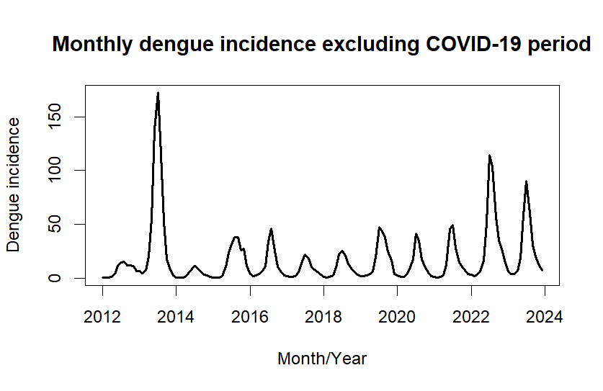
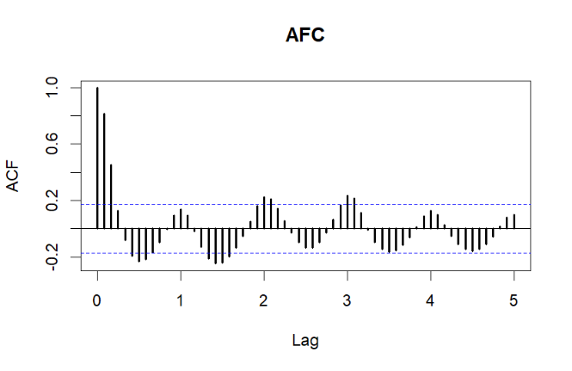 | 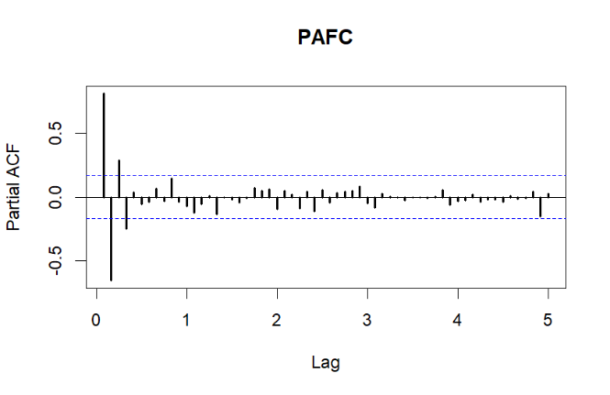
Model Diagnostics: Seasonal ARIMA (2,0,0)(2,1,0)¹²
Variables | Parameter |  |  | p-value of Box-Ljung test |  |  |  | AIC
Variables | β | SE | p-value | Lag 1 | Lag 12 | Lag 17 | Lag 20 | AIC
AR (1) | 1.23 | 0.09 | < 0.001 | 0.753 | 0.918 | 0.831 | 0.986 | 40.46
AR (2) | -0.33 | 0.09 | < 0.001
SAR (1) | -0.79 | 0.08 | < 0.001
SAR (2) | -0.51 | 0.08 | < 0.001

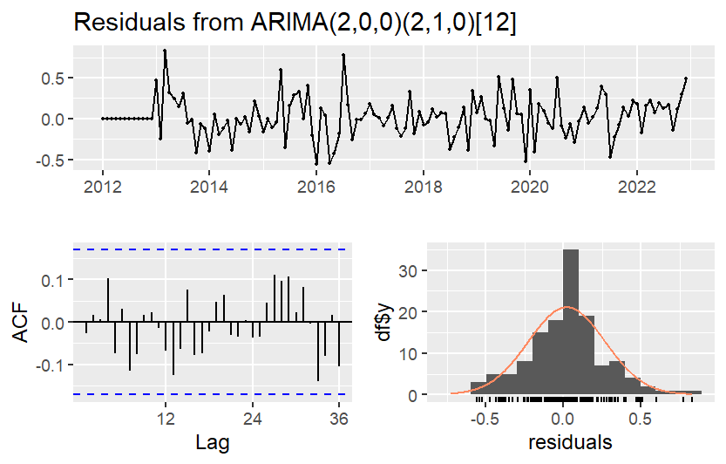 | 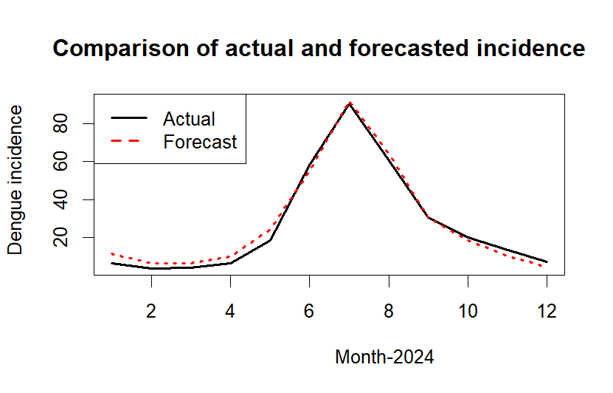
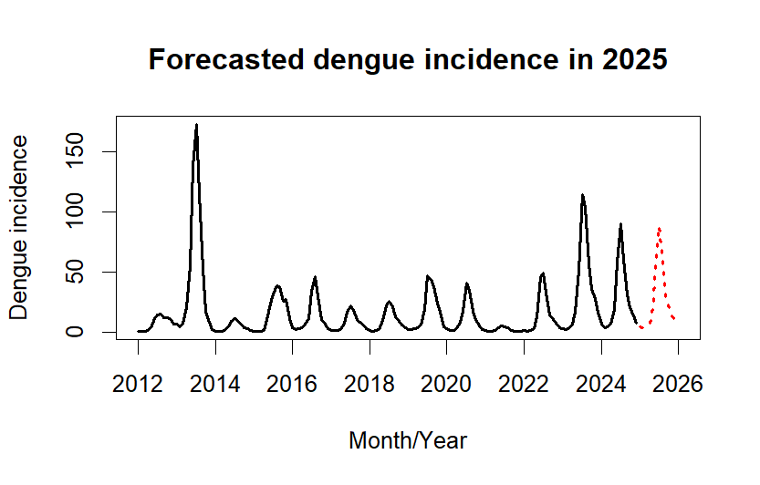 | 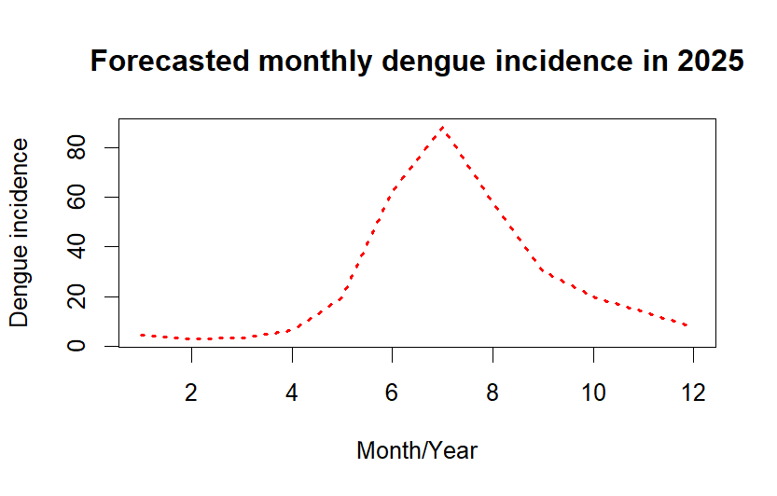

- Chiang Rai Province
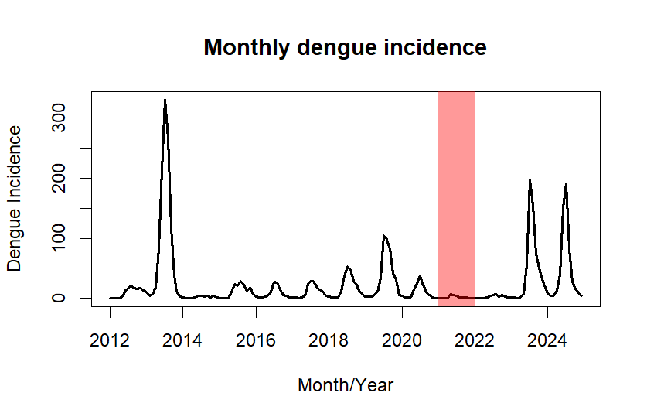 | 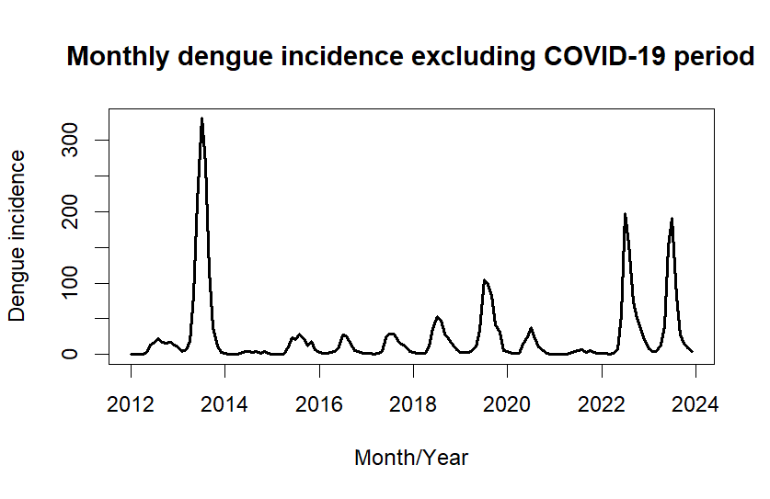
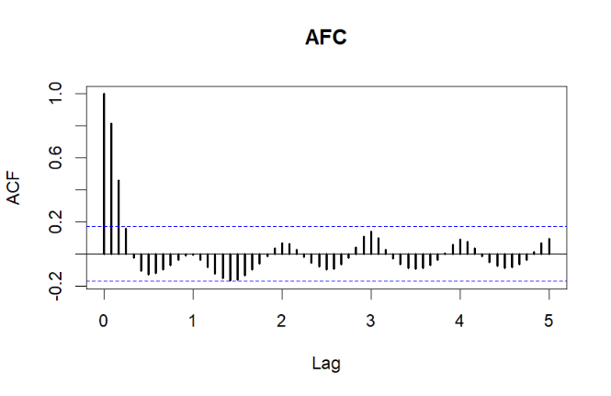 | 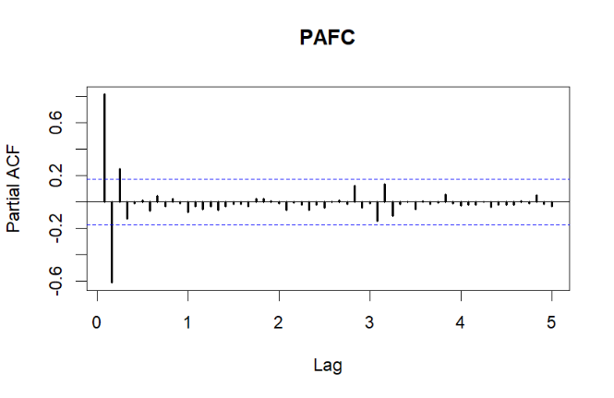
Model Diagnostics: Seasonal ARIMA (1,0,2)(2,1,1)¹²
Variables | Parameter |  |  | p-value of Box-Ljung test |  |  |  | AIC
Variables | β | SE | p-value | Lag 1 | Lag 12 | Lag 17 | Lag 20 | AIC
AR (1) | 0.894 | 0.05 | < 0.001 | 0.753 | 0.784 | 0.352 | 0.486 | 126.20
MA (1) | 0.05 | 0.11 | 0.637
MA (2) | 0.21 | 0.10 | 0.033
SAR (1) | -0.42 | 0.16 | 0.007
SAR (2) | -0.23 | 0.14 | 0.123
SMA (1) | -0.64 | 0.15 | < 0.001

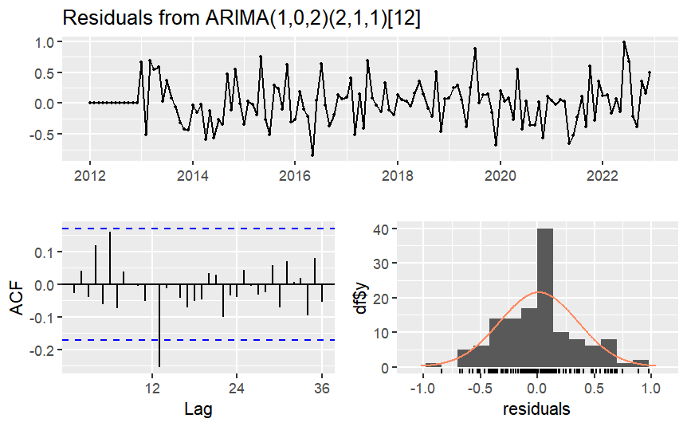 | 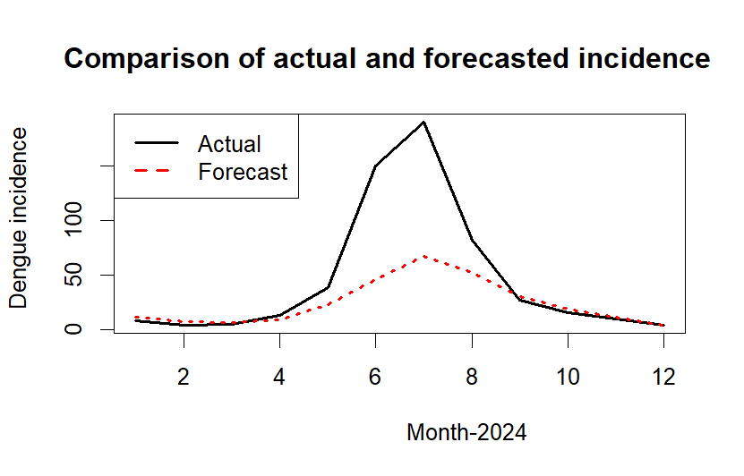
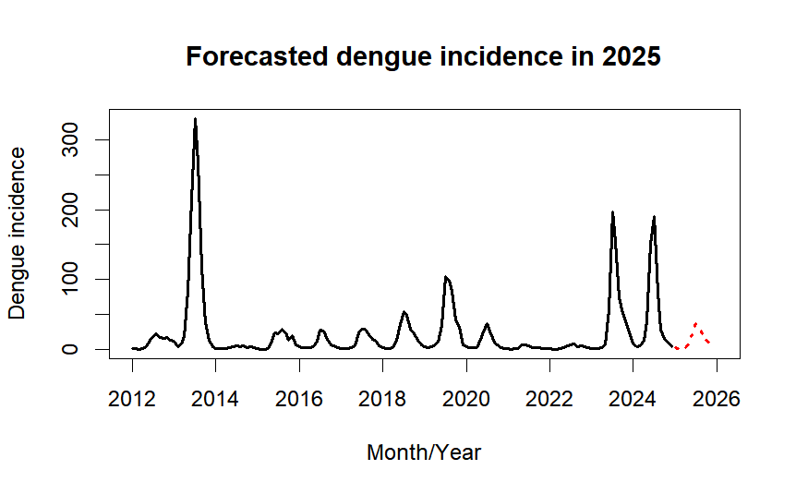 | 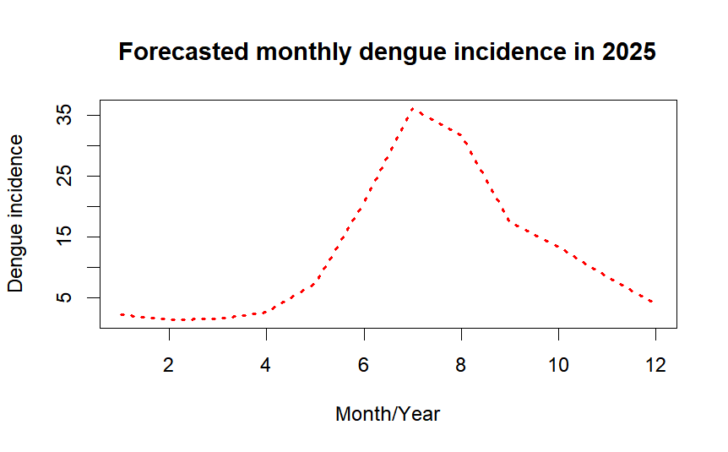
- Chiang Mai Province
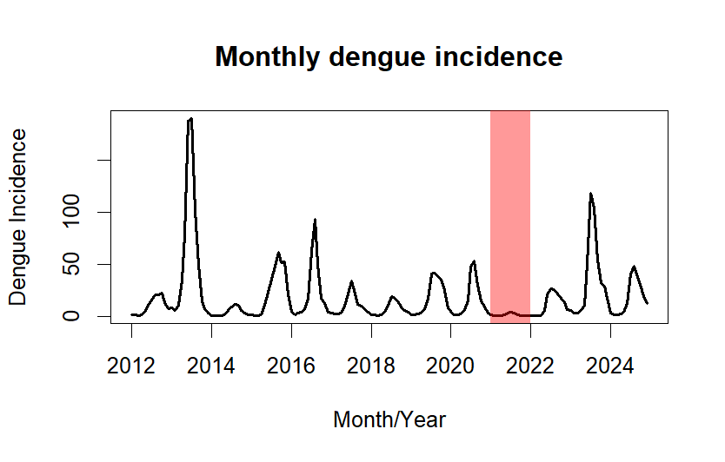 | 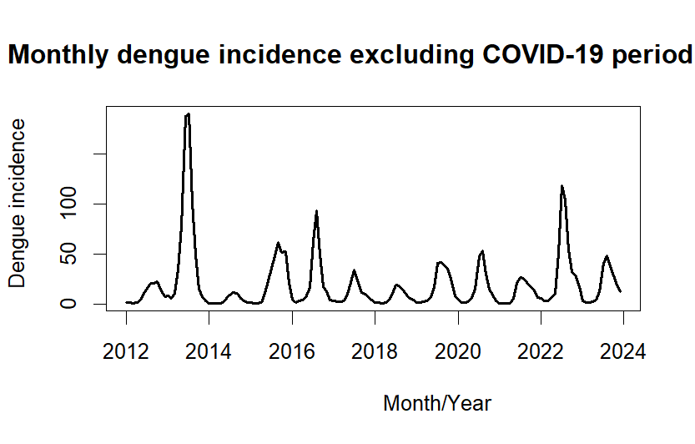
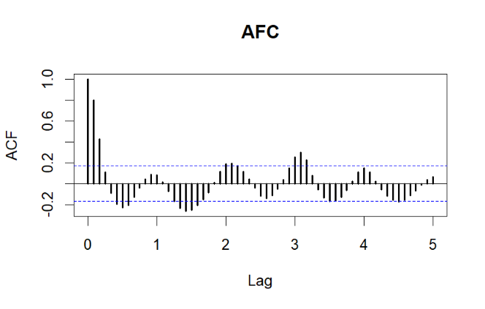 | 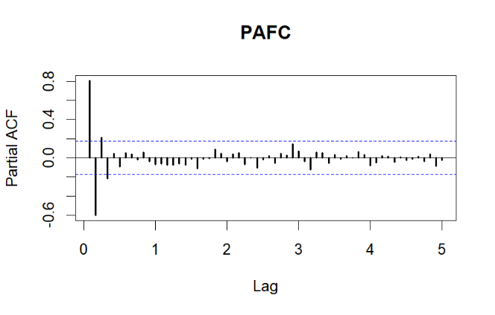
Model Diagnostics: Seasonal ARIMA (2,0,0)(0,1,2)¹²
Variables | Parameter |  |  | p-value of Box-Ljung test |  |  |  | AIC
Variables | β | SE | p-value | Lag 1 | Lag 12 | Lag 17 | Lag 20 | AIC
AR (1) | 1.08 | 0.09 | < 0.001 | 0.993 | 0.654 | 0.643 | 0.624 | 91.68
AR (2) | -0.20 | 0.09 | 0.030
SAR (1) | -1.14 | 0.10 | < 0.001
SAR (2) | 0.40 | 0.11 | < 0.001

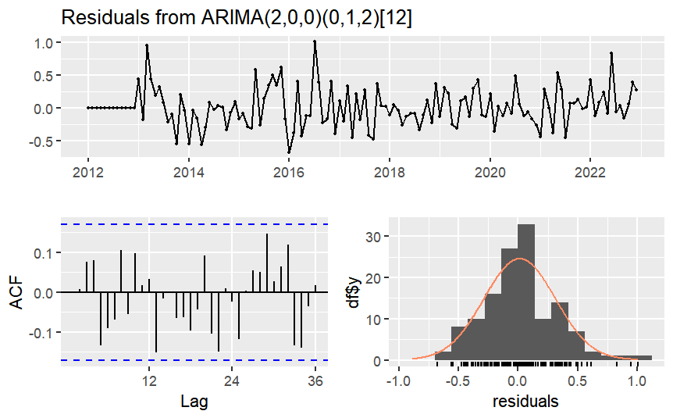 | 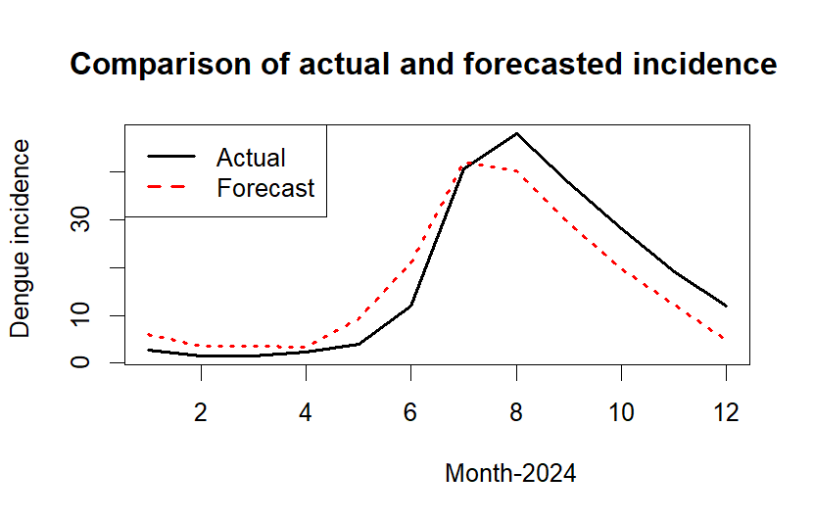
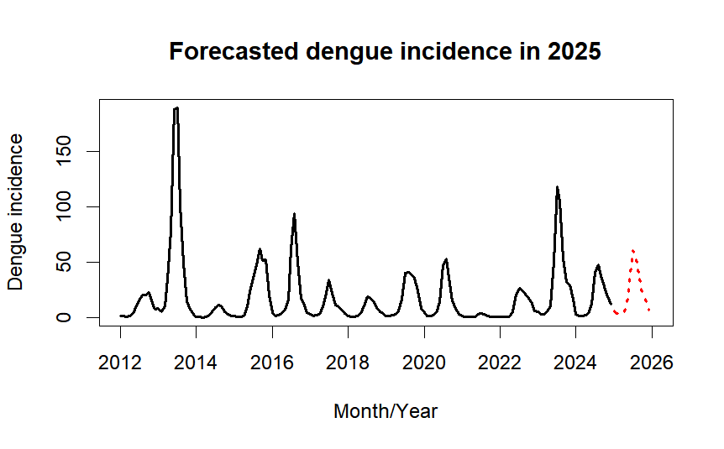 | 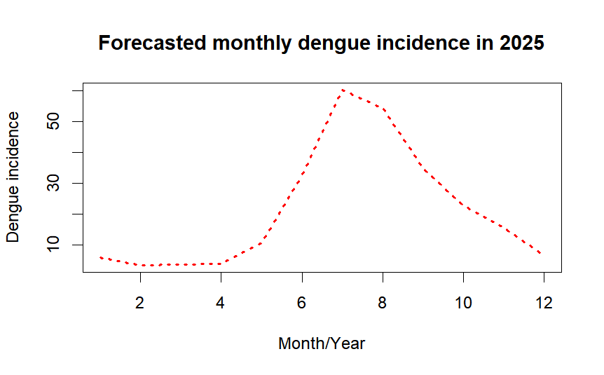

- Nan Province
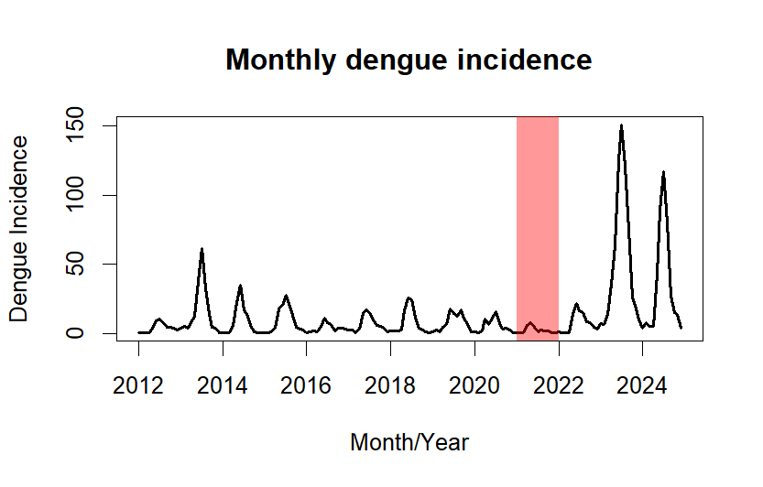 | 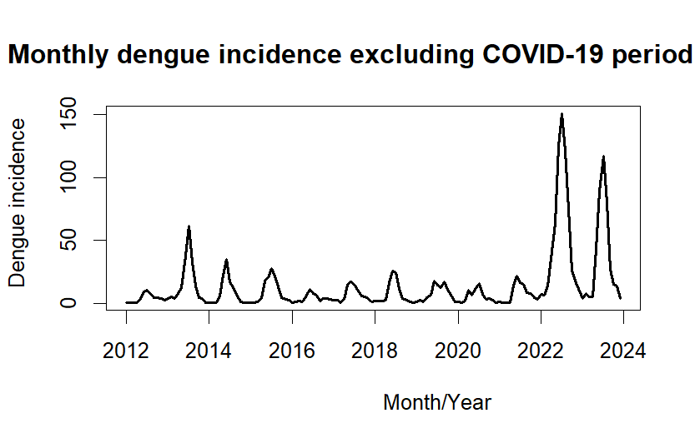
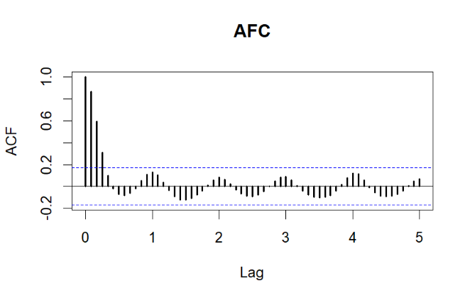 | 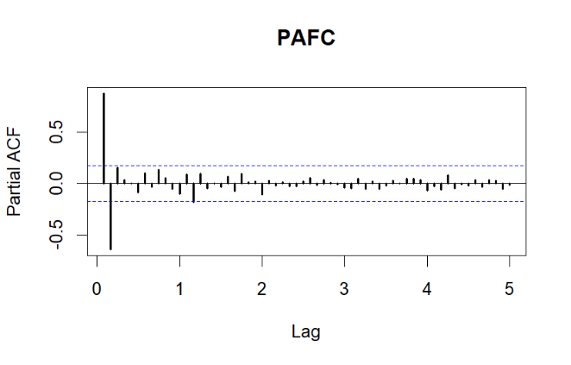
Model Diagnostics: Seasonal ARIMA (0,1,0)(1,1,2)¹²
Variables | Parameter |  |  | p-value of Box-Ljung test |  |  |  | AIC
Variables | β | SE | p-value | Lag 1 | Lag 12 | Lag 17 | Lag 20 | AIC
SAR (1) | 0.72 | 0.22 | < 0.001 | 0.175 | 0.655 | 0.725 | 0.691 | 185.81
SMA(1) | -1.98 | 0.43 | < 0.001
SMA (2) | 1.00 | 0.43 | 0.019

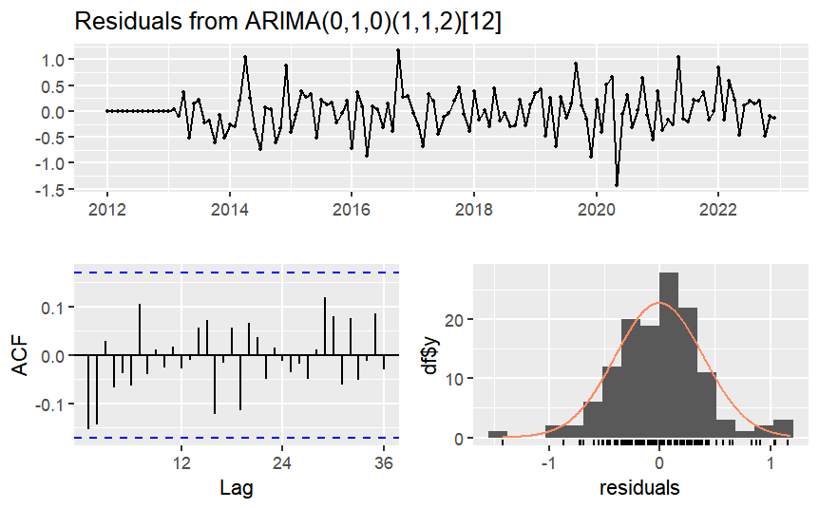 | 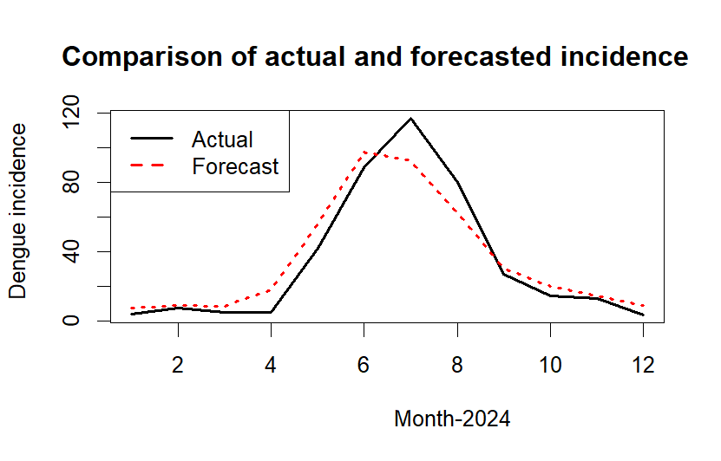
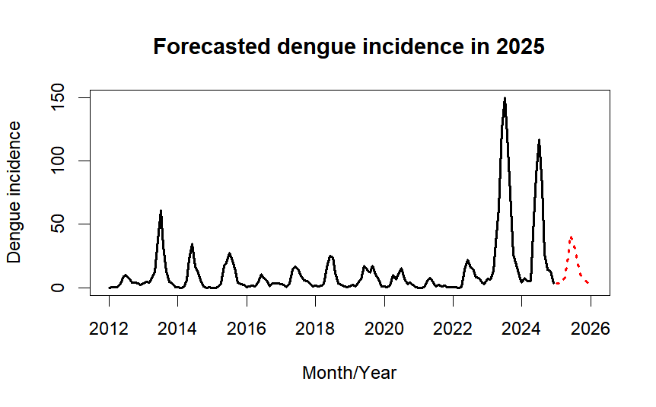 | 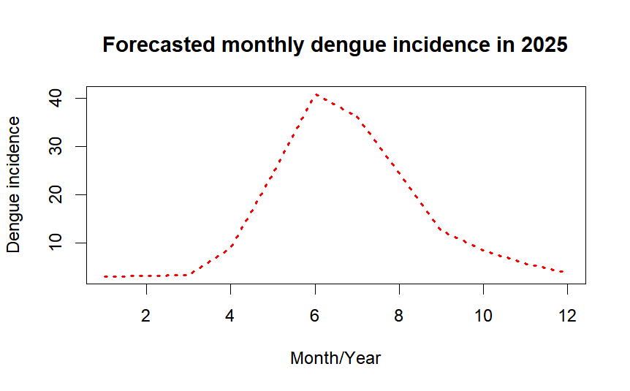

- Phayao province
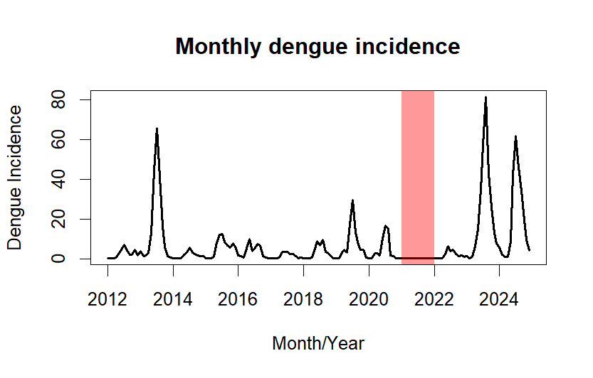 | 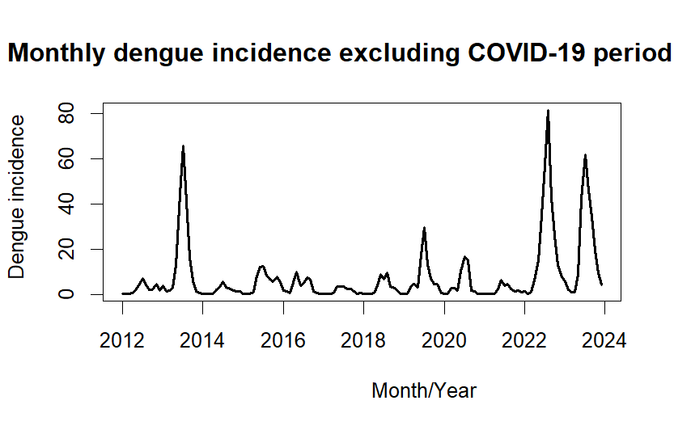
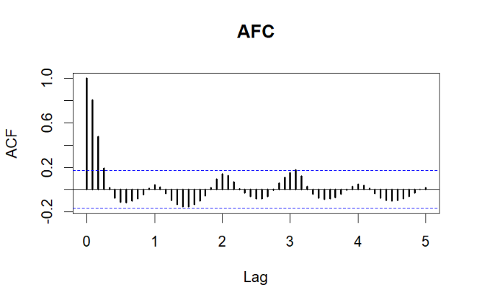 | 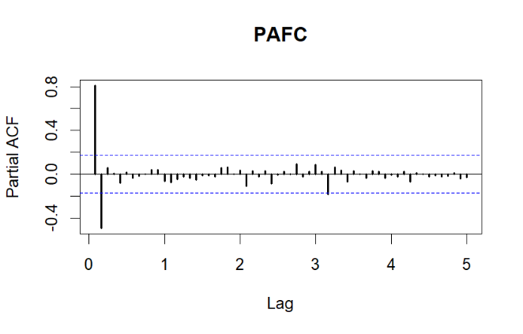
Model Diagnostics: Seasonal ARIMA (0,1,1)(0,1,1)¹²
Variables | Parameter |  |  | p-value of Box-Ljung test |  |  |  | AIC
Variables | β | SE | p-value | Lag 1 | Lag 12 | Lag 17 | Lag 20 | AIC
MA (1) | -0.31 | 0.11 | 0.004 | 0.434 | 0.106 | 0.199 | 0.102 | 194.31
SMA (1) | -1.00 | 0.24 | < 0.001

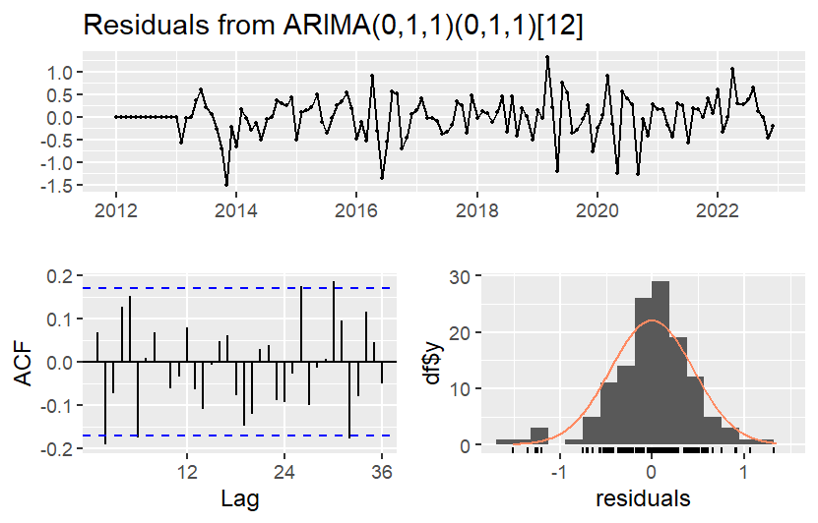 | 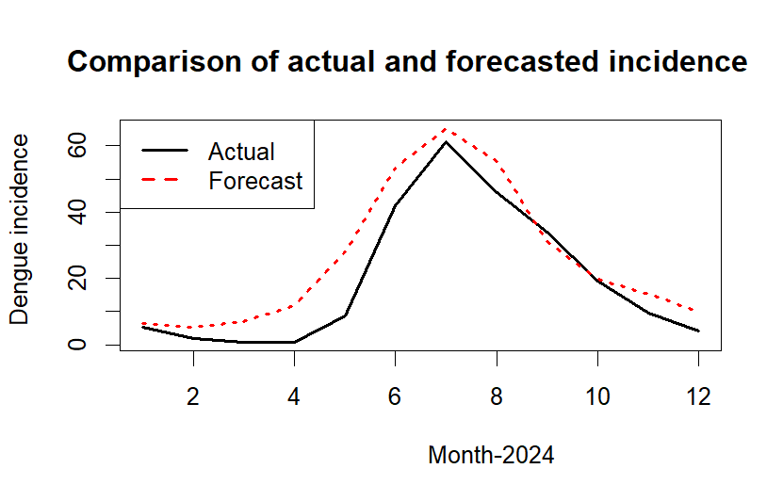
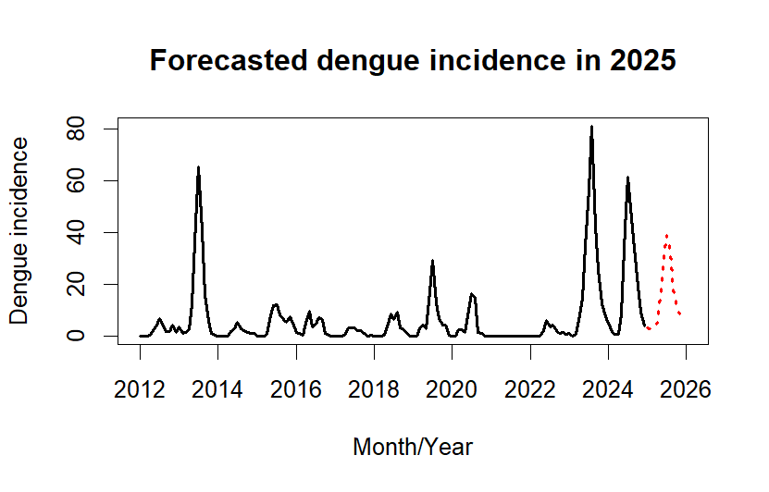 | 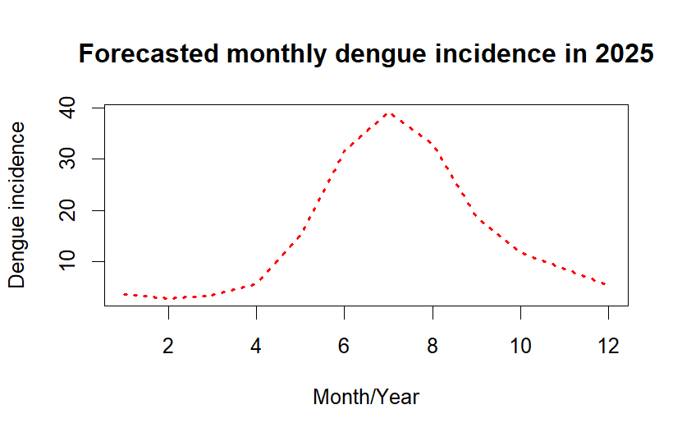

- Phrea province
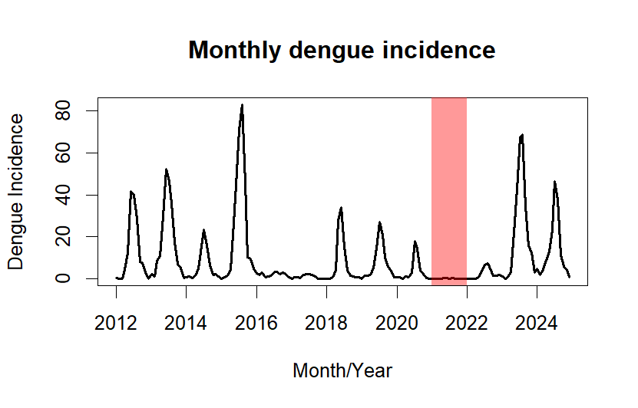 | 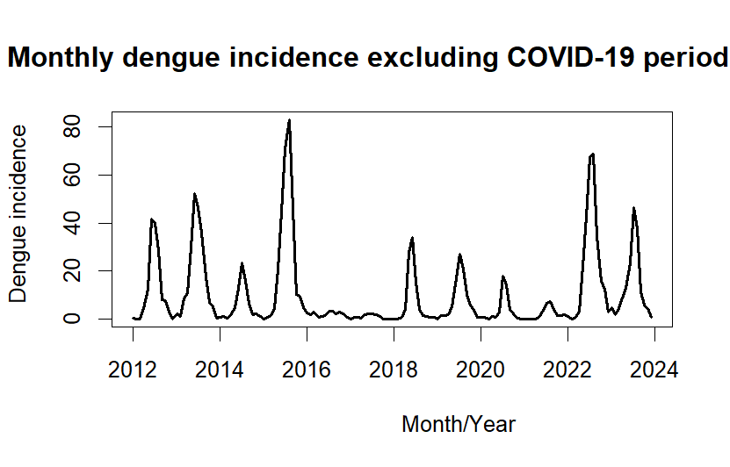
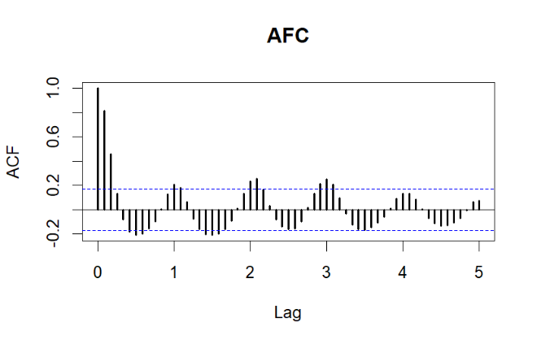 | 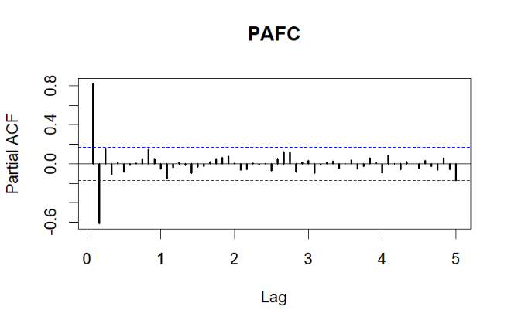
Model Diagnostics: Seasonal ARIMA (0,1,0)(0,1,1)¹²
Variables | Parameter |  |  | p-value of Box-Ljung test |  |  |  | AIC
Variables | β | SE | p-value | Lag 1 | Lag 12 | Lag 17 | Lag 20 | AIC
SMA (1) | -1.00 | 0.24 | < 0.001 | 0.893 | 0.291 | 0.401 | 0.504 | 191.64

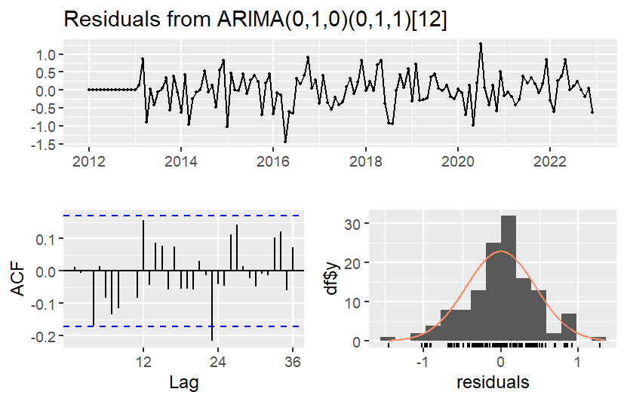 | 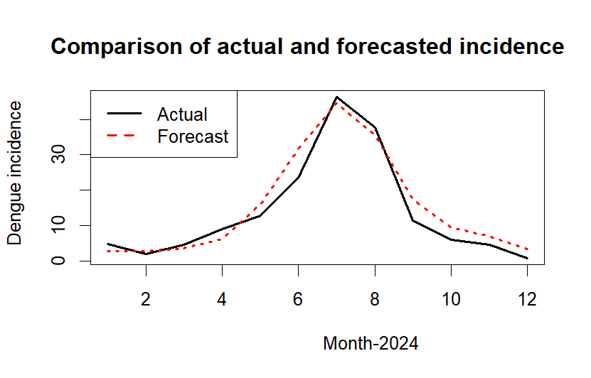
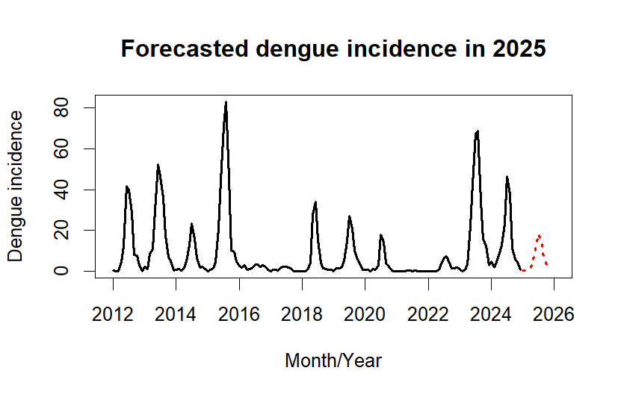 | 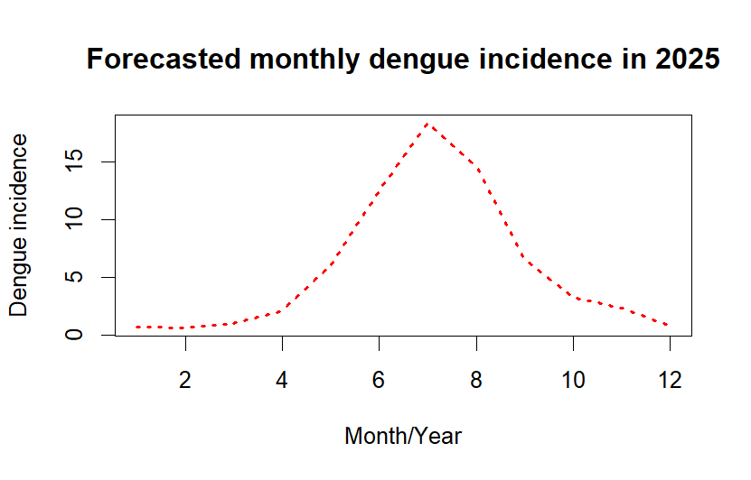

- Mae Hong Son province
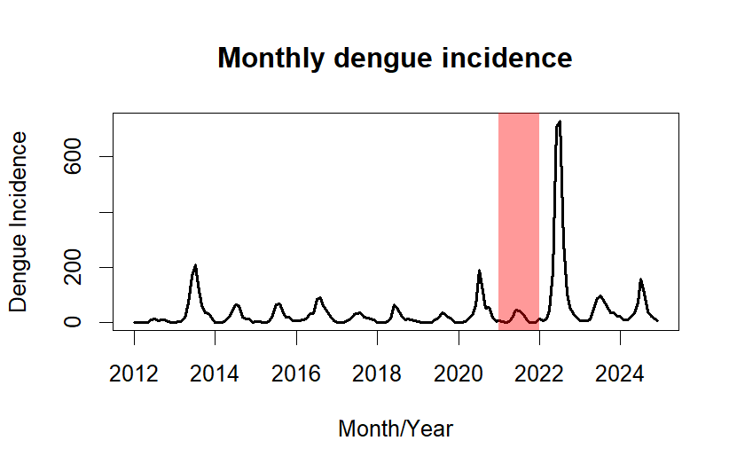 | 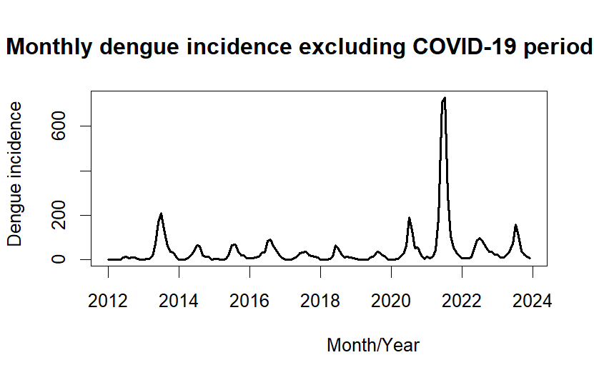
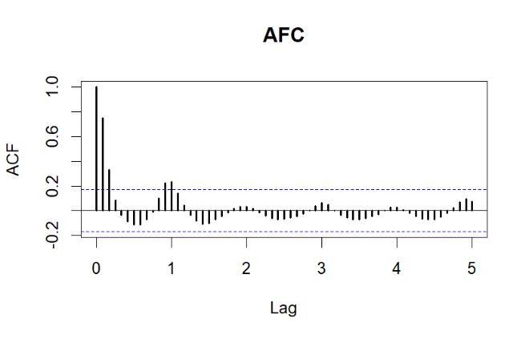 | 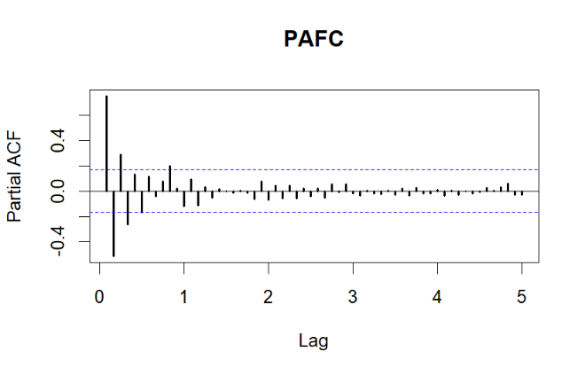
Model Diagnostics: Seasonal ARIMA (1,0,0)(1,1,2)¹²
Variables | Parameter |  |  | p-value of Box-Ljung test |  |  |  | AIC
Variables | β | SE | p-value | Lag 1 | Lag 12 | Lag 17 | Lag 20 | AIC
AR (1) | 0.85 | 0.05 | < 0.001 | 0.601 | 0.718 | 0.536 | 0.552 | 209.12
SAR (1) | -0.61 | 0.28 | 0.029
SMA (1) | -0.25 | 0.27 | 0.355
SMA (2) | -0.75 | 0.26 | 0.004

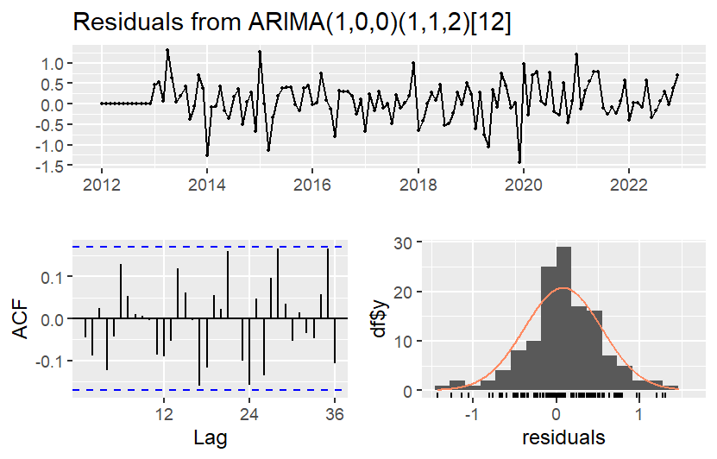 | 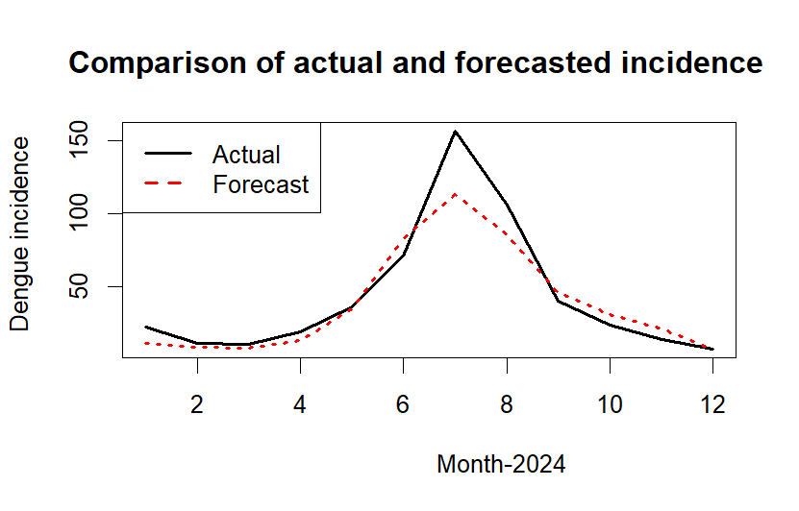
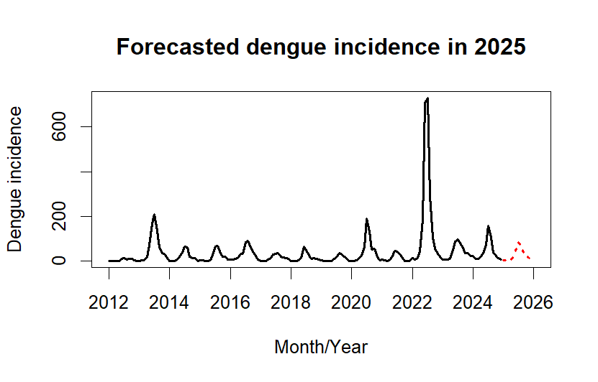 | 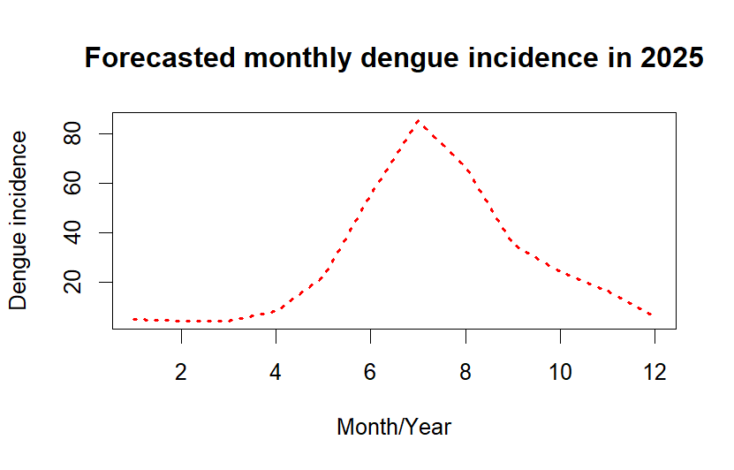

- Lampang province
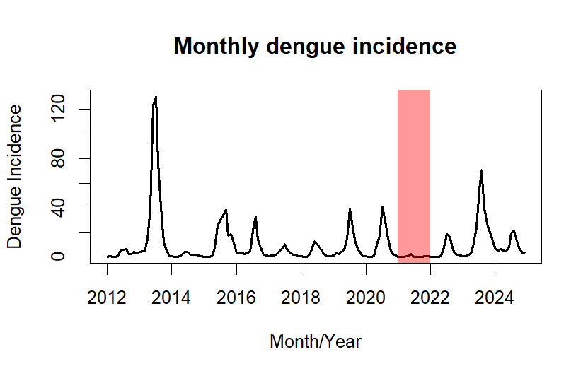 | 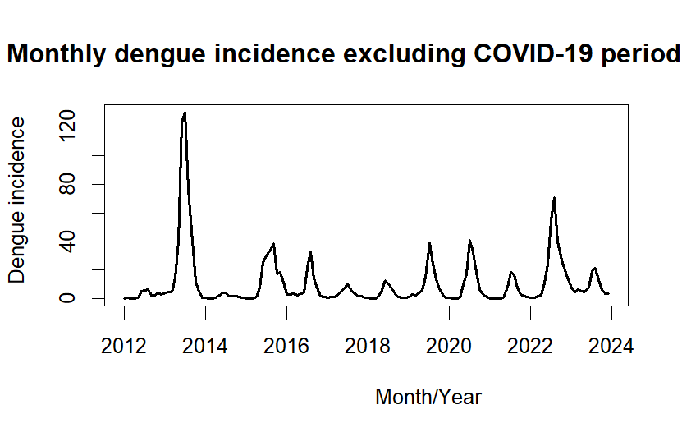
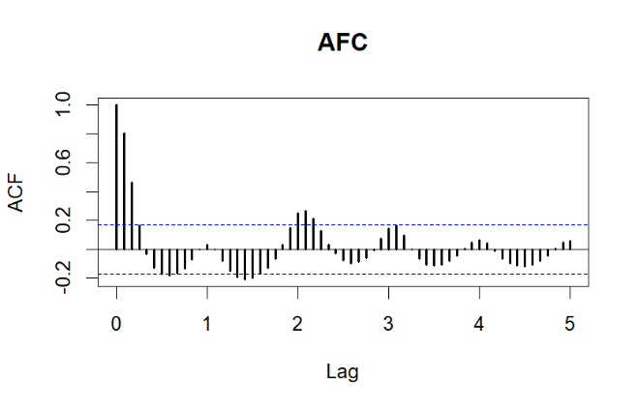 | 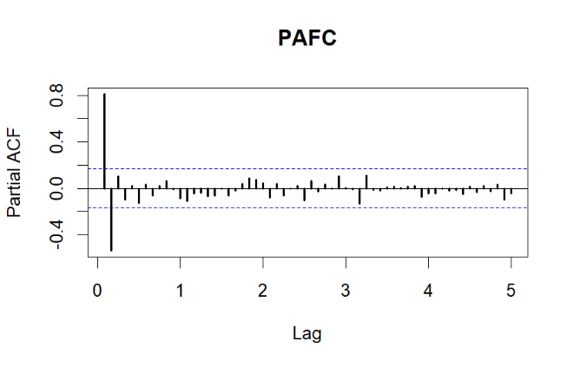
Model Diagnostics: Seasonal ARIMA (1,0,2)(1,1,1)¹²
Variables | Parameter |  |  | p-value of Box-Ljung test |  |  |  | AIC
Variables | β | SE | p-value | Lag 1 | Lag 12 | Lag 17 | Lag 20 | AIC
AR (1) | 0.84 | 0.07 | < 0.001 | 0.918 | 0.963 | 0.954 | 0.730 | 152.80
MA (1) | 0.18 | 0.11 | 0.116
MA (2) | 0.13 | 0.11 | 0.206
SAR (1) | -0.18 | 0.10 | 0.070
SMA (1) | -1.00 | 0.32 | 0.002

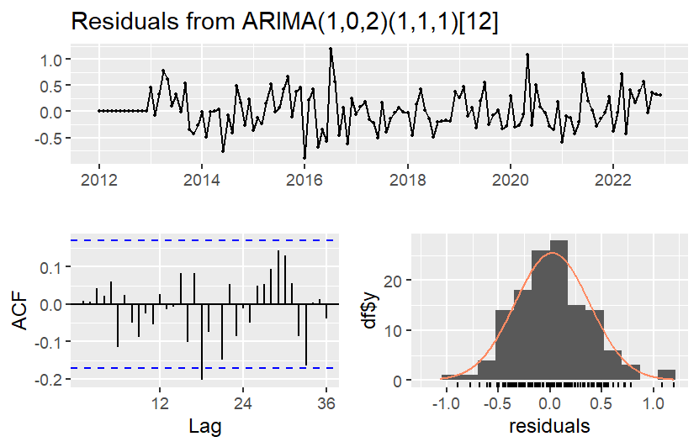 | 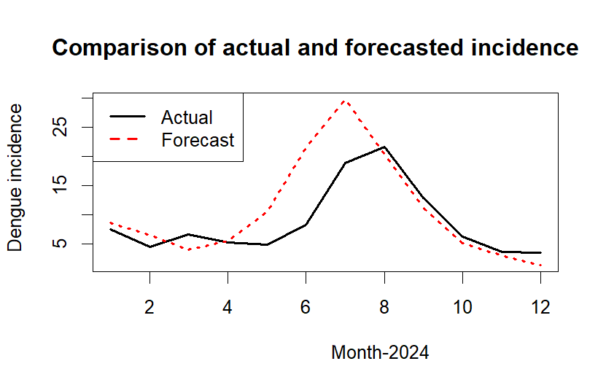
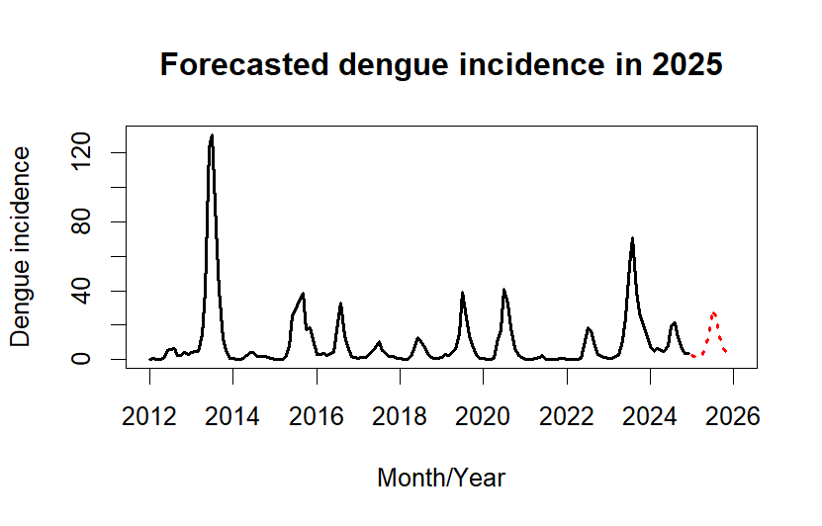 | 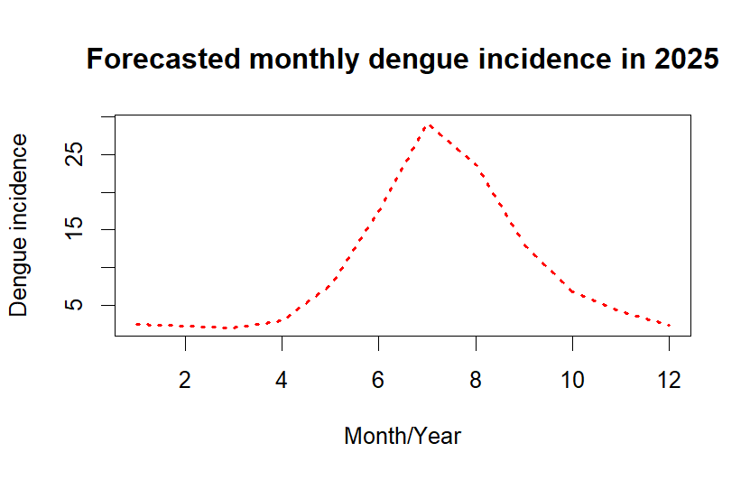

- Lamphun province
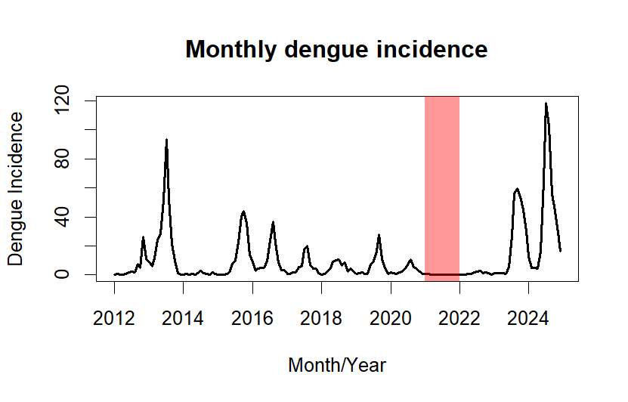 | 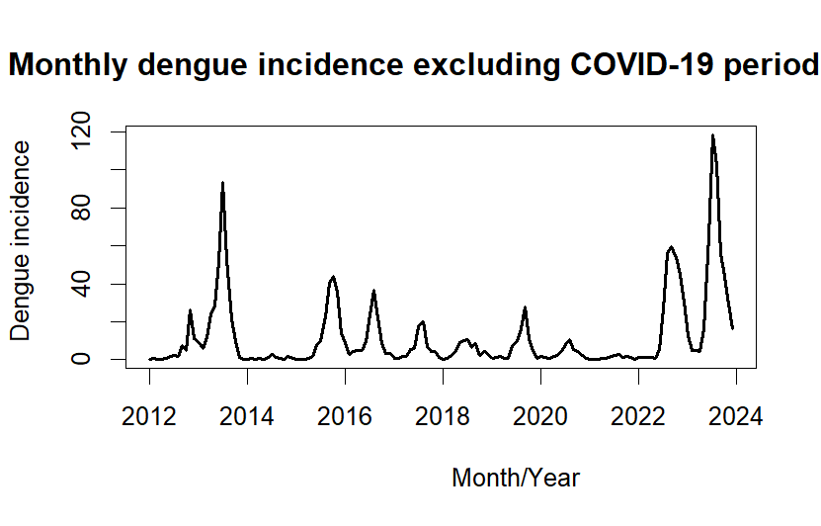
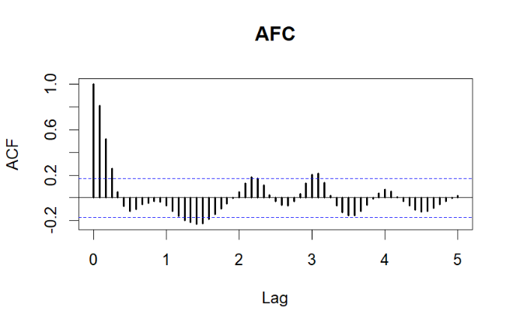 | 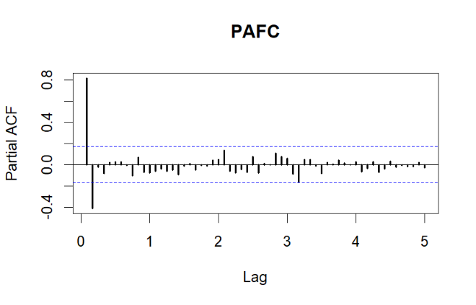
Model Diagnostics: Seasonal ARIMA (0,1,0)(1,1,2)¹²
Variables | Parameter |  |  | p-value of Box-Ljung test |  |  |  | AIC
Variables | β | SE | p-value | Lag 1 | Lag 12 | Lag 17 | Lag 20 | AIC
SAR (1) | 0.54 | 0.14 | < 0.001 | 0.902 | 0.818 | 0.344 | 0.488 | 199.36
SMA (1) | -1.91 | 0.48 | < 0.001
SMA (2) | -1.00 | 0.50 | 0.047

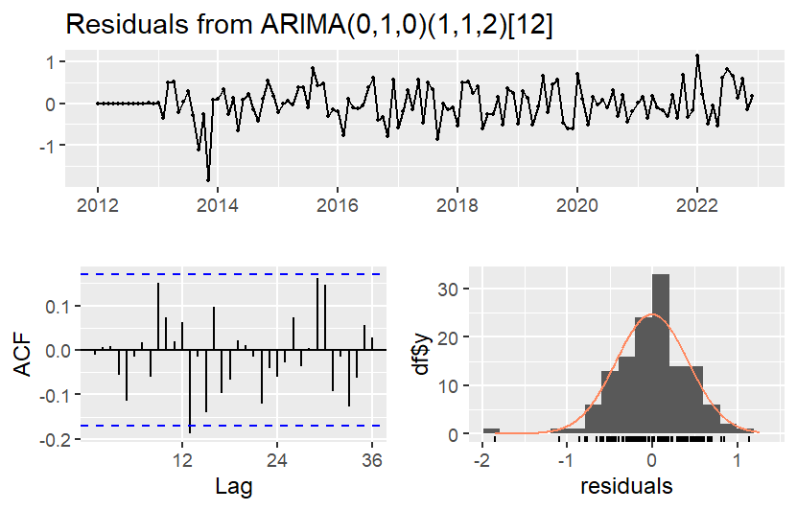 | 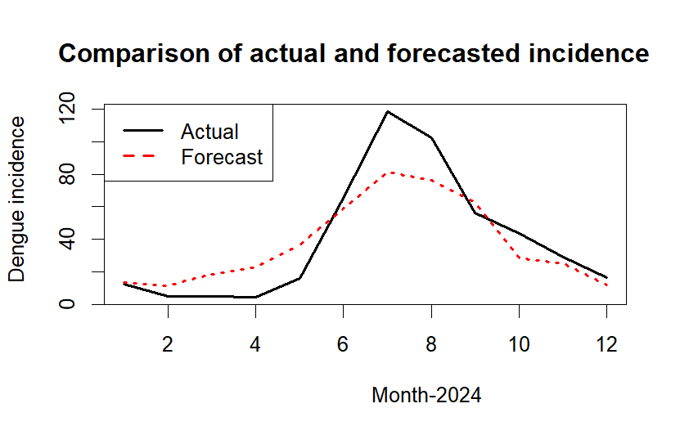
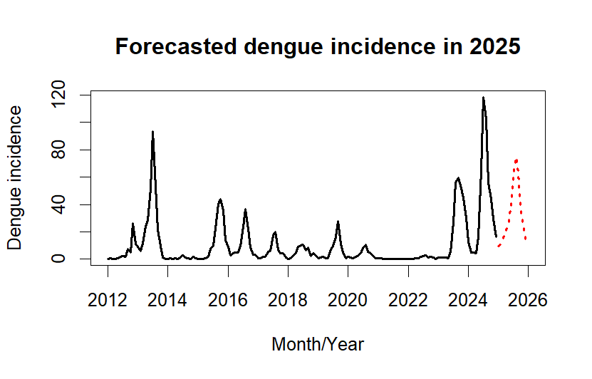 | 