Table S1: Overall Trends and Disparities in Diseases of the Respiratory System and Parkinson’s Disease-Related Age Adjusted Mortality Rate (AAMR) in the United States from 1999-2020.
Year | Deaths | Population | Age Adjusted Rate | Age Adjusted Rate Lower 95% Confidence Interval | Age Adjusted Rate Upper 95% Confidence Interval
1999 | 11349 | 34797841 | 33.07 | 32.46 | 33.68
2000 | 11369 | 34991753 | 32.69 | 32.09 | 33.29
2001 | 11094 | 35290291 | 31.39 | 30.8 | 31.97
2002 | 11100 | 35522207 | 31.05 | 30.47 | 31.63
2003 | 11079 | 35863529 | 30.59 | 30.02 | 31.16
2004 | 10522 | 36203319 | 28.73 | 28.18 | 29.28
2005 | 11082 | 36649798 | 29.68 | 29.13 | 30.24
2006 | 10258 | 37164107 | 27.03 | 26.5 | 27.55
2007 | 9843 | 37825711 | 25.52 | 25.01 | 26.02
2008 | 9714 | 38777621 | 24.77 | 24.28 | 25.26
2009 | 9215 | 39623175 | 23.09 | 22.62 | 23.56
2010 | 9302 | 40267984 | 23.05 | 22.58 | 23.52
2011 | 9688 | 41394141 | 23.38 | 22.92 | 23.85
2012 | 9250 | 43145356 | 21.78 | 21.33 | 22.22
2013 | 9671 | 44704074 | 22.26 | 21.82 | 22.71
2014 | 9258 | 46243211 | 20.86 | 20.43 | 21.28
2015 | 9795 | 47760852 | 21.58 | 21.15 | 22.01
2016 | 9971 | 49244195 | 21.41 | 20.98 | 21.83
2017 | 10482 | 50858679 | 21.9 | 21.48 | 22.33
2018 | 10688 | 52431193 | 21.74 | 21.33 | 22.16
2019 | 10740 | 54058263 | 21.25 | 20.85 | 21.66
2020 | 14753 | 55659365 | 28.58 | 28.12 | 29.05
 | 230223 | 9.28E+08 | 25.38 | 25.27 | 25.48

Figure S1: Overall Annual Percentage Change (APC) Trends and Disparities in Diseases of the Respiratory System and Parkinson’s Disease-Related in the United Stats from 1999-2020.

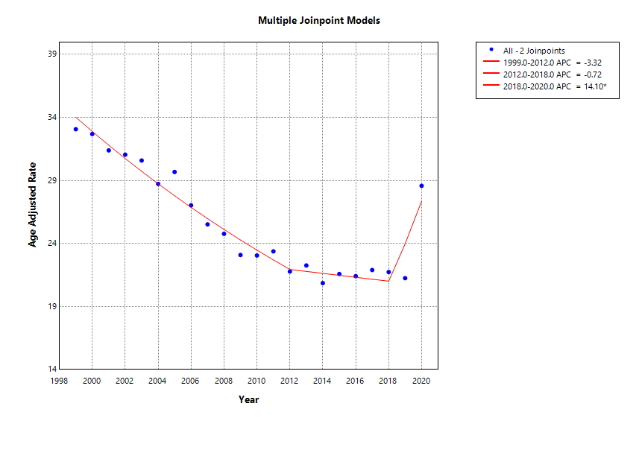
Table S2: Gender Stratified Trends and Disparities in Diseases of the Respiratory System and Parkinson’s Disease-Related Age Adjusted Mortality Rate (AAMR) in the United States from 1999-2020

Sex | Year | Deaths | Age Adjusted Rate | Age Adjusted Rate Lower 95% Confidence Interval | Age Adjusted Rate Upper 95% Confidence Interval
Female | 1999 | 4136 | 18.81 | 18.24 | 19.39
Female | 2000 | 4159 | 18.7 | 18.13 | 19.27
Female | 2001 | 4066 | 18.1 | 17.54 | 18.66
Female | 2002 | 4014 | 17.68 | 17.13 | 18.23
Female | 2003 | 3909 | 17.12 | 16.58 | 17.66
Female | 2004 | 3818 | 16.55 | 16.02 | 17.08
Female | 2005 | 4134 | 17.66 | 17.12 | 18.2
Female | 2006 | 3752 | 15.81 | 15.3 | 16.32
Female | 2007 | 3516 | 14.66 | 14.17 | 15.15
Female | 2008 | 3475 | 14.3 | 13.82 | 14.78
Female | 2009 | 3308 | 13.42 | 12.95 | 13.88
Female | 2010 | 3213 | 12.86 | 12.41 | 13.31
Female | 2011 | 3422 | 13.46 | 13.01 | 13.92
Female | 2012 | 3142 | 12.09 | 11.66 | 12.52
Female | 2013 | 3326 | 12.57 | 12.13 | 13
Female | 2014 | 3196 | 11.92 | 11.5 | 12.34
Female | 2015 | 3324 | 12.07 | 11.65 | 12.49
Female | 2016 | 3431 | 12.25 | 11.83 | 12.67
Female | 2017 | 3528 | 12.4 | 11.98 | 12.81
Female | 2018 | 3614 | 12.38 | 11.97 | 12.79
Female | 2019 | 3558 | 11.94 | 11.54 | 12.33
Female | 2020 | 4925 | 16.29 | 15.83 | 16.75
Male | 1999 | 7213 | 58.5 | 57.13 | 59.87
Male | 2000 | 7210 | 57.78 | 56.43 | 59.14
Male | 2001 | 7028 | 55.01 | 53.7 | 56.31
Male | 2002 | 7086 | 54.7 | 53.4 | 55.99
Male | 2003 | 7170 | 53.85 | 52.59 | 55.11
Male | 2004 | 6704 | 49.48 | 48.28 | 50.68
Male | 2005 | 6948 | 50.19 | 48.99 | 51.38
Male | 2006 | 6506 | 45.76 | 44.64 | 46.88
Male | 2007 | 6327 | 43.52 | 42.45 | 44.6
Male | 2008 | 6239 | 41.96 | 40.91 | 43
Male | 2009 | 5907 | 38.8 | 37.8 | 39.79
Male | 2010 | 6089 | 39.26 | 38.27 | 40.25
Male | 2011 | 6266 | 38.96 | 38 | 39.93
Male | 2012 | 6108 | 36.78 | 35.85 | 37.7
Male | 2013 | 6345 | 36.99 | 36.07 | 37.9
Male | 2014 | 6062 | 34.34 | 33.47 | 35.21
Male | 2015 | 6471 | 35.64 | 34.77 | 36.52
Male | 2016 | 6540 | 34.84 | 33.99 | 35.69
Male | 2017 | 6954 | 35.96 | 35.1 | 36.81
Male | 2018 | 7074 | 35.3 | 34.47 | 36.12
Male | 2019 | 7182 | 34.6 | 33.8 | 35.41
Male | 2020 | 9828 | 46.04 | 45.12 | 46.96

Figure S2: Annual Percentage Change (APC) Trends and Disparities in Diseases of the Respiratory System and Parkinson’s Disease-Related Mortality in the United States by Gender from 1999-2020.

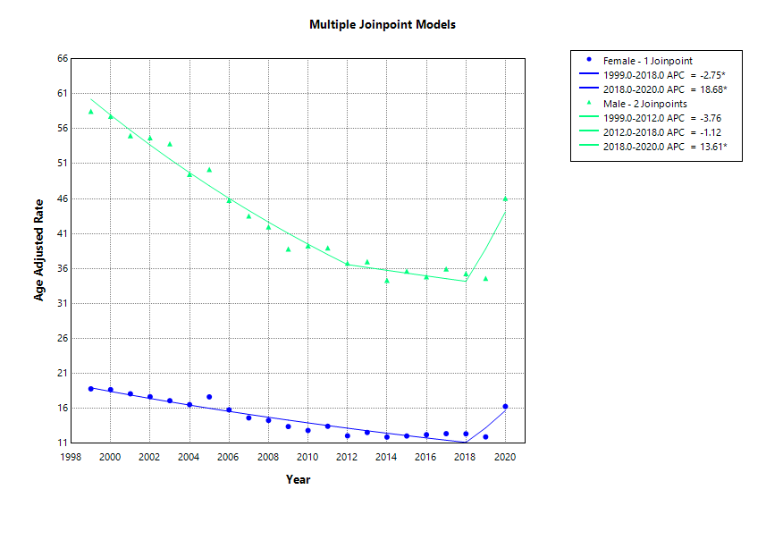

Table S3: Race Stratified Trends and Disparities in Diseases of the Respiratory System and Parkinson’s Disease-Related Age Adjusted Mortality Rate (AAMR) in the United States from 1999-2020.

 | Age-Adjusted Mortality Rate
Year | American Indian or Alaska Native | Asian or Pacific Islander | Black or African American | White | Hispanic or Latino
1999 | 22.47 | 28.99 | 13.56 | 34.84 | 24.04
2000 | 23.77 | 24.09 | 14.06 | 34.55 | 23.93
2001 | 18.09 | 24.29 | 13.78 | 33.14 | 25.2
2002 | 26.28 | 22.79 | 12.33 | 32.87 | 23.94
2003 | 30.87 | 26.32 | 13.88 | 32.13 | 19.21
2004 | 17.01 | 21.52 | 12.53 | 30.36 | 21.64
2005 | 23.33 | 22.51 | 14.24 | 31.31 | 22.2
2006 | 21.39 | 21.51 | 11.19 | 28.63 | 23.08
2007 | 18.53 | 22.03 | 11.84 | 26.88 | 19
2008 | 18.22 | 18.86 | 11.16 | 26.15 | 19.93
2009 | 16.59 | 18.69 | 10.45 | 24.45 | 17.45
2010 | 20.45 | 18.15 | 10.57 | 24.32 | 18.14
2011 | 14.41 | 20.93 | 10.39 | 24.72 | 17.59
2012 | 18.18 | 15.58 | 9.59 | 23.21 | 17.05
2013 | 18.15 | 16.78 | 11.7 | 23.57 | 18.12
2014 | 15.49 | 16.7 | 10.23 | 22.1 | 17.03
2015 | 11.87 | 17.15 | 10.2 | 22.97 | 17.4
2016 | 12.45 | 16.82 | 10.87 | 22.77 | 17.34
2017 | 16.94 | 17.41 | 10.2 | 23.36 | 19.33
2018 | 15.96 | 15.87 | 11.13 | 23.17 | 18.64
2019 | 11.65 | 18.7 | 11.13 | 22.54 | 17.45
2020 | 18.21 | 20.41 | 16.42 | 30.4 | 26.56

Figure S3: Annual Percentage Change (APC) Trends and Disparities in Diseases of the Respiratory System and Parkinson’s Disease-Related Mortality in the United States by Race from 1999-2020.

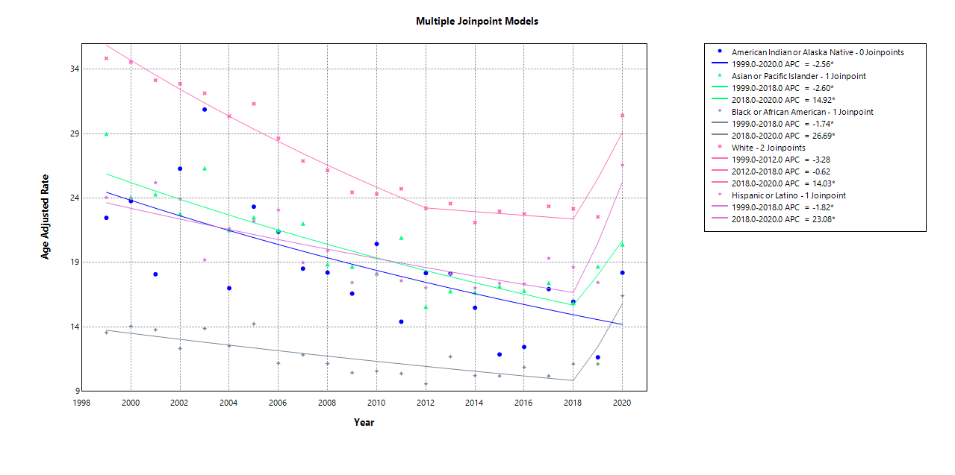
Table S4: Census Stratified Trends and Disparities in Diseases of the Respiratory System and Parkinson’s Disease-Related Mortality Age Adjusted Mortality Rate (AAMR) in the United States from 1999-2020.

 | Age-Adjusted Mortality Rate
Year | Northeast | Midwest | South | West
1999 | 32.05 | 34.75 | 28.93 | 39.31
2000 | 31.83 | 34.15 | 29.54 | 37.36
2001 | 31.64 | 31.79 | 28.03 | 36.44
2002 | 30.01 | 32.98 | 27.75 | 35.62
2003 | 28.71 | 32.21 | 27.98 | 35.04
2004 | 27.04 | 31.12 | 25.18 | 33.69
2005 | 29.17 | 32.92 | 26.14 | 32.62
2006 | 25.59 | 29.08 | 23.79 | 31.76
2007 | 24.82 | 26.37 | 23.12 | 29.38
2008 | 24.07 | 26.74 | 21.38 | 28.7
2009 | 22.04 | 24.98 | 20.65 | 26.35
2010 | 21.88 | 24.1 | 21.27 | 25.96
2011 | 23.69 | 24.07 | 20.92 | 26.43
2012 | 20.09 | 23.31 | 19.99 | 24.55
2013 | 22.38 | 23.59 | 20.65 | 23.42
2014 | 20.48 | 22.11 | 18.99 | 22.96
2015 | 21.73 | 21.15 | 20.23 | 23.95
2016 | 20.26 | 21.74 | 20.27 | 23.89
2017 | 21.28 | 21.68 | 21.45 | 23.37
2018 | 20.93 | 21.82 | 21.22 | 23.14
2019 | 20.21 | 20.61 | 21.01 | 23.11
2020 | 29.47 | 29.42 | 27.65 | 28.5

Figure S4: Annual Percentage Change (APC) Trends and Disparities in Diseases of the Respiratory System and Parkinson’s Disease-Related Mortality Age Adjusted Mortality Rate (AAMR) in the United States by Census Region from 1999-2020.

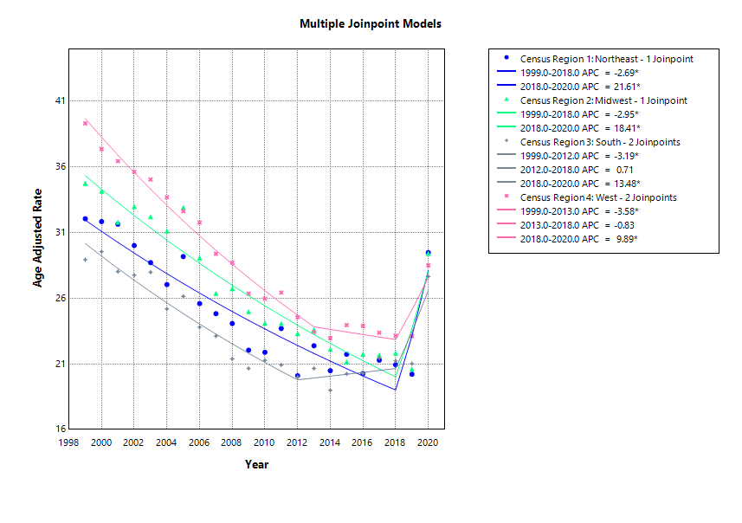

Table S5: State Trends and Disparities in Diseases of the Respiratory System and Parkinson’s Disease-Related Mortality Rate (AAMR) in the United States from 1999-2020.

State | Deaths | Age Adjusted Rate
Alabama | 2699 | 19.18
Alaska | 241 | 24.08
Arizona | 4069 | 21.2
Arkansas | 2201 | 24.22
California | 29864 | 30.75
Colorado | 3272 | 27.52
Connecticut | 3579 | 29.12
Delaware | 512 | 18.52
District of Columbia | 326 | 20.32
Florida | 13815 | 18.24
Georgia | 4248 | 19.83
Hawaii | 1172 | 25.34
Idaho | 1173 | 27.88
Illinois | 9150 | 24.61
Indiana | 5255 | 27.89
Iowa | 3445 | 31.31
Kansas | 2506 | 27.75
Kentucky | 3722 | 30.09
Louisiana | 2010 | 16.47
Maine | 1272 | 26.86
Maryland | 4081 | 25.79
Massachusetts | 5618 | 25.79
Michigan | 6581 | 21.46
Minnesota | 4607 | 28.45
Mississippi | 1962 | 23.96
Missouri | 4867 | 25.74
Montana | 825 | 25.24
Nebraska | 2303 | 38.75
Nevada | 976 | 15.28
New Hampshire | 1048 | 26.21
New Jersey | 6606 | 23.87
New Mexico | 1363 | 23.71
New York | 13142 | 21.44
North Carolina | 6321 | 24.02
North Dakota | 762 | 31.59
Ohio | 10753 | 29.12
Oklahoma | 3158 | 28.62
Oregon | 3009 | 24.88
Pennsylvania | 12485 | 26.65
Rhode Island | 1210 | 31.96
South Carolina | 3239 | 24.71
South Dakota | 900 | 31.45
Tennessee | 5033 | 27.87
Texas | 15658 | 28.06
Utah | 1412 | 26.22
Vermont | 783 | 38.39
Virginia | 4593 | 21.81
Washington | 6047 | 32.66
West Virginia | 1783 | 27.75
Wisconsin | 4212 | 23.07
Wyoming | 355 | 23.57

