SUPPLEMENTAL
List S1. List of Conditions Searched in ClinicalTrials.gov: “psoriasis,” “systemic lupus erythematosus,” “discoid lupus erythematosus,” “scleroderma,” “morphea,” “dermatomyositis,” “bullous pemphigoid,” “pemphigus vulgaris,” “pemphigus foliaceus,” “vitiligo,” “alopecia areata,” “lichen planus,” “linear IgA bullous dermatosis,” “autoimmune dermatitis,” “dermatitis herpetiformis,” “epidermolysis bullosa,” “chronic idiopathic urticaria,” “subacute cutaneous lupus erythematosus,” “urticarial vasculitis,”)

NCTId | Title | Enrollment Count | # of Sites | Start Date | End Date | Decentralized Trial Strategy
NCT03840928 | PatientSpot Formerly Known as ArthritisPower | 40000 | 1 | 2015-04-01 | 2025-03-01 | Web/Mobile/App Based Data Collection
NCT04110522 | Psoriatic Arthritis D2P Screening | 18000 | 2 | 2019-07-22 | 2025-12-31 | Mailed Survey
NCT01931644 | At-Home Research Study for Patients With Autoimmune, Inflammatory, Genetic, Hematological, Infectious, Neurological, CNS, etc. | 17667 | 1 | 2013-07 | 2024-04 | mHealth App
NCT03661866 | A Longitudinal Observational Study of Patients Undergoing Therapy for IMISC | 15000 | 63 | 2018-12-21 | 2050-12 | Community Center Recruitment
NCT05084417 | A Prospective, Observational Study of Clinician and Patient-reported Outcomes in Patients With Dermatological Conditions | 10000 | 1 | 2023-06-09 | 2026-01-15 | N/A

Table S1. Top 5 Clinical Studies by Enrollment for Autoimmune and Dermatological Conditions. The table lists the top five clinical studies ranked by enrollment count, providing information about the study title, enrollment numbers, number of sites, and the start and end dates.

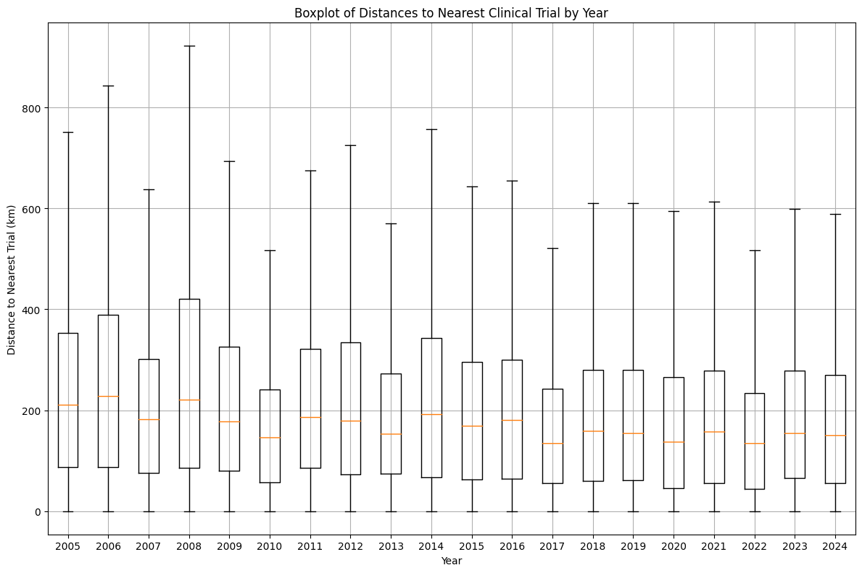
Figure S1. Boxplot of Distances to Nearest Clinical study by Year. This boxplot shows the yearly distribution of distances to the nearest clinical study site from 2005 to 2024. Each box represents the interquartile range, with the median distance marked inside the box. The reduction in the median and IQR values over time indicates better accessibility to clinical studies, though maximum distances remain relatively high in specific years.

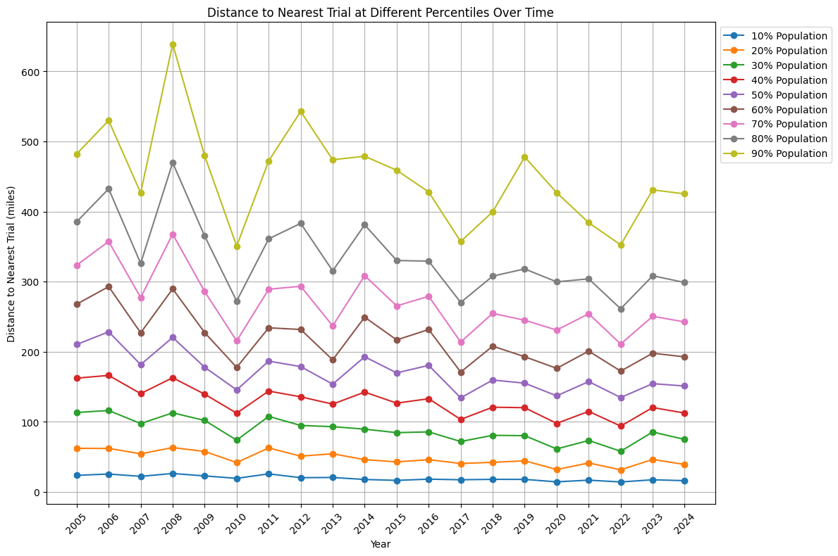
Figure S2. Distance to Nearest Clinical study at Different Percentiles Over Time. This line graph illustrates the distance to the nearest clinical study site at various population percentiles over time, from the 10th to the 90th percentile. Higher percentiles represent farther distances for a proportion of the population, with the 90th percentile showing the greatest distances. The data demonstrates a reduction in distances over time across all percentiles, suggesting an improvement in accessibility.
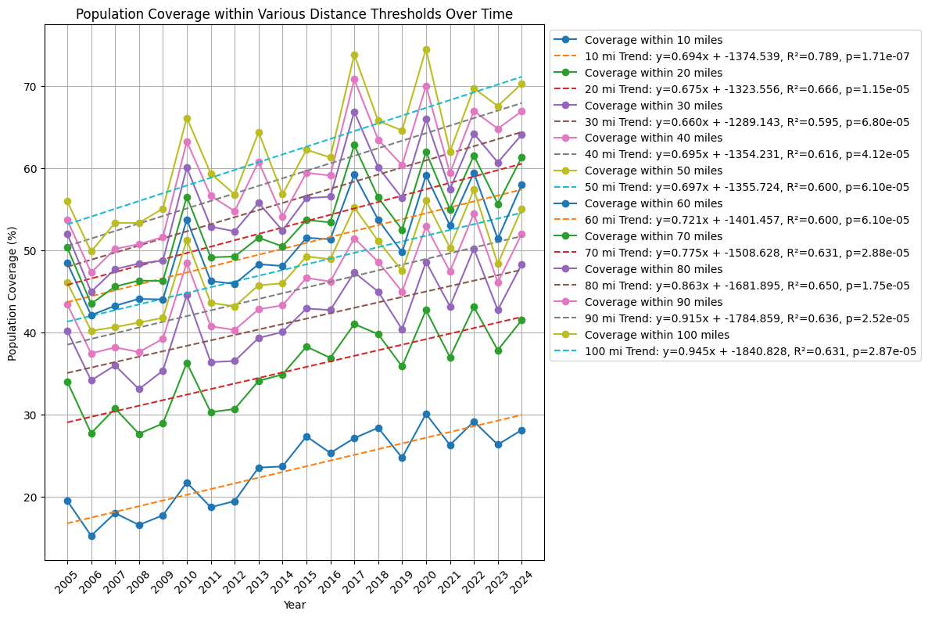
Figure S3. Population Coverage within Various Distance Thresholds Over Time. This line graph represents the population percentage within specific distance thresholds (10-100 miles) of clinical study sites over time. The trendlines show a general increase in population coverage across all distances, with the steepest gains for shorter distances. This shows that a growing proportion of the population has closer access to clinical studies.
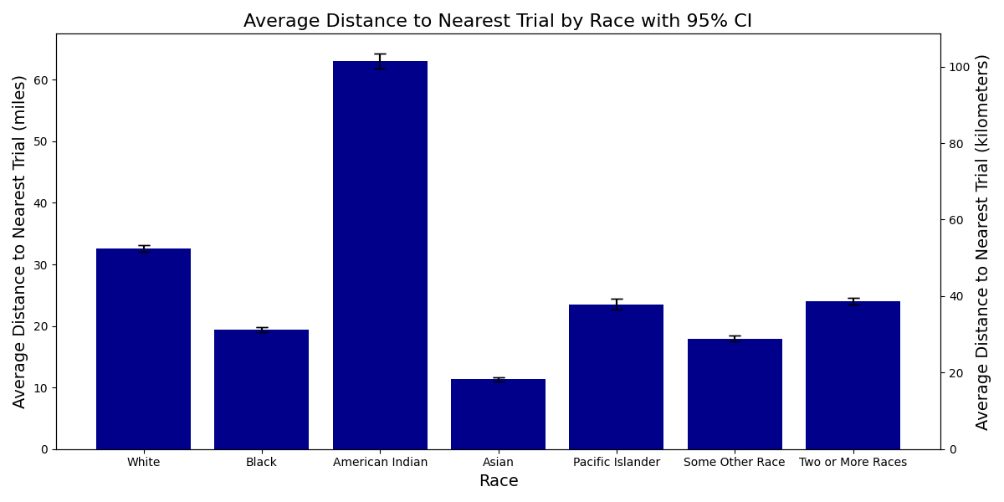
Figure S4. Average Distance to Nearest Clinical Study by Race with 95% Confidence Intervals. This bar graph shows the average distance to the nearest clinical study for autoimmune conditions, broken down by racial groups in miles and kilometers. The error bars represent 95% confidence intervals. Notably, American Indian populations have the most significant average distance to clinical study sites, showing a potential geographic disparity in access to research opportunities. In contrast, Asian populations have the shortest average distance, indicating closer proximity to clinical study locations.
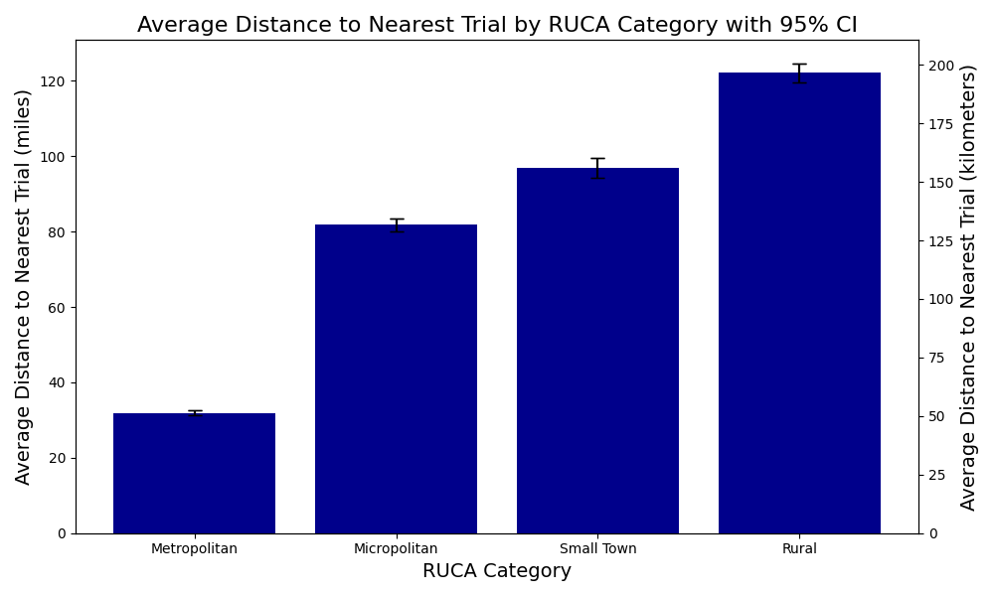
Figure S5. Average Distance to Nearest Clinical study by RUCA Category with 95% Confidence Intervals. The bar graph shows the average distance to the nearest clinical study for autoimmune conditions, categorized by RUCA classification: Metropolitan, Micropolitan, Small Town, and Rural. Distances are shown in miles and kilometers with 95% confidence intervals. This graph shows that participants in rural areas face the greatest average distance to study sites, showing significant disparities in clinical study accessibility based on geographic classification.
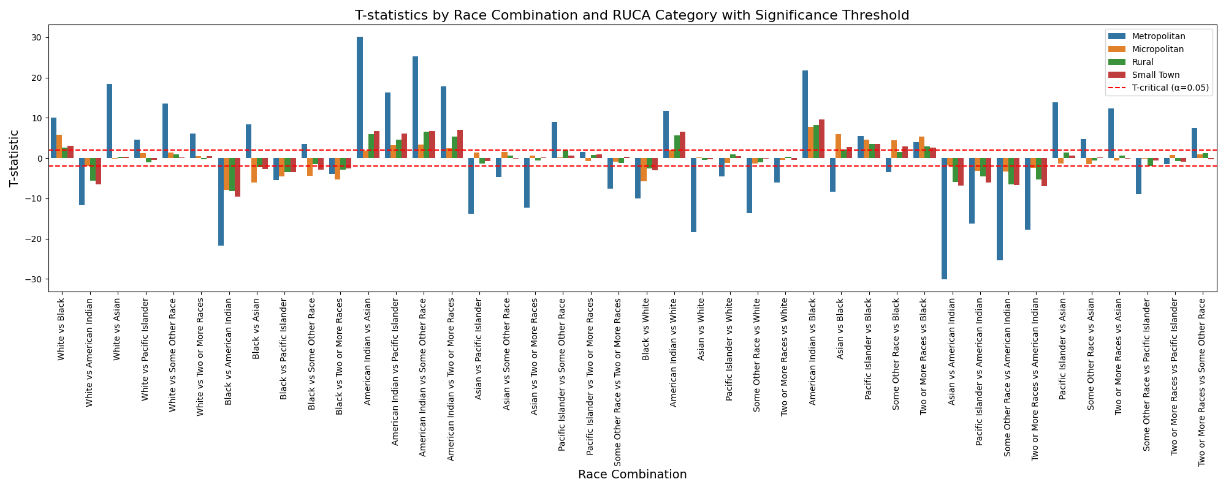
Figure S6. T-Statistics by Race Combination and RUCA Category with Significance Threshold. This bar chart presents the T-statistics for comparisons of clinical study accessibility across various racial combinations and RUCA categories (Metropolitan, Micropolitan, Rural, and Small Town). Each bar color represents a specific RUCA category. The red dashed line marks the significance threshold (T-critical = ±1.96, α = 0.05), with values above or below this line indicating statistically significant differences in accessibility between racial groups. The chart shows substantial variability in T-statistics across combinations, with notable disparities in both metropolitan and rural areas, underscoring the role of both race and geography in clinical study accessibility.

