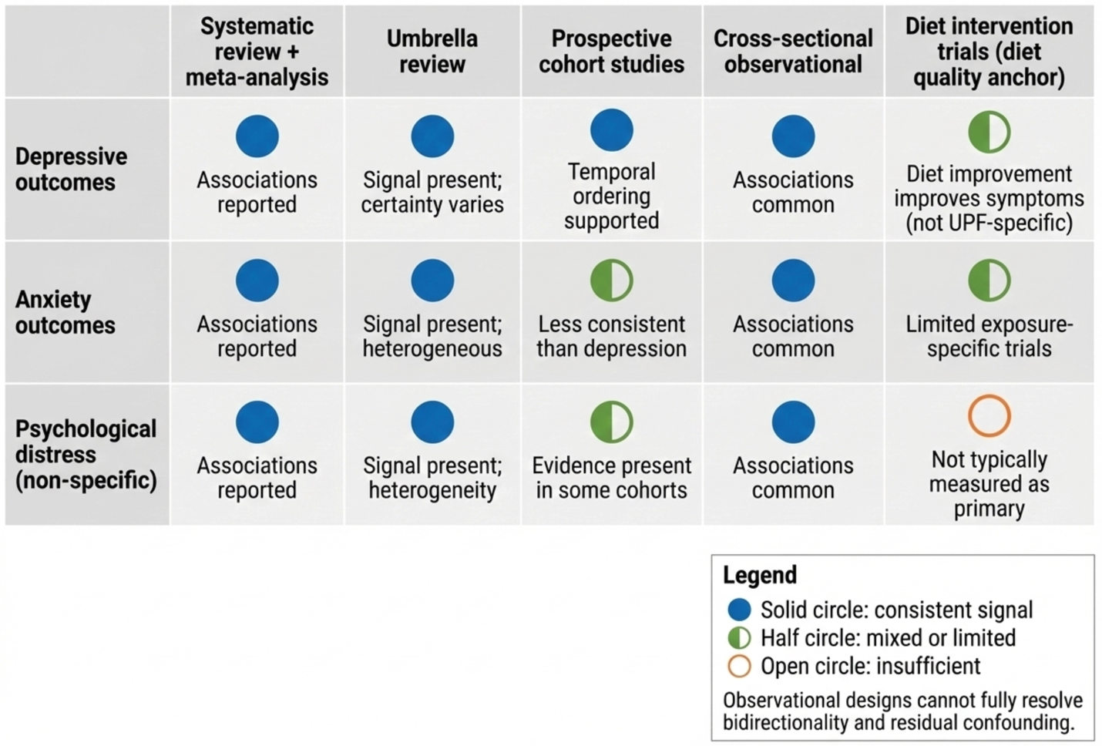
Supplementary Fig. S1. Epidemiologic evidence linking ultra-processed food (UPF) exposure to common mental disorder-related outcomes, organized by study design. The figure summarizes the evidence base synthesized in this review by separating pooled observational syntheses (systematic reviews, meta-analyses, umbrella review) from prospective cohort studies to clarify where temporal ordering is more strongly supported. Outcomes are grouped as depressive outcomes, anxiety-related outcomes, and non-specific psychological distress, reflecting common operationalizations in population research (for example, PHQ-9, GAD-7, and K6 as representative anchors). The figure is intended to communicate differences in strength of inference by design (cross-sectional versus prospective) rather than causal certainty, and should be interpreted in light of heterogeneity in UPF exposure metrics and outcome definitions.

