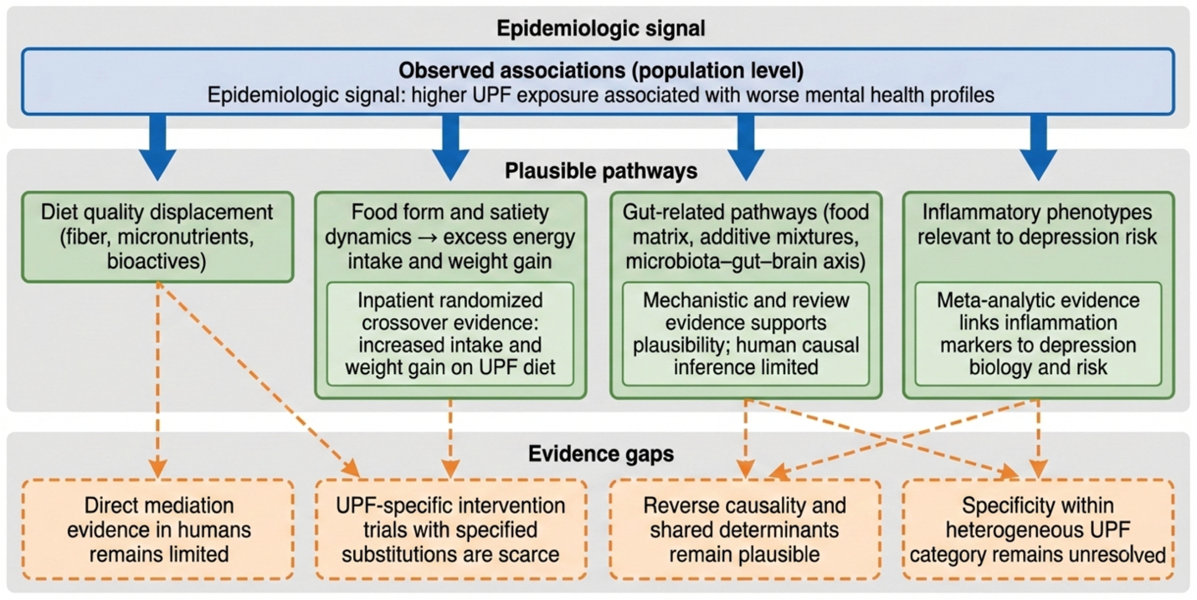
Supplementary Fig. S2. Plausible pathways consistent with observed associations between higher UPF exposure and mental health outcomes, with evidence strength distinguished across pathway elements. The figure maps four converging pathway domains discussed in this review: (1) displacement of minimally processed foods and overall diet quality shifts, (2) food structure and satiety dynamics that can increase energy intake and weight gain, (3) gut-related pathways, including food matrix and additive mixture exposures with potential microbiota–gut–brain axis perturbations, and (4) inflammatory phenotypes relevant to depressive outcomes. Elements are categorized as “supported by experimental or meta-analytic evidence,” “biologically plausible with limited human adjudication,” and “evidence gaps.” The figure is not intended to imply proven mediation or UPF-specific causal mechanisms in humans. Dietary improvement trial evidence is indicated to support diet as a modifiable lever in depression care, without isolating UPF reduction as the sole active ingredient.

