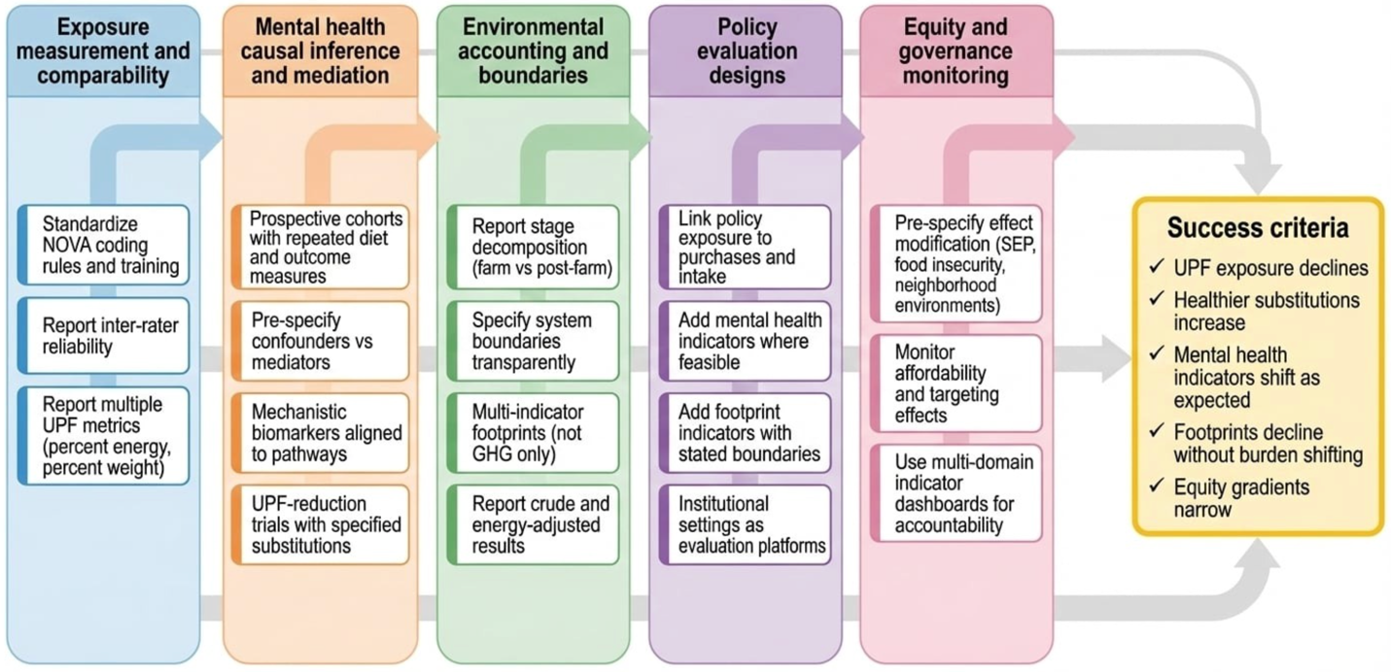
Supplementary Fig. S3. Research and monitoring roadmap for the UPF planetary nutrition nexus: measurement, causal inference, environmental accounting, policy evaluation, and equity-centered governance. The figure outlines five linked priorities: (1) improved UPF exposure measurement and classification reproducibility, including documentation of decision rules and reliability; (2) stronger mental health causal inference using repeated measures designs and explicit mediation frameworks; (3) environmental footprint methods with transparent system boundaries and routine life-cycle stage decomposition; (4) policy evaluation designs that link interventions to exposure change and downstream outcomes beyond sales or nutrient profiles, including mental health indicators where feasible; and (5) equity-centered monitoring and governance using multi-domain indicator frameworks to reduce narrow metric fixation. The roadmap is intended to align research outputs with implementable monitoring systems that can track substitution pathways and potential co-benefits across the value chain.

