Supplemental File 1: Research question 1: What socio-cultural, structural, and systemic factors contribute to the disproportionate rates of HIV among Indigenous peoples in different global regions?
(
("Indigenous" OR Aborigin* OR "First Nation*" OR Inuit OR Métis OR "American Indian*" OR "Native American*" OR "Alaska Native*" OR Maori OR Sami OR "Aboriginal Australian*" OR "Torres Strait Islander*" OR Adivasi OR "Tribal population*" OR "Indigenous community" OR "Native people*" OR "Original people*" OR "Autochthonous people*")
)
AND
(
HIV OR "Human Immunodeficiency Virus" OR AIDS OR "Acquired Immunodeficiency Syndrome" OR "HIV Infections" OR "HIV positive" OR "HIV incidence" OR "HIV prevalence" OR "HIV transmission" OR "HIV risk"
)
AND
(
Disparit* OR inequal* OR inequit* OR disproportion* OR excess* OR overrepresent* OR "burden of disease" OR "health inequit*" OR "health disparit*" OR "epidemiologic factors" OR vulnerab* OR marginali*
)
AND
(
# SOCIO-CULTURAL
"Socio-cultural factor*" OR culture OR "cultural safety" OR stigma OR discrimination OR racism OR "social stigma" OR "HIV stigma" OR gender OR "gender inequalit*" OR "sexual behaviour" OR "substance use" OR "injection drug use" OR "alcohol use" OR trauma OR "historical trauma" OR "intergenerational trauma" OR "sexual violence" OR "social determinant*" OR "social support" OR "community engagement" OR "traditional knowledge" OR "health beliefs" OR spirituality OR religion OR language
OR
# STRUCTURAL
"Structural factor*" OR "social determinant*" OR poverty OR "socioeconomic status" OR unemployment OR housing OR "food insecurity" OR "geographic isolation" OR remot* OR "access to healthcare" OR "health services accessibility" OR transportation OR incarceration OR "criminal justice system" OR "legal framework" OR policy OR legislation OR colonialism OR "colonial legacy" OR "land dispossession" OR "residential school*"
OR
# SYSTEMIC
"Systemic factor*" OR "healthcare system" OR "health policy" OR "health services" OR "healthcare access" OR "healthcare quality" OR "cultural competency" OR "provider bias" OR "institutional racism" OR "funding allocation" OR "program design" OR governance OR "data collection" OR "surveillance systems" OR "research ethics" OR "decolonizing health"
)
Supplemental File 2: Research Question 2: What are the key barriers and facilitators to initiating and sustaining PrEP use in Indigenous communities?
("Pre-Exposure Prophylaxis"[Mesh] OR "pre-exposure prophylaxis"[tiab] OR PrEP[tiab] OR "HIV preexposure prophylaxis"[tiab] OR Truvada[tiab] OR Descovy[tiab] OR "tenofovir emtricitabine"[tiab] OR "HIV prevention"[tiab])
AND
("Indigenous Peoples"[Mesh] OR Indigenous[tiab] OR "First Nations"[tiab] OR "Aboriginal and Torres Strait Islander"[tiab] OR Māori[tiab] OR "Native Hawaiian"[tiab] OR "Pacific Islander"[tiab] OR Inuit[tiab] OR "American Indian"[tiab] OR "Alaska Native"[tiab] OR "Native American"[tiab] OR "Indians, North American"[Mesh] OR "Indians, South American"[Mesh] OR "Health Services, Indigenous"[Mesh] OR "Oceanic Ancestry Group"[Mesh] OR tribe[tiab] OR tribal[tiab] OR Adivasi[tiab] OR Sami[tiab] OR Mapuche[tiab])
AND
(
(barrier*[tiab] OR challenge*[tiab] OR obstacle*[tiab] OR hindrance*[tiab] OR difficult*[tiab] OR access[tiab] OR disparit*[tiab] OR inequit*[tiab] OR stigma[tiab] OR discrimination[tiab] OR "medical mistrust"[tiab] OR "structural racism"[tiab] OR "historical trauma"[tiab] OR "health literacy"[tiab] OR cost[tiab] OR affordability[tiab] OR transportation[tiab] OR distance[tiab] OR "healthcare provider"[tiab] OR "provider bias"[tiab] OR "cultural safety"[tiab] OR "lack of privacy"[tiab] OR fear[tiab] OR "side effects"[tiab] OR adherence[tiab] OR dropout*[tiab] OR discontinu*[tiab])
OR
(facilitator*[tiab] OR enabler*[tiab] OR promot*[tiab] OR "success factor*"[tiab] OR strateg*[tiab] OR intervention*[tiab] OR "culturally appropriate"[tiab] OR "culturally safe"[tiab] OR "culturally competent"[tiab] OR "community engagement"[tiab] OR "peer support"[tiab] OR "community health worker"[tiab] OR "nurse-led"[tiab] OR "integrated care"[tiab] OR "mobile health"[tiab] OR telehealth[tiab] OR decentralized[tiab] OR "simplified monitoring"[tiab] OR "patient navigation"[tiab] OR "financial assistance"[tiab] OR "transportation support"[tiab] OR "trusted provider"[tiab] OR "health education"[tiab] OR "tailored messaging"[tiab])
OR
("PrEP initiation"[tiab] OR "PrEP uptake"[tiab] OR "PrEP adherence"[tiab] OR "PrEP persistence"[tiab] OR "PrEP continuation"[tiab] OR "PrEP discontinuation"[tiab] OR "PrEP implementation"[tiab] OR "PrEP acceptability"[tiab] OR "PrEP awareness"[tiab] OR "PrEP knowledge"[tiab])
OR
("Health Services Accessibility"[Mesh] OR "Healthcare Disparities"[Mesh] OR "Patient Acceptance of Health Care"[Mesh] OR "Medication Adherence"[Mesh] OR "Treatment Refusal"[Mesh] OR "Patient Dropouts"[Mesh] OR "Health Knowledge, Attitudes, Practice"[Mesh] OR "Social Stigma"[Mesh] OR "Cultural Competency"[Mesh] OR "Community-Based Participatory Research"[Mesh] OR "Patient Navigation"[Mesh] OR "Community Health Workers"[Mesh] OR "Implementation Science"[Mesh])
)
Supplemental File 3. Preferred Reporting Items for Systematic Reviews and Meta-Analyses (PRISMA) flow chart for research question 1 (What socio-cultural, structural, and systemic factors contribute to the disproportionate rates of HIV among Indigenous peoples in different global regions?)
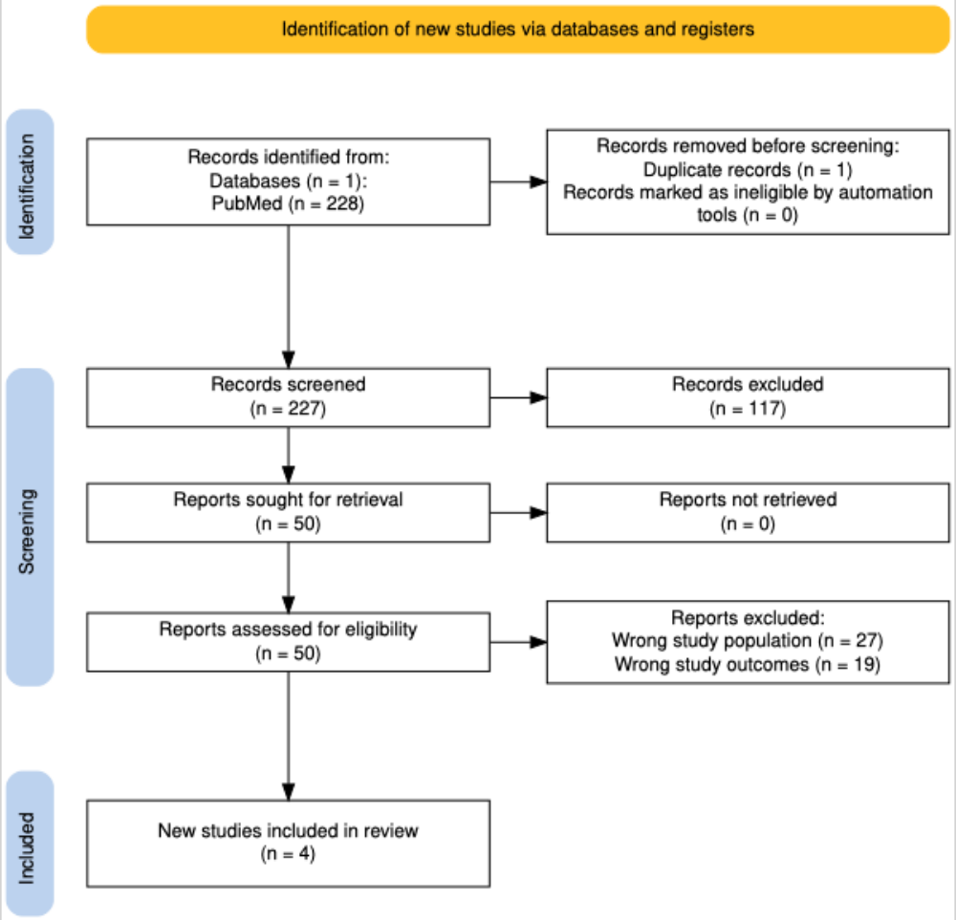
Supplemental File 4. Preferred Reporting Items for Systematic Reviews and Meta-Analyses (PRISMA) flow chart for research question 2 (What are the key barriers and facilitators to initiating and sustaining PrEP use in Indigenous communities?)
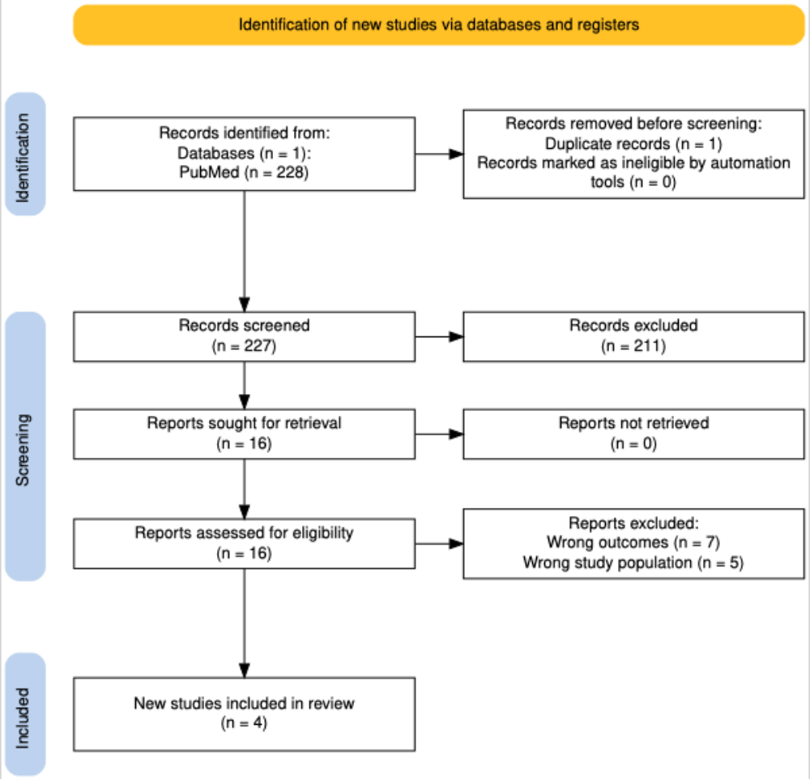
Supplemental File 5: Checklist to guide the extraction of information for research question 1 (What socio-cultural, structural, and systemic factors contribute to the disproportionate rates of HIV among Indigenous peoples in different global regions?)
Indigenous Population | (e.g., First Nations, Aboriginal and Torres Strait Islander, American Indian, Māori, specific tribe/nation if named)
Study Design | (e.g., Qualitative, Quantitative, Mixed-Methods, Review)

Population focus options
[ ] MSM
[ ] People Who Inject Drugs (PWID)
[ ] Sex Workers
[ ] Women
[ ] Youth
[ ] General Population
[ ] Other: _________
Factors Contributing to HIV Disparities by Factor Category and Specific Factor
SOCIO-CULTURAL FACTORS
Stigma (general, HIV-related)
Discrimination & Racism (interpersonal)
Gender Inequality & IPV
Sexual Behaviour Norms/Practices
Substance Use (non-injecting, e.g., alcohol)
Injection Drug Use
Historical/Intergenerational Trauma
Distrust (of gov't, medical system)
Spirituality/Healing Practices
Language & Communication Barriers
Other Socio-cultural: _________
STRUCTURAL FACTORS
Poverty & Low Socioeconomic Status
Unemployment & Underemployment
Housing Insecurity & Overcrowding
Food Insecurity
Geographic Isolation & Lack of Transport
Incarceration & Criminalization
Colonialism & Legacy Policies (e.g., child removal)
Other Structural: _________
SYSTEMIC FACTORS (within health systems)
Poor Healthcare Accessibility
Lack of Cultural Safety/Competency
Provider Bias & Discrimination
Fragmented/Underfunded Health Services
Lack of Indigenous Leadership in Program Design
Inappropriate/Unavailable Prevention Programs
Weak HIV Surveillance & Data Gaps
Other Systemic: _________

Supplemental File 6: Data extraction guide for research question 2 (What are the key barriers and facilitators to initiating and sustaining PrEP use in Indigenous communities?)
Indigenous Population | (e.g., First Nations, Aboriginal and Torres Strait Islander, American Indian, Māori, specific tribe/nation if named)
Study Design | (e.g., Qualitative, Quantitative, Mixed-Methods, Review)
Participant Group | (e.g., Potential PrEP users, Current PrEP users, Healthcare providers, Community leaders, Youth, Women, MSM)

B1: BARRIERS to PrEP Initiation and Sustained Use
Code Category | Specific Barrier | Population Group
Knowledge & Awareness | Low PrEP Awareness | Potential Users
 | Misinformation | Community
Structural & Access | Cost & Insurance | Patients
 | Geographic & Transportation | Patients
 | Clinic Hours & Wait Times | Patients
Healthcare System | Provider Lack of Knowledge | Providers
 | Provider Bias & Stigma | Providers/Patients
 | Lack of Cultural Safety | Patients
 | Fragmented Care | System
Social & Cultural | HIV Stigma & Shame | Community/Patients
 | Substance Use Stigma | Patients
 | Homophobia / Transphobia | Community/Patients
 | Medical Mistrust | Community/Patients
 | Colonial Legacy | Community
Individual | Fear of Side Effects | Patients
 | Low Perceived Risk | Patients
 | Adherence Challenges | Patients
 | Privacy Concerns | Patients

B2: FACILITATORS to PrEP Initiation and Sustained Use
Code Category | Specific Facilitator | Population Group
Culturally-Grounded Strategies | Community Leadership & Ownership | System/Community
 | Elders' Support & Blessing | Community
 | Integration with Cultural Values | Intervention
 | Use of Traditional Stories/Art | Intervention
Healthcare System & Access | Culturally Safe Providers | Providers
 | Embedding Indigenous Staff | System
 | Patient Navigation Systems | System
 | Integrated & Co-located Services | System
 | Flexible & Low-Barrier Care | System
 | Financial Support | System
Social & Peer Support | Peer Education & Outreach | Community
 | Destigmatizing Campaigns | Community
 | Supportive Social Networks | Patients
Education & Messaging | Culturally-Tailored Messaging | Intervention
 | Trauma-Informed Communication | Providers
 | Plain-Language Information | Intervention

Supplementary Table 7. Details of excluded studies for research question 1 - What socio-cultural, structural, and systemic factors contribute to the disproportionate rates of HIV among Indigenous peoples in different global regions?
S/N | NAME OF AUTHOR | TITLE | REASON FOR EXCLUSION
1 | Villacis-Alvarez et al., 2025 | "Our needs, our priorities, listen to us!" Recommendations for improving HIV prevention and the cascade of care from people living with HIV in Manitoba, Canada: a qualitative study. | Wrong population
2 | Thompson et al., 2009 | "Slowed right down": Insights into the use of alcohol from research with Aboriginal Australians living with HIV. | Wrong outcome
3 | Redman-MacLaren et al., 2017 | Implications of male circumcision for women in Papua New Guinea: a transformational grounded theory study. | Wrong outcome
4 | Burke et al., 2024 | Reasons for disengagement from antiretroviral care in the era of "Treat All" in low- or middle-income countries: a systematic review. | Wrong population
5 | Cavaleri et al., 2010 | Barriers to HIV care: an exploration of the complexities that influence engagement in and utilization of treatment. | Wrong population
6 | Oliver et al., 2015 | 'Women are supposed to be the leaders': intersections of gender, race, and colonisation in HIV prevention with Indigenous young people. | Wrong outcome
7 | Pearce et al., 2019 | "Another thing to live for": Supporting HCV treatment and cure among Indigenous people impacted by substance use in Canadian cities. | Wrong outcome
8 | Nowshin et al., 2022 | Sexual and reproductive health and rights of "last mile" adolescents: a scoping review. | Wrong population
9 | Moore et al., 2024 | Structural violence and necropolitics among Indigenous Peoples living with HIV who use substances in the Prairie provinces during COVID-19. | Wrong outcome
10 | Ubrihien et al., 2022 | Barriers and enablers for young Aboriginal people in accessing public sexual health services: A mixed-method systematic review. | Wrong outcome
11 | Kronfli et al., 2017 | Access and engagement in HIV care among a national cohort of women living with HIV in Canada. | Wrong population
12 | Erickson et al., 2022 | "They look at you like you're contaminated": how HIV-related stigma shapes access to care for incarcerated women living with HIV in a Canadian setting. | Wrong population
13 | Mullens et al., 2018 | Exploring HIV risks, testing, and prevention among sub-Saharan African community members in Australia. | Wrong population
14 | Lemons et al., 2018 | Characteristics of HIV-Positive Transgender Men Receiving Medical Care: United States, 2009-2014. | Wrong outcome
15 | Ngunyulu et al., 2017 | Collaborative HIV care in primary health care: nurses' views. | Wrong population
16 | Ojoet al., 1997 | Economic and demographic consequences of AIDS in Namibia: rapid assessment of the costs. | Wrong population
17 | Spurlin et al., 2019 | Queer Theory and Biomedical Practice: The Biomedicalization of Sexuality/The Cultural Politics of Biomedicine. | Wrong outcome
18 | Gogishvili et al., 2021 | Late HIV diagnosis among immigrants in Spain vs. native-born Spaniards, 2010-15. | Wrong population
19 | Rich et al., 2022 | Exploring the beliefs, experiences, and impacts of HIV-related self-stigma amongst adolescents and young adults living with HIV in Harare, Zimbabwe: A qualitative study. | Wrong population
20 | Gelpí-Acosta et al., 2021 | Toward Community Empowerment: The Puerto Rican Ganchero. | Wrong population
21 | Tingey et al., 2015 | Increasing access to screening for blood-borne viruses and sexually transmissible infections for Aboriginal and Torres Strait Islander Australians: evaluation of the Deadly Liver Mob program's 'cascade of care' across nine sites in New South Wales, Australia. | Wrong outcome
22 | Sánchez-Gómez et al., 2016 | Social factors associated with the use of prenatal care in Ecuador | Wrong population
23 | Andermann et al., 2017 | Outbreaks in the age of syndemics: New insights for improving Indigenous health | Wrong outcome
24 | McClarty et al., 2021 | Leaving no one behind? An equity analysis of the HIV care cascade among a cohort of people living with HIV in Manitoba, Canada. | Wrong population
25 | Ikeda et al., 2018 | Risk Behaviors and Perceptions Among Self-identified Men Who Have Sex with Men (MSM), Bisexuals, Transvestites, and Transgender Women in Western Guatemala. | Wrong population
26 | Ponce et al., 2017 | Indigenous peoples, HIV and public policy in Latin America: an exploration of the current situations of epidemiological prevalence, prevention, care and timely treatment | Wrong population
27 | Cavaleri et al., 2010 | Barriers to HIV care: an exploration of the complexities that influence engagement in and utilization of treatment. | Wrong population
28 | Lua et al., 2023 | The effects of social determinants of health on acquired immune deficiency syndrome in a low-income population of Brazil: a retrospective cohort study of 28.3 million individuals. | Wrong population
29 | Bertolli et al., 2004 | Surveillance systems monitoring HIV/AIDS and HIV risk behaviors among American Indians and Alaska Natives. | Wrong outcome
30 | O’Regan et al., 2023 | Inequality in Health Care and the Experiences of Women From the Irish Traveller Community. | Wrong population
31 | Daniels et al., 2021 | INPACVIH: tackling HIV in Peru's indigenous communities. | Wrong outcome
32 | Gorgos et al., 2006 | Determinants of survival for Native American adults with HIV infection. | Wrong outcome
33 | Osborne et al., 2019 | Meaningful Engagement as a Cornerstone for Implementing the Key Recommendations to Advance the Sexual and Reproductive Health and Rights of Women Living With HIV Across Policy, Practice, and Research in Canada. | Wrong population
34 | Mullens et al., 2018 | Exploring HIV risks, testing, and prevention among sub-Saharan African community members in Australia. | Wrong population
35 | Larcombe et al., 2019 | A Dene First Nation's community readiness assessment to take action against HIV/AIDS: a pilot project. | Wrong outcome
36 | Palacios et al., 2015 | Storytelling: A Qualitative Tool to Promote Health Among Vulnerable Populations. | Wrong population
37 | O’Rouke et al., 2025 | Preexposure Prophylaxis for HIV Prevention: Awareness and Interest among a Northern Midwestern US Indigenous Population. | Wrong outcome
38 | Aghaizu et al., 2018 | HIV incidence among sexual health clinic attendees in England: First estimates for black African heterosexuals using a biomarker, 2009-2013. | Wrong population
39 |  | Impact of COVID-19 Among Immigrant and Communities of Color Living with HIV in Oregon, 2020: Two Pandemics Rooted in Racism. | Wrong outcome
40 | Wood et al., 2012 | 'Every teacher is a researcher!': Creating indigenous epistemologies and practices for HIV prevention through values-based action research. | Wrong outcome
41 | Wood et al., | Sociodemographic disparities in access to addiction treatment among a cohort of Vancouver injection drug users | Wrong population
42 | Tyndall et al., 2006 | HIV seroprevalence among participants at a Supervised Injection Facility in Vancouver, Canada: implications for prevention, care and treatment. | Wrong population
43 | Treloar et al., 2014 | "I can't do this, it's too much": building social inclusion in cancer diagnosis and treatment experiences of Aboriginal people, their carers and health workers. | Wrong outcome
44 | Touloumiet al., 2020 | Design and Development of a Viral Hepatitis and HIV Infection Screening Program (Hprolipsis) for the General, Greek Roma, and Migrant Populations of Greece: Protocol for Three Cross-Sectional Health Examination Surveys. | Wrong population
45 | Li et al., 2024 | Disparities in Tuberculosis Incidence by Race and Ethnicity Among the U.S.-Born Population in the United States, 2011 to 2021: An Analysis of National Disease Registry Data. | Wrong outcome
46 | Walters et al., 2024 | Mentoring the Mentors of Underrepresented Racial/Ethnic Minorities Who are Conducting HIV Research: Beyond Cultural Competency. | Wrong population
Supplementary Table 8. Details of excluded studies for research question 2 - What are the key barriers and facilitators to initiating and sustaining PrEP use in Indigenous communities?
S/N | NAME OF AUTHOR | TITLE | REASON FOR EXCLUSION
1 | Bever et al.,2019 | Cohort profile: the STOP HIV/AIDS Program Evaluation (SHAPE) study in British Columbia, Canada. | Wrong population
2 | Rueda et al., 2023 | Social and structural barriers and facilitators to HIV healthcare and harm reduction services for people experiencing syndemics in Manitoba: study protocol. | Wrong population
3 | Moore et al., 2024 | Structural violence and necropolitics among Indigenous Peoples living with HIV who use substances in the Prairie provinces during COVID-19. | Wrong outcome
4 | Rich et al., 2022 | Exploring the beliefs, experiences, and impacts of HIV-related self-stigma amongst adolescents and young adults living with HIV in Harare, Zimbabwe: A qualitative study. | Wrong outcome
5 | Pascom et al., 2018 | Sociodemographic determinants of attrition in the HIV continuum of care in Brazil, in 2016. | Wrong population
6 | Souleymanov et al., 2025 | Systemic inequities and sources of resilience: challenges faced by Indigenous women living with HIV during COVID-19 in the Canadian prairies. | Wrong population
7 | Shannon et al., 2008 | Mapping violence and policing as an environmental-structural barrier to health service and syringe availability among substance-using women in street-level sex work. | Wrong population and outcome
8 | Burks et al., 2011 | American Indian gay, bisexual, and two-spirit men: a rapid assessment of HIV/AIDS risk factors, barriers to prevention, and culturally-sensitive intervention. | Wrong outcome
9 | Treloar et al., 2014 | "I can't do this, it's too much": building social inclusion in cancer diagnosis and treatment experiences of Aboriginal people, their carers and health workers. | Wrong outcome
10 | Jongbloed et al., 2016 | The Cedar Project WelTel mHealth intervention for HIV prevention in young Indigenous people who use illicit drugs: study protocol for a randomized controlled trial. | Wrong outcome
11 | Ruffinen et al., 2015 | Point-of-care screening for syphilis and HIV in the borderlands: challenges in implementation in the Brazilian Amazon. | Wrong outcome
12 | Larcombe et al., 2023 | "Because of COVID…": The impacts of COVID-19 on First Nation people accessing the HIV cascade of care in Manitoba, Canada. | Wrong outcome

