Supplementary Table 1 Adjusted Odds Ratios from the BDHS 2017–18 Used to Derive Informative Priors, with Corresponding Log-Odds Estimates and Standard Errors
Variable | Category | AOR | Lower CI | Upper CI | log(OR) | log(Lower CI) | log(Upper CI) | SE
Gender | Female | 1.0 | — | — | 0 | — | — | —
 | Male | 0.94 | 0.85 | 1.04 | -0.0619 | -0.1625 | 0.0392 | 0.0515
Marital_Status | No | 1.0 | — | — | 0 | — | — | —
 | Yes | 1.26 | 1.01 | 1.57 | 0.2311 | 0.00995 | 0.451 | 0.1117
BMI | Normal | 1.0 | — | — | 0 | — | — | —
 | Overweight | 1.6 | 1.4 | 1.9 | 0.4700 | 0.3365 | 0.6419 | 0.0776
 | Obese | 1.9 | 1.5 | 2.5 | 0.6419 | 0.4055 | 0.9163 | 0.1306
Wealth Index | Poorest | 1.0 | — | — | 0 | — | — | —
 | Poorer | 1.0 | 0.8 | 1.3 | 0 | -0.2231 | 0.2624 | 0.1249
 | Middle | 1.3 | 1.0 | 1.7 | 0.2624 | 0 | 0.5306 | 0.1353
 | Richer | 1.7 | 1.3 | 2.2 | 0.5306 | 0.2624 | 0.7885 | 0.1345
 | Richest | 2.6 | 2.0 | 3.3 | 0.9555 | 0.6931 | 1.1939 | 0.1276
Residence | Rural | 1.0 | — | — | 0 | — | — | —
 | Urban | 1.0 | 0.9 | 1.2 | 0 | -0.1054 | 0.1823 | 0.0737
Division | Dhaka | 1.0 | — | — | 0 | — | — | —
 | Chattagram | 0.7 | 0.6 | 0.9 | -0.3567 | -0.5108 | -0.1054 | 0.1037
 | Barishal | 0.7 | 0.5 | 1.0 | -0.3567 | -0.6931 | 0 | 0.1767
 | Khulna | 0.5 | 0.4 | 0.7 | -0.6931 | -0.9163 | -0.3567 | 0.1434
 | Mymensingh | 0.6 | 0.5 | 0.8 | -0.5108 | -0.6931 | -0.2231 | 0.1193
 | Rajshahi | 0.6 | 0.5 | 0.8 | -0.5108 | -0.6931 | -0.2231 | 0.1193
 | Rangpur | 0.4 | 0.3 | 0.6 | -0.9163 | -1.2039 | -0.5108 | 0.1776
 | Sylhet | 0.7 | 0.5 | 0.9 | -0.3567 | -0.6931 | -0.1054 | 0.1485
Education | No education | 1.0 | — | — | 0 | — | — | —
 | Primary | 1.2 | 1.0 | 1.5 | 0.1823 | 0 | 0.4055 | 0.1033
 | Secondary and Above | 1.2 | 1.0 | 1.5 | 0.1823 | 0 | 0.4055 | 0.1033
Hypertension | No | 1 | — | — | 0 | — | — | —
 | Yes | 1.52 | 1.36 | 1.69 | 0.4191 | 0.3075 | 0.5258 | 0.0553
Age | 18-34 | 1 | — | — | 0 | — | — | —
 | 35-64 | 2.50 | 2.20 | 2.85 | 0.9163 | 0.7885 | 1.0473 | 0.0660
 | 65+ | 3.29 | 2.73 | 3.96 | 1.1900 | 1.003 | 1.3780 | 0.0963

Supplementary Table 2 Comparison of Bayesian Models Using Leave-One-Out Cross-Validation (LOO) and Widely Applicable Information Criterion (WAIC)
Model | Structure | Prior | LOOIC | SE (LOOIC) | ΔLOOIC | WAIC | SE (WAIC) | ΔWAIC
Model A | No Cluster | Informative | 11116.37 | 163.89 | 296.74 | 11116.36 | 163.89 | 298.69
Model B | With Cluster | Informative | 10819.63 | 161.94 | 0.00 | 10817.67 | 161.89 | 0.00
Model C | With Cluster | Weakly Informative | 10821.34 | 163.21 | 1.71 | 10819.35 | 163.16 | 1.68

Supplementary Table 3 Bayesian Model Convergence Diagnostics Based on Gelman–Rubin Statistic ($\hat{R}$) Across All Models
Diagnostic | Minimum R̂ | Maximum R̂ | Convergence Criterion | Decision
Gelman–Rubin (R̂) | 0.9999 | 1.0003 | R̂ < 1.01 | Converged

Supplementary Table 4 Posterior Odds Ratios and Convergence Diagnostics from Bayesian Logistic Regression with Informative Prior (No Cluster)
Variable | Characteristics | OR | 95% CrI | R̂ | Bulk ESS | Tail ESS
Intercept | – | 0.06 | (0.05, 0.07) | 1.000 | 31,869.36 | 30,750.03
Age | 18–34 years (Ref.) | 1.00 | Reference | – | – | –
 | 35–64 years | 2.52 | (2.32, 2.74) | 1.000 | 31,755.87 | 30,757.21
 | ≥65 years | 3.34 | (2.95, 3.78) | 1.000 | 31,511.51 | 30,907.16
Gender | Female (Ref.) | 1.00 | Reference | – | – | –
 | Male | 0.92 | (0.86, 0.99) | 1.000 | 30,565.46 | 31,722.05
Education | No education (Ref.) | 1.00 | Reference | – | – | –
 | Primary | 1.14 | (1.02, 1.27) | 1.000 | 31,085.66 | 31,191.53
 | Secondary or above | 1.08 | (0.97, 1.19) | 1.000 | 31,505.81 | 31,886.76
Marital Status | Not married (Ref.) | 1.00 | Reference | – | – | –
 | Married | 1.12 | (1.00, 1.25) | 1.000 | 31,875.32 | 31,599.22
BMI | Normal/Underweight (Ref.) | 1.00 | Reference | – | – | –
 | Overweight | 1.47 | (1.34, 1.61) | 1.000 | 31,273.09 | 31,802.81
 | Obesity | 1.91 | (1.64, 2.21) | 1.000 | 31,572.48 | 30,391.85
Hypertension | No (Ref.) | 1.00 | Reference | – | – | –
 | Yes | 1.53 | (1.42, 1.65) | 1.000 | 32,082.10 | 32,003.31
Wealth Index | Poorest (Ref.) | 1.00 | Reference | – | – | –
 | Poorer | 1.16 | (1.01, 1.32) | 1.000 | 32,366.44 | 31,556.54
 | Middle | 1.39 | (1.22, 1.58) | 1.000 | 31,723.10 | 31,384.79
 | Richer | 1.57 | (1.38, 1.79) | 1.000 | 31,896.85 | 29,838.67
 | Richest | 2.20 | (1.94, 2.51) | 1.000 | 32,201.80 | 31,188.12
Residence | Rural (Ref.) | 1.00 | Reference | – | – | –
 | Urban | 1.14 | (1.05, 1.24) | 1.000 | 31,600.43 | 31,848.78
Division | Dhaka (Ref.) | 1.00 | Reference | – | – | –
 | Barishal | 0.71 | (0.59, 0.85) | 1.000 | 31,222.43 | 31,847.18
 | Chattogram | 0.85 | (0.76, 0.95) | 1.000 | 32,371.97 | 31,929.67
 | Khulna | 0.59 | (0.51, 0.68) | 1.000 | 32,211.60 | 31,930.96
 | Mymensingh | 0.59 | (0.50, 0.69) | 1.000 | 32,042.38 | 31,834.75
 | Rajshahi | 0.53 | (0.46, 0.60) | 1.000 | 29,859.02 | 30,509.20
 | Rangpur | 0.76 | (0.66, 0.88) | 1.000 | 32,570.18 | 32,012.90
 | Sylhet | 0.82 | (0.69, 0.96) | 1.000 | 31,571.91 | 32,011.39
Smoking Status | No (Ref.) | 1.00 | Reference | – | – | –
 | Yes | 0.98 | (0.82, 1.17) | 1.000 | 31,262.33 | 31,153.02
Physical Exercise | No (Ref.) | 1.00 | Reference | – | – | –
 | Yes | 0.76 | (0.55, 1.04) | 1.000 | 32,049.08 | 31,682.40

Supplementary Table 5 Posterior Odds Ratios and Convergence Diagnostics from Multilevel Bayesian Logistic Regression with Weakly Informative Prior (Cluster)
Variable | Characteristics | OR | 95% CrI | R̂ | Bulk ESS | Tail ESS
Intercept | – | 0.04 | (0.03, 0.06) | 1.000 | 31,559.42 | 31,761.60
Age | 18–34 years (Ref.) | 1.00 | Reference | – | – | –
 | 35–64 years | 2.79 | (2.45, 3.18) | 1.000 | 32,293.47 | 31,888.92
 | ≥65 years | 3.75 | (3.10, 4.53) | 1.000 | 31,929.33 | 31,060.77
Gender | Female (Ref.) | 1.00 | Reference | – | – | –
 | Male | 0.88 | (0.80, 0.98) | 1.000 | 32,672.56 | 31,973.74
Education | No education (Ref.) | 1.00 | Reference | – | – | –
 | Primary | 1.14 | (0.98, 1.31) | 1.000 | 31,718.12 | 31,295.44
 | Secondary or above | 1.11 | (0.96, 1.29) | 1.000 | 31,973.75 | 30,998.50
Marital Status | Not married (Ref.) | 1.00 | Reference | – | – | –
 | Married | 1.06 | (0.92, 1.22) | 1.000 | 32,066.72 | 32,057.51
BMI | Normal/Underweight (Ref.) | 1.00 | Reference | – | – | –
 | Overweight | 1.40 | (1.24, 1.57) | 1.000 | 32,493.72 | 32,289.06
 | Obesity | 1.94 | (1.59, 2.38) | 1.000 | 32,705.74 | 32,125.83
Hypertension | No (Ref.) | 1.00 | Reference | – | – | –
 | Yes | 1.63 | (1.45, 1.84) | 1.000 | 32,321.44 | 31,596.93
Wealth Index | Poorest (Ref.) | 1.00 | Reference | – | – | –
 | Poorer | 1.16 | (0.96, 1.40) | 1.000 | 31,560.68 | 31,598.78
 | Middle | 1.31 | (1.08, 1.58) | 1.000 | 31,479.22 | 31,631.37
 | Richer | 1.49 | (1.23, 1.81) | 1.000 | 31,851.20 | 31,717.24
 | Richest | 2.03 | (1.66, 2.49) | 1.000 | 32,013.58 | 31,725.50
Residence | Rural (Ref.) | 1.00 | Reference | – | – | –
 | Urban | 1.38 | (1.17, 1.62) | 1.000 | 30,973.30 | 31,053.83
Division | Dhaka (Ref.) | 1.00 | Reference | – | – | –
 | Barishal | 0.78 | (0.57, 1.06) | 1.000 | 32,630.63 | 32,003.87
 | Chattogram | 0.98 | (0.77, 1.25) | 1.000 | 31,211.36 | 31,448.26
 | Khulna | 0.70 | (0.54, 0.91) | 1.000 | 30,961.11 | 31,430.12
 | Mymensingh | 0.64 | (0.47, 0.85) | 1.000 | 31,612.39 | 31,432.95
 | Rajshahi | 0.56 | (0.43, 0.73) | 1.000 | 32,250.77 | 31,762.69
 | Rangpur | 0.89 | (0.68, 1.15) | 1.000 | 29,706.38 | 31,053.80
 | Sylhet | 0.97 | (0.72, 1.30) | 1.000 | 31,449.07 | 31,256.99
Smoking Status | No (Ref.) | 1.00 | Reference | – | – | –
 | Yes | 0.99 | (0.82, 1.19) | 1.000 | 32,162.21 | 31,549.99
Physical Exercise | No (Ref.) | 1.00 | Reference | – | – | –
 | Yes | 0.77 | (0.55, 1.06) | 1.000 | 31,609.16 | 31,480.84

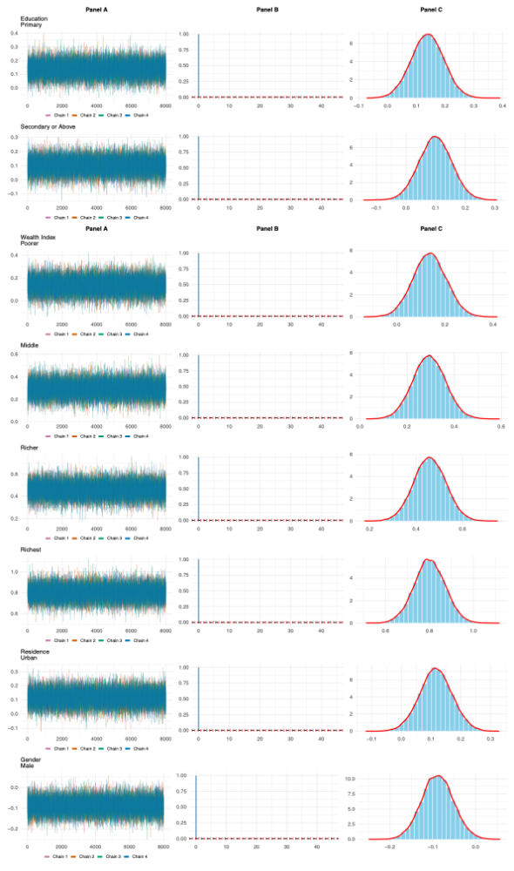
Supplementary Figure 1: Trace, ACF, and Density plots of covariance estimates from MCMC-based multilevel Bayesian logistic with informative prior.
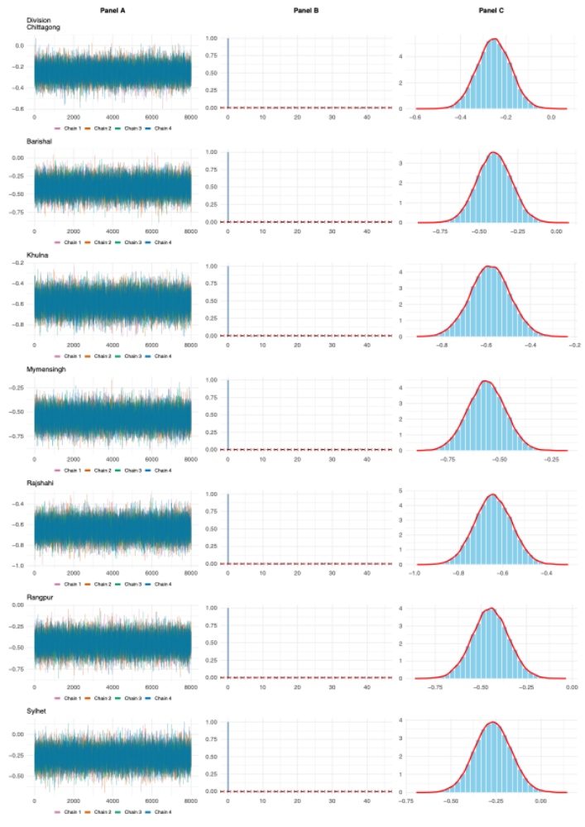
Supplementary Figure 2: Trace, ACF, and Density plots of covariance estimates from MCMC-based Multi-level Bayesian logistic with informative prior.
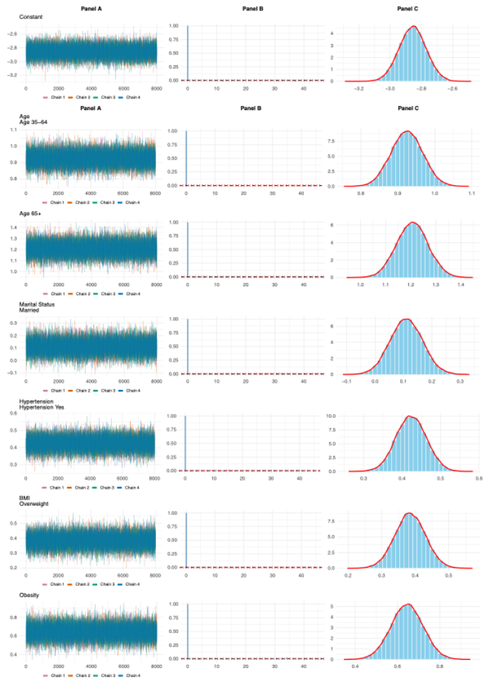
Supplementary Figure 3: Trace, ACF, and Density plots of covariance estimates from MCMC-based Bayesian logistic with informative prior.
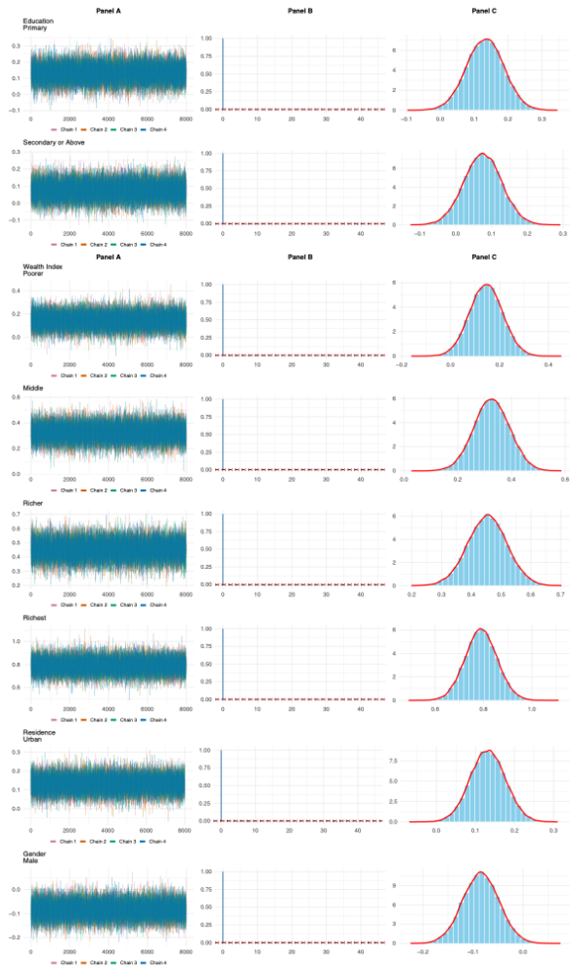
Supplementary Figure 4: Trace, ACF, and Density plots of covariance estimates from MCMC-based Bayesian logistic with informative prior.
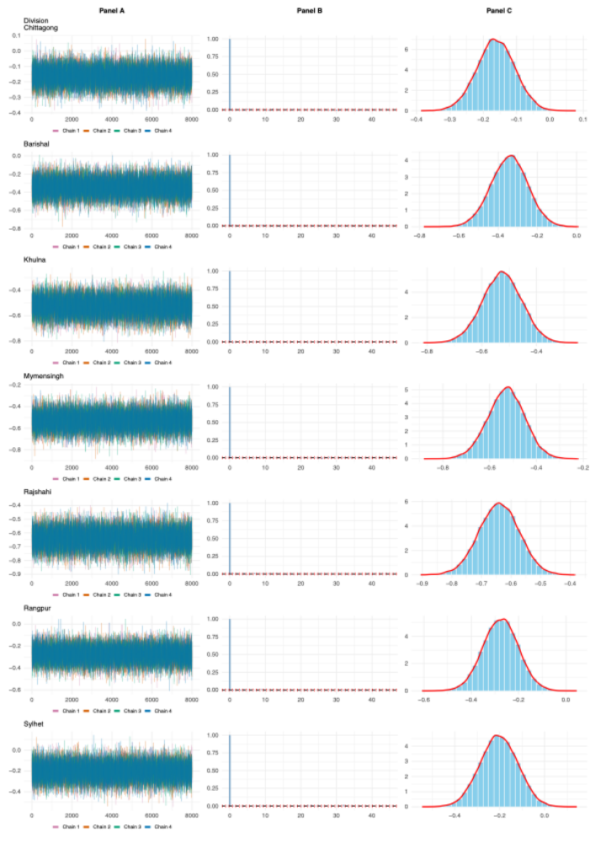
Supplementary Figure 5: Trace, ACF, and Density plots of covariance estimates from MCMC-based Bayesian logistic with informative prior.

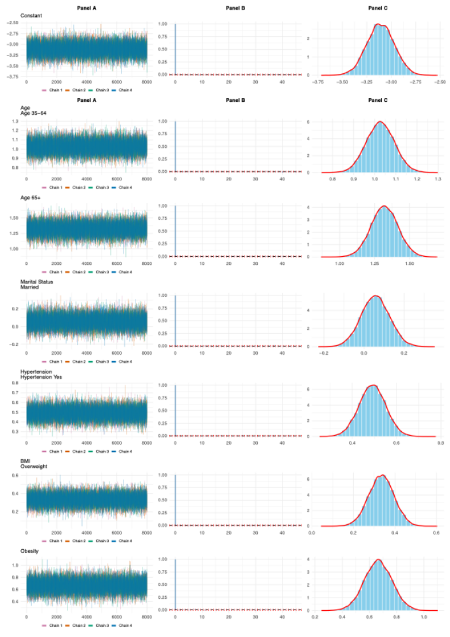
Supplementary Figure 6: Trace, ACF, and Density plots of covariance estimates from MCMC-based Multi-level Bayesian logistic with weakly informative prior.
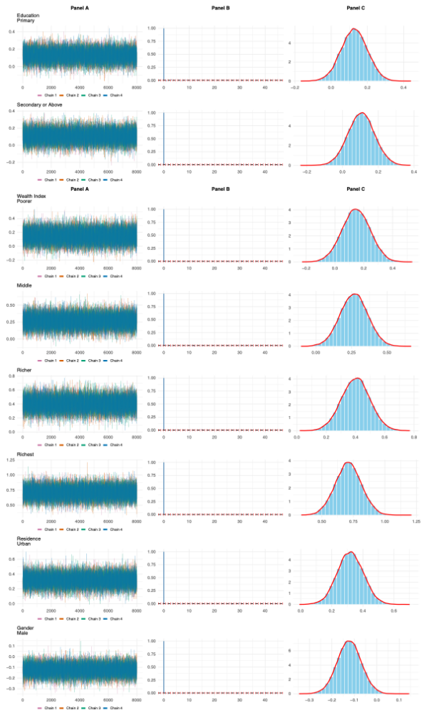
Supplementary Figure 7: Trace, ACF, and Density plots of covariance estimates from MCMC-based Multi-level Bayesian logistic with weakly informative prior.
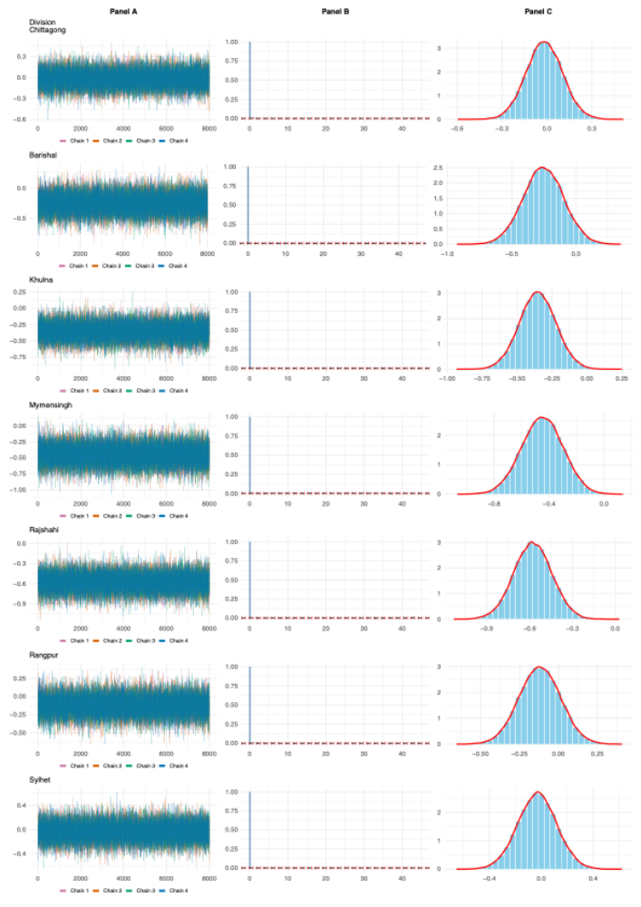
Supplementary Figure 8: Trace, ACF, and Density plots of covariance estimates from MCMC-based Multi-level Bayesian logistic with weakly informative prior.

