supplementary Materials
Public awareness and behaviors regarding plastic consumption, recycling, and microplastics among residents of Tehran, Iran

Table S1. Main inferential results
Outcome | Predictor or comparison | Test | Statistic | df | Raw p | Adjusted p | Effect size | Interpretation
Perceived cleanliness | Residential area | Kruskal-Wallis | H = 10.807 | 2 | 0.005 |  | epsilon-squared = .030 | Significant; small effect
Plastic-bag consumption | Residential area | Kruskal-Wallis | H = 6.469 | 2 | 0.039 |  | epsilon-squared = .015 | Significant; small effect
Bottle consumption | Residential area | Kruskal-Wallis | H = 1.494 | 2 | 0.474 |  | epsilon-squared < .001 | Not significant
Glove consumption | Residential area | Kruskal-Wallis | H = 0.516 | 2 | 0.772 |  | epsilon-squared < .001 | Not significant
Reaction to image | Residential area | Kruskal-Wallis | H = 1.335 | 2 | 0.513 |  | epsilon-squared < .001 | Not significant
Littering in nature | Residential area | Kruskal-Wallis | H = 1.097 | 2 | 0.578 |  | epsilon-squared < .001 | Not significant
Littering in city | Residential area | Kruskal-Wallis | H = 0.998 | 2 | 0.607 |  | epsilon-squared < .001 | Not significant
Microplastic awareness | Residential area | Kruskal-Wallis | H = 0.357 | 2 | 0.836 |  | epsilon-squared < .001 | Not significant
Animal mortality Q19 | Residential area | Kruskal-Wallis | H = 3.614 | 2 | 0.164 |  | epsilon-squared = .005 | Not significant
Human-health-risk score | Residential area | Kruskal-Wallis | H = 2.249 | 2 | 0.325 |  | epsilon-squared < .001 | Not significant
Bottle consumption | Gender | Mann-Whitney | U = 9465.00; Z = -2.288 |  | 0.022 | 0.066 | r = .132 | Not significant after Holm correction
Bag consumption | Gender | Mann-Whitney | U = 9622.50; Z = -1.937 |  | 0.053 | 0.090 | r = .112 | Not significant
Glove consumption | Gender | Mann-Whitney | U = 9939.50; Z = -2.005 |  | 0.045 | 0.090 | r = .116 | Not significant after Holm correction
Reaction to image | Gender | Mann-Whitney | U = 9630.50; Z = -2.453 |  | 0.014 | 0.043 | r = .142 | Significant after Holm correction; small effect
Animal mortality Q19 | Gender | Mann-Whitney | U = 10817.50; Z = -0.285 |  | 0.776 |  | r = .016 | Not significant
Human-health-risk score | Gender | Mann-Whitney | U = 10375.50; Z = -0.855 |  | 0.392 |  | r = .049 | Not significant
Bottle consumption | Education three levels | Kruskal-Wallis | H = 2.708 | 2 | 0.258 |  | epsilon-squared = .002 | Not significant
Bag consumption | Education three levels | Kruskal-Wallis | H = 3.709 | 2 | 0.156 |  | epsilon-squared = .006 | Not significant
Glove consumption | Education three levels | Kruskal-Wallis | H = 0.265 | 2 | 0.876 |  | epsilon-squared < .001 | Not significant
Reaction to image | Education three levels | Kruskal-Wallis | H = 3.351 | 2 | 0.187 |  | epsilon-squared = .005 | Not significant
Animal mortality Q19 | Education three levels | Kruskal-Wallis | H = 0.074 | 2 | 0.964 |  | epsilon-squared < .001 | Not significant
Human-health-risk score | Education three levels | Kruskal-Wallis | H = 4.451 | 2 | 0.108 |  | epsilon-squared = .008 | Not significant
Microplastic awareness | Education seven levels | Spearman correlation | rho = .186 |  | 0.001 |  | rho = .186 | Weak positive association
Human-health-risk score | Education seven levels | Spearman correlation | rho = .134 |  | 0.021 |  | rho = .134 | Weak positive association
Mask-disposal method | Gender; N = 296 | Pearson χ² | χ² = 1.952 | 2 | 0.377 |  | Cramer's V = .081 | Not significant
Mask-disposal method | Education three levels; N = 296 | Pearson χ² | χ² = 5.159 | 4 | 0.271 |  | Cramer's V = .093 | Not significant
Mask-disposal method | Residential area; N = 296 | Pearson χ² | χ² = 7.045 | 4 | 0.134 |  | Cramer's V = .109 | Not significant
Littering in nature | Gender | Pearson χ² | χ² = 14.678 | 4 | 0.005 |  | Cramer's V = .221 | Significant
Littering in city | Gender | Pearson χ² | χ² = 38.574 | 4 | <.001 |  | Cramer's V = .359 | Significant
Action intention Q20a | Gender | Pearson χ² | χ² = 12.733 | 4 | 0.013 |  | Cramer's V = .206 | Significant
Positive participation feeling Q24 | Gender | Pearson χ² | χ² = 14.554 | 4 | 0.006 |  | Cramer's V = .220 | Significant
Plastic-bag consumption | Middle vs Upper area | Dunn-Bonferroni | Z = -2.501 |  | 0.012 | 0.037 |  | Middle higher than Upper
Plastic-bag consumption | Upper vs Lower area | Dunn-Bonferroni | Z = -0.947 |  | 0.344 | 1.000 |  | Not significant
Plastic-bag consumption | Middle vs Lower area | Dunn-Bonferroni | Z = 0.666 |  | 0.505 | 1.000 |  | Not significant
Perceived cleanliness | Upper vs Middle area | Dunn-Bonferroni | Z = 0.396 |  | 0.692 | 1.000 |  | Not significant
Perceived cleanliness | Upper vs Lower area | Dunn-Bonferroni | Z = 3.277 |  | 0.001 | 0.003 |  | Upper higher than Lower
Perceived cleanliness | Middle vs Lower area | Dunn-Bonferroni | Z = 2.770 |  | 0.006 | 0.017 |  | Middle higher than Lower
Note: For inferential analyses, the seven original educational categories were collapsed into three groups because of small cell sizes: lower education (below diploma, student, and diploma; n = 63), undergraduate education (associate and bachelor’s degrees; n = 184), and postgraduate education (master’s and doctorate/Ph.D. degrees; n = 53). The original seven categories were retained for descriptive reporting.

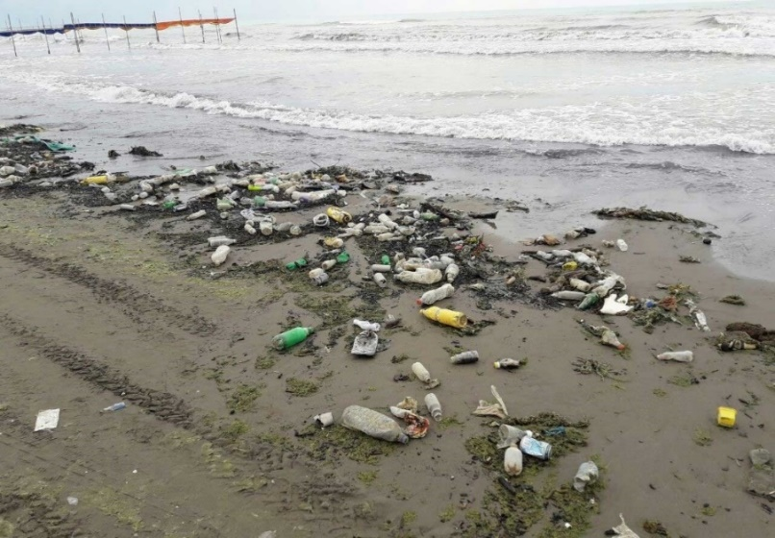
Figure S1. Photograph of plastic litter on the Caspian Sea coast presented to respondents before the visual-pollution annoyance item.

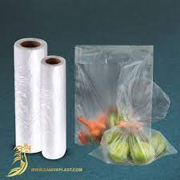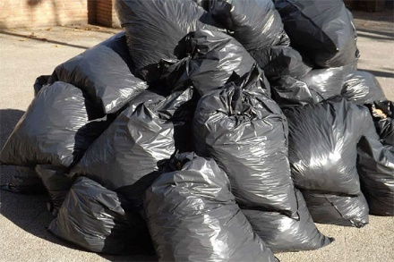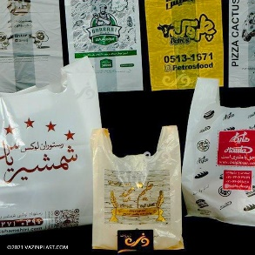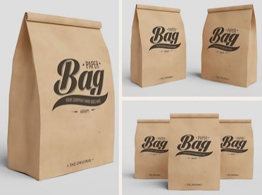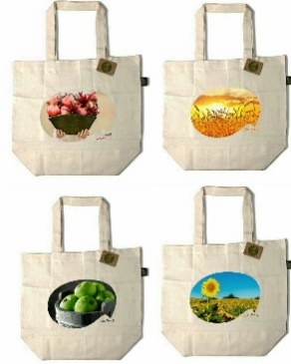
Figure S2. Images of bag types presented in the questionnaire to support item recognition: freezer bag, black garbage bag, colored shopping bag, paper bag, and reusable cloth bag. Figure S2: Photos of the types of plastic bags in the questionnaire; First row from the right, sanitary freezer bag, black garbage bag colored bags; Second row: paper bags, cloth bagGGGGGل

