Figur 1: Autocorrelation plot of Generalised additive mixed model on individual daily mean body temperature of 14 wolverines, monitored from 2011 – 2014 in Sarek study area.
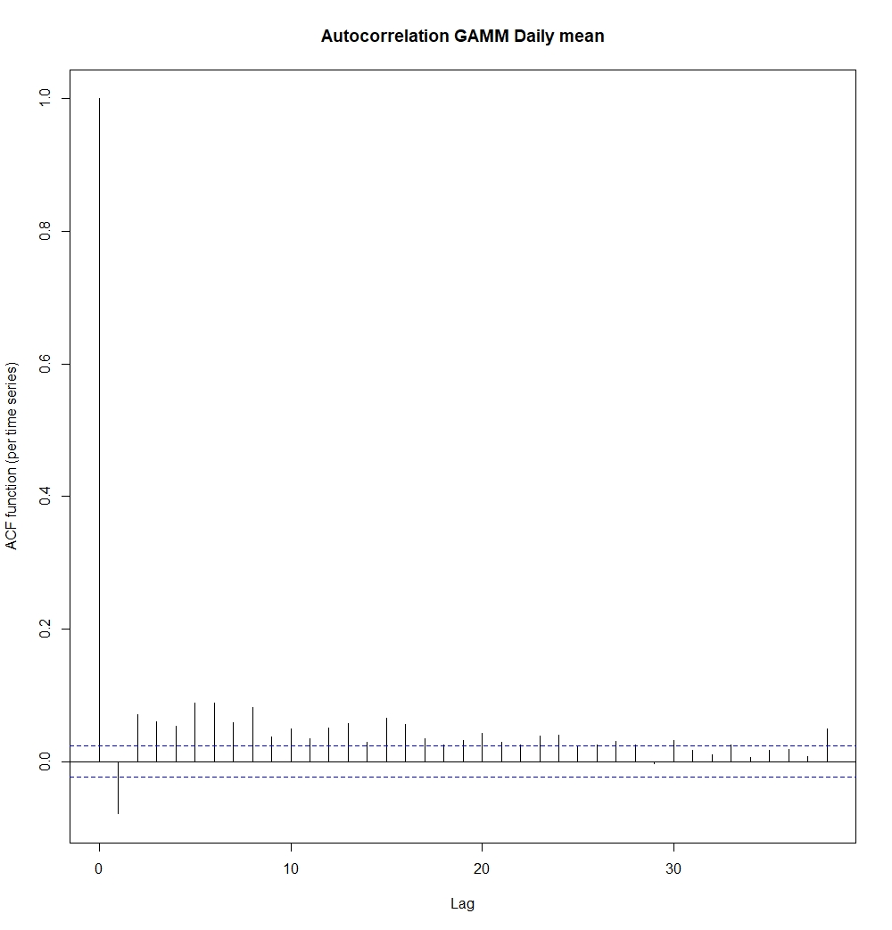

Figur 2: Autocorrelaton plot of Generalised additive mixed effect model on individual daily variation in body temperature of 14 wolverines, monitored from 2011 – 2014 in Sarek study area.
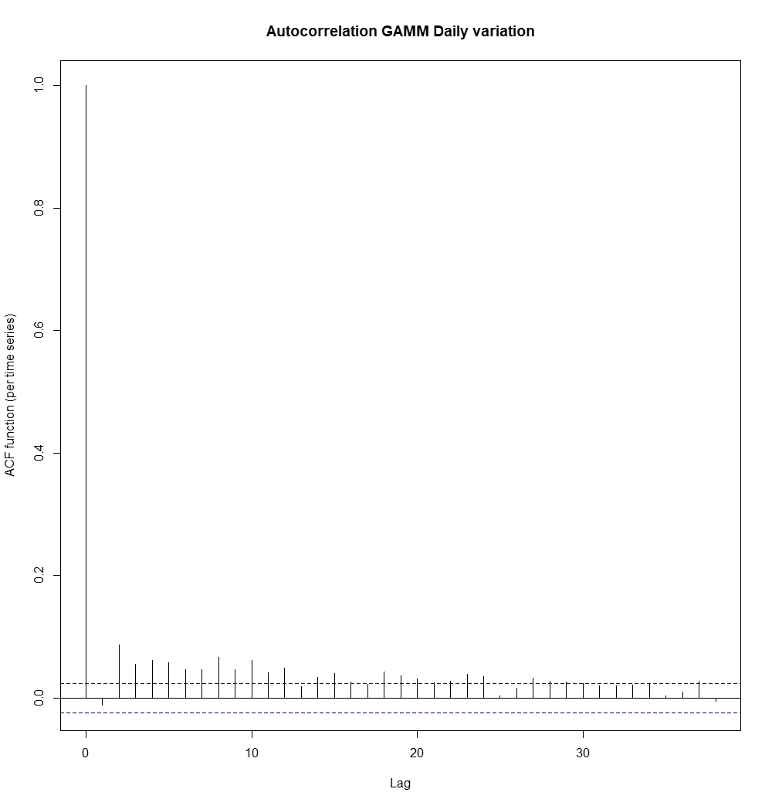
Figur 3: Autocorrelation plot of Generalised additive mixed model on 24 hours circadian rhythm in body temperature of 14 wolverines, monitored from 2011 – 2014 in Sarek study area.
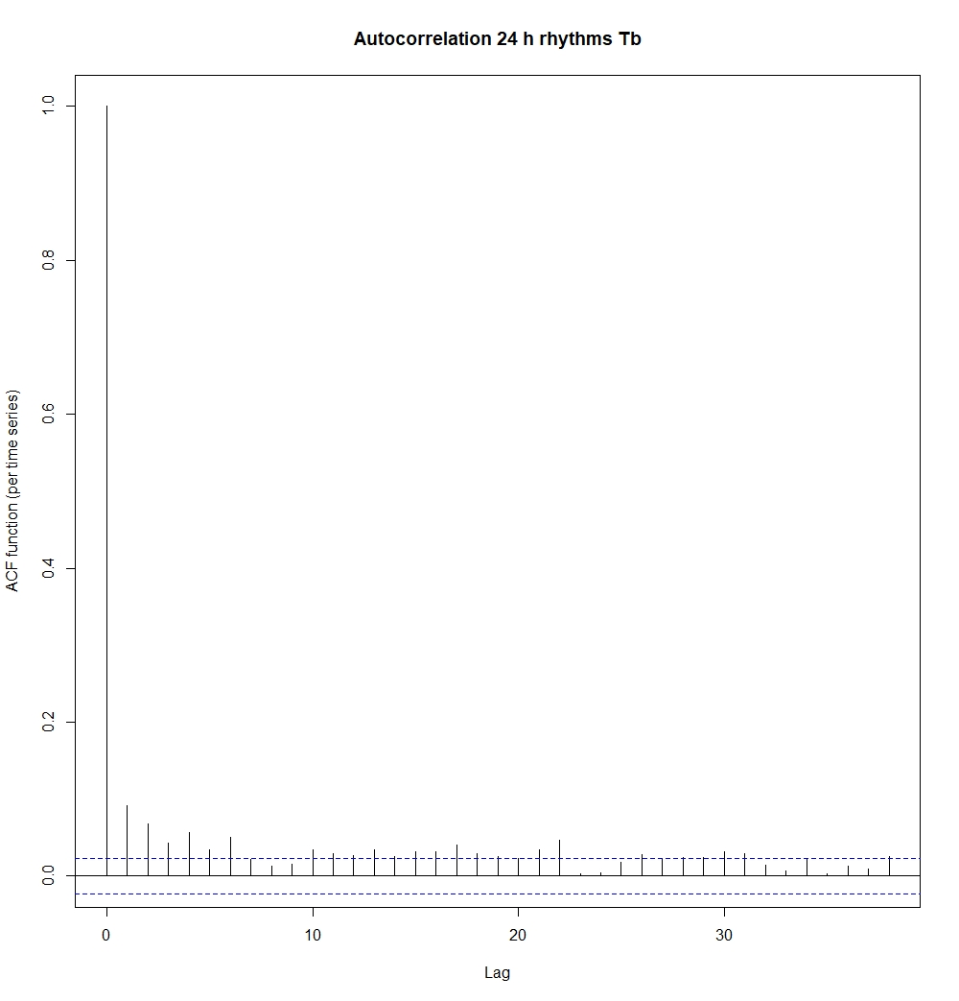

Figur 4: Autocorrelation plot of Generalised additive mixed model on 12 hours rhythm in body temperature of 14 wolverines, monitored from 2011 – 2014 in Sarek study area.
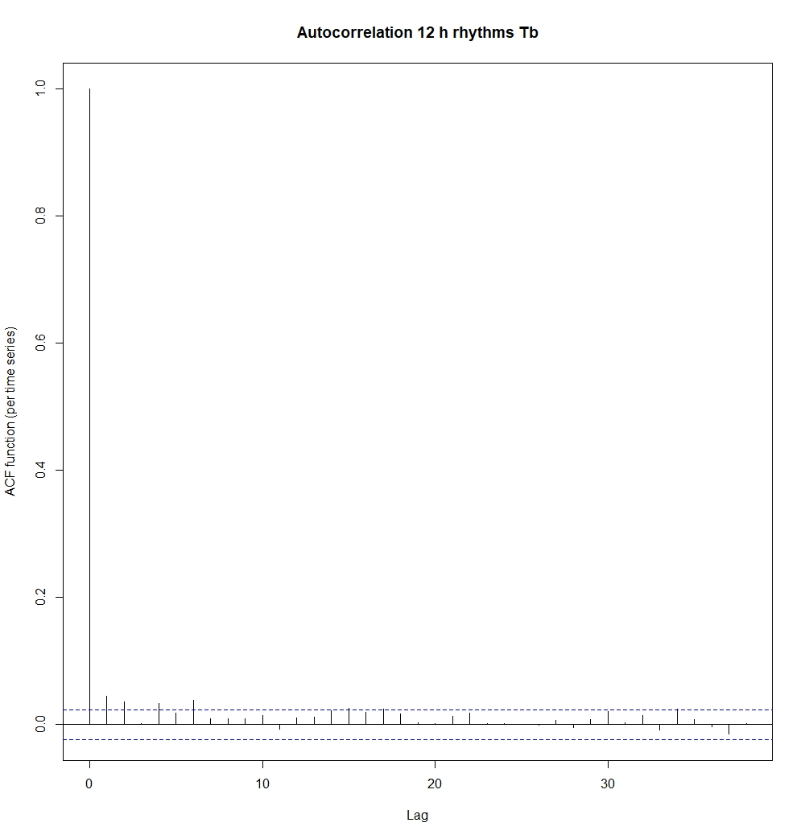
Figur 5: Autocorrelation plot of Generalised additive mixed model on 24 hours circadian rhythm in activity of 10 wolverines, monitored from 2011 – 2014 in Sarek study area.
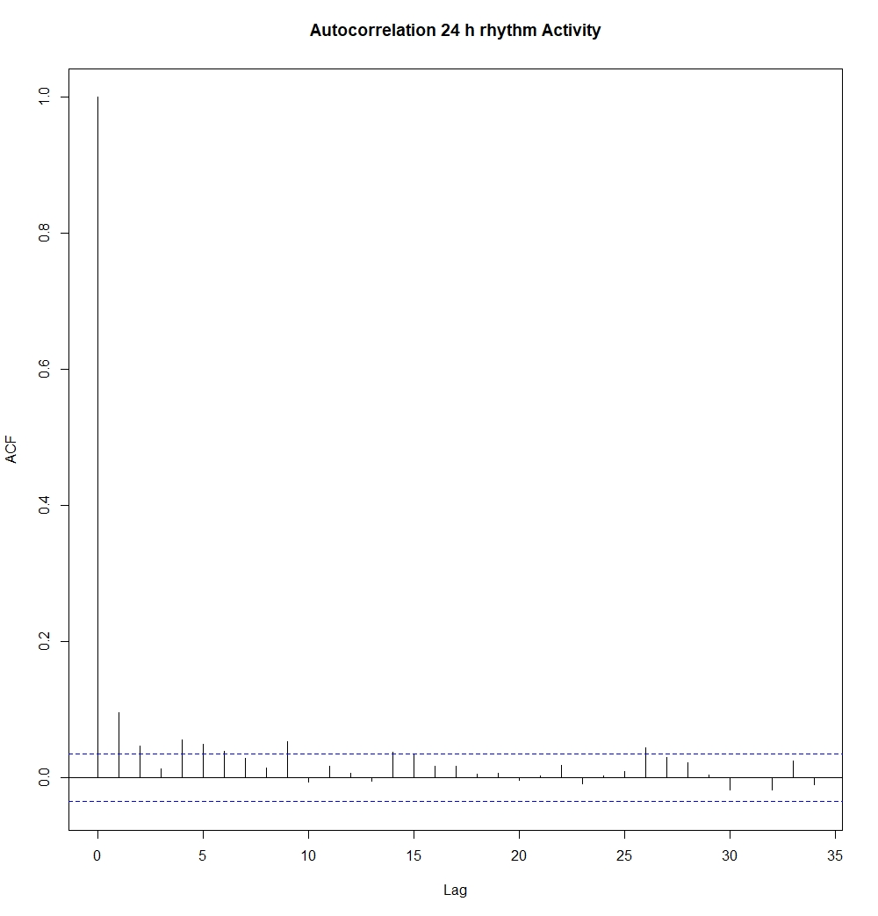

Figur 6: Autocorrelation plot of Generalised additive mixed model on 12 hours rhythm in activity of 10 wolverines, monitored from 2011 – 2014 in Sarek study area.
