Additional file 2

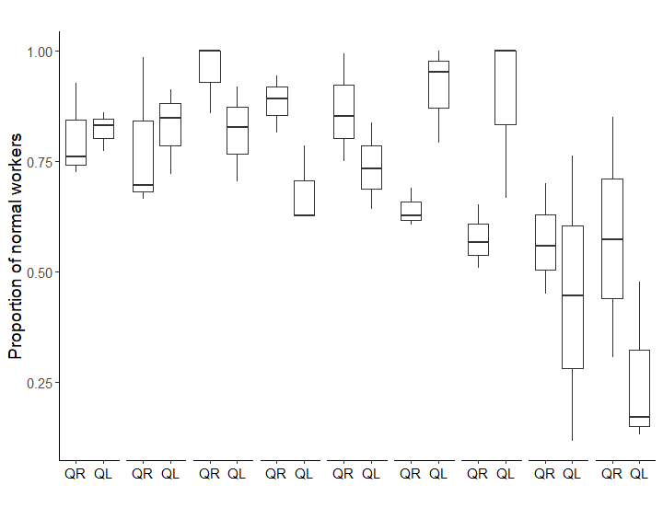
*
**
**
**

0 day
15 days
30 days
45 days
60 days
90 days
105 days
120 days
75 days
QR QL
QR QL
QR QL
QR QL
QR QL
QLm QRm
QLm QRm
QLm QRm
QLm QRm

Figure S1. Proportion of normal workers in the queen transfer experiment by colony status (QR=queenright, QL=queenless, N=3 for each) and number of days since the start of the experiment until day 120. indicates when queens have been moved from the queenright subcolonies to the queenless subcolonies. After this date, queenright colonies became queenless (QLm) and queenless colonies became queenright (QRm). * indicates a significant difference between queenright and queenless colonies for the corresponding time (GLMM: binomial, Table 2, post hoc tests, *p<0.05, **p<0.01).

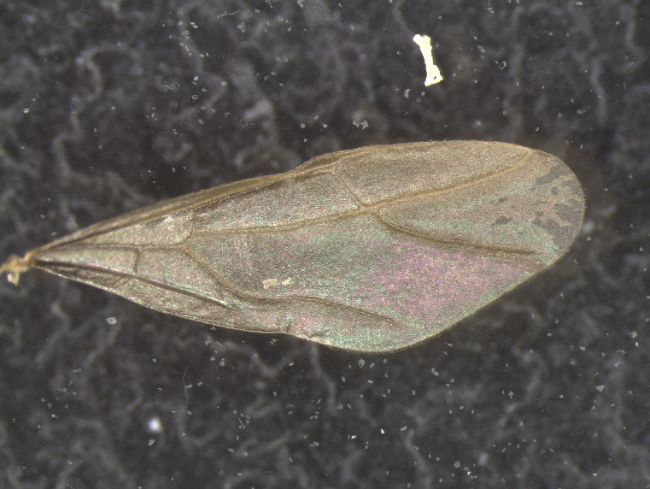

Figure S2. Forewing of a male A. gracilipes showing typical wing venation. Wing width (in blue) and wing length (in red) were always measured using the same wing veins as reference.

Appendix S1: Genotyping protocol
We washed each individual sample three times in distilled water to avoid contamination and extracted the DNA of whole ants using Puregene DNA isolation kits (Gentra Systems) with minor modifications to the supplier’s protocol (addition of 20µl of 200µg/ml Proteinase K and 2-hours water bath incubation after addition of the cell lysis solution). We resuspended the DNA pellets in 30μl DNA hydration solution and stored the DNA samples at 4°C. We used six microsatellite markers which have been found to be polymorphic for A. gracilipes (Table S5) . We conducted the polymerase chain reaction (PCR) amplification as in Drescher et al. (2007). We used a total reaction volume of 12.5μl with approximately 10ng of template DNA (2μl), 1 × PCR-buffer (1.25μl), 160μM dNTPs (1μl), 2.5μM of each primer (0.25μl) and 0.5U of Taq DNA polymerase (0.1μl, PEQLAB GmbH). The forward primers were labelled with fluorescent IR-700 or IR-800 dye (LI-COR). The cycle parameters were as follow: initial denaturation step at 3 min at 94°C, 30 cycles comprising 40 seconds of DNA denaturing at 94˚C, specific primer annealing temperature Table S5) for 40 seconds, 40 seconds DNA extension at 72˚C, and a final extension step of 3 minutes at 72˚C. We conducted a 1:10 dilution on the PCR products and analysed them on a LI-COR 4300 DNA Analyzer.

Table S5. Characteristics of microsatellite loci of Anoplolepis gracilipes used in this study. Ta: annealing temperature, bp: base pairs, N_{I} / N_{C}: number of individuals successfulliy sequenced / number of colonies they were collected from

Primer name | Sequence (5`- 3`) | Ta (°C) | Size range(bp)* | N alleles* | N_{I} / N_{C}* | Publication
Ano1 forward | ACTATCGTTTCTCTCACTAGG | 57 | 99 - 107 | 5 | 133/20 | Feldhaar et al. 2006
Ano1 reverse | TCGGGTCTTAAAATACAGAGC
Ano3 forward | TCTTATCGTGCCTATTTGCTCG | 55 | 140 - 168 | 4 | 121/20 | Feldhaar et al. 2006
Ano3 reverse | AGCGCAAACATTGCTAAGATG
Ano4 forward | TGACGTTTAGGCCTAATTTGACG | 60 | 156 - 174 | 3 | 129/21 | Feldhaar et al. 2006
Ano4 reverse | TGAAGAGAGGATGAAAAAAGACG
Ano5 forward | ACGTGAATATTCGCTTGGACC | 60 | 116 - 122 | 4 | 74/18 | Feldhaar e tal. 2006
Ano5 reverse | TCGGCTTCGCGTACTTCC
Ano6 forward | TGGTAGATTCCTTCTTATCG | 51 | 114 - 130 | 4 | 100/20 | Feldhaar et al. 2006
Ano6 reverse | ACAAAATAAATACCCGCTGC
Ano9 forward | TCATGCTACCCTGAAGC | 52 | 149-155 | 3 | 124/20 | unpublished
Ano9 reverse | ACGTCTTATGGCAGTCG
*calculated for present dataset

References
Drescher J, Blüthgen N, Feldhaar H. Population structure and intraspecific aggression in the invasive ant species Anoplolepis gracilipes in Malaysian Borneo. Mol Ecol. 2007;16:1453–65.
Feldhaar H, Drescher J, Blüthgen N. Characterization of microsatellite markers for the invasive ant species Anoplolepis gracilipes. Mol Ecol Notes. 2006;6:912–4.

