Supplemental Figures
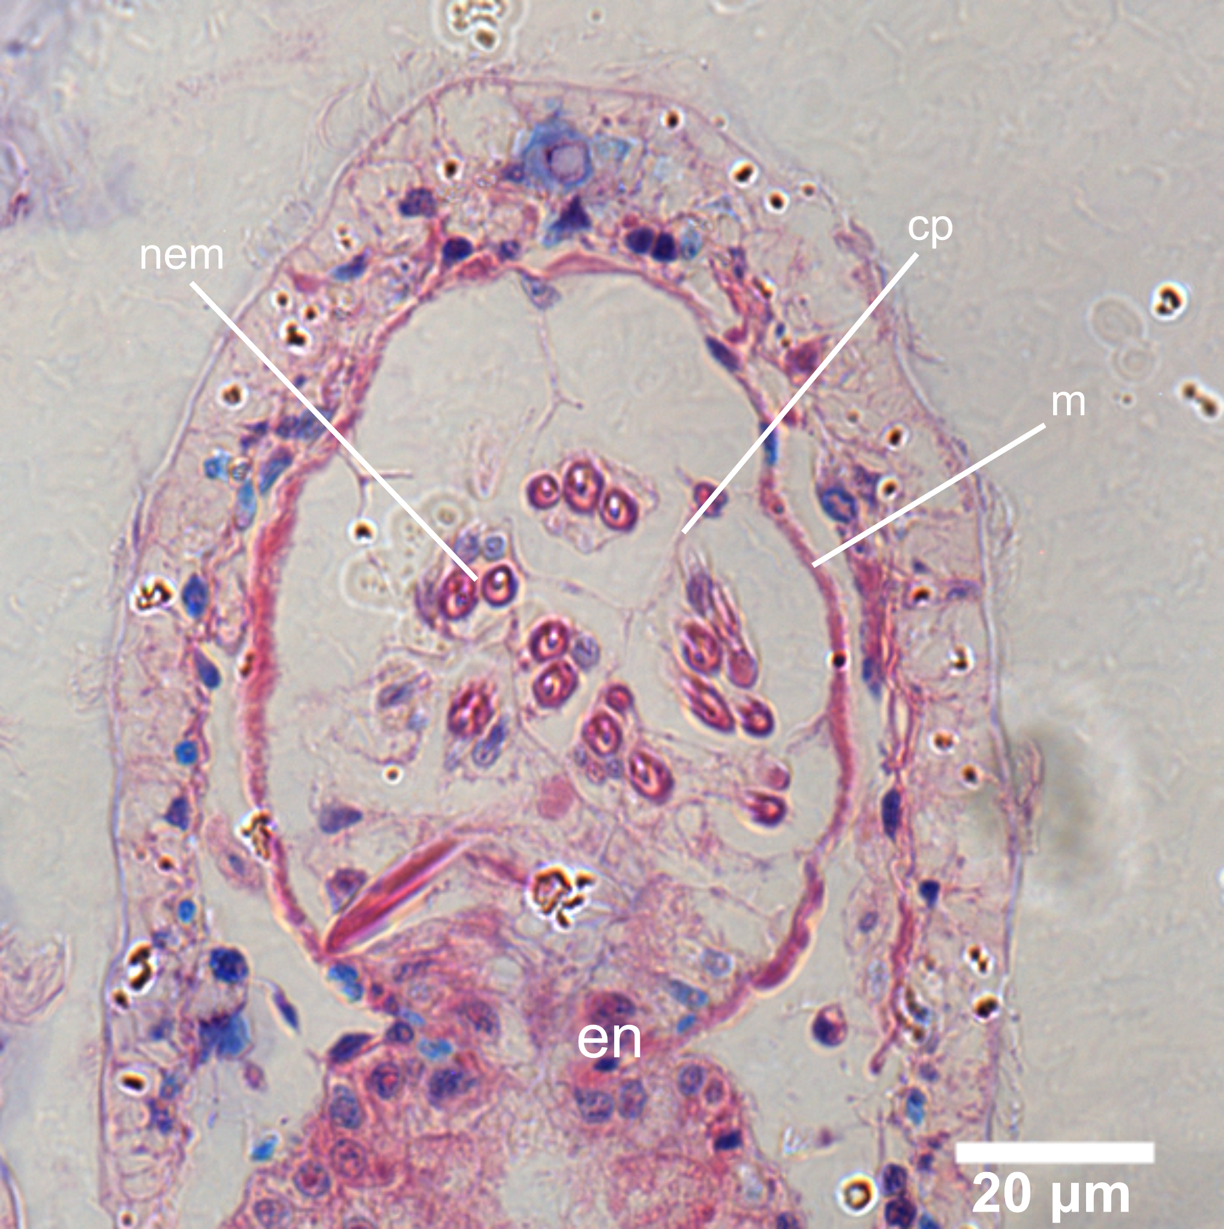
Supplementary Figure 1. Histological section of a Berghia stephanieae cnidosac showing a clear and simple entrance from the digestive gland to the cnidosac. Abbreviations: cp, cnidophages; en, entrance; m, musculature; nem, sequestered nematocysts.

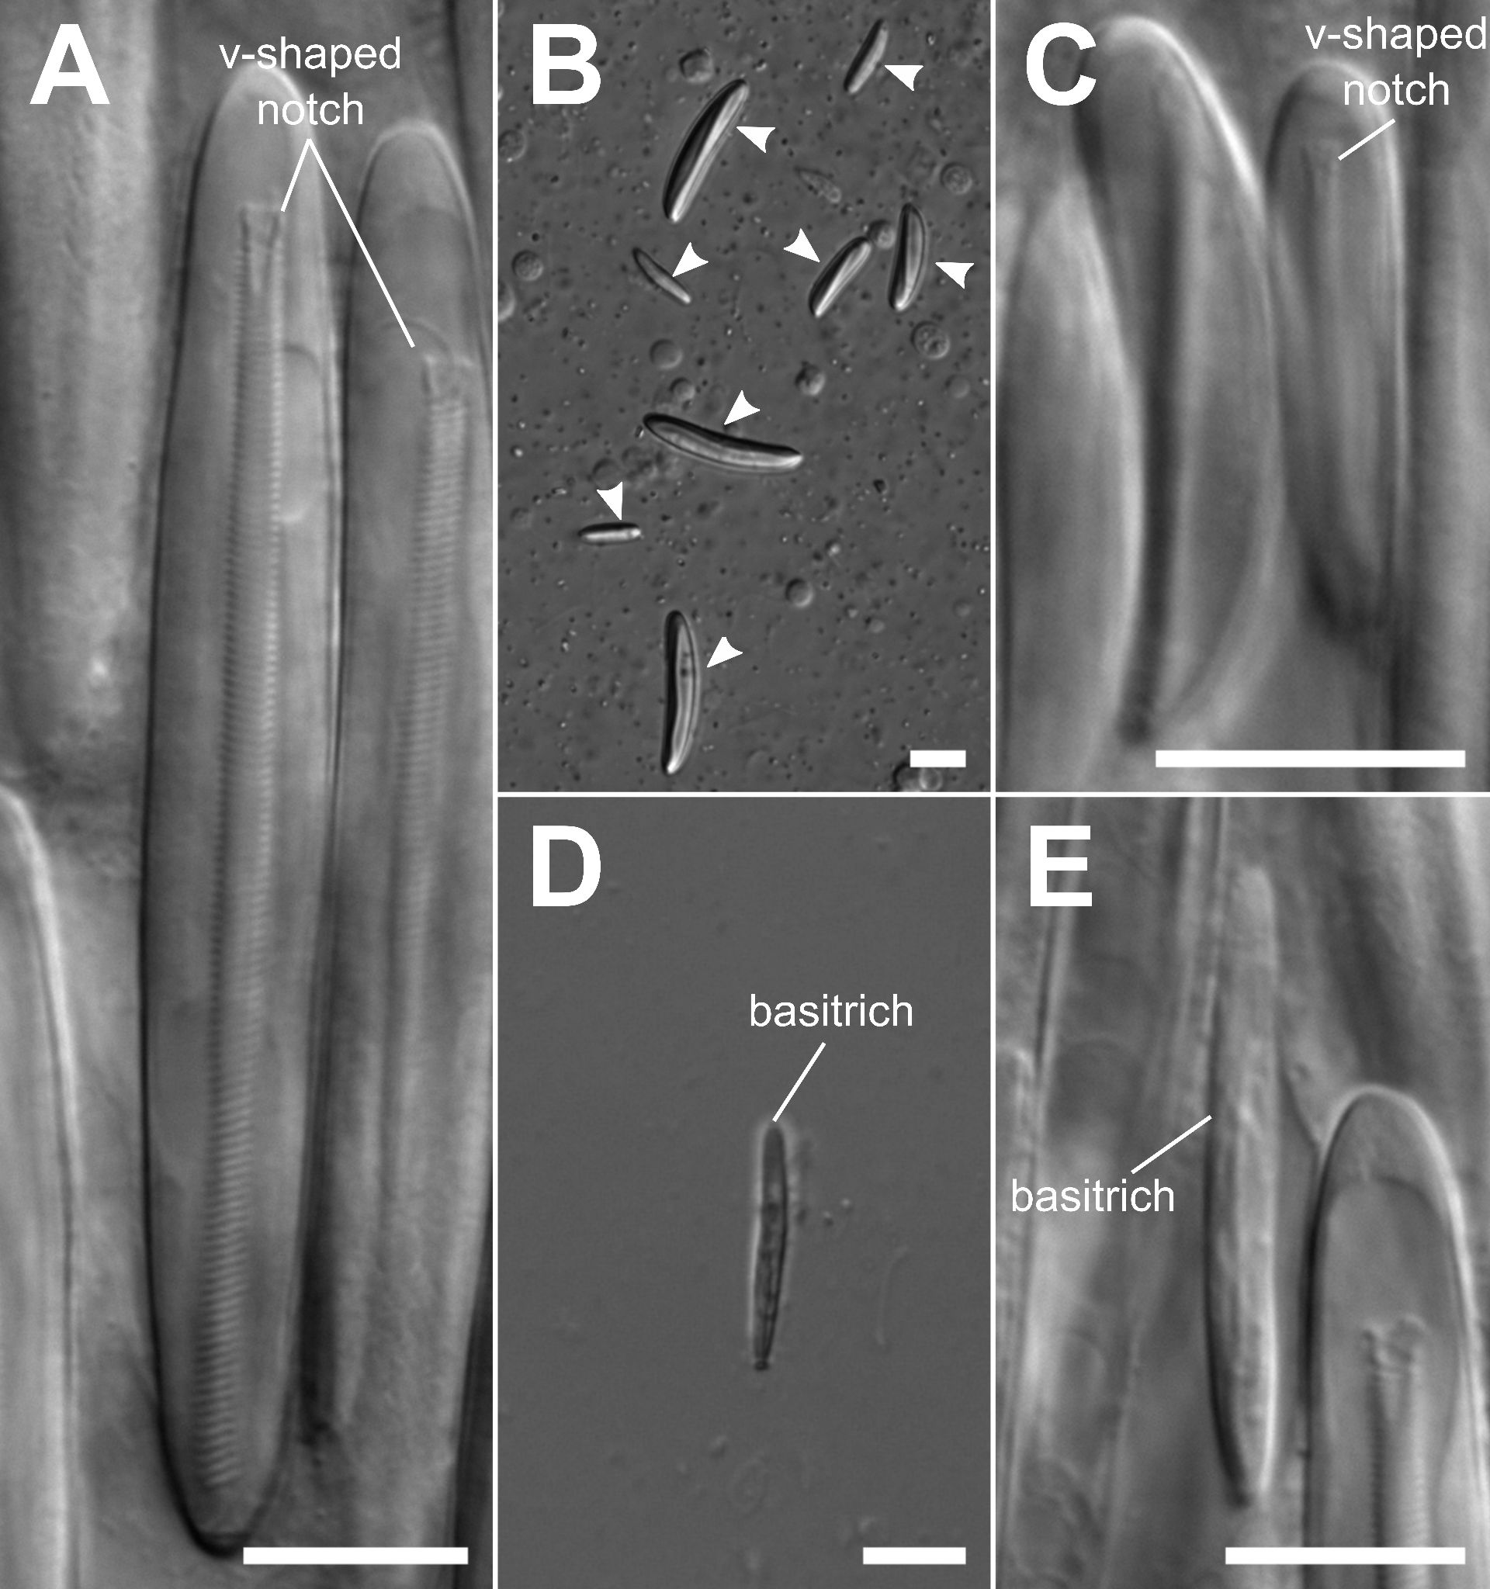
Supplementary Figure 2. DIC images of unfired nematocysts from inside the Berghia stephanieae cnidosac, including (A,C,E) nematocysts still packaged inside the cnidophage cells, and (B,D) nematocysts extruded from the cnidosac. Nematocyst types identified include: (A) large p-mastigophores from the Exaiptasia diaphana acontia, identified by their characteristic v-shaped notch and large size; (B) mastigophores of various sizes (arrows), including (C) small p-amastigophores (with the v-shaped notch); and (D-E) basitrichous isorhizas (basitrichs). Scale bars = 10 μm.

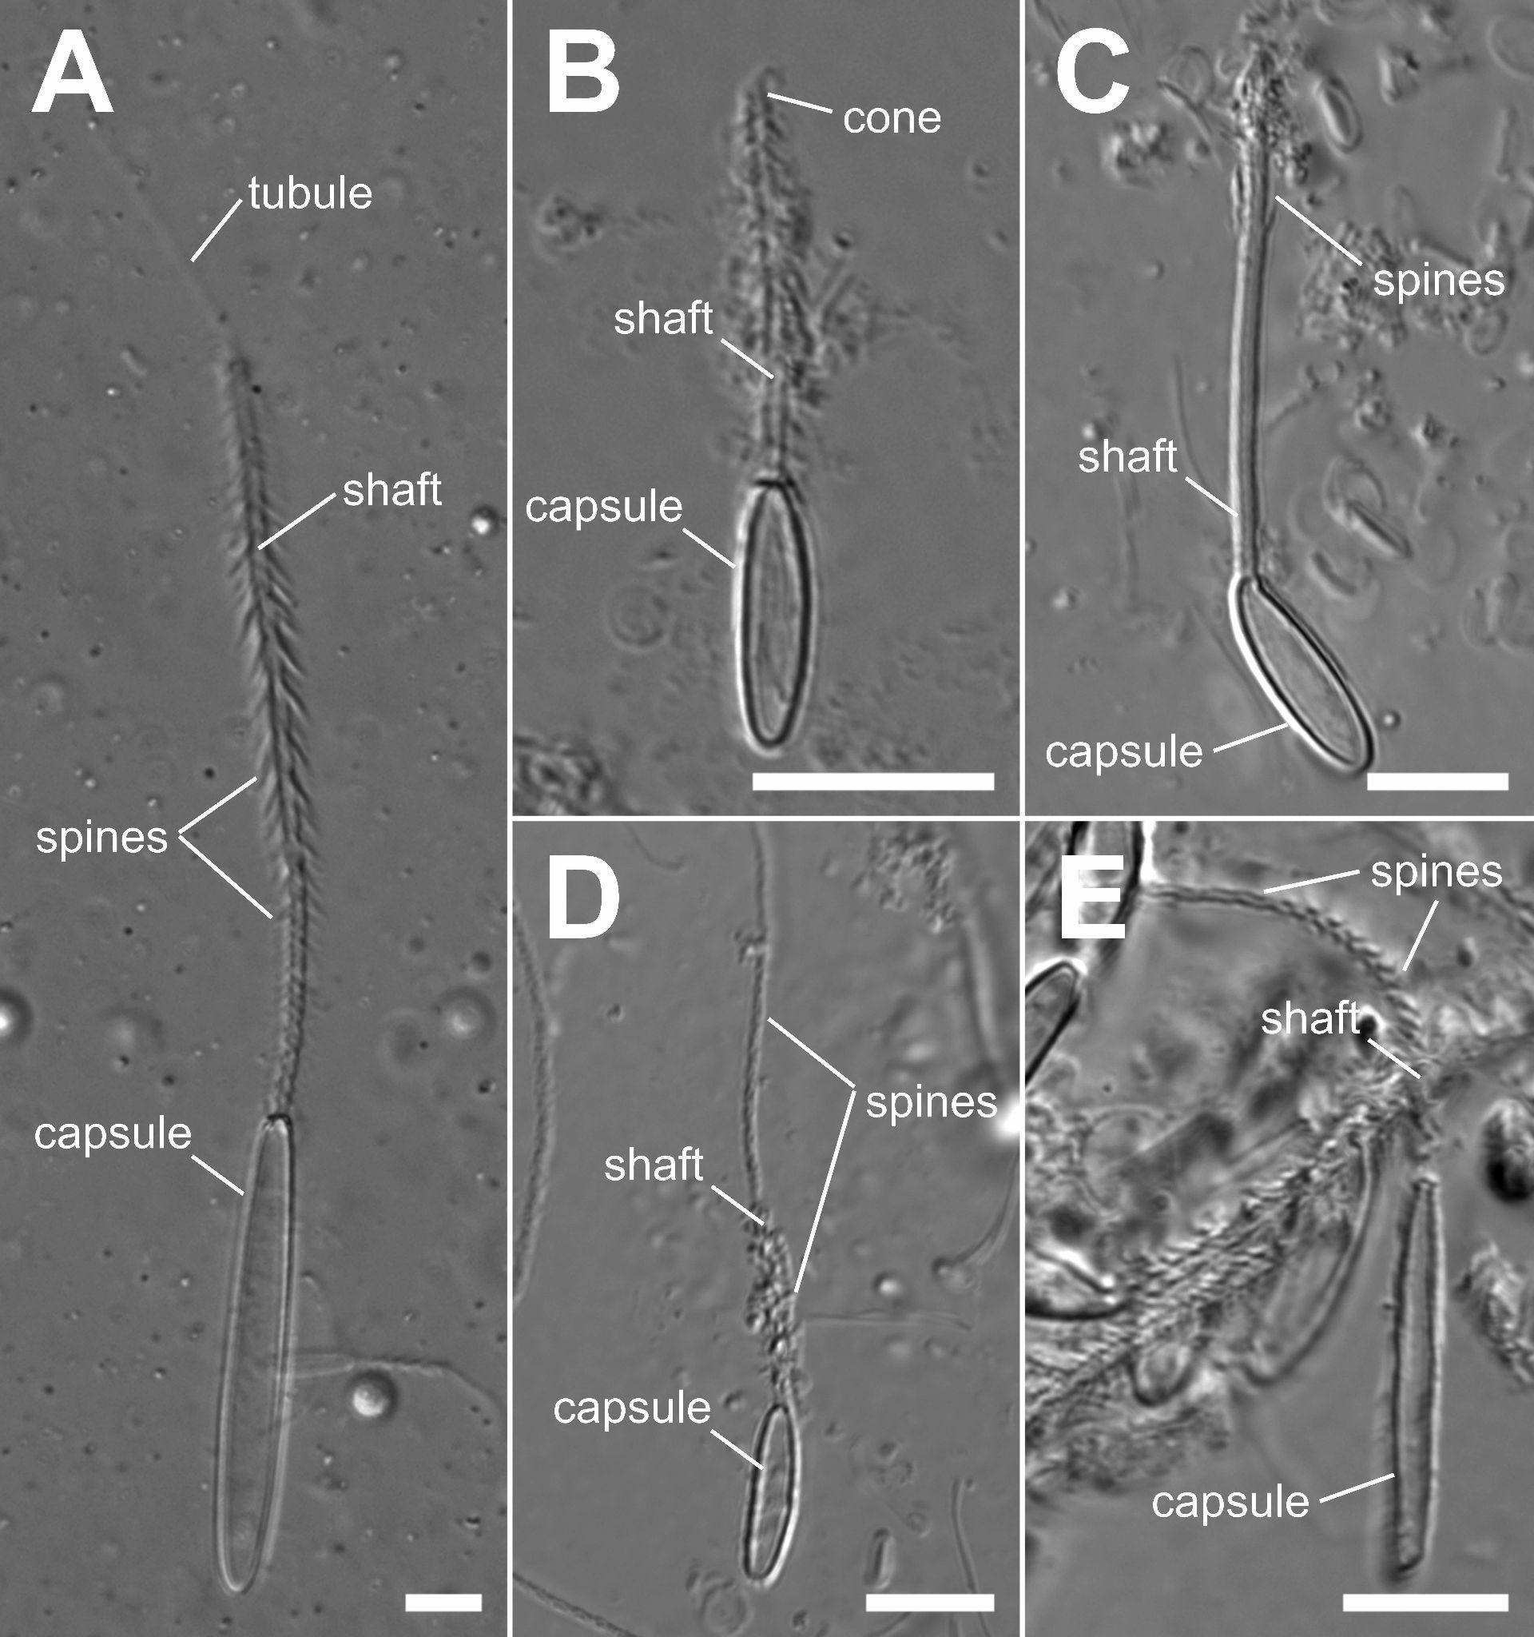
Supplementary Figure 3. DIC images of fired nematocysts from inside the Berghia stephanieae cnidosac. Nematocyst types identified include: (A) large p-mastigophores from the Exaiptasia diaphana acontia, identified by their characteristic narrow tubule extending from the end of the shaft, the increase in spine size distally along the shaft, and their large size; (B-C) smaller p-amastigophores, identified by the increase in spine size distally along the shaft, with the shaft ending in a cone; (D-E) basitrichous isorhizas identified by the large spine size along the base of the shaft, with shorter spines towards the tips. Scale bars = 10 μm.

