Title: Interactions between carnivore species: limited spatiotemporal partitioning between apex predator and smaller carnivores in a Mediterranean protected area
Author list: Francesco Ferretti^{1,2*}, Raquel Oliveira¹, Mariana Rossa³, Irene Belardi¹, Giada Pacini¹, Sara Mugnai¹, Niccolò Fattorini¹ & Lorenzo Lazzeri¹
Affiliations: ¹Research Unit of Behavioural Ecology, Ethology and Wildlife Management – Department of Life Sciences – University of Siena. Via P.A. Mattioli 4, 53100, Siena, Italy; ²NBFC, National Biodiversity Future Center, Palermo 90133, Italy; ³CESAM, Department of Biology, University of Aveiro, Campus de Santiago, 3810-193 Aveiro, Portugal
Corresponding author: Francesco Ferretti, Research Unit of Behavioural Ecology, Ethology and Wildlife Management – Department of Life Sciences – University of Siena. Via P.A. Mattioli 4, 53100, Siena, Italy. E-mail: francesco.ferretti@unisi.it.

Additional file 2
Temporal activity patterns of wolf, red fox, badger, Martes spp., and humans, were estimated at the seasonal scale (spring: April-June; summer: July-September; autumn: October-December; winter: January-March), in the three different study years (First year: October 2017-September 2018; Second year: April 2019-March 2020; Third year: April 2020-March 2021) (Figures S1-S5). Temporal activity patterns were estimated through kernel density estimators, together with bootstrapped 0.95 confidence intervals. For a detailed description of methods, see main text.

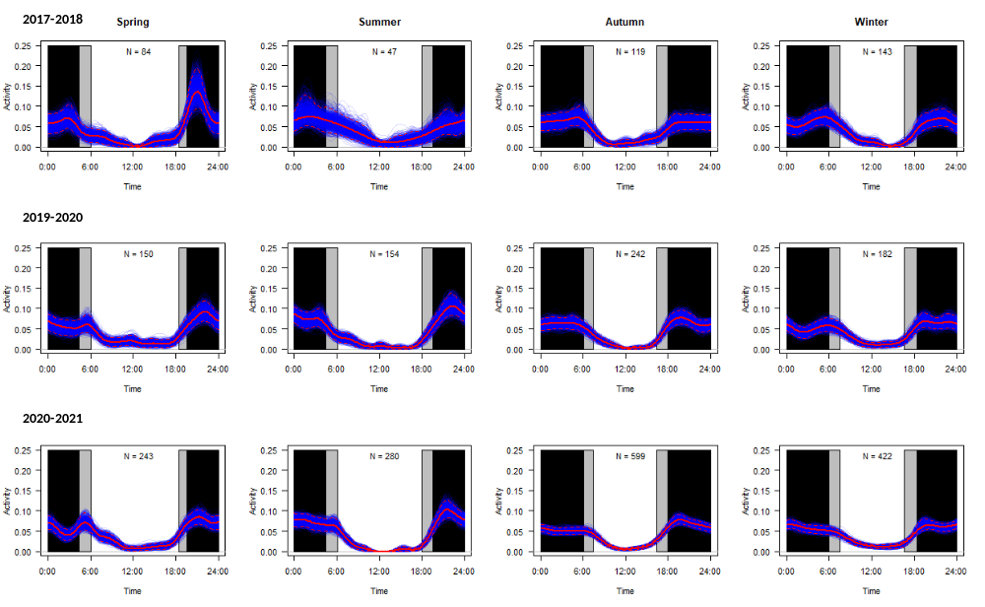
Figure S1. Temporal activity patterns of the wolf at seasonal scale (spring: April-June; summer: July-September; autumn: October-December; winter: January-March) in the three study years (First year: October 2017-September 2018; Second year: April 2019-March 2020; Third year: April 2020-March 2021). Red solid lines indicate estimates of temporal activity patterns through kernel density estimators; colored lines represent bootstrapped estimates of activity patterns through 1000 replicates; dashed red lines represent 0.95 bootstrapped confidence intervals. Grey rectangles indicate times of day of dawn and dusk during each season; black rectangles indicate times of day preceding the dawn and following the dusk. Sample size (i.e., number of detections) is shown in each panel.
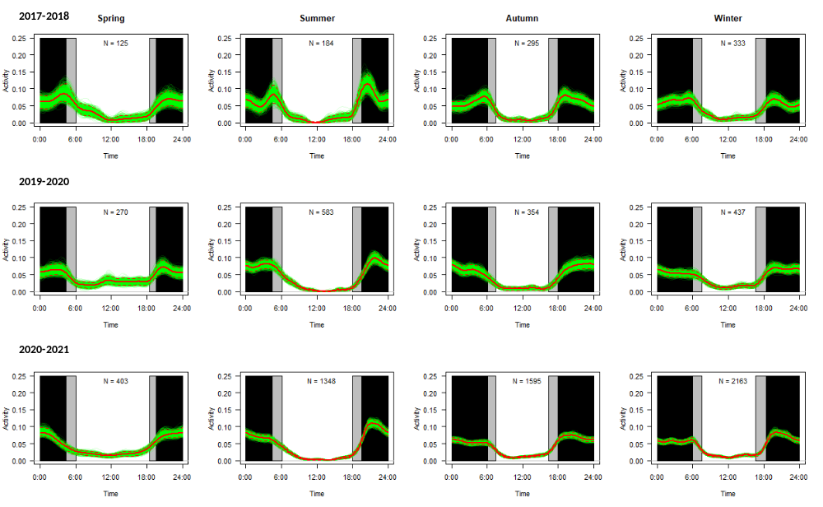
Figure S2. Temporal activity patterns of the red fox at seasonal scale (spring: April-June; summer: July-September; autumn: October-December; winter: January-March) in the three study years (First year: October 2017-September 2018; Second year: April 2019-March 2020; Third year: April 2020-March 2021). Red solid lines indicate estimates of temporal activity patterns through kernel density estimators; colored lines represent bootstrapped estimates of activity patterns through 1000 replicates; dashed red lines represent 0.95 bootstrapped confidence intervals. Grey rectangles indicate times of day of dawn and dusk during each season; black rectangles indicate times of day preceding the dawn and following the dusk. Sample size (i.e., number of detections) is shown in each panel.
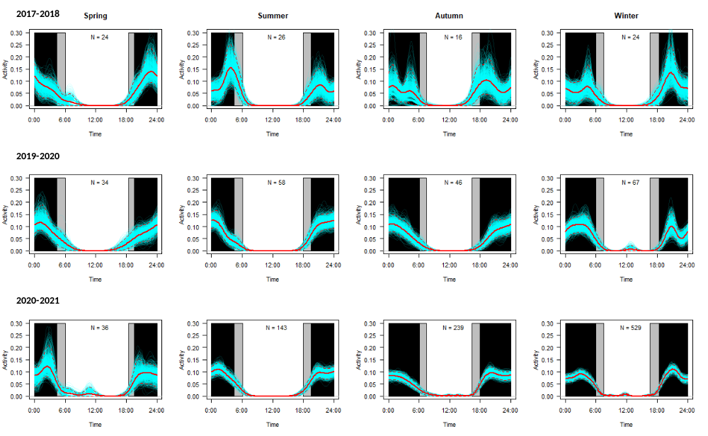
Figure S3. Temporal activity patterns of the badger at seasonal scale (spring: April-June; summer: July-September; autumn: October-December; winter: January-March) in the three study years (First year: October 2017-September 2018; Second year: April 2019-March 2020; Third year: April 2020-March 2021). Red solid lines indicate estimates of temporal activity patterns through kernel density estimators; colored lines represent bootstrapped estimates of activity patterns through 1000 replicates; dashed red lines represent 0.95 bootstrapped confidence intervals. Grey rectangles indicate times of day of dawn and dusk during each season; black rectangles indicate times of day preceding the dawn and following the dusk. Sample size (i.e., number of detections) is shown in each panel.
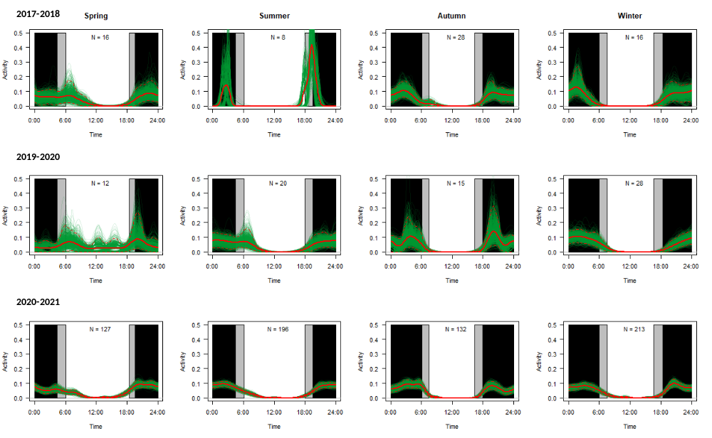
Figure S4. Temporal activity patterns of the Martes spp. at seasonal scale (spring: April-June; summer: July-September; autumn: October-December; winter: January-March) in the three study years (First year: October 2017-September 2018; Second year: April 2019-March 2020; Third year: April 2020-March 2021). Red solid lines indicate estimates of temporal activity patterns through kernel density estimators; colored lines represent bootstrapped estimates of activity patterns through 1000 replicates; dashed red lines represent 0.95 bootstrapped confidence intervals. Grey rectangles indicate times of day of dawn and dusk during each season; black rectangles indicate times of day preceding the dawn and following the dusk. Sample size (i.e., number of detections) is shown in each panel.

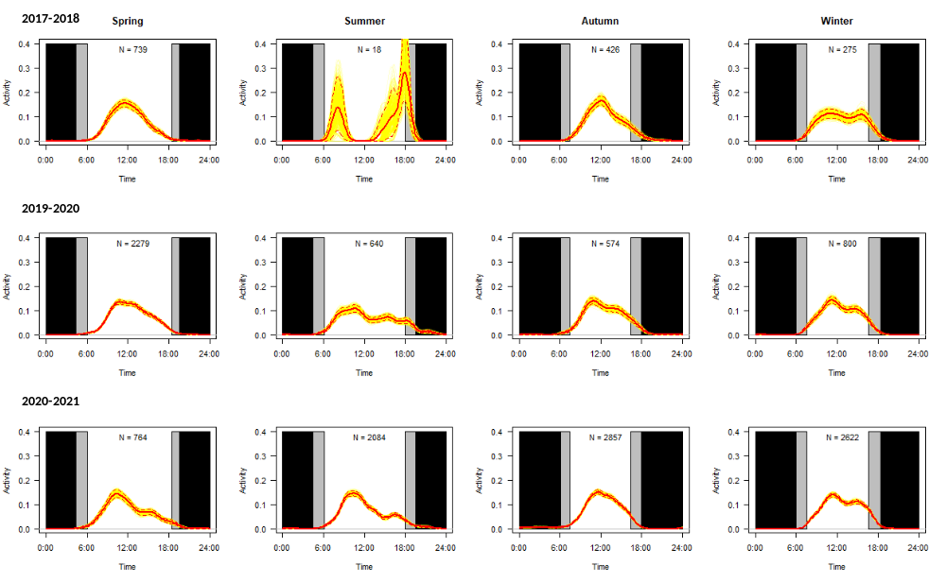
Figure S5. Temporal activity patterns of humans at seasonal scale (spring: April-June; summer: July-September; autumn: October-December; winter: January-March) in the three study years (First year: October 2017-September 2018; Second year: April 2019-March 2020; Third year: April 2020-March 2021). Red solid lines indicate estimates of temporal activity patterns through kernel density estimators; colored lines represent bootstrapped estimates of activity patterns through 1000 replicates; dashed red lines represent 0.95 bootstrapped confidence intervals. Grey rectangles indicate times of day of dawn and dusk during each season; black rectangles indicate times of day preceding the dawn and following the dusk. Sample size (i.e., number of detections) is shown in each panel.

