Supporting Information

S1. Link to Modis terra satellite data: https://www.earthdata.nasa.gov/learn/find-data/near-real-time/modis#ed-modis-c61

S2: Correlation matrix for the set of covariates:

S3: Zonal NDVI trend for each 200m elevation zone.
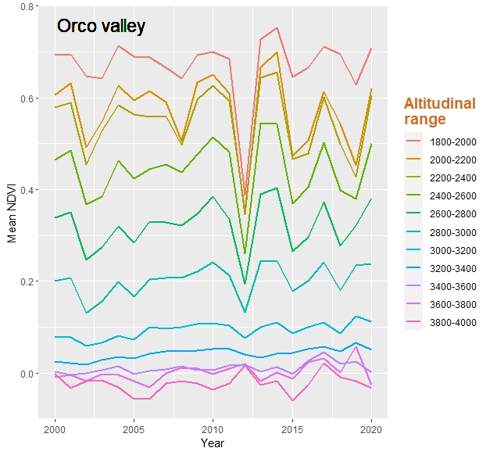
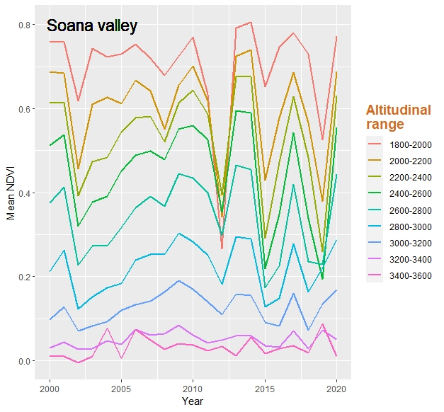

S4 Complete model selection table for variables explaining chamois elevation and group size. Selected models are shown in italic bold.
Variable | Rank | Model structure | df | logLik | AIC | ΔAIC | Weight
Elevation | 1st | Wolf + Valley + Wolf * Valley + slope + Tmax survey | 8 | -25674 | 51364.6 | 0.00 | 0.281
 | 2nd | Wolf + Valley + Wolf*Valley + slope | 7 | -25675 | 51365.0 | 0.42 | 0.231
 | 3rd | Wolf + Valley + Wolf*Valley + avg. summer Tmax + Tmax survey + slope | 9 | -25673 | 51365.6 | 1.04 | 0.17
 | 4th | Wolf + Valley + Wolf*Valley + avg. summer Tmax + slope | 8 | -25675 | 51366.4 | 1.81 | 0.115
 | 5th | Wolf + Valley + Wolf*Valley + Tmax survey + tot. prec. august + slope | 9 | -25674 | 51366.4 | 1.81 | 0.115
 | 6th | Wolf + Valley + Wolf*Valley + tot. prec. august + slope | 8 | -25675 | 51367.0 | 2.39 | 0.086
Group size | 1st | Wolf + Valley + Wolf*Valley + NDVI | 7 | -10982.87 | 21979.8 | 0.00 | 0.127
 | 2nd | Wolf + Valley + Wolf*Valley + NDVI + tot. prec. august | 8 | -10982.03 | 21980.1 | 0.33 | 0.106
 | 3rd | Wolf + Valley + Wolf*Valley + NDVI + Tmax survey | 8 | -10982.03 | 21980.1 | 0.34 | 0.106
 | 4th | Wolf + Valley + Wolf*Valley + NDVI + Tmax survey + tot.prec.august | 9 | -10981.13 | 21980.3 | 0.54 | 0.096
 | 5th | Wolf + Valley + Wolf*Valley + NDVI + avg. summer Tmax | 8 | -10981.35 | 21980.7 | 0.97 | 0.077
 | 6th | Wolf + Valley + Wolf*Valley + NDVI + avg. summer Tmax + Tmax survey | 9 | -10981.36 | 21980.8 | 1.00 | 0.076
 | 7th | Wolf + Valley + Wolf*Valley + NDVI + avg. summer Tmax + Tmax survey + tot.prec.august | 10 | -10980.44 | 21980.9 | 1.18 | 0.069
 | 8th | Wolf + Valley + Wolf*Valley + NDVI + slope | 8 | -10982.48 | 21981.0 | 1.24 | 0.067
 | 9th | Wolf + Valley + Wolf*Valley + NDVI + tot.prec.august + avg. summer Tmax | 9 | -10981.51 | 21981.1 | 1.31 | 0.065
 | 10th | Wolf + Valley + Wolf*Valley + NDVI + slope + Tmax survey | 9 | -10981.64 | 21981.3 | 1.57 | 0.057
 | 11th | Wolf + Valley + Wolf*Valley + NDVI + slope + tot.prec.august | 9 | -10981.67 | 21981.4 | 1.63 | 0.055
 | 12th | Wolf + Valley + Wolf*Valley + NDVI + slope + tot.prec.august + Tmax survey | 10 | -10980.76 | 21981.6 | 1.82 | 0.050
 | 13th | Wolf + Valley + Wolf*Valley + NDVI + slope + avg. summer Tmax | 9 | -10981.96 | 21982.0 | 2.20 | 0.043

