Supplementary materials
Not all heads are the same: species- and sex-specific differences in eye and postocular area morphology of burying beetles (Nicrophorus spp.)

Daria Bajerlein¹, Julian Katzke², Edward Baraniak³, Arkadiusz Urbański^{4*}

¹Department of Animal Taxonomy and Ecology, Faculty of Biology, Adam Mickiewicz University, Uniwersytetu Poznańskiego 6, 61-614, Poznań, Poland,
² Department of Entomology, Smithsonian Institution National Museum of Natural History, 10th St. and Constitution Ave. NW, Washington, D.C. 20560, USA
³ Department of Systematic Zoology, Faculty of Biology, Adam Mickiewicz University, Uniwersytetu Poznańskiego 6, 61-614, Poznań, Poland
⁴Department of Animal Physiology and Developmental Biology, Adam Mickiewicz University, Uniwersytetu Poznańskiego 6, 61-614, Poznań, Poland

Correspondence to: * Arkadiusz Urbański, email: arur@amu.edu.pl

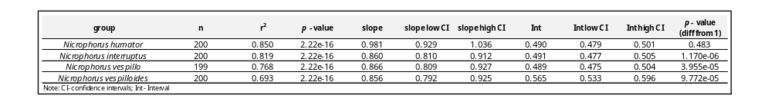
Table S1. Summary of the standardized major axis (SMA) models estimating the effect of log-transformed left eye length on the log-transformed left eye width in different burying beetle species. Table was enriched by analysis of differences of obtained slopes from 1 with likelihood ratio test (p – value (diff from 1)).

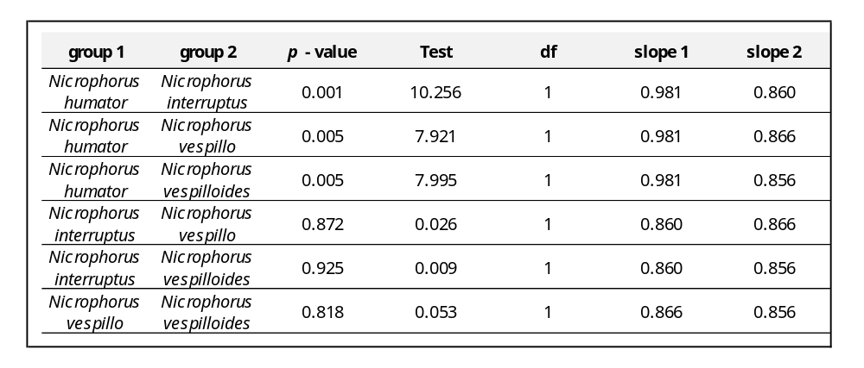
Table S2. Pairwise comparisons of regression slopes (standardized major axis, SMA) estimating the relationship between log-transformed left eye length and log-transformed left eye width across burying beetle species, tested using the Wald test.
Table S3. Results of Tukey’s HSD post hoc comparisons for differences in eye aspect ratio (eye length-to-eye width) among Nicrophorus species. *** p < 0.001
comparison
mean diff
lower CI
upper CI
adj
p
-value
significance
N. interruptus – N. humator
0.066
0.044
0.088
< 0.001
***
N. vespillo – N. humator
0.055
0.033
0.077
< 0.001
***
N. vespilloides – N. humator
0.255
0.234
0.277
< 0.001
***
N. vespillo – N. interruptus
-0.012
-0.033
0.01
0.524
N. vespilloides – N. interruptus
0.189
0.167
0.211
< 0.001
***
N. vespilloides - N. vespillo
0.201
0.17887
0.223
< 0.001
***
Note: Cl - confidence intervals
Table S4. Pairwise comparisons of regression slopes (standardized major axis, SMA) estimating the relationships between log-transformed left eye length, eye width, and log-transformed pronotum width across burying beetle species, tested using the Wald test.
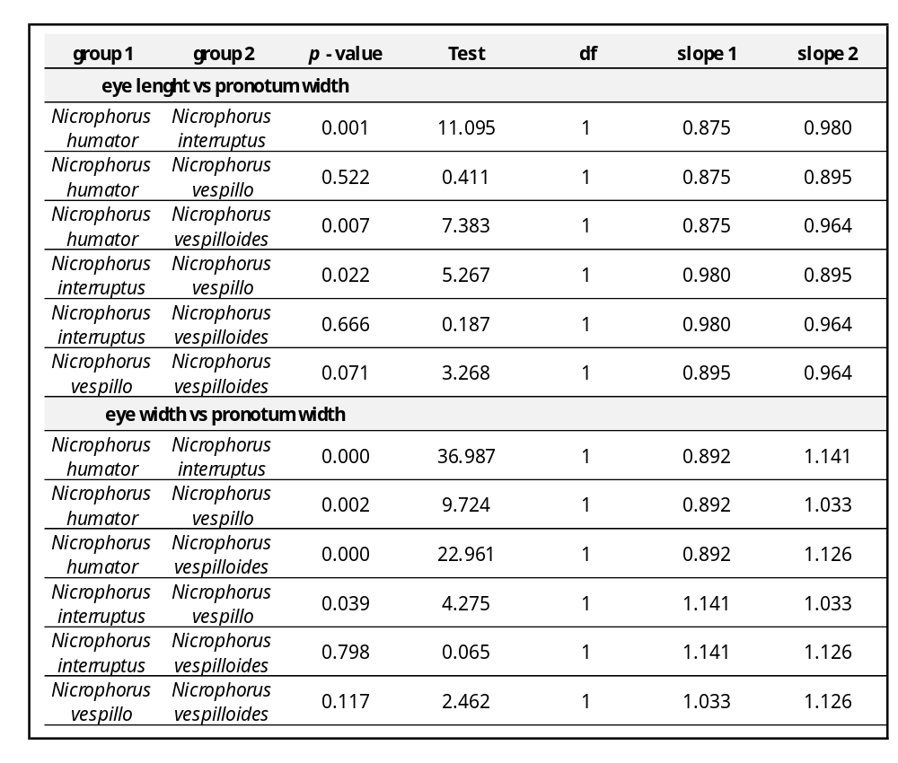
Fig S1. Correlations between eye size expressed as a square root of eye width x length and body size expressed as a pronotum width in four Nicrophorus species. Lines represent ordinary least squares regression models based on log–log transformed data, with 95% confidence intervals.
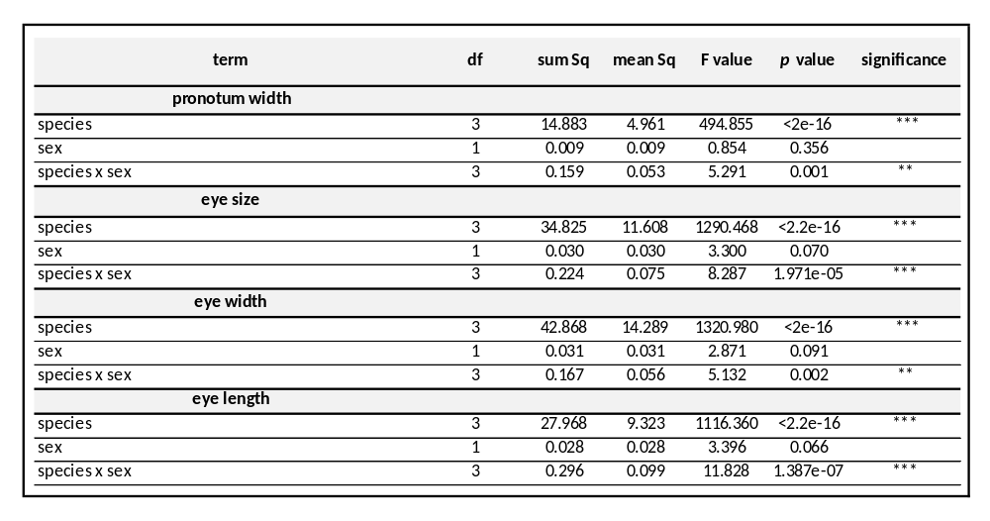
Table S5. Summary of MANOVA analysis performed for chosen morphological parameters in terms of analysis of differences between species and sexes. ** p ≤ 0.01; *** p ≤ 0.001.

Table S6. Summary of the linear regression model estimating the effect of eye aspect ratio (length/width) with pronotum size in females and males of different burying beetle species. F – females, M – males.
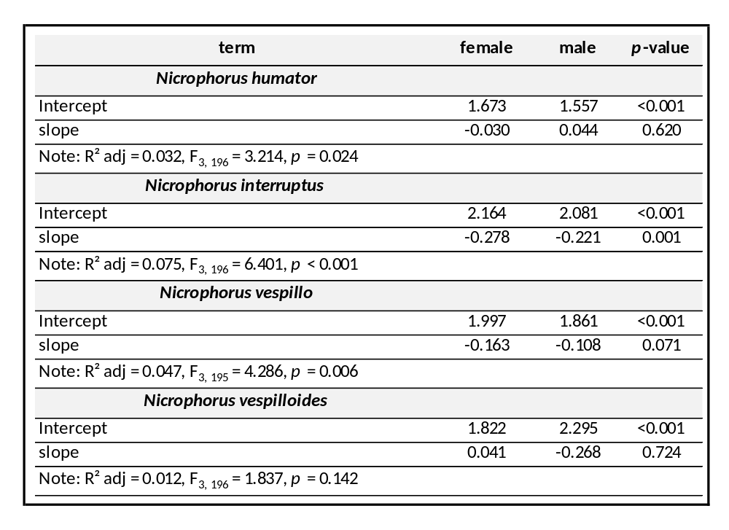

Fig S2. Allometric relationships between interocular distance and body size, expressed as pronotum width, including analysis of sexual dimorphism in burying beetles. The data are presented separately for each tested Nicrophorus species (A-D). Lines represent standardized major axis (SMA) models fitted to log–log transformed data, with 95% confidence intervals. Sex‑specific slope values for the two variables tested are shown in the upper corner of each graph. The solid lines with circles represent females; the dashed lines with triangles represent males.

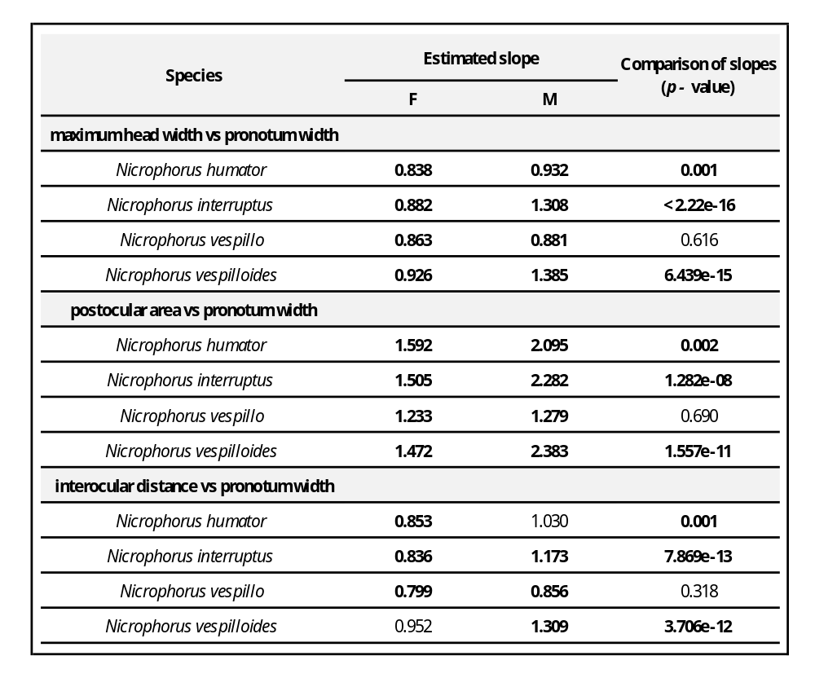
Table S7. Summary of the results of the statistical analysis of the sexual dimorphism of head width, postocular area size, and interocular distance vs pronotum width, the indicator of Nicrophorus body size. F – females, M – males. In the F and M columns, bolded values indicate that the slope is significantly different from 1. p value column - statistically significant differences between slopes estimated for females and males are bolded. The slope values were estimated with the standard major axis (SMA) method; the slopes were compared with the likelihood ratio test.

