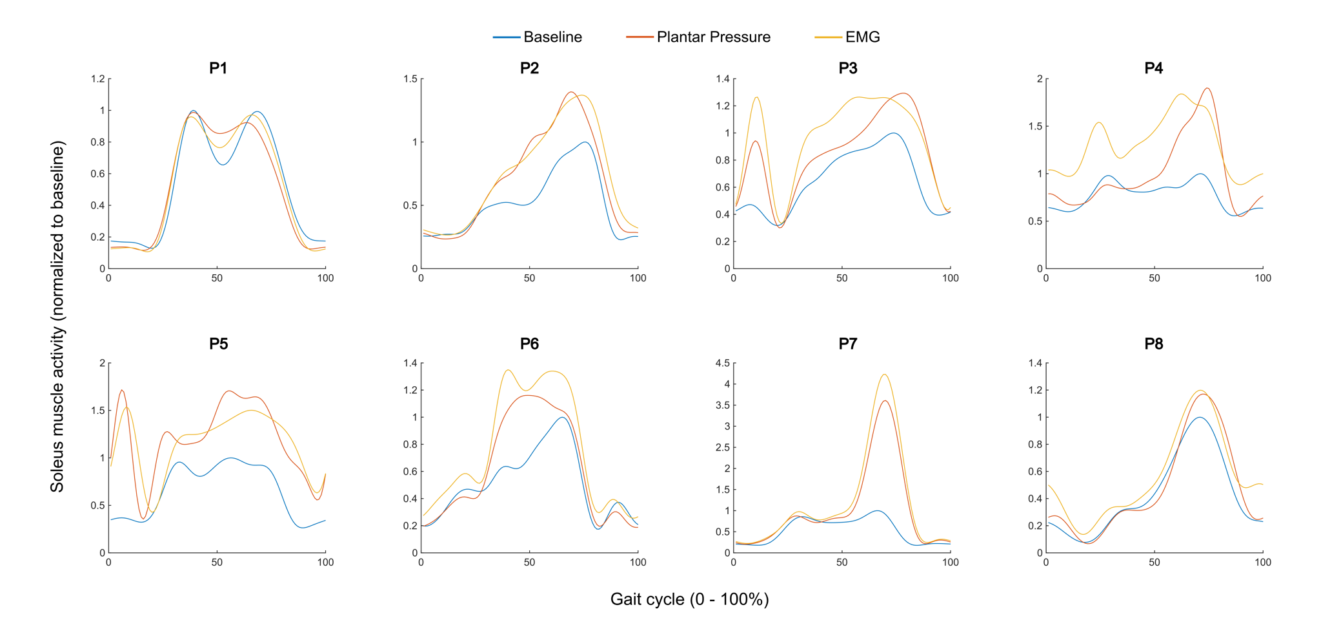

Figure S1. Mean soleus muscle activation curves, averaged over 20 gait cycles and normalized to peak baseline activation, across baseline (blue), plantar pressure-based biofeedback (orange), and EMG-based biofeedback (yellow) conditions.

