Exploring high-density corticomuscular networks after stroke to enable a hybrid Brain-Computer Interface for hand motor rehabilitation
Floriana Pichiorri^{1*}, Jlenia Toppi^{1,2*}, Valeria de Seta^{1,2}, Emma Colamarino^{1,2}, Marcella Masciullo³, Federica Tamburella⁴, Matteo Lorusso⁴, Febo Cincotti^{1,2}, Donatella Mattia¹

¹Neuroelectrical Imaging and Brain Computer Interface Lab, IRCCS Fondazione Santa Lucia, Rome, Italy, ²Dept. Of Computer, Control and Management Engineering, Sapienza University of Rome, Rome, Italy, ³Neurology and Neurovascular Treatment Unit, Belcolle Hospital, Viterbo, Italy, ⁴Laboratory of Robotic Neurorehabilitation (NeuroRobot Lab), Neurorehabilitation 1 Department, IRCCS Fondazione Santa Lucia, Rome, Italy

Additional File 1
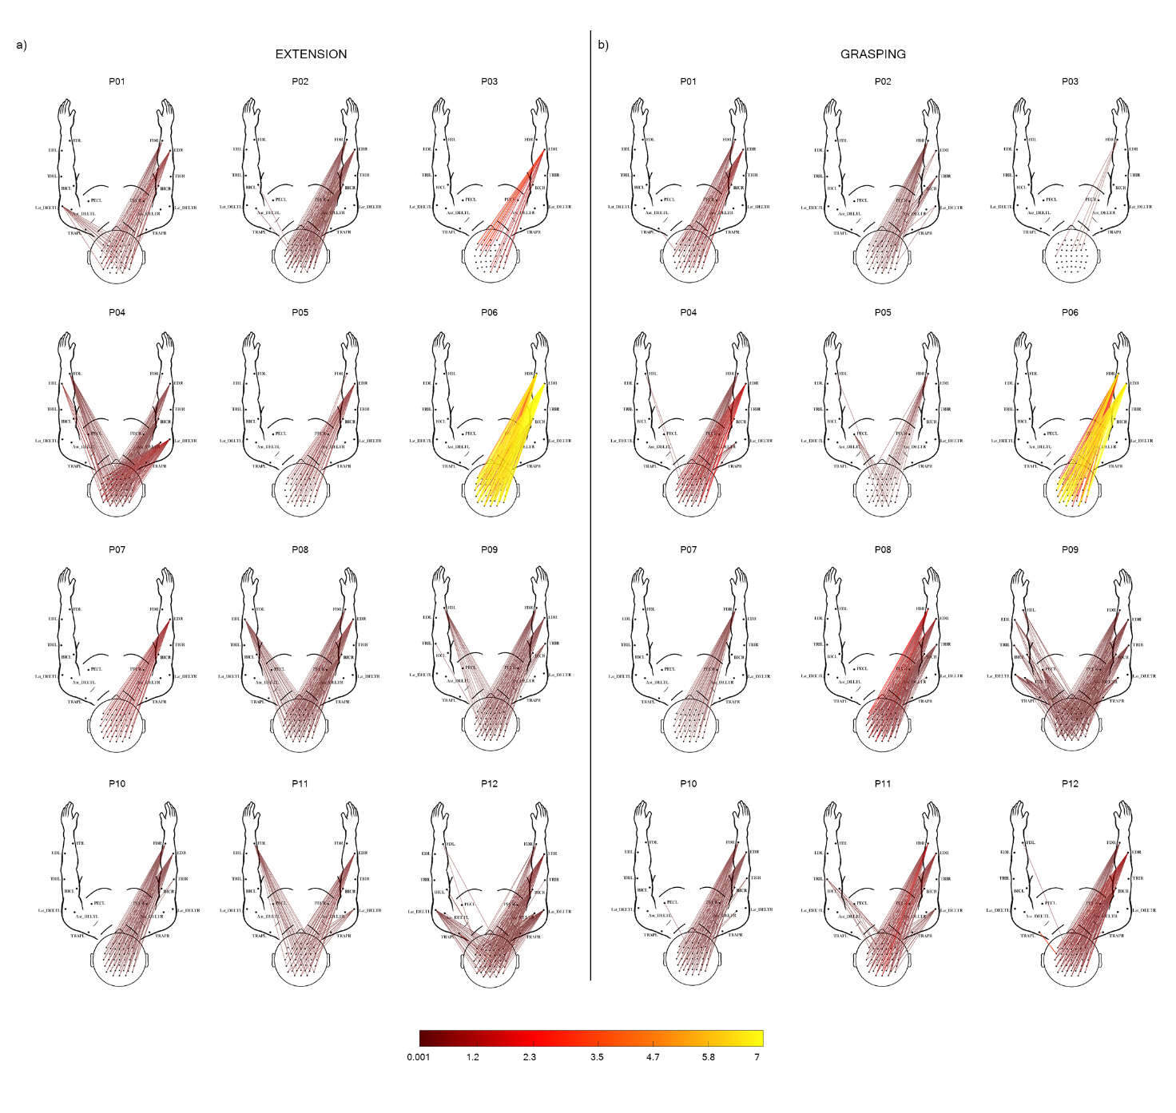
Figure S1. Single-subject corticomuscular coherence patterns in EXP (stroke) group estimated for alpha band (8–12 Hz) during extension (panel a) and grasping (panel b) movement attempted with the affected hand (AH). The 2D body model is seen from the above: scalp with nose pointing up the top and arms in front of the participant. Only statistically significant CMC values are represented (unpaired t-test between task and rest intervals, α =0.05 FDR correction). The color bar codes for the CMC average value across trials for each stroke participant (N participants = 12) in the task trial.

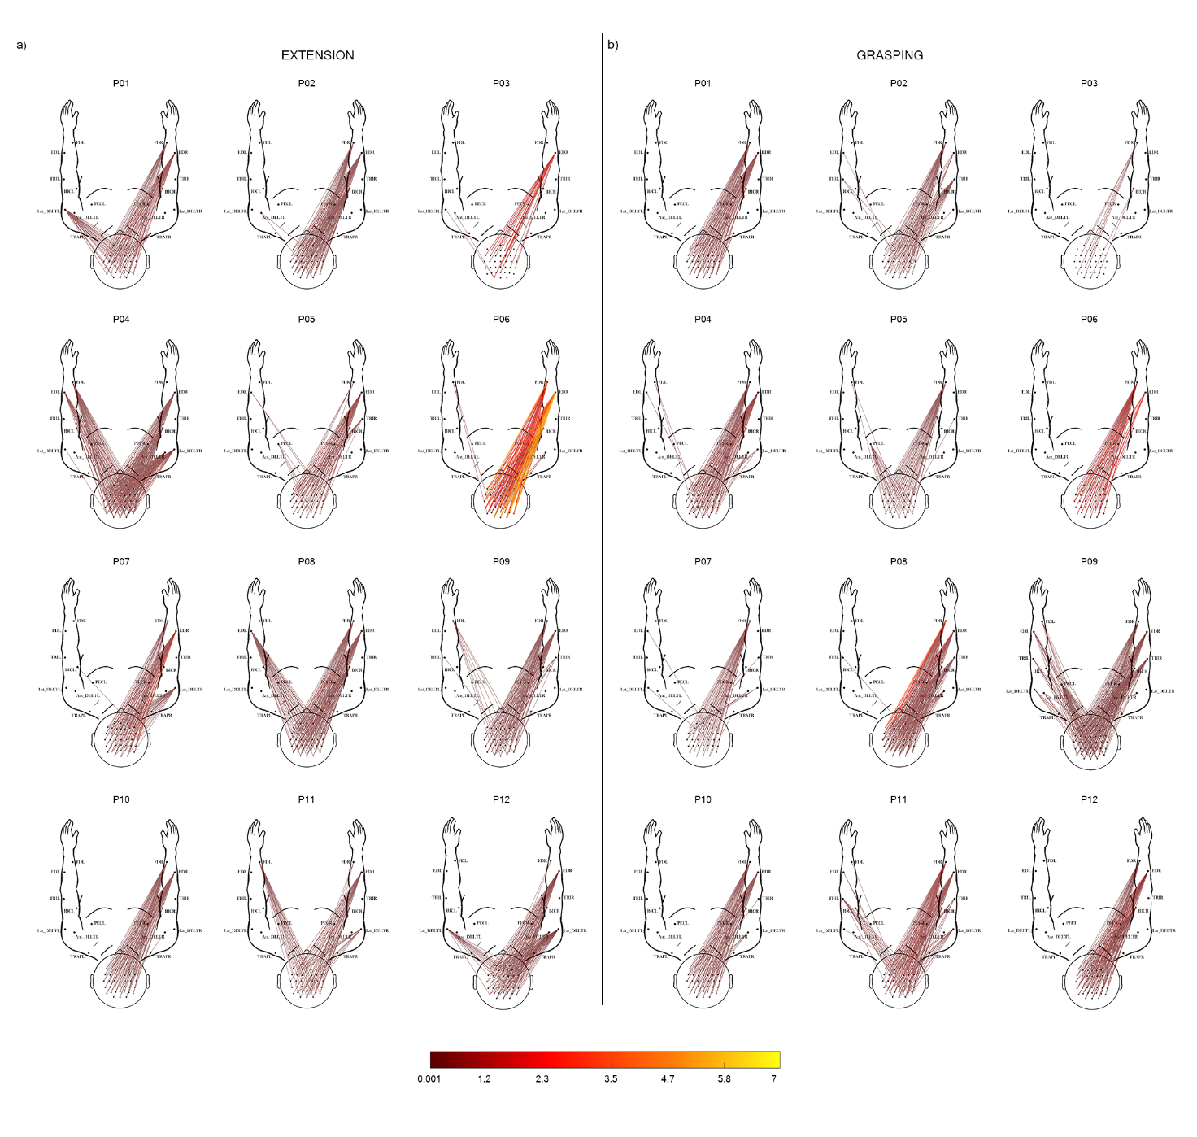
Figure S2. Single-subject corticomuscular coherence patterns in EXP (stroke) group estimated for beta band (13–30 Hz) during extension (panel a) and grasping (panel b) movement attempted with the affected hand (AH). The 2D body model is seen from the above: scalp with nose pointing up the top and arms in front of the participant. Only statistically significant CMC values are represented (unpaired t-test between task and rest intervals, α =0.05 FDR correction). The color bar codes for the CMC average value across trials for each stroke participant (N participants = 12) in the task trial.
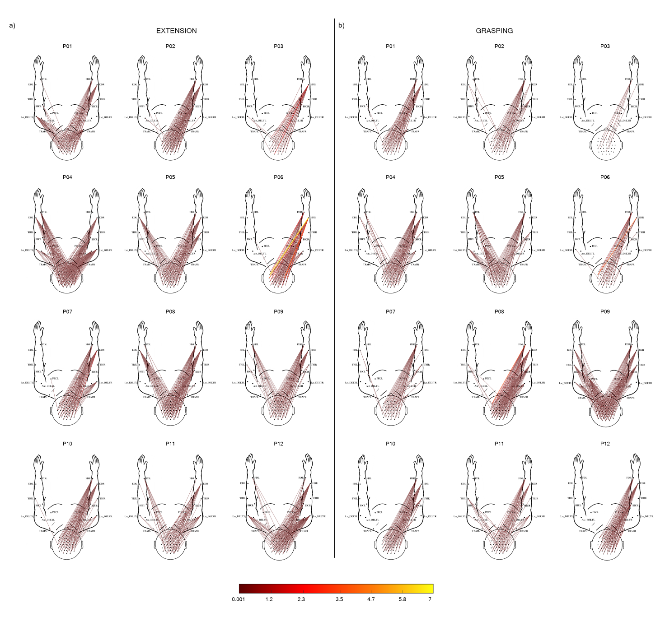
Figure S3. Single-subject corticomuscular coherence patterns in EXP (stroke) group estimated for gamma band (31–60 Hz) during extension (panel a) and grasping (panel b) movement attempted with the affected hand (AH). The 2D body model is seen from the above: scalp with nose pointing up the top and arms in front of the participant. Only statistically significant CMC values are represented (unpaired t-test between task and rest intervals, α =0.05 FDR correction). The color bar codes for the CMC average value across trials for each stroke participant (N participants = 12) in the task trial.

