Additional Figures

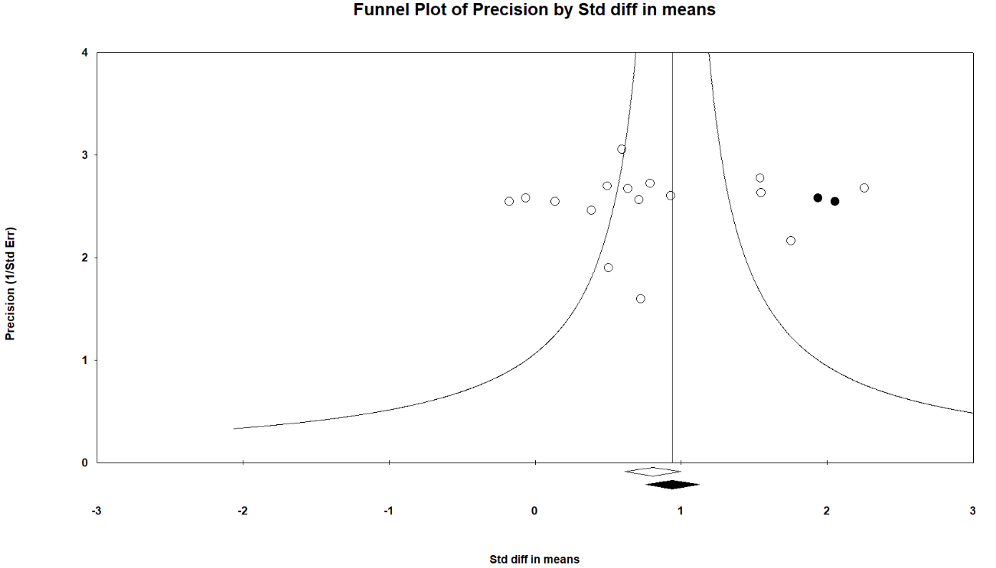
Figure S1. Funnel Plot of the Effect of VRBT on Functional Balance

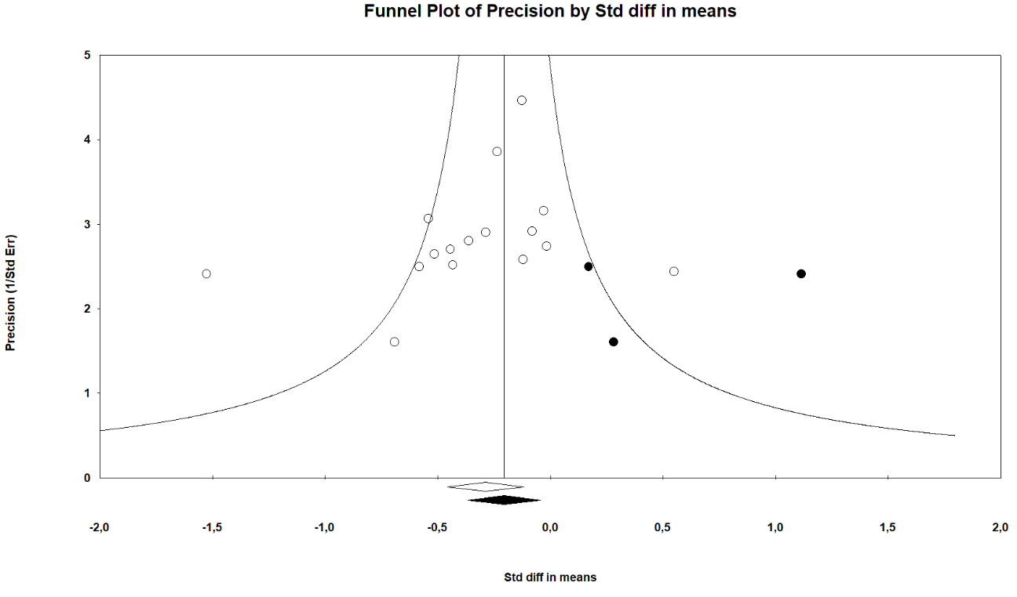
Figure S2. Funnel Plot of the Effect of VRBT on Dynamic Balance

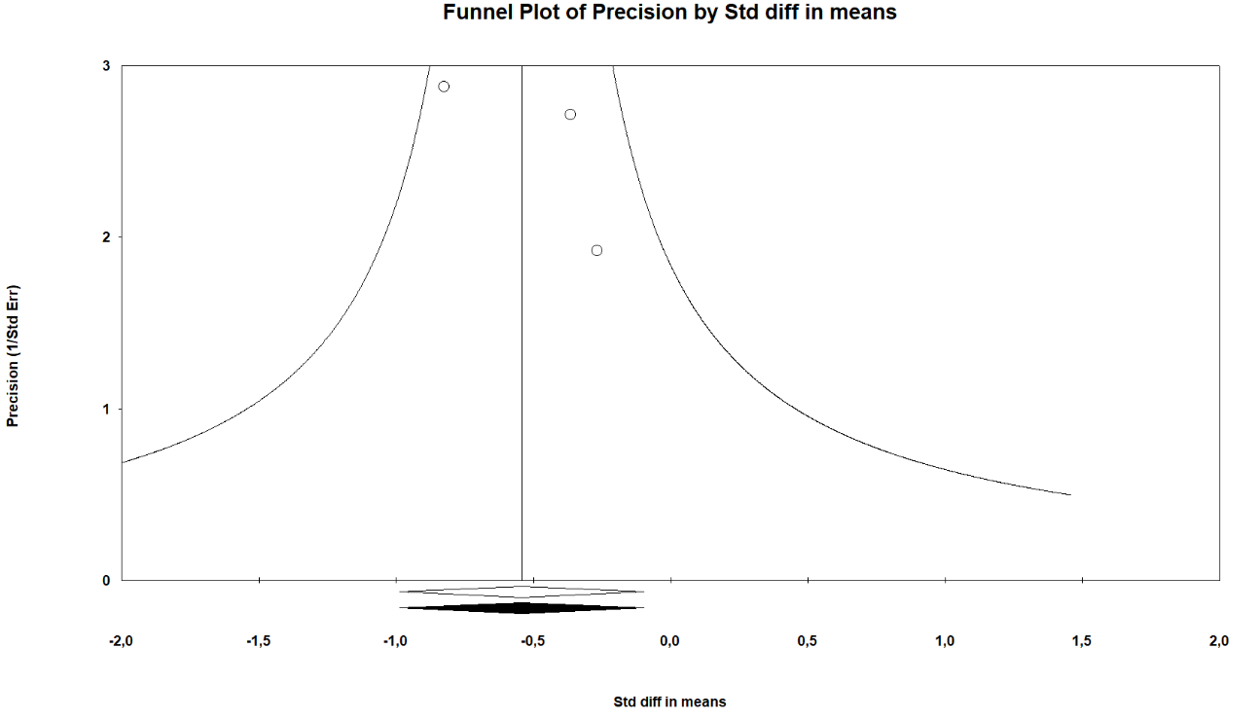
Figure S3. Funnel Plot of the Effect of VRBT on Sway Area with Eyes Closed

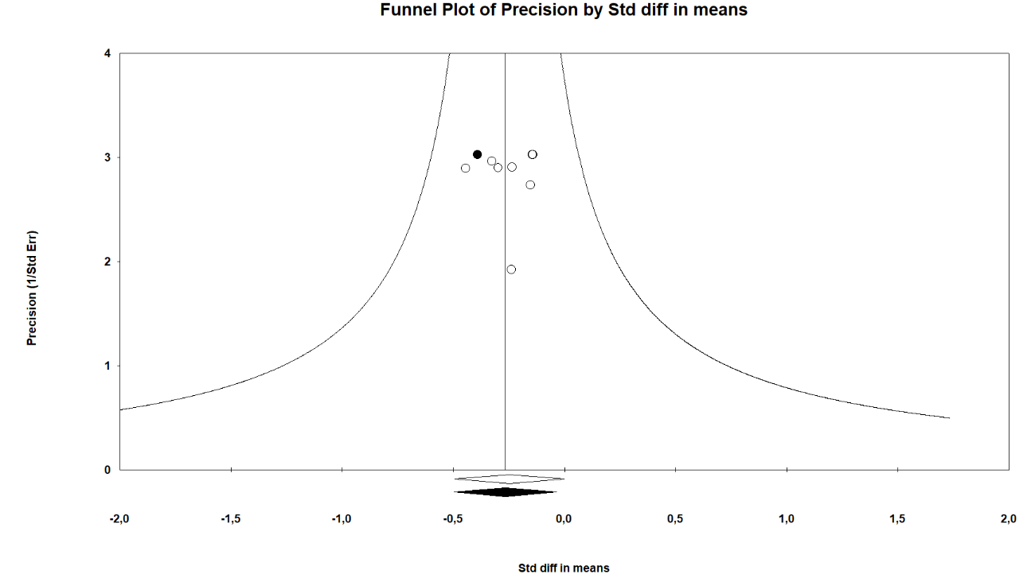
Figure S4. Funnel Plot of the Effect of VRBT on Centre of Pressure Excursion with Eyes Open
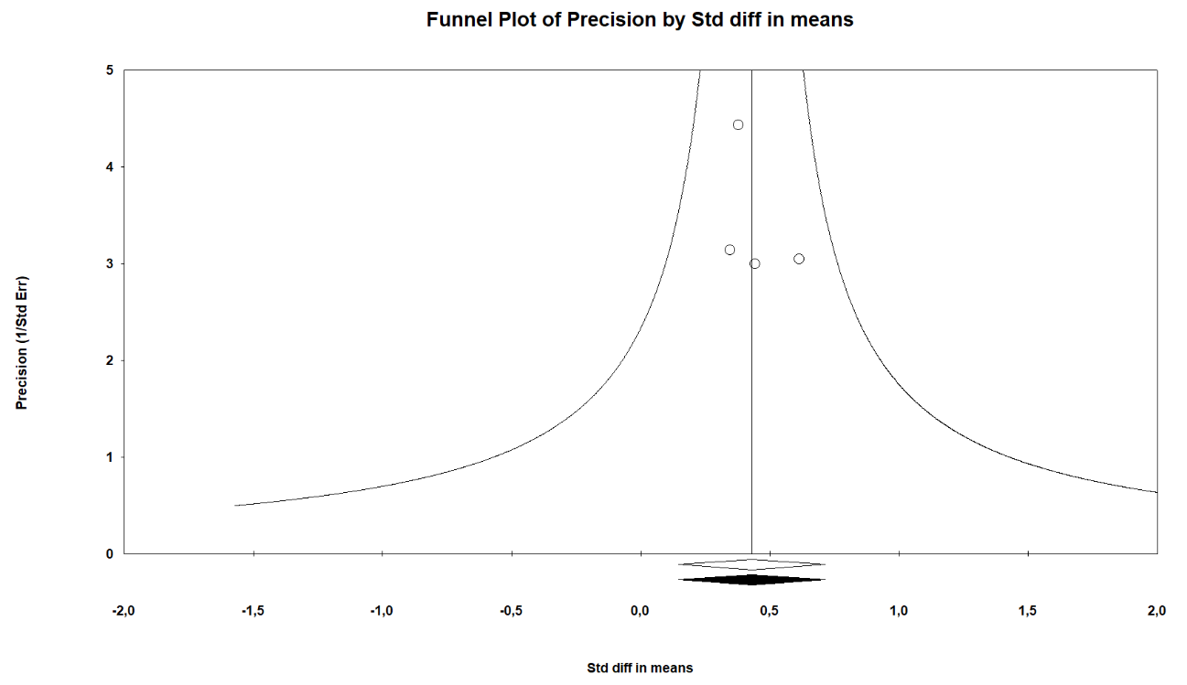
Figure S5. Funnel Plot of the Effect of VRBT on Confidence of Balance

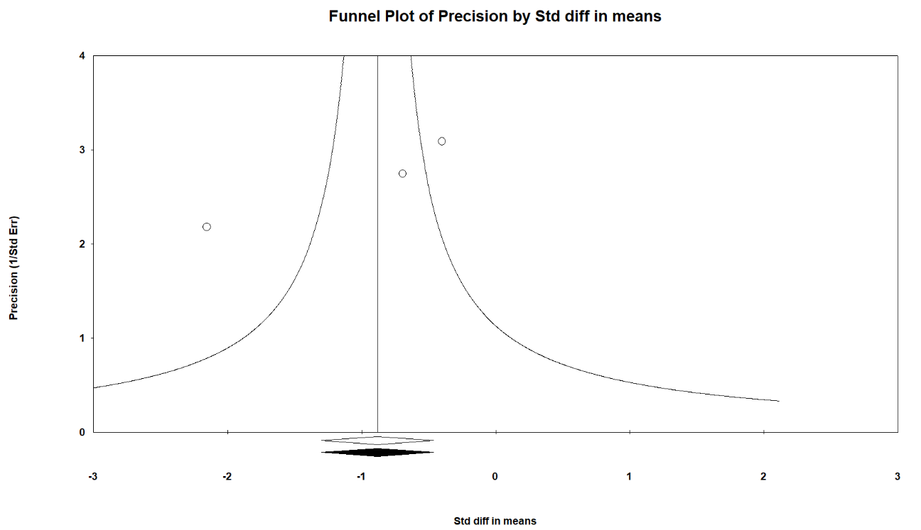
Figure S6. Funnel Plot of the Effect of VRBT on Fear of Falling
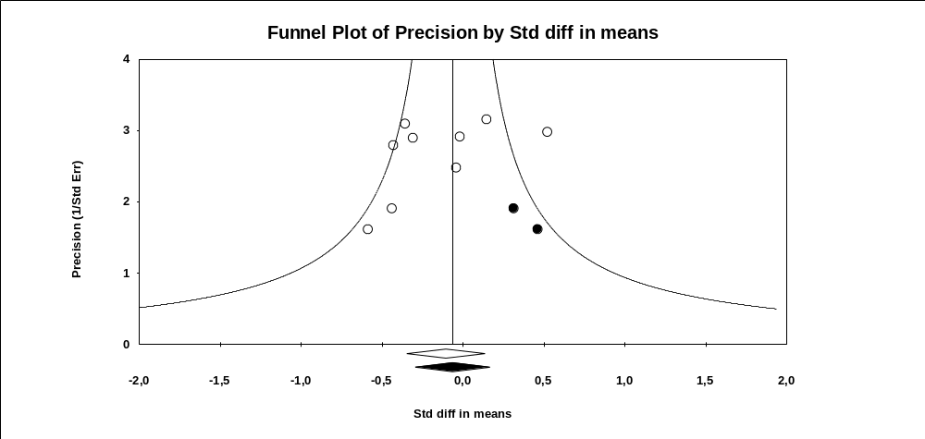
Figure S7. Funnel Plot of the Effect of VRBT on Gait Speed

