Additional Information

Title: Muscle synergy patterns as altered coordination strategies in individuals with chronic low back pain: a cross-sectional study

Hiroki Saito^{1,2}, Hikaru Yokoyama^{3*}, Atsushi Sasaki^{4, 5}, Kimitaka Nakazawa¹

¹ Graduate School of Arts and Sciences, Department of Life Sciences, The University of Tokyo, Tokyo, Japan
² Department of Physical Therapy, Tokyo University of Technology, Tokyo, Japan
³ Institute of Engineering, Tokyo University of Agriculture and Technology, Tokyo, Japan
⁴ Graduate School of Engineering Science, Department of Mechanical Science and Bioengineering, Osaka University,
⁵ Japan Society for the Promotion of Science, Tokyo, Japan

Correspondence to: Hikaru Yokoyama
Institute of Engineering, Tokyo University of Agriculture and Technology, Tokyo, Japan
Email: h-yokoyama@go.tuat.ac.jp

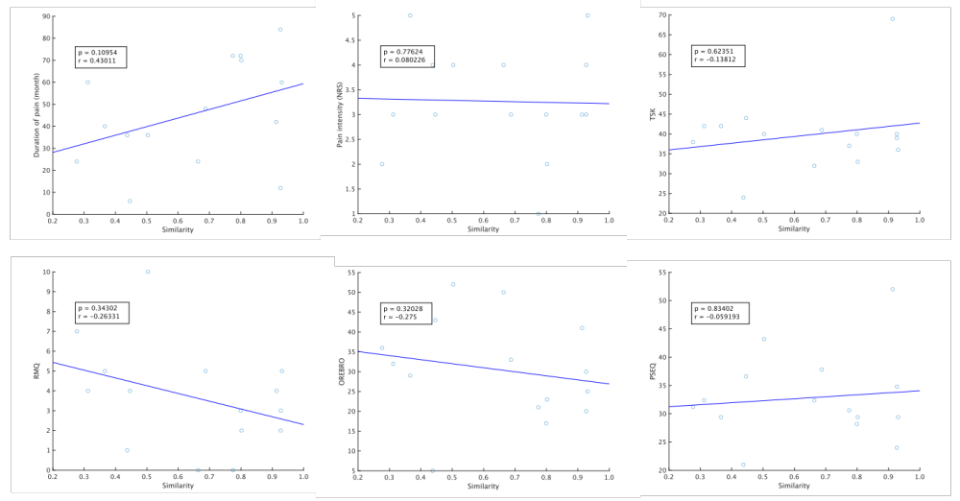
Figure S1. Correlations between the averages similarity between the centroids of muscle weighting components and each muscle weighting components in CLBP group, and clinical scores. Above: Spearman’s rank correlation coefficient (r) and its significance (p-value) between similarity and clinical scales. Black dots show similarity values (X axis) and clinical scores (Y axis) for CLBP participants (n = 15) and the blue lines represent the regression lines.
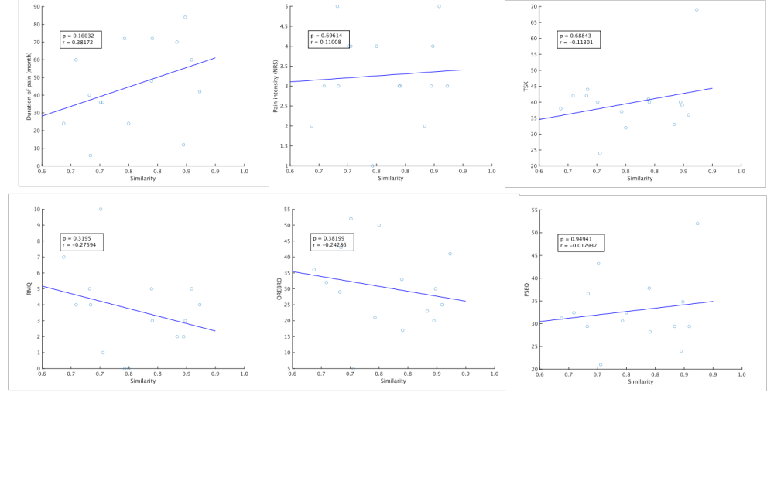
Figure S2. Correlations between the averages similarity between the centroids of temporal pattern components and each temporal pattern components in CLBP group, and clinical scores. Above: Spearman’s rank correlation coefficient (r) and its significance (p-value) between similarity and clinical scales. Black dots show similarity values (X axis) and clinical scores (Y axis) for CLBP participants (n = 15) and the blue lines represent the regression lines.

