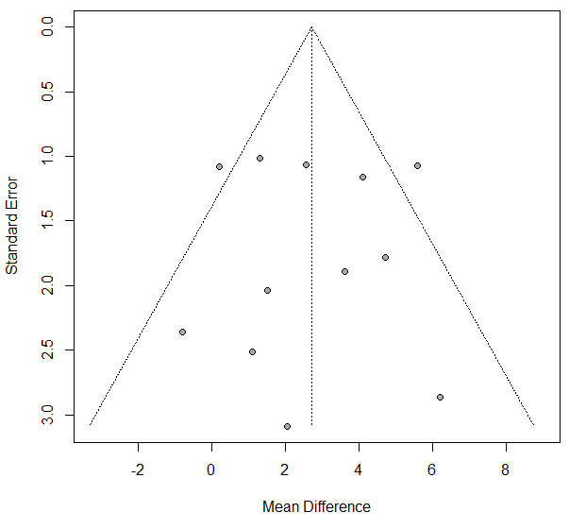
b
a
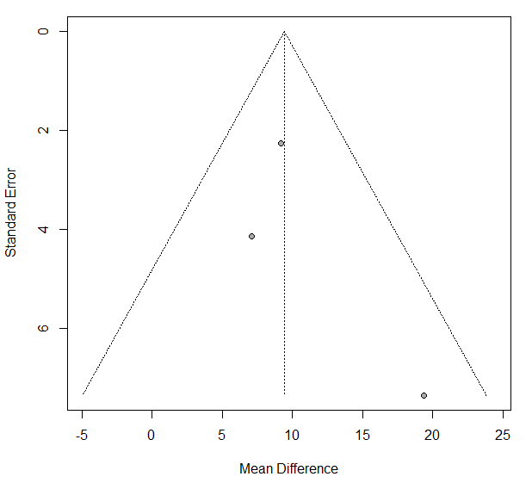
c
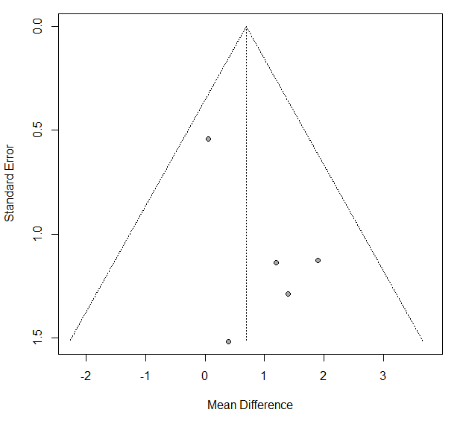
Figure S1. Funnel plots for the meta-analysis of balance function. (a) the Berg balance scale (BBS), (b) the activities-specific balance confidence (ABC), and (c) the dynamic gait index (DGI).
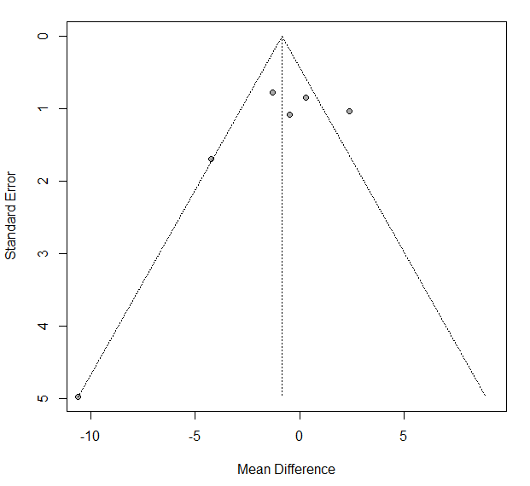
a
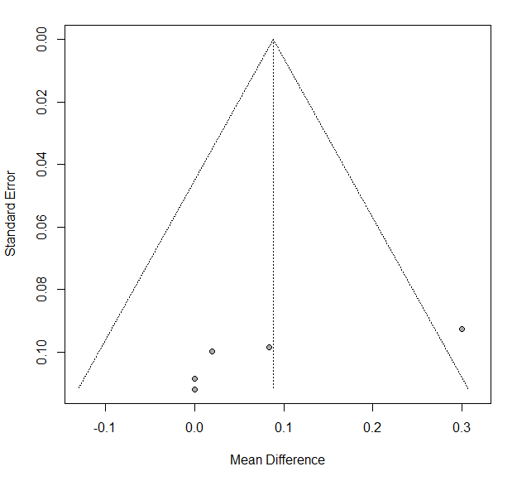
b
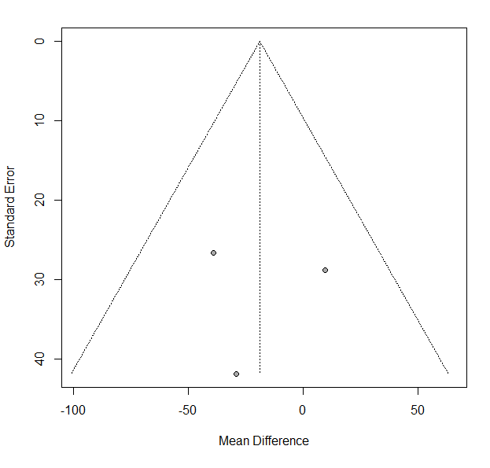
c
Figure S2. Funnel plots for the meta-analysis of gait ability. (a) the time up and go test (TUGT), (b) the 10-meter walk test (10MWT), and (c) the 6-minute walk test (6MWT).
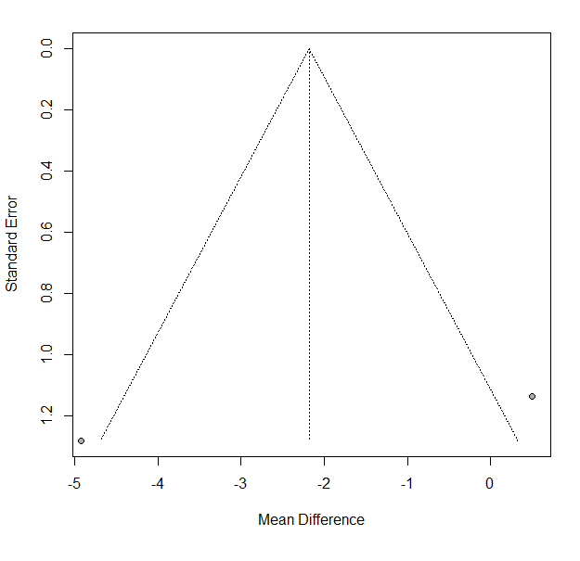
a
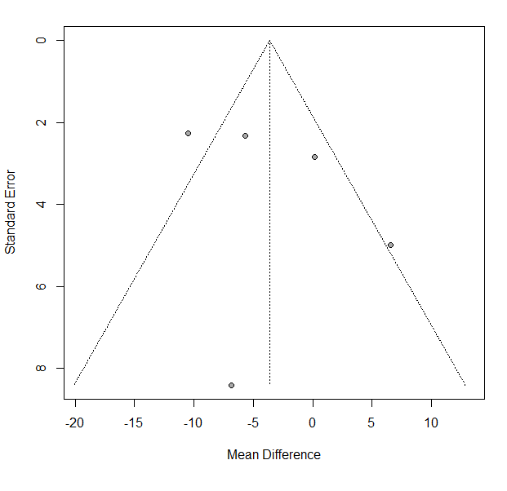
b
Figure S3. Funnel plots for the meta-analysis of activities of daily living and motor function. (a) the Unified Parkinson’s disease rating scale (UPDRS) II and (b) the UPDRS III.

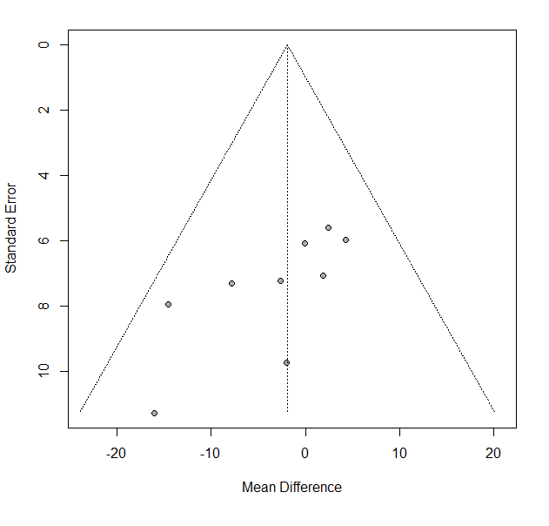
Figure S4. Funnel plot for the meta-analysis of quality of life measured by the Parkinson’s disease questionnaire-39 (PDQ-39).

