Additional File 1

Selection of Predictors in Bolasso
Bolasso was used as feature selection method to identify which AAN-outcome measure(s) could better predict the timed walking tests. Here the variables selected in 1000 bootstrap runs are presented.

Prediction of 10MWT using only AAN outcome measures
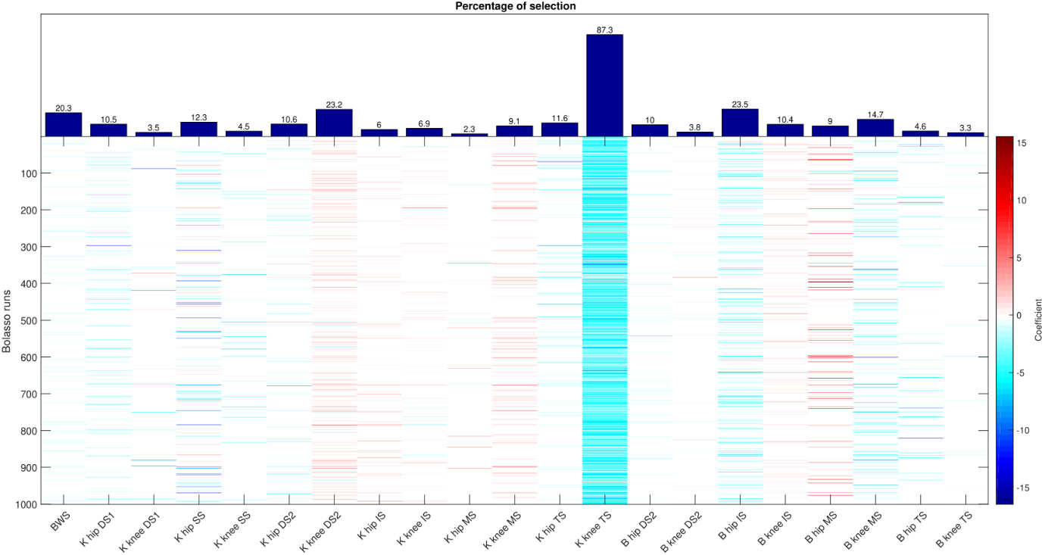
Figure A.1.1.: Output of the Bolasso algorithm for the prediction of 10MWT in ambulatory patients. The colored bars indicate if the coefficient of the predictor in a certain Bolasso run was different from 0, positive (red) or negative (blue). The percentage of selection is shown in the bar plot above.

Prediction of TUG using only AAN outcome measures
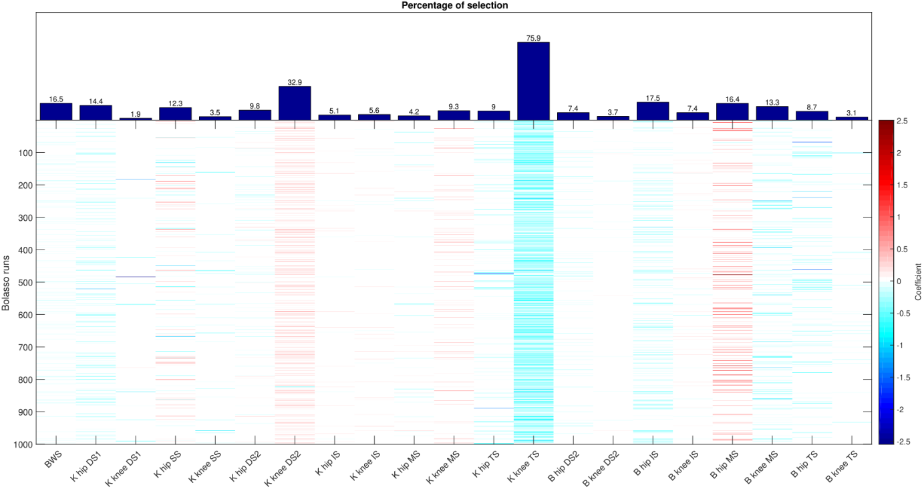
Figure A.1.2.: Output of the Bolasso algorithm for the prediction of TUG in ambulatory patients. The colored bars indicate if the coefficient of the predictor in a certain Bolasso run was different from 0, positive (red) or negative (blue). The percentage of selection is shown in the bar plot above.

Prediction of 10MWT using AAN outcome measures and L-FORCE measures
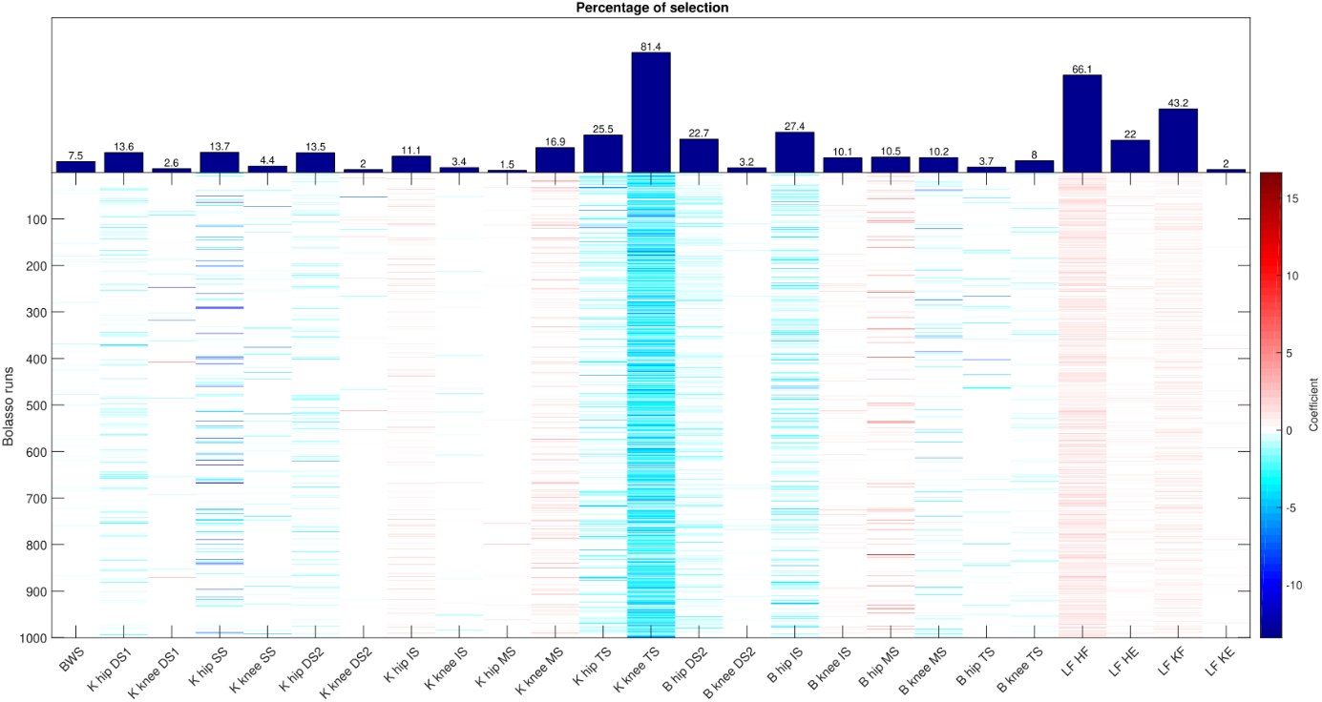
Figure A.1.3.: Output of the Bolasso algorithm for the prediction of 10MWT in ambulatory patients when also the L-FORCE measures are added to the pool of possible predictors. The colored bars indicate if the coefficient of the predictor in a certain Bolasso run was different from 0, positive (red) or negative (blue). The percentage of selection is shown in the bar plot above.

Prediction of TUG using AAN outcome measures and L-FORCE measures
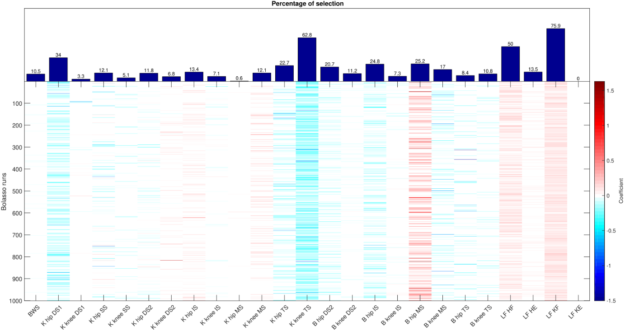
Figure A.1.4.: Output of the Bolasso algorithm for the prediction of TUG in ambulatory patients when also the L-FORCE measures are added to the pool of possible predictors. The colored bars indicate if the coefficient of the predictor in a certain Bolasso run was different from 0, positive (red) or negative (blue). The percentage of selection is shown in the bar plot above.

Prediction of 10MWT in able-bodied subjects using AAN outcome measures and L-FORCE measures
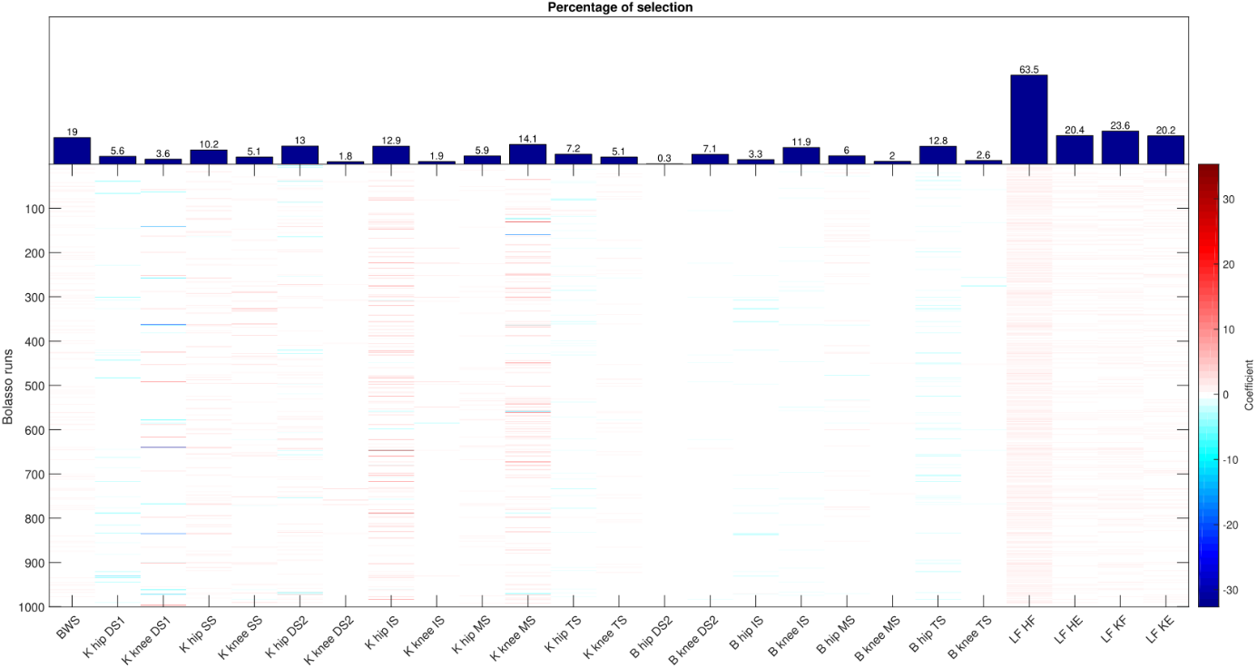
Figure A.1.5.: Output of the Bolasso algorithm for the prediction of 10MWT in able-bodied subjects when also the L-FORCE measures are added to the pool of possible predictors. The colored bars indicate if the coefficient of the predictor in a certain Bolasso run was different from 0, positive (red) or negative (blue). The percentage of selection is shown in the bar plot above.

Prediction of TUG in Non-ambulatory Patients and in Able-bodied Subjects
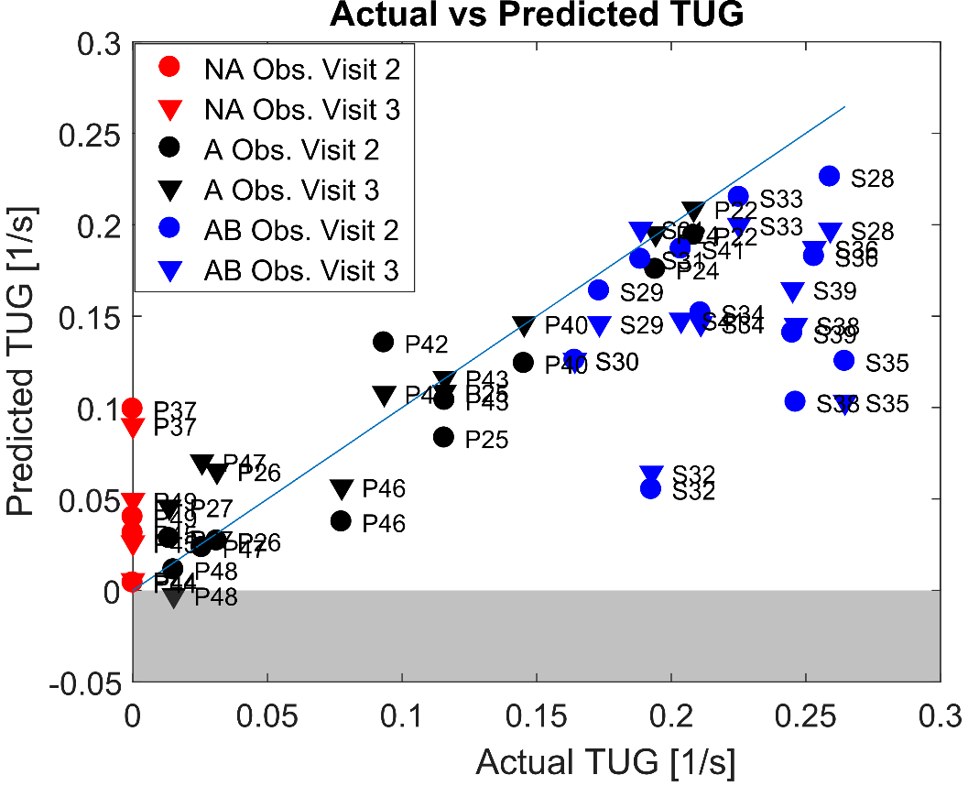
Figure A.1.6.: Prediction of virtual TUG using model with 2 predictors (K knee TS and LF KF). In blue, the identity line is shown

