Supplemental Material 1 (a-c): Notes about the FreeD Settings
(a) FreeD activation in the Lokomat software settings screen (Lokomat User Manual L6.2-UM6.5-en, page 230):
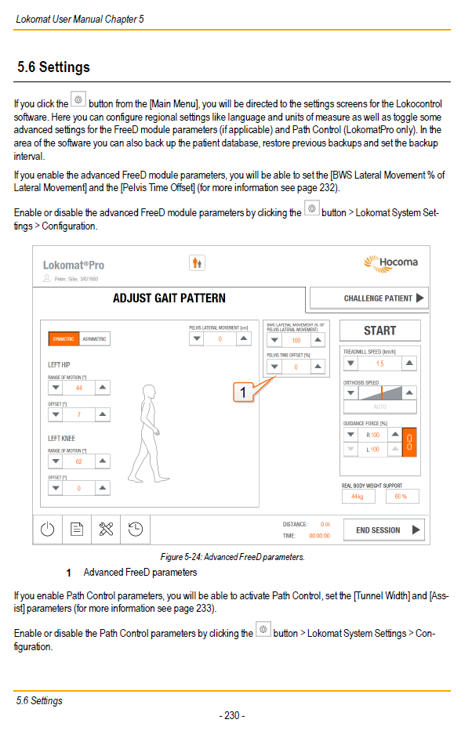
(b) Lokomat FreeD cuffs (Lokomat User Manual L6.2-UM6.5-en, page 175): Conventional FreeD system: Cuff can only be fixed at one point (lateral) and can therefore only slide inward=medial.
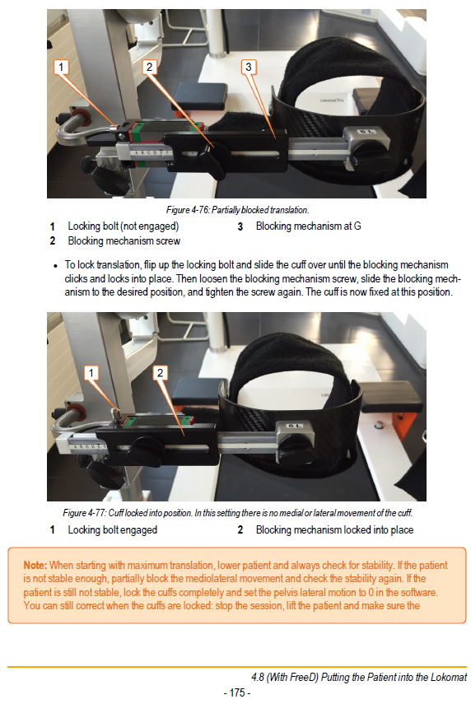
Our FreeD system has 3 fixation points (lateral, middle, medial) and the cuff can slide from the middle point (our default setting) to the outside/lateral and to the inside/medial direction.
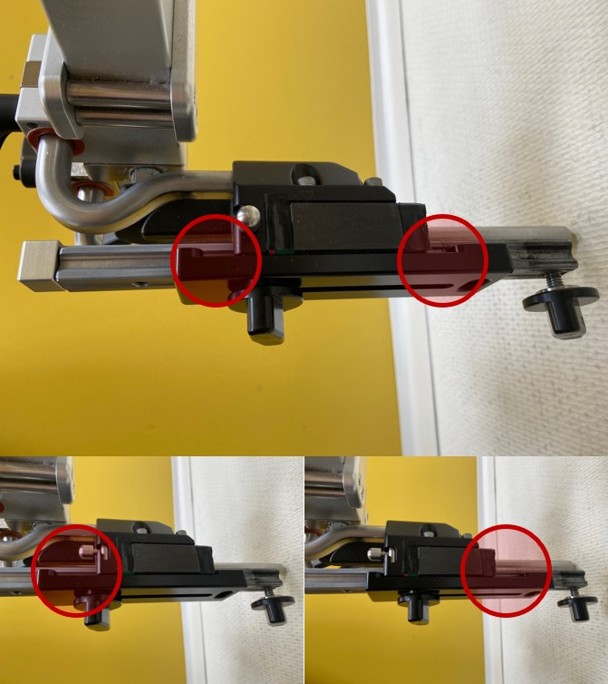

(c) Advanced FreeD Parameters explanation (Lokomat User Manual L6.2-UM6.5-en, page 232):
